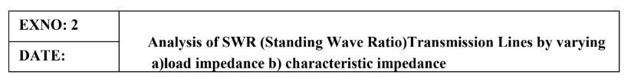

AIM: To analyze the SWR of a transmission line for a fixed characteristic impedance (Zo) of 50
ohms, as the load impedance (ZL) is varied across the following values: 25 ohms, 50 ohms, 75
ohms, and 100 ohms. To verify how the SWR changes with each value of ZL and when ZL =Zo.

SOFTWAREREQUIRED:
SCILABVersion6.1.1
PROCEDURE:

● Open SCILAB software
● Open file-new
● Put the input values
● Typetheprogram
● Execute the program
● End the program

CALCULATION
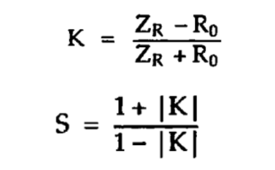

PROGRAM
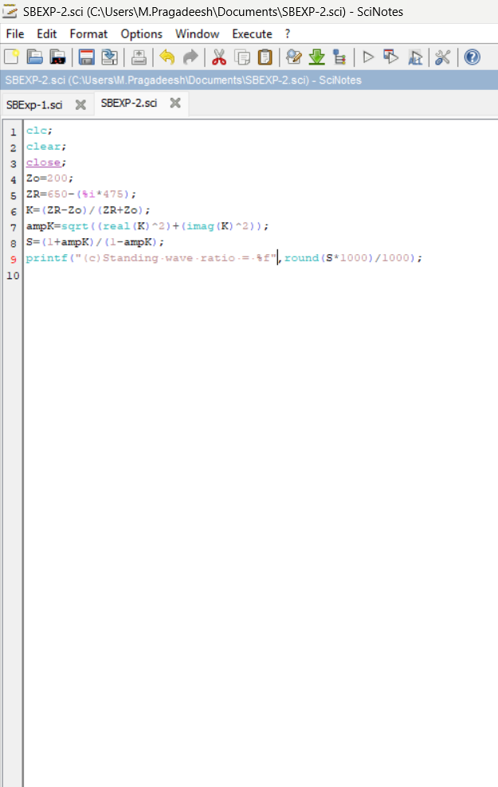

OUTPUT
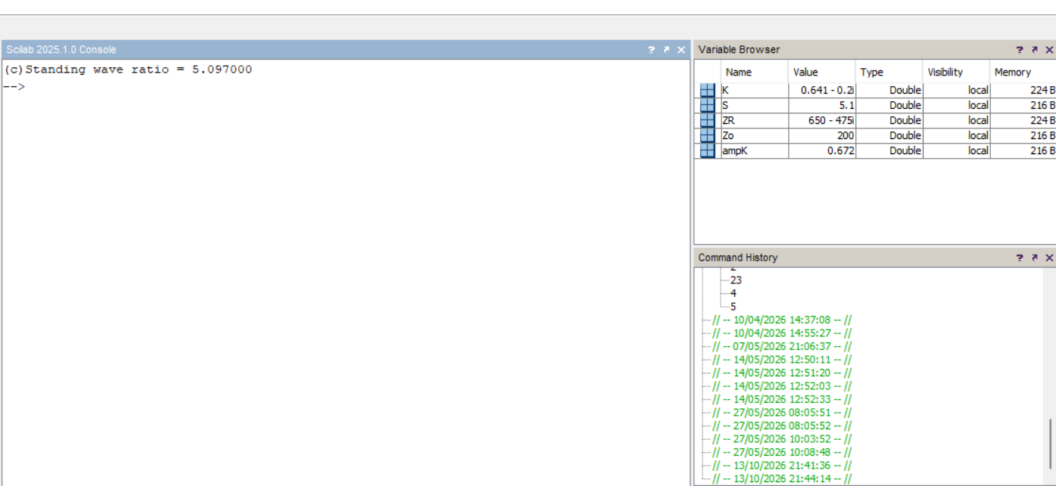

RESULT:
The SWR of a transmission line for a fixed characteristic impedance (Zo) of 50 ohms, is
analyzed for various values of load impedance ZL. SWR is also examined for the condition ZL.

