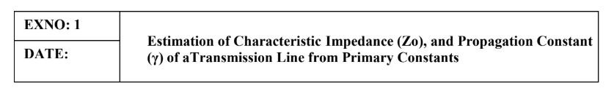

AIM: Investigating the significance of Characteristic Impedance (Zo), and Propagation
Constant (γ) of a Transmission Line with Resistance =10 Ω/Km, Capacitance = 8 μF/Km, Inductance
=3.5 mH/Km, Conductance =4 μmho/Km, Frequency= 2 Khz

SOFTWARE REQUIRED:
SCILAB Version 6.1.1
PROCEDURE:
● Open SCILAB software
● Open file-new
● Put the input values
● Type the program
● Execute the program
● End the program
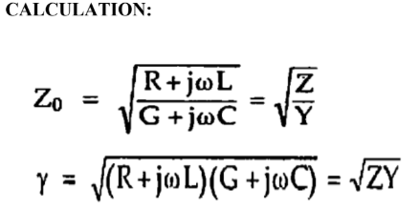

PROGRAM
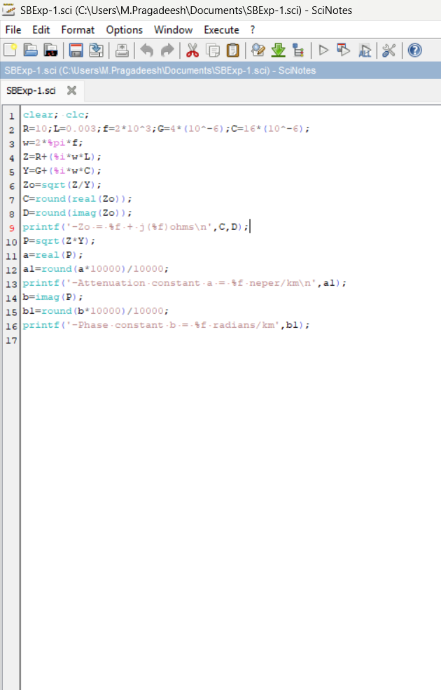

OUTPUT
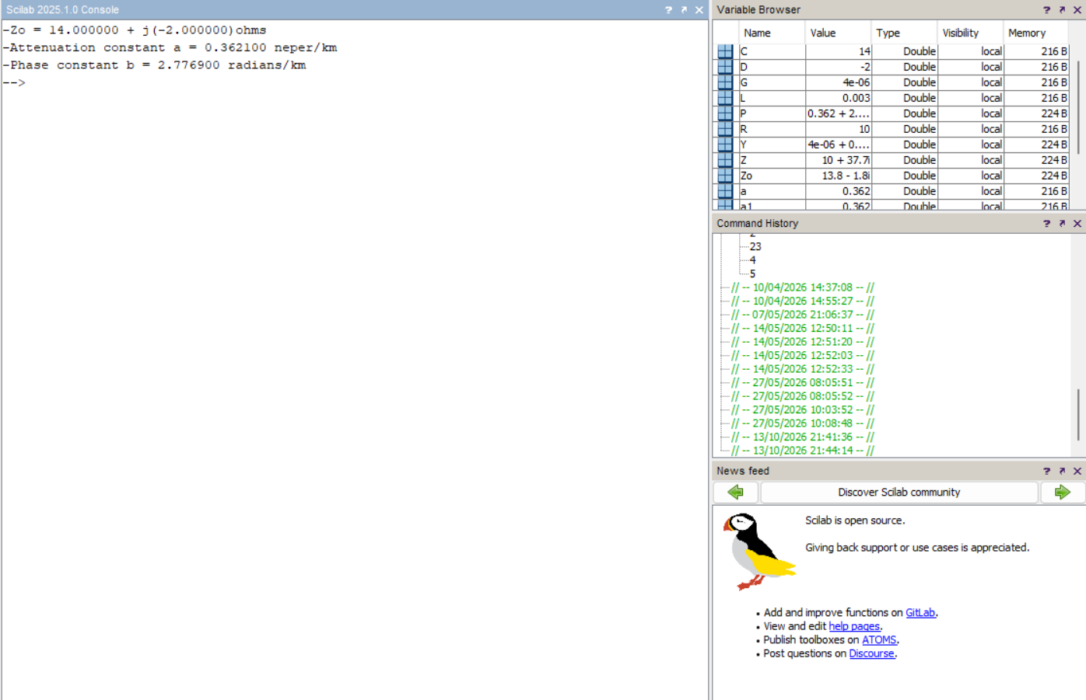

RESULT:
The characteristic impedance and propagation constant of a transmission line is calculated using
SCILAB and the impact of primary constants on secondary constants are investigated.

