**MySQL TASK**

**Lesson 1: SELECT queries 101**

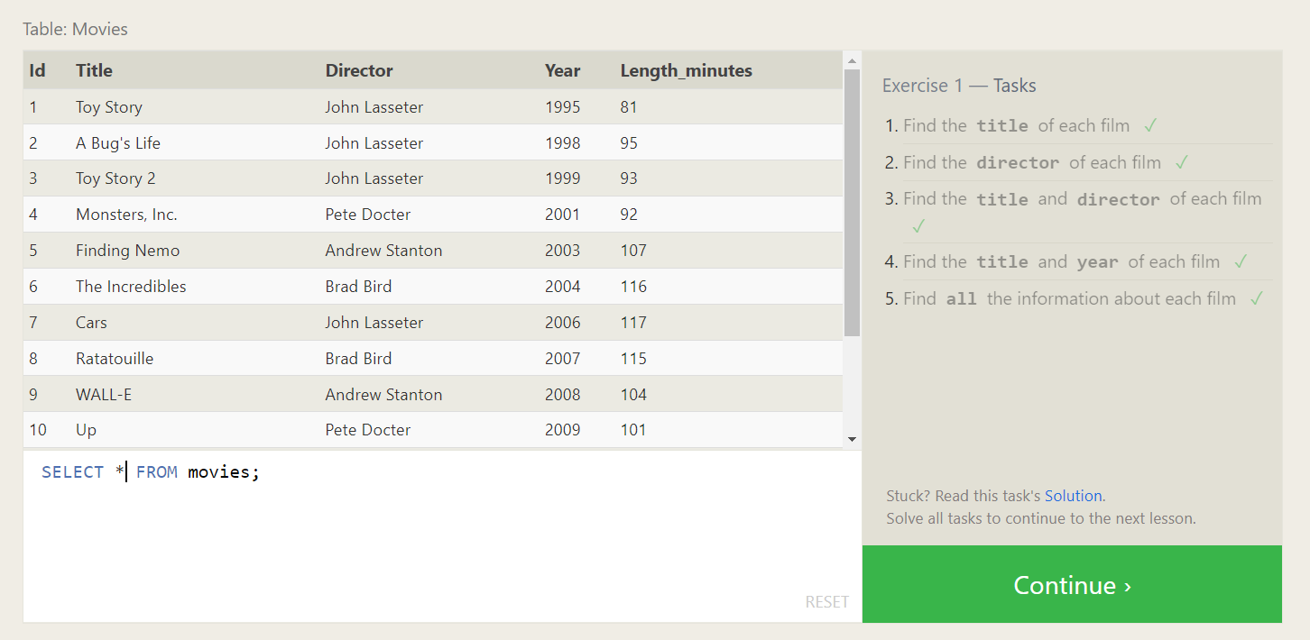

**Solutions :**

1. SELECT title FROM movies;
2. SELECT director FROM movies;
3. SELECT title,director FROM movies;
4. SELECT title,year FROM movies;
5. SELECT * FROM movies;

**Lesson 2: Queries with constraints (Pt. 1)**

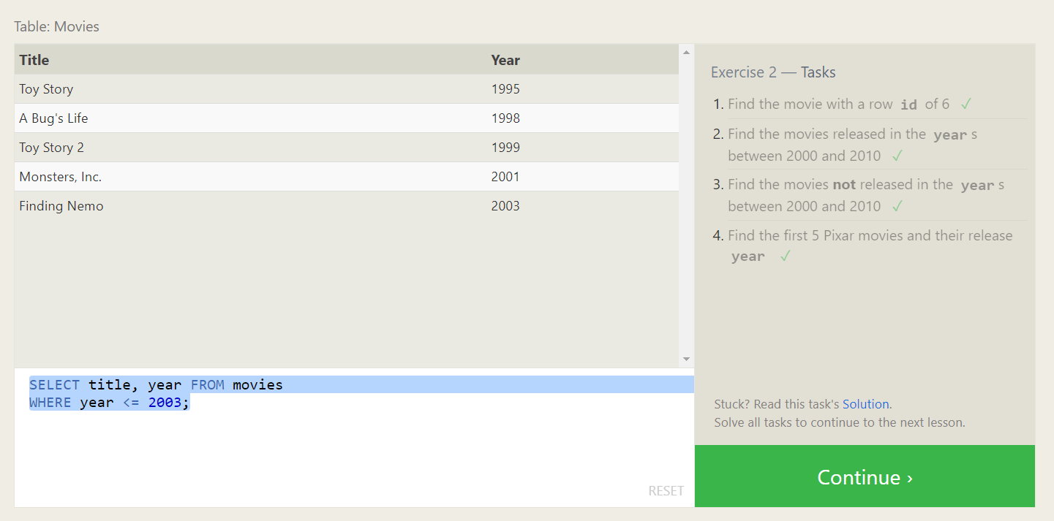

**Solutions :**

1. SELECT * FROM movies

WHERE Id = 6;

1. SELECT * FROM movies

WHERE year BETWEEN 2000 AND 2010;

1. SELECT * FROM movies

WHERE Year NOT BETWEEN 2000 AND 2010;

1. SELECT title, year FROM movies

WHERE year <= 2003;

**Lesson 3: Queries with constraints (Pt. 2)**

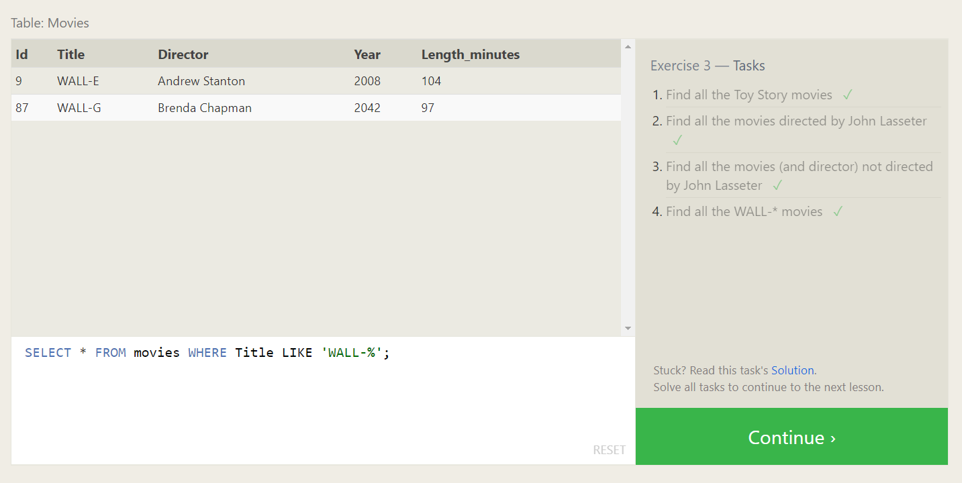

**Solutions :**

1. SELECT * FROM movies WHERE Title LIKE 'Toy Story%';
2. SELECT * FROM movies WHERE Director = 'John Lasseter';
3. SELECT * FROM movies WHERE Director != 'John Lasseter';
4. SELECT * FROM movies WHERE Title LIKE 'WALL-%';

**Lesson 4: Filtering and sorting Query results**

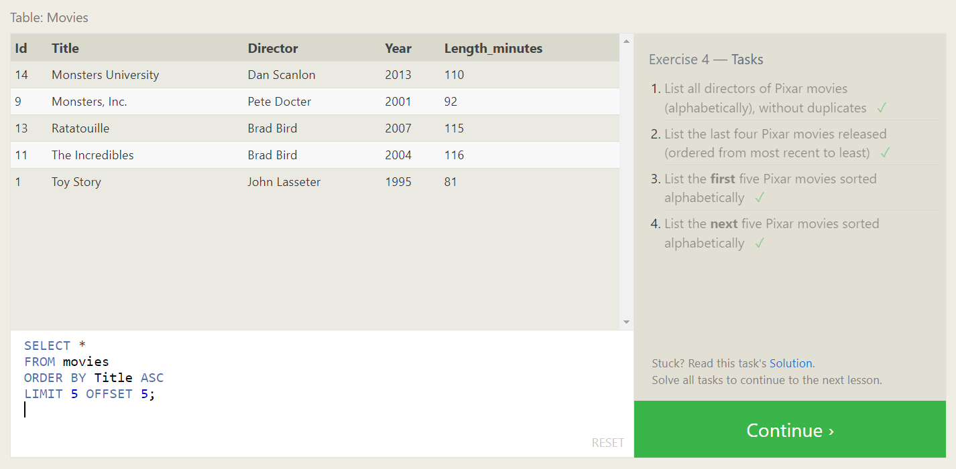

**Solutions :**

1. SELECT DISTINCT Director

FROM movies

ORDER BY Director ASC;

1. SELECT *

FROM movies

ORDER BY Year DESC

LIMIT 4;

1. SELECT *

FROM movies

ORDER BY Title ASC

LIMIT 5;

1. SELECT *

FROM movies

ORDER BY Title ASC

LIMIT 5 OFFSET 5;

**MySQL Review: Simple SELECT Queries**

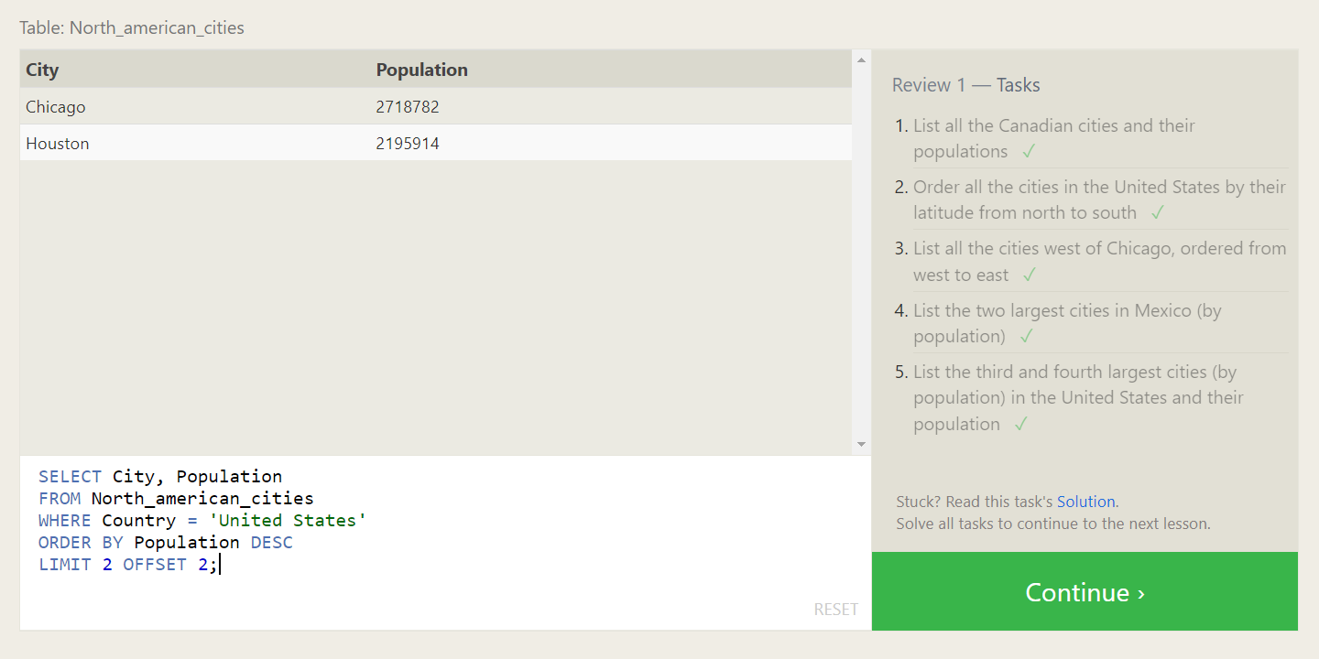

**Solutions :**

1. SELECT City, Population

FROM North_american_cities

WHERE Country = 'Canada';

1. SELECT City, Latitude

FROM North_american_cities

WHERE Country = 'United States'

ORDER BY Latitude DESC;

1. SELECT City, Longitude

FROM North_american_cities

WHERE Longitude < (SELECT Longitude FROM North_american_cities WHERE City = 'Chicago')

ORDER BY Longitude ASC;

1. SELECT City, Population

FROM North_american_cities

WHERE Country = 'Mexico'

ORDER BY Population DESC

LIMIT 2;

1. SELECT City, Population

FROM North_american_cities

WHERE Country = 'United States'

ORDER BY Population DESC

LIMIT 2 OFFSET 2;

**Lesson 6: Multi-table queries with JOINs**

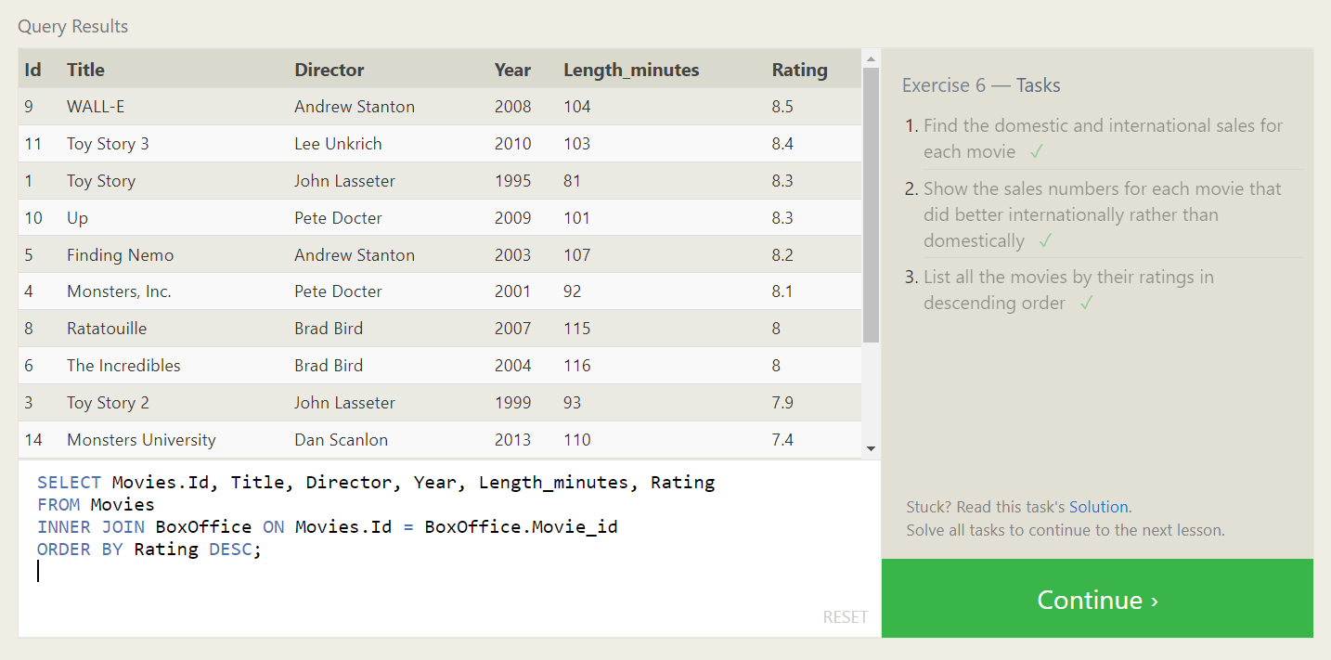

**Solutions :**

1. SELECT Movies.Id, Title, Director, Year, Length_minutes, Domestic_sales, International_sales

FROM Movies

INNER JOIN BoxOffice ON Movies.Id = BoxOffice.Movie_id;

1. SELECT Movies.Id, Title, Director, Year, Length_minutes, Domestic_sales, International_sales

FROM Movies

INNER JOIN BoxOffice ON Movies.Id = BoxOffice.Movie_id

WHERE International_sales > Domestic_sales;

1. SELECT Movies.Id, Title, Director, Year, Length_minutes, Rating

FROM Movies

INNER JOIN BoxOffice ON Movies.Id = BoxOffice.Movie_id

ORDER BY Rating DESC;

**Lesson 7: OUTER JOINs**

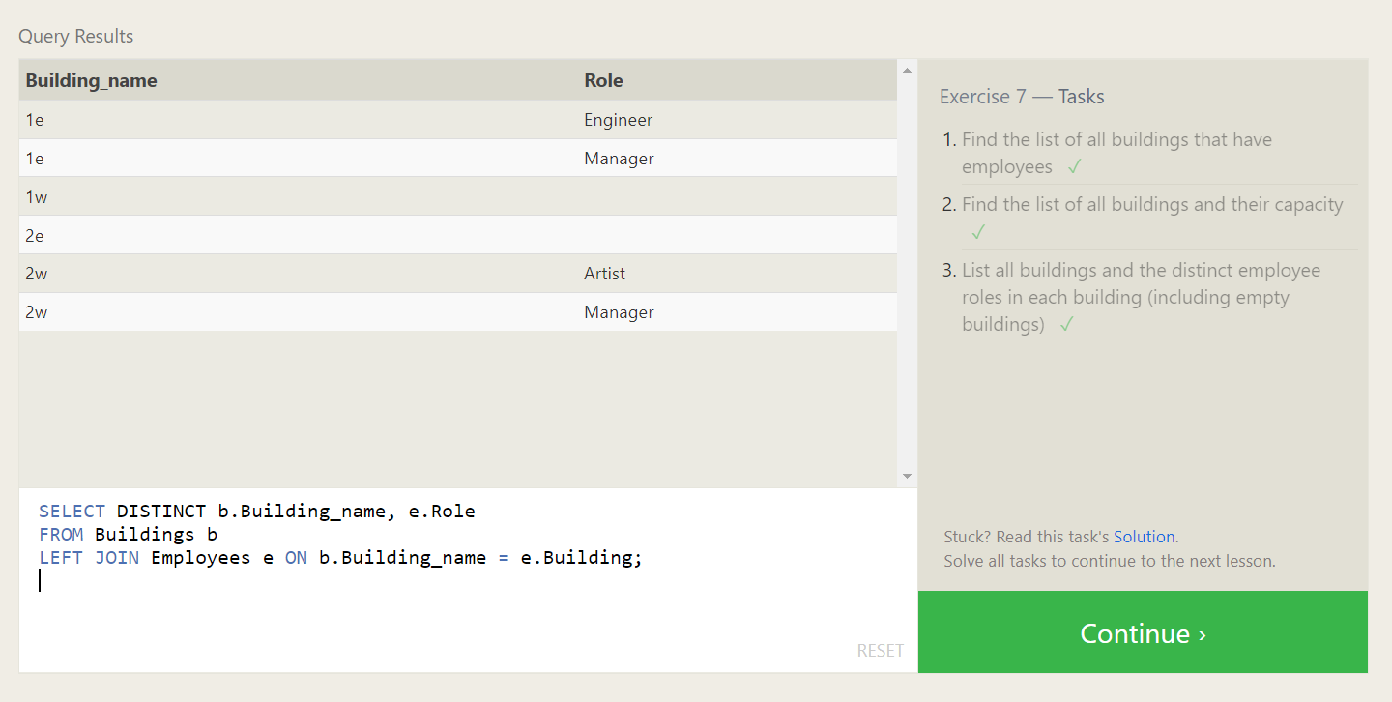

**Solutions :**

1. SELECT DISTINCT e.Building

FROM Employees e

LEFT JOIN Buildings b ON e.Building = b.Building_name

WHERE e.Building IS NOT NULL;

1. SELECT b.Building_name, b.Capacity

FROM Buildings b

LEFT JOIN Employees e ON b.Building_name = e.Building

GROUP BY b.Building_name, b.Capacity;

1. SELECT DISTINCT b.Building_name, e.Role

FROM Buildings b

LEFT JOIN Employees e ON b.Building_name = e.Building;

**Lesson 8: A short note on NULLs**

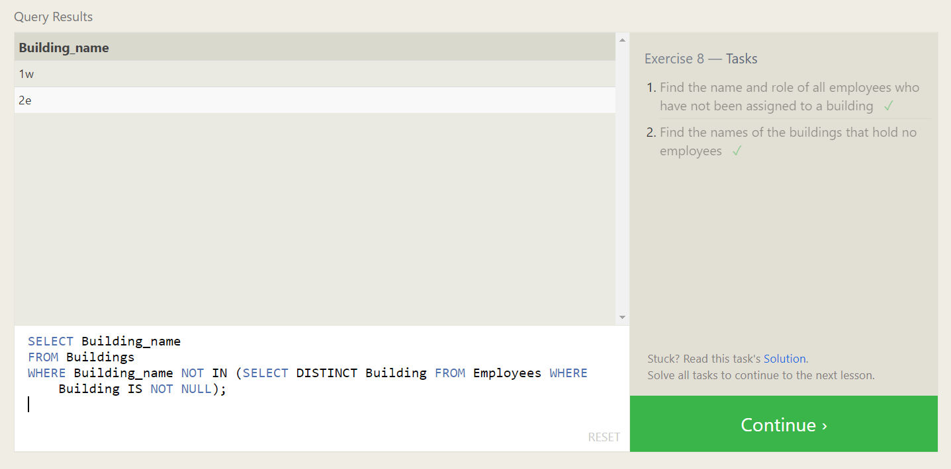

**Solutions :**

1. SELECT Name, Role

FROM Employees

WHERE Building IS NULL;

1. SELECT Building_name

FROM Buildings

WHERE Building_name NOT IN (SELECT DISTINCT Building FROM Employees WHERE Building IS NOT NULL);

**Lesson 9: Queries with expressions**

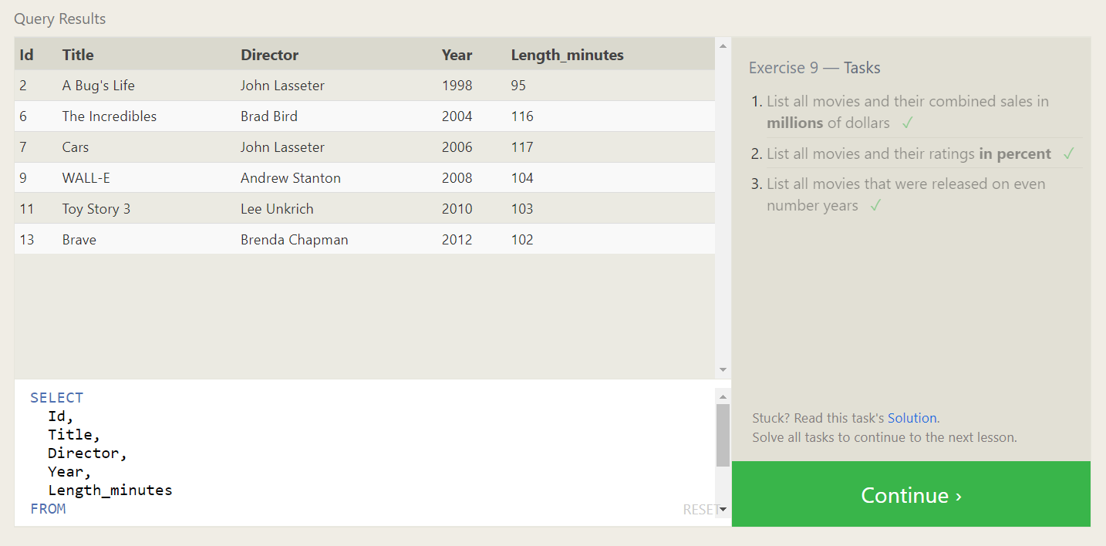

**Solutions :**

1. SELECT

m.Id,

m.Title,

m.Director,

m.Year,

m.Length_minutes,

(b.Domestic_sales + b.International_sales) / 1000000 AS combined_sales_millions

FROM

Movies m

JOIN

Boxoffice b ON m.Id = b.Movie_id;

1. SELECT

m.Id,

m.Title,

m.Director,

m.Year,

m.Length_minutes,

b.Rating * 10 AS rating_percent

FROM

Movies m

JOIN

Boxoffice b ON m.Id = b.Movie_id;

1. SELECT

Id,

Title,

Director,

Year,

Length_minutes

FROM

Movies

WHERE

Year % 2 = 0;

**Lesson 10: Queries with aggregates (Pt. 1)**

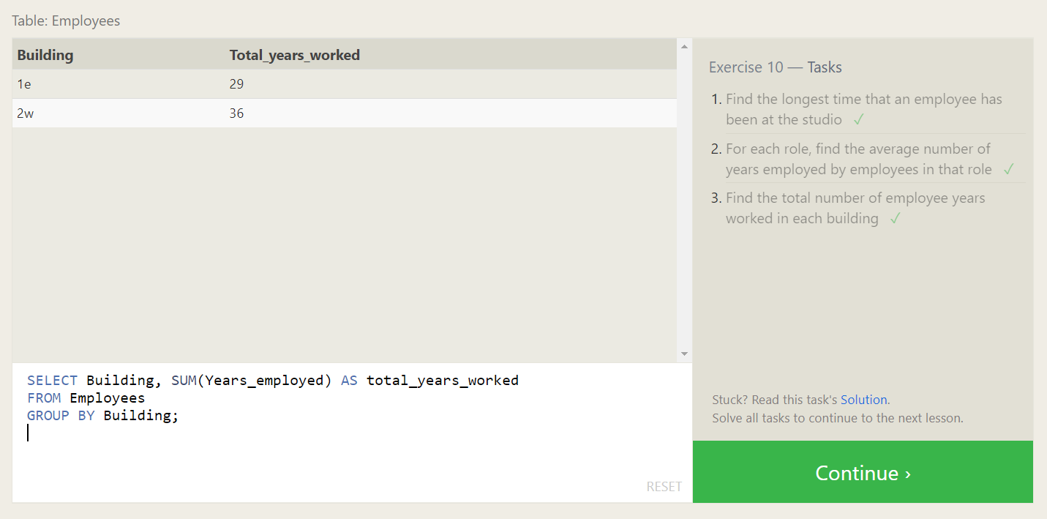

**Solutions :**

1. SELECT MAX(Years_employed) AS longest_time

FROM Employees;

1. SELECT Role, AVG(Years_employed) AS avg_years_employed

FROM Employees

GROUP BY Role;

1. SELECT Building, SUM(Years_employed) AS total_years_worked

FROM Employees

GROUP BY Building;

**Lesson 11: Queries with aggregates (Pt. 2)**

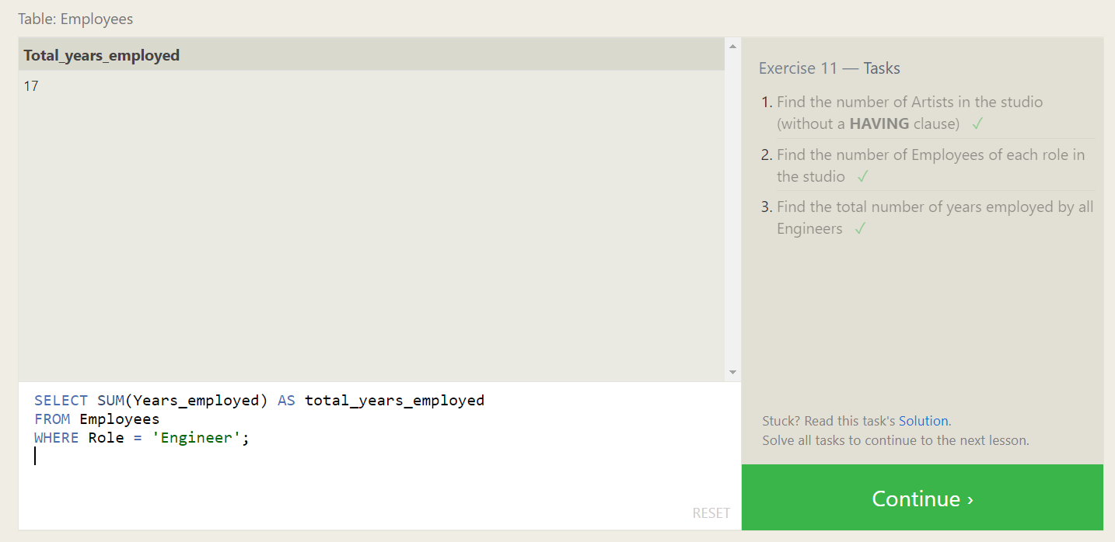

**Solutions :**

1. SELECT COUNT(*) AS num_artists

FROM Employees

WHERE Role = 'Artist';

1. SELECT Role, COUNT(*) AS num_employees

FROM Employees

GROUP BY Role;

1. SELECT SUM(Years_employed) AS total_years_employed

FROM Employees

WHERE Role = 'Engineer';

**Lesson 12: Order of execution of a Query**

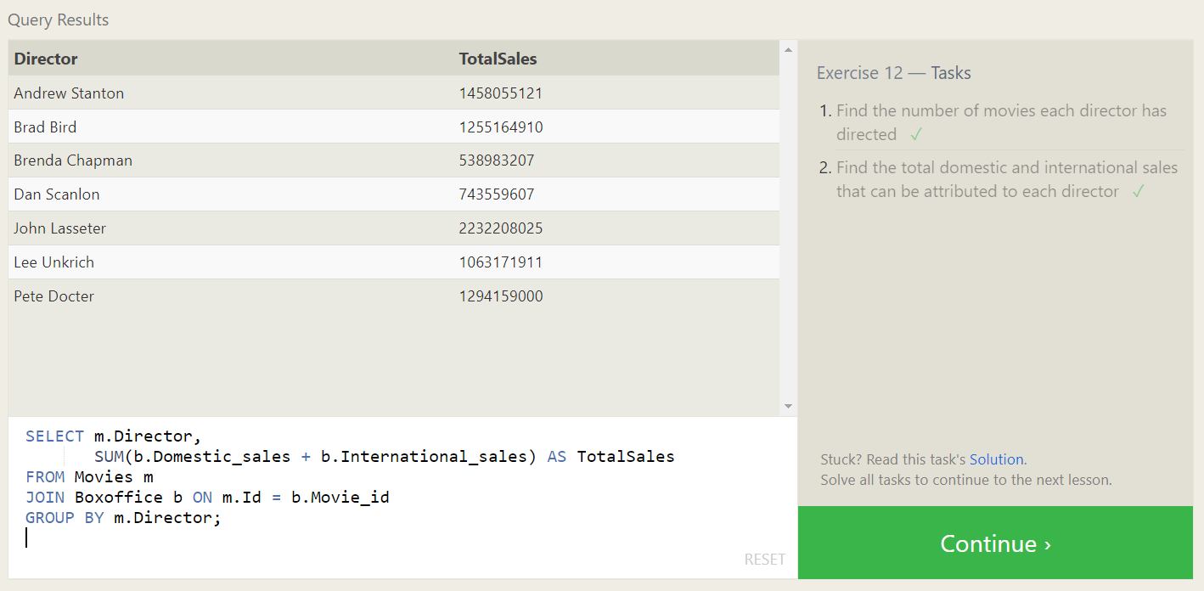

**Solutions :**

1. SELECT Director, COUNT(*) AS NumMoviesDirected

FROM Movies

GROUP BY Director;

1. SELECT m.Director,

SUM(b.Domestic_sales + b.International_sales) AS TotalSales

FROM Movies m

JOIN Boxoffice b ON m.Id = b.Movie_id

GROUP BY m.Director;

**Lesson 13: Inserting rows**

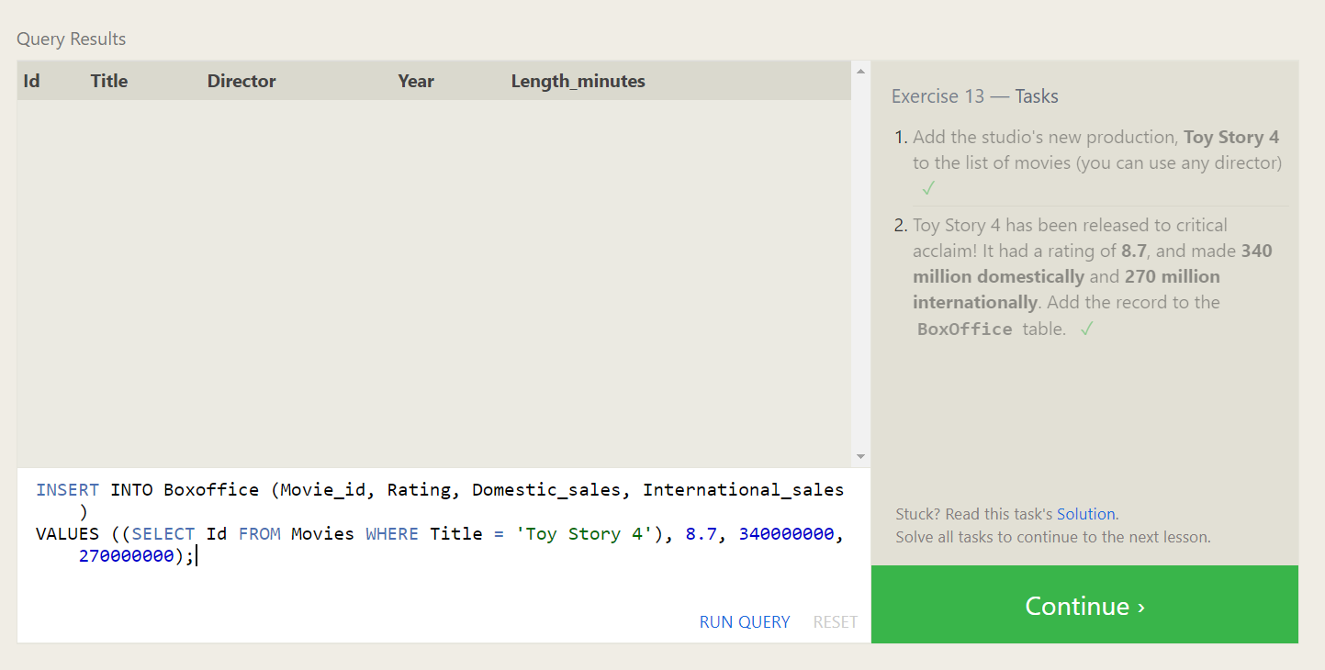

**Solutions :**

1. INSERT INTO Movies (Title, Director, Year, Length_minutes)

VALUES ('Toy Story 4', 'Any Director', 2023, 100);

1. INSERT INTO Boxoffice (Movie_id, Rating, Domestic_sales, International_sales)

VALUES ((SELECT Id FROM Movies WHERE Title = 'Toy Story 4'), 8.7, 340000000, 270000000);

**Lesson 14: Updating rows**

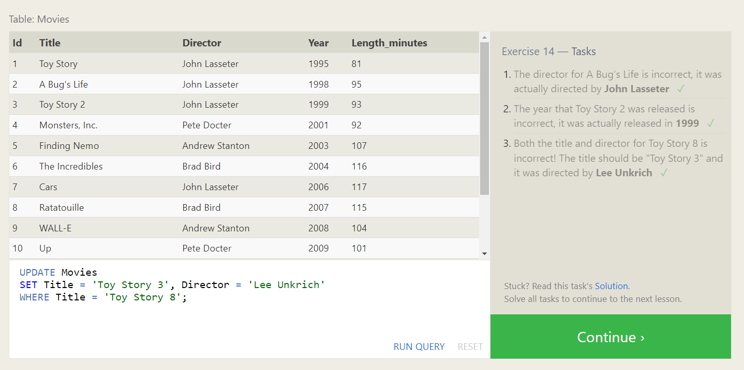

**Solutions :**

1. UPDATE Movies

SET Director = 'John Lasseter'

WHERE Title = 'A Bug''s Life';

1. UPDATE Movies

SET Year = 1999

WHERE Title = 'Toy Story 2';

1. UPDATE Movies

SET Title = 'Toy Story 3', Director = 'Lee Unkrich'

WHERE Title = 'Toy Story 8';

**Lesson 15: Deleting rows**

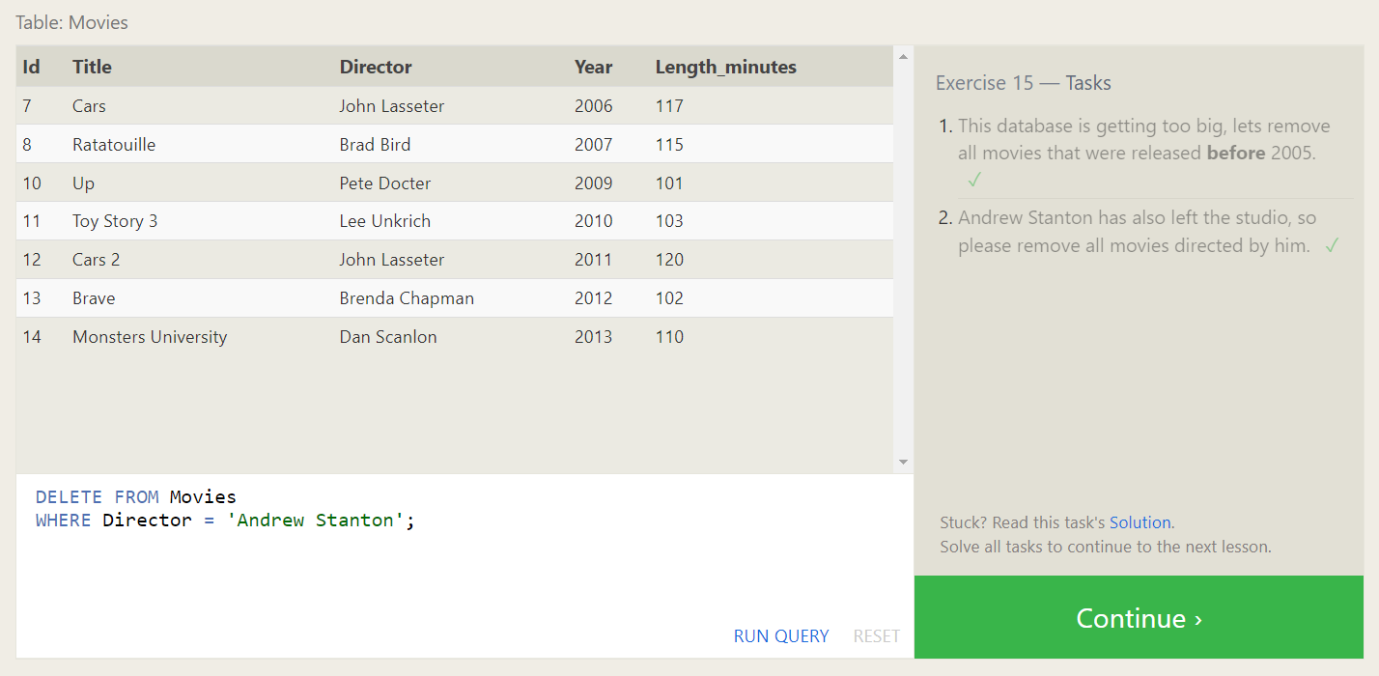

**Solutions :**

1. DELETE FROM Movies

WHERE Year < 2005;

1. DELETE FROM Movies

WHERE Director = 'Andrew Stanton';

**Lesson 16: Creating tables**

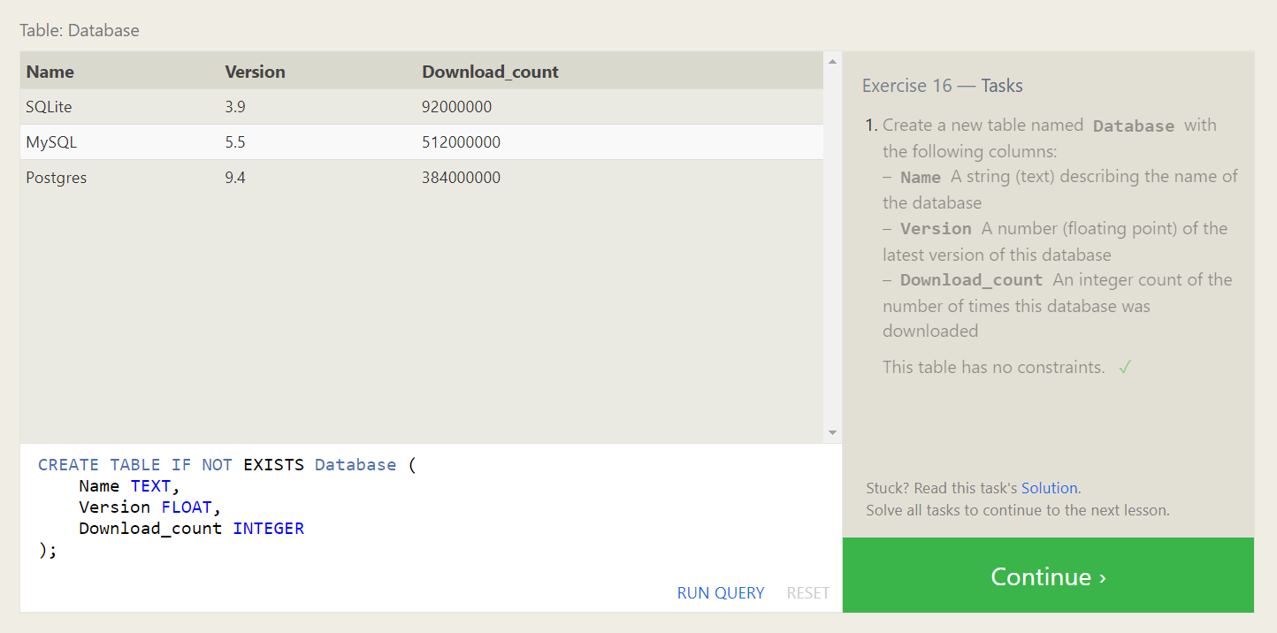

**Solutions :**

1. CREATE TABLE IF NOT EXISTS Database (

Name TEXT,

Version FLOAT,

Download_count INTEGER

);

**Lesson 17: Altering tables**

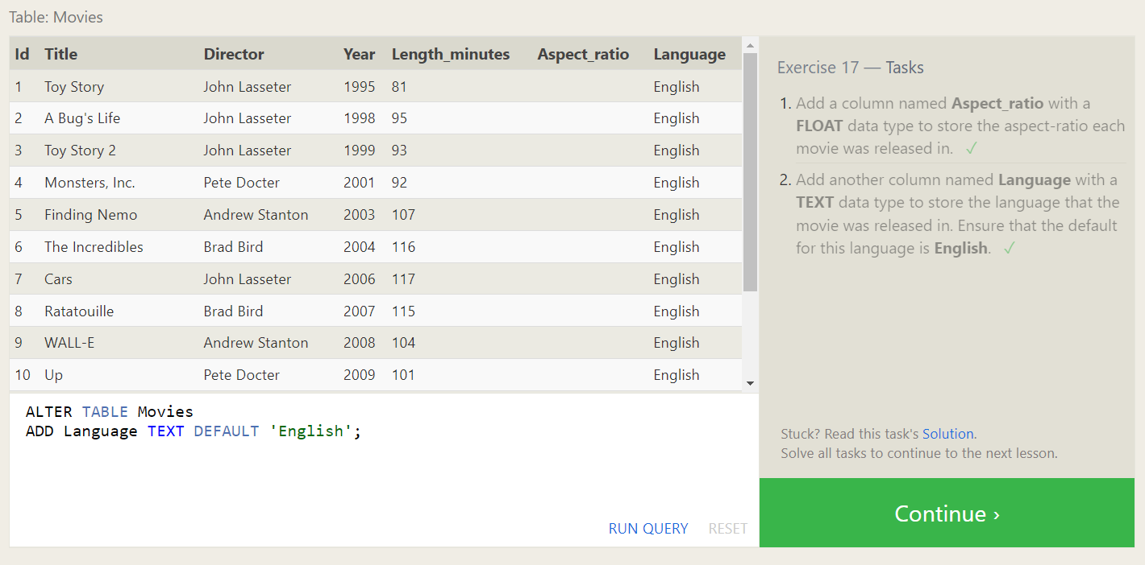

**Solutions :**

1. ALTER TABLE Movies

ADD Aspect_ratio FLOAT;

1. ALTER TABLE Movies

ADD Language TEXT DEFAULT 'English';

**Lesson 18: Dropping tables**

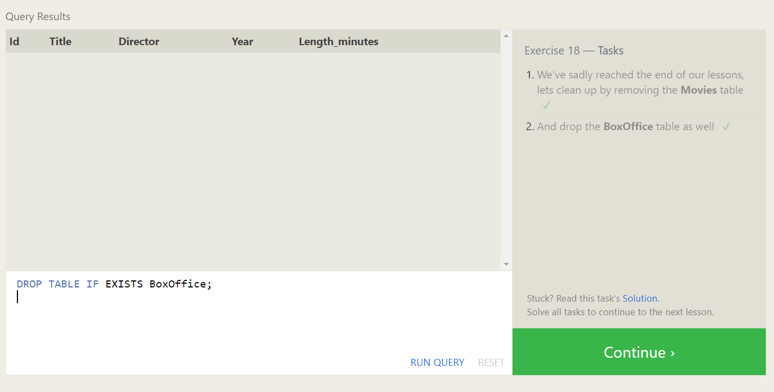

**Solutions :**

1. DROP TABLE IF EXISTS Movies;
2. DROP TABLE IF EXISTS BoxOffice;