
DEERWALK INSTITUTE OF TECHNOLOGY
Sifal, Kathmandu
Course: NET Centric Computing (CSC 378)
Lab 1 Report
The C# Language Preliminaries
Submitted by: | Submitted to:
Pragalva Sapkota  1318 | Mr. Nawaraj Prajapati

Lab #1: Language Preliminaries
Objectives:
To understand and implement:
1. Write a program to display “Welcome CSharp Program”.
2. Write a program to display id, name, address and salary from user.
3. Write a program to demonstrate the bitwise left shift and right shift.
4. Write a program to demonstrate the Assignment operators.
5. Write a program to find the Fibonacci series.
6. Write a program to initialize and display jagged array elements with sum of each row.
7. Write a program for multiplication of two matrixes.
8. Write a program to find the sum of diagonal matrix.
9. Write a program to implement the passing array as parameters.
10. Write a program to demonstrate the parameterized constructor.
11. Write a program to implement the auto implemented properties display id, name and age.
12. Write a program to demonstrate the method overloading.
13. Write a program to demonstrate the method overriding.
14. Write a program to demonstrate the method hiding.
15. Write a program to demonstrate the abstract class.
16. Write a program to demonstrate the interface.
17. Write a program to demonstrate the base keyword.
18. Write a program to demonstrate the struct.
19. Write a program that demonstrates the use of delegates to add and subtract two numbers.
20. Write a C# program that demonstrates the use of delegate and event. Create a Windows Forms application with a button. When the button is clicked, an event is raised, and a message is displayed.
21. Write a C# program that will read balance and withdraw amount from keyboard and display the remaining balance on screen if balance is greater than withdraw amount, otherwise throw an ApplicationException with appropriate message.

1. Write a program to display “Welcome CSharp Program”.
Source code:
using System;
namespace WelcomeCSharp_1318
{
// Lab 1, Q1: display a simple message.
internal class Program
{
static void Main(string[] args)
{
Console.WriteLine("Welcome CSharp Program");
}
}
}
Output:
2. Write a program to display id, name, address and salary from user.
Source code:
using System;
namespace EmployeeDetails_1318
{
// Lab 1, Q2: read id, name, address and salary from the user and display them.
internal class Program
{
static void Main(string[] args)
{
Console.Write("Enter ID: ");
int id = Convert.ToInt32(Console.ReadLine());
Console.Write("Enter Name: ");
string name = Console.ReadLine() ?? "";
Console.Write("Enter Address: ");
string address = Console.ReadLine() ?? "";
Console.Write("Enter Salary: ");
double salary = Convert.ToDouble(Console.ReadLine());
Console.WriteLine("\nEmployee Details");
Console.WriteLine("ID: " + id);
Console.WriteLine("Name: " + name);
Console.WriteLine("Address: " + address);
Console.WriteLine("Salary: " + salary);
}
}
}
Output:
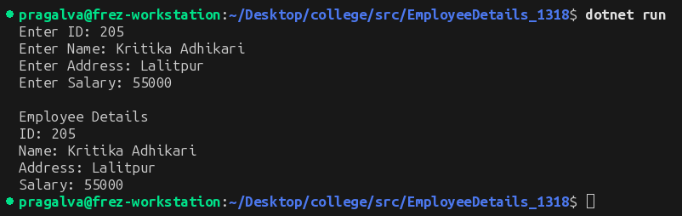
3. Write a program to demonstrate the bitwise left shift and right shift.
Source code:
using System;
namespace BitwiseShift_1318
{
// Lab 1, Q3: bitwise left shift (<<) and right shift (>>).
// Shifting left by 1 doubles the number; shifting right by 1 halves it
// (integer division), because every bit moves one position.
internal class Program
{
static void Main(string[] args)
{
Console.Write("Enter a number: ");
int num = Convert.ToInt32(Console.ReadLine());
Console.WriteLine("Original Number: " + num);
Console.WriteLine("Left Shift by 1 (num << 1): " + (num << 1));
Console.WriteLine("Right Shift by 1 (num >> 1): " + (num >> 1));
}
}
}
Output:
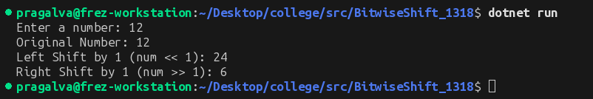
4. Write a program to demonstrate the Assignment operators.
Source code:
using System;
namespace AssignmentOperators_1318
{
// Lab 1, Q4: compound assignment operators (+=, -=, *=, /=, %=).
// Each one is shorthand: a += 5 means a = a + 5.
internal class Program
{
static void Main(string[] args)
{
int a = 20;
Console.WriteLine("Initial Value of a = " + a);
a += 5;
Console.WriteLine("After a += 5 : " + a);
a -= 3;
Console.WriteLine("After a -= 3 : " + a);
a *= 2;
Console.WriteLine("After a *= 2 : " + a);
a /= 4;
Console.WriteLine("After a /= 4 : " + a);
a %= 3;
Console.WriteLine("After a %= 3 : " + a);
}
}
}
Output:
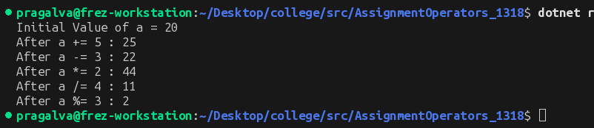
5. Write a program to find the Fibonacci series.
Source code:
using System;
namespace FibonacciSeries_1318
{
// Lab 1, Q5: print the first n Fibonacci numbers.
// Each term is the sum of the previous two: 0 1 1 2 3 5 8 ...
internal class Program
{
static void Main(string[] args)
{
Console.Write("Enter the number of terms: ");
int n = Convert.ToInt32(Console.ReadLine());
int first = 0, second = 1;
Console.WriteLine("Fibonacci Series:");
for (int i = 1; i <= n; i++)
{
Console.Write(first + " ");
int next = first + second;
first = second;
second = next;
}
Console.WriteLine();
}
}
}
Output:
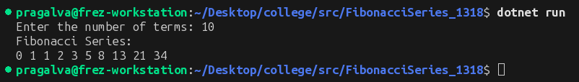
6. Write a program to initialize and display jagged array elements with sum of each row.
Source code:
using System;
namespace JaggedArraySum_1318
{
// Lab 1, Q6: jagged array — an "array of arrays" where each row
// can have a different length. Display each row with its sum.
internal class Program
{
static void Main(string[] args)
{
int[][] arr = new int[3][];
arr[0] = new int[] { 1, 2, 3 };
arr[1] = new int[] { 4, 5 };
arr[2] = new int[] { 6, 7, 8, 9 };
for (int i = 0; i < arr.Length; i++)
{
int sum = 0;
Console.Write("Row " + (i + 1) + ": ");
for (int j = 0; j < arr[i].Length; j++)
{
Console.Write(arr[i][j] + " ");
sum += arr[i][j];
}
Console.WriteLine("\nSum of Row " + (i + 1) + " = " + sum);
Console.WriteLine();
}
}
}
}
Output:
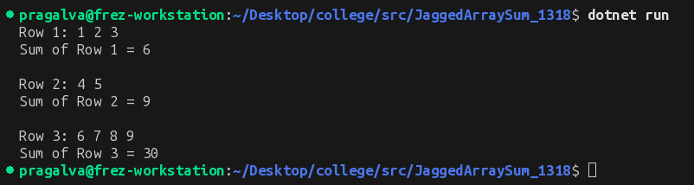
7. Write a program for multiplication of two matrixes.
Source code:
using System;
namespace MatrixMultiplication_1318
{
// Lab 1, Q7: multiply two 2x2 matrices.
// C[i,j] is the dot product of row i of A and column j of B.
internal class Program
{
static void Main(string[] args)
{
int[,] a = { { 1, 2 }, { 3, 4 } };
int[,] b = { { 5, 6 }, { 7, 8 } };
int[,] c = new int[2, 2];
for (int i = 0; i < 2; i++)
{
for (int j = 0; j < 2; j++)
{
c[i, j] = 0;
for (int k = 0; k < 2; k++)
{
c[i, j] += a[i, k] * b[k, j];
}
}
}
Console.WriteLine("Resultant Matrix:");
for (int i = 0; i < 2; i++)
{
for (int j = 0; j < 2; j++)
{
Console.Write(c[i, j] + "\t");
}
Console.WriteLine();
}
}
}
}
Output:
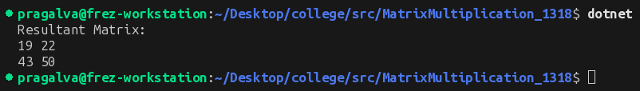
8. Write a program to find the sum of diagonal matrix.
Source code:
using System;
namespace DiagonalSum_1318
{
// Lab 1, Q8: sum of the principal diagonal of a square matrix —
// the elements where the row index equals the column index.
internal class Program
{
static void Main(string[] args)
{
int[,] matrix =
{
{ 1, 2, 3 },
{ 4, 5, 6 },
{ 7, 8, 9 }
};
int sum = 0;
for (int i = 0; i < 3; i++)
{
sum += matrix[i, i];
}
Console.WriteLine("Matrix:");
for (int i = 0; i < 3; i++)
{
for (int j = 0; j < 3; j++)
{
Console.Write(matrix[i, j] + " ");
}
Console.WriteLine();
}
Console.WriteLine("\nSum of Principal Diagonal = " + sum);
}
}
}
Output:
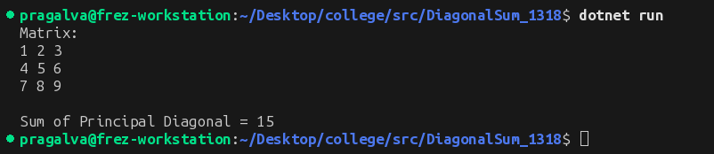
9. Write a program to implement the passing array as parameters.
Source code:
using System;
namespace ArrayAsParameter_1318
{
// Lab 1, Q9: pass an array to a method. Arrays are reference types,
// so the method receives a reference to the same array (no copy is made).
internal class Program
{
static void DisplayArray(int[] arr)
{
Console.WriteLine("Array Elements:");
foreach (int item in arr)
{
Console.Write(item + " ");
}
Console.WriteLine();
}
static void Main(string[] args)
{
int[] numbers = { 10, 20, 30, 40, 50 };
DisplayArray(numbers);
}
}
}
Output:
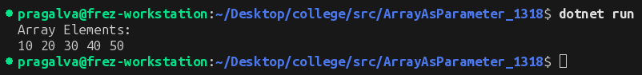
10. Write a program to demonstrate the parameterized constructor.
Source code:
using System;
namespace ParameterizedConstructor_1318
{
// Lab 1, Q10: a parameterized constructor lets the caller supply
// initial values at the moment the object is created.
class Student
{
private readonly int id;
private readonly string name;
public Student(int id, string name)
{
this.id = id;
this.name = name;
}
public void Display()
{
Console.WriteLine("Student ID: " + id);
Console.WriteLine("Student Name: " + name);
}
}
internal class Program
{
static void Main(string[] args)
{
Student s1 = new Student(101, "Bibek Tamang");
s1.Display();
}
}
}
Output:
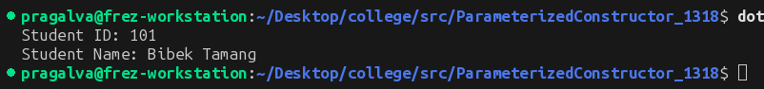
11. Write a program to implement the auto implemented properties display id, name and age.
Source code:
using System;
namespace AutoProperties_1318
{
// Lab 1, Q11: auto-implemented properties — the compiler generates
// the hidden backing field, so `{ get; set; }` is all we write.
class Student
{
public int Id { get; set; }
public string Name { get; set; } = "";
public int Age { get; set; }
}
internal class Program
{
static void Main(string[] args)
{
Student s = new Student
{
Id = 104,
Name = "Anisha Shrestha",
Age = 21
};
Console.WriteLine("ID: " + s.Id);
Console.WriteLine("Name: " + s.Name);
Console.WriteLine("Age: " + s.Age);
}
}
}
Output:
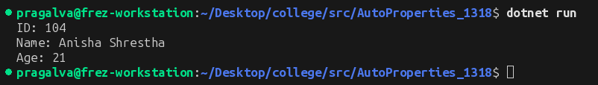
12. Write a program to demonstrate the method overloading.
Source code:
using System;
namespace MethodOverloading_1318
{
// Lab 1, Q12: method overloading — same method name, different
// parameter lists. The compiler picks the right one at compile time.
class Calculate
{
public void Sum(int a, int b)
{
Console.WriteLine("Sum of two numbers: " + (a + b));
}
public void Sum(int a, int b, int c)
{
Console.WriteLine("Sum of three numbers: " + (a + b + c));
}
}
internal class Program
{
static void Main(string[] args)
{
Calculate obj = new Calculate();
obj.Sum(10, 20);
obj.Sum(10, 20, 30);
}
}
}
Output:
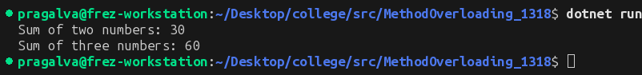
13. Write a program to demonstrate the method overriding.
Source code:
using System;
namespace MethodOverriding_1318
{
// Lab 1, Q13: method overriding — a derived class replaces a base
// class method marked `virtual` using `override`. The call is resolved
// at run time from the object's actual type, not the variable's type.
class Animal
{
public virtual void Speak()
{
Console.WriteLine("The animal makes a sound.");
}
}
class Dog : Animal
{
public override void Speak()
{
Console.WriteLine("The dog barks.");
}
}
internal class Program
{
static void Main(string[] args)
{
// The variable is typed Animal, but the Dog override runs.
Animal a = new Dog();
a.Speak();
}
}
}
Output:
14. Write a program to demonstrate the method hiding.
Source code:
using System;
namespace MethodHiding_1318
{
// Lab 1, Q14: method hiding — the derived class declares a method with
// the same name using `new`. Unlike overriding, the call is resolved
// from the variable's compile-time type.
class Parent
{
public void Display()
{
Console.WriteLine("This is Parent class.");
}
}
class Child : Parent
{
public new void Display()
{
Console.WriteLine("This is Child class.");
}
}
internal class Program
{
static void Main(string[] args)
{
Child obj = new Child();
obj.Display(); // Child's method — variable type is Child
Parent p = obj;
p.Display(); // Parent's method — hiding is not polymorphic
}
}
}
Output:
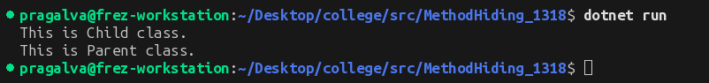
15. Write a program to demonstrate the abstract class.
Source code:
using System;
namespace AbstractClassDemo_1318
{
// Lab 1, Q15: an abstract class cannot be instantiated; it forces
// derived classes to implement its abstract members.
abstract class Animal
{
public abstract void Sound();
}
class Dog : Animal
{
public override void Sound()
{
Console.WriteLine("Dog barks.");
}
}
internal class Program
{
static void Main(string[] args)
{
Dog d = new Dog();
d.Sound();
}
}
}
Output:
16. Write a program to demonstrate the interface.
Source code:
using System;
namespace InterfaceDemo_1318
{
// Lab 1, Q16: an interface is a contract — any class that implements
// IShape must provide a Draw method.
interface IShape
{
void Draw();
}
class Circle : IShape
{
public void Draw()
{
Console.WriteLine("Drawing a Circle.");
}
}
internal class Program
{
static void Main(string[] args)
{
Circle c = new Circle();
c.Draw();
}
}
}
Output:
17. Write a program to demonstrate the base keyword.
Source code:
using System;
namespace BaseKeywordDemo_1318
{
// Lab 1, Q17: the `base` keyword — a derived class uses it to call
// the parent's constructor (or members). The parent constructor
// always runs before the child's body.
class Parent
{
public Parent()
{
Console.WriteLine("Parent Constructor");
}
}
class Child : Parent
{
public Child() : base()
{
Console.WriteLine("Child Constructor");
}
}
internal class Program
{
static void Main(string[] args)
{
Child obj = new Child();
}
}
}
Output:
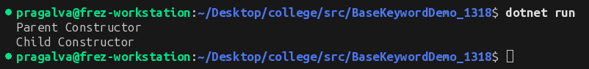
18. Write a program to demonstrate the struct.
Source code:
using System;
namespace StructDemo_1318
{
// Lab 1, Q18: a struct is a value type — it lives on the stack and is
// copied on assignment, unlike a class (reference type).
struct Student
{
public int Id;
public string Name;
}
internal class Program
{
static void Main(string[] args)
{
Student s;
s.Id = 107;
s.Name = "Prakash Thapa";
Console.WriteLine("ID: " + s.Id);
Console.WriteLine("Name: " + s.Name);
}
}
}
Output:
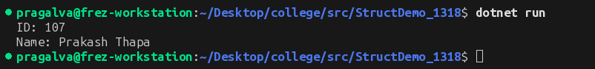
19. Write a program that demonstrates the use of delegates to add and subtract two numbers.
Source code:
using System;
namespace DelegateCalculator_1318
{
// Lab 1, Q19: a delegate is a type-safe reference to a method.
// With += it becomes multicast: one call invokes every attached method.
public delegate void Operation(int x, int y);
public class Calculation
{
public static void Add(int a, int b)
{
Console.WriteLine("Add: " + (a + b));
}
public static void Subtract(int a, int b)
{
Console.WriteLine("Subtract: " + (a - b));
}
}
internal class Program
{
static void Main(string[] args)
{
Operation op = Calculation.Add;
op += Calculation.Subtract; // multicast: both methods run
op(10, 5);
}
}
}
Output:
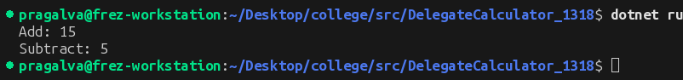
20. Write a C# program that demonstrates the use of delegate and event. Create a Windows Forms application with a button. When the button is clicked, an event is raised, and a message is displayed.
Source code:
using System;
using System.Drawing;
using System.Windows.Forms;
namespace ButtonEventDemo_1318
{
// A delegate defines the shape of methods that can handle the event.
public delegate void MessageHandler(string message);
public class MainForm : Form
{
// The event is raised through the delegate when the button is clicked.
public event MessageHandler OnMessage;
public MainForm()
{
Text = "Delegate and Event Demo";
Button button = new Button();
button.Text = "Click Me";
button.Location = new Point(100, 60);
button.Parent = this;
button.Click += Button_Click;
OnMessage += ShowMessage; // subscribe the handler to the event
}
private void Button_Click(object sender, EventArgs e)
{
// Button clicked -> raise the custom event through the delegate.
OnMessage?.Invoke("Button Clicked! Event raised successfully.");
}
private void ShowMessage(string message)
{
MessageBox.Show(message, "Event Raised");
}
[STAThread]
static void Main()
{
Application.Run(new MainForm());
}
}
}
Output:
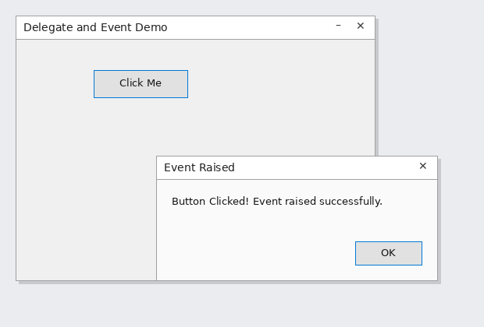
21. Write a C# program that will read balance and withdraw amount from keyboard and display the remaining balance on screen if balance is greater than withdraw amount, otherwise throw an ApplicationException with appropriate message.
Source code:
using System;
namespace WithdrawException_1318
{
// Lab 1, Q21: read balance and withdraw amount; display the remaining
// balance, or throw an ApplicationException when funds are insufficient
// and handle it with try/catch.
internal class Program
{
static void Main(string[] args)
{
Console.Write("Enter Balance: ");
double balance = Convert.ToDouble(Console.ReadLine());
Console.Write("Enter Withdraw Amount: ");
double withdraw = Convert.ToDouble(Console.ReadLine());
try
{
if (balance >= withdraw)
{
balance -= withdraw;
Console.WriteLine("Remaining Balance: " + balance);
}
else
{
throw new ApplicationException("Insufficient Balance.");
}
}
catch (ApplicationException ex)
{
Console.WriteLine(ex.Message);
}
}
}
}
Output:
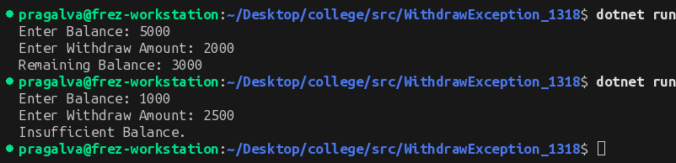
Conclusion:
In this lab, the fundamental building blocks of the C# language were practiced: console input/output, operators (bitwise shift and compound assignment), loops, single and multi-dimensional arrays including jagged arrays and matrix operations, and passing arrays to methods. The object-oriented portion covered constructors, auto-implemented properties, method overloading, overriding and hiding, abstract classes, interfaces, the base keyword, and structs. Finally, delegates and events were used to build a simple event-driven program, and exception handling was demonstrated by throwing and catching an ApplicationException. Working through these programs gave a clear picture of how C# combines procedural and object-oriented features, and forms a solid base for the upcoming labs on more advanced .NET topics.

