Model Editor
UI Design Document
CAD Base Parameters → Visual Editor

Lens Tray — Top View
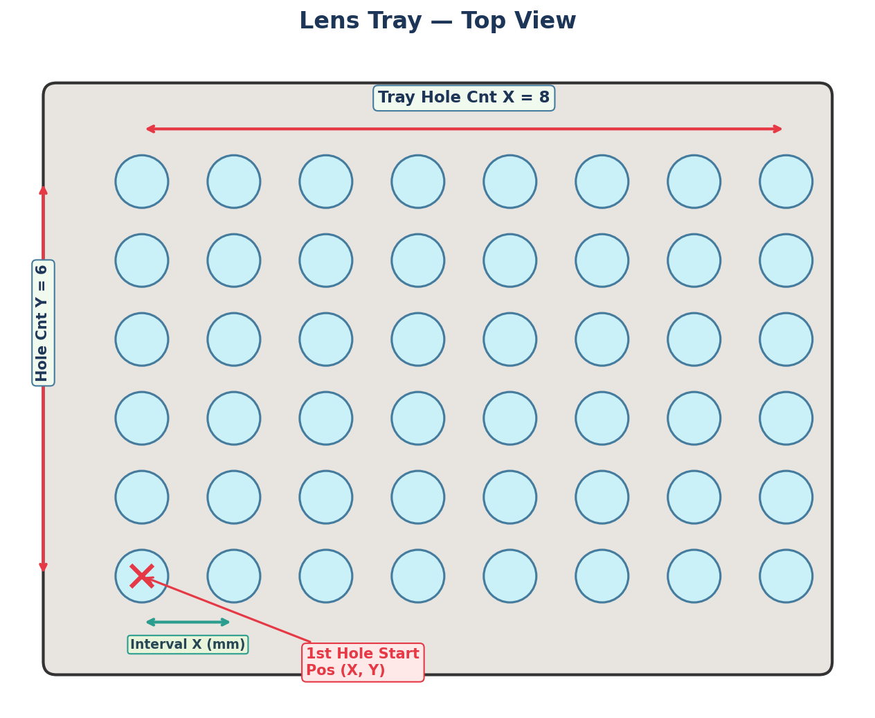

Lens Tray:
Base Parameters:
• Tray Hole Count (X × Y)
• Tray Hole Interval (X, Y) mm
• 1st Hole Start Position (X, Y) mm

Barrel Tray (Assy Tray) — Top View
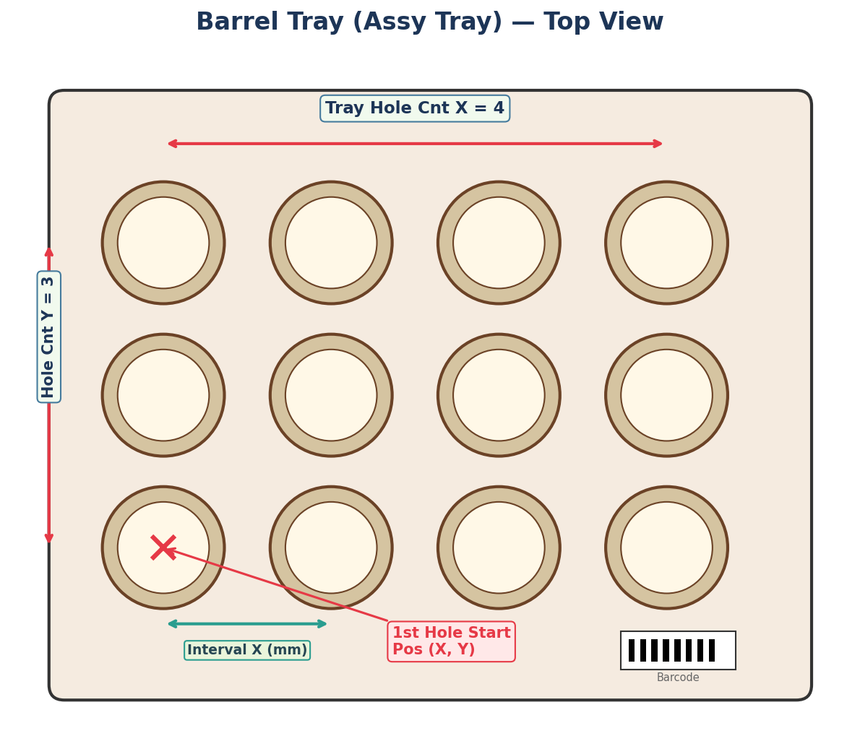

Barrel tray
Base Parameters:
• Tray Hole Count (X × Y)
• Tray Hole Interval (X, Y) mm
• 1st Hole Start Position (X, Y) mm

Barrel Assembly — Cross Section (Stepped Interior)
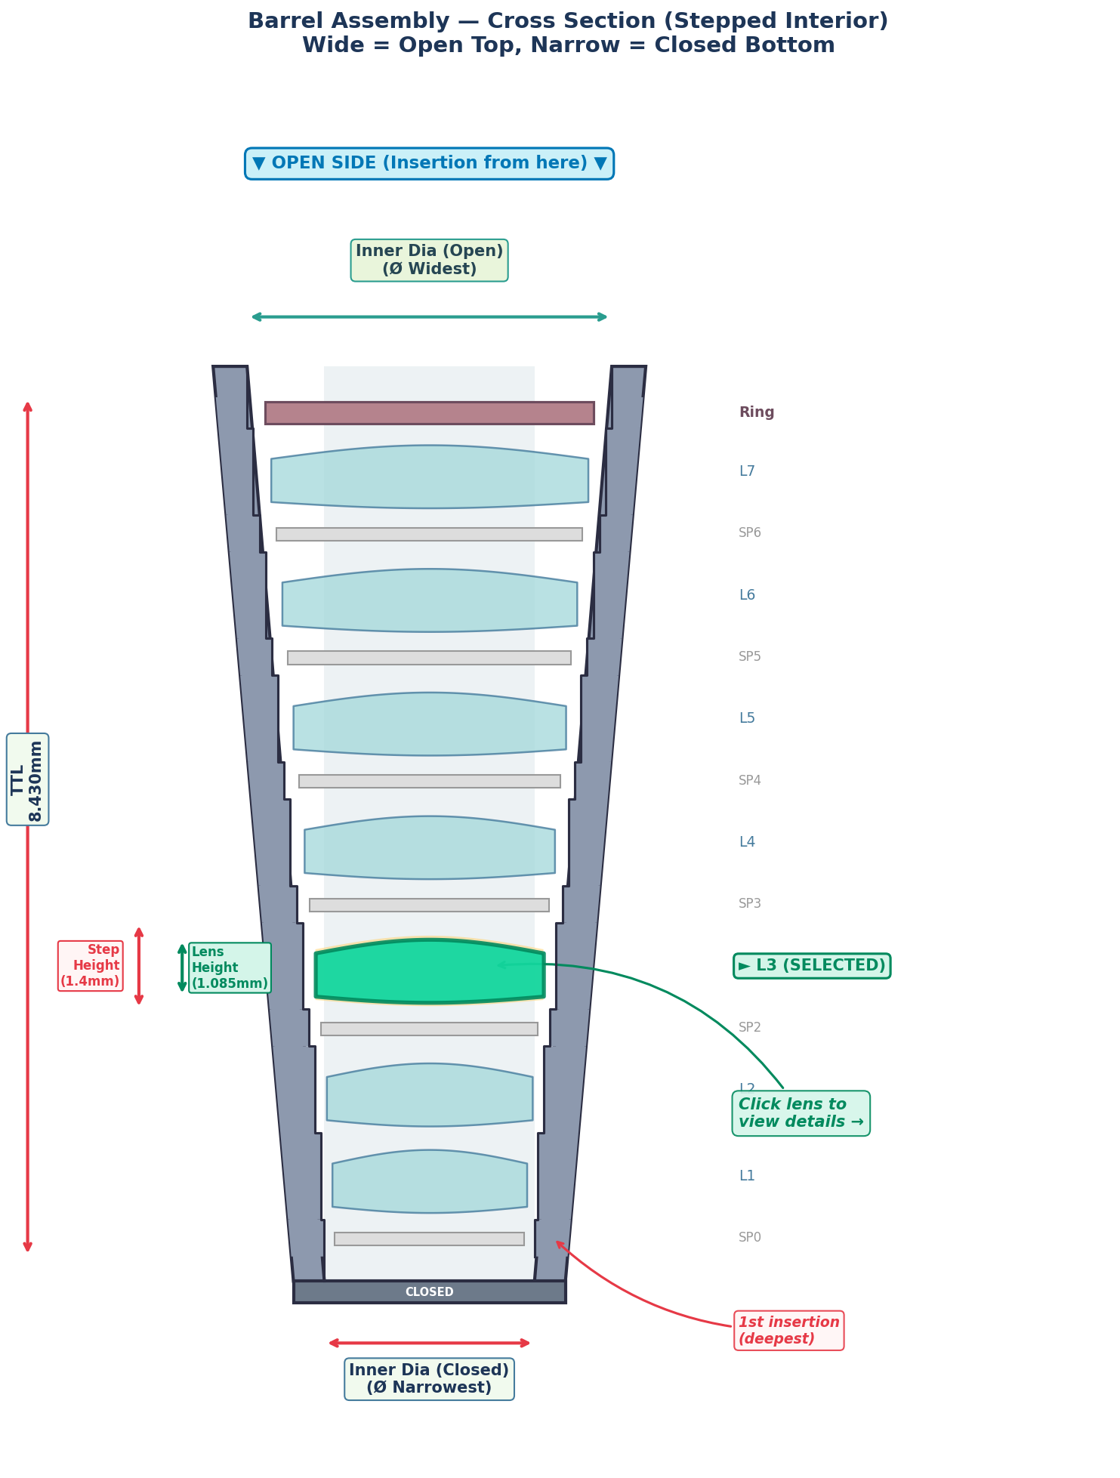

Barrel
Base Parameters:
• Inner Diameter (Closed/Open)
• TTL
• Step Height per position
• Lens/Spacer Height

Lens — Top View (Opened from Barrel)
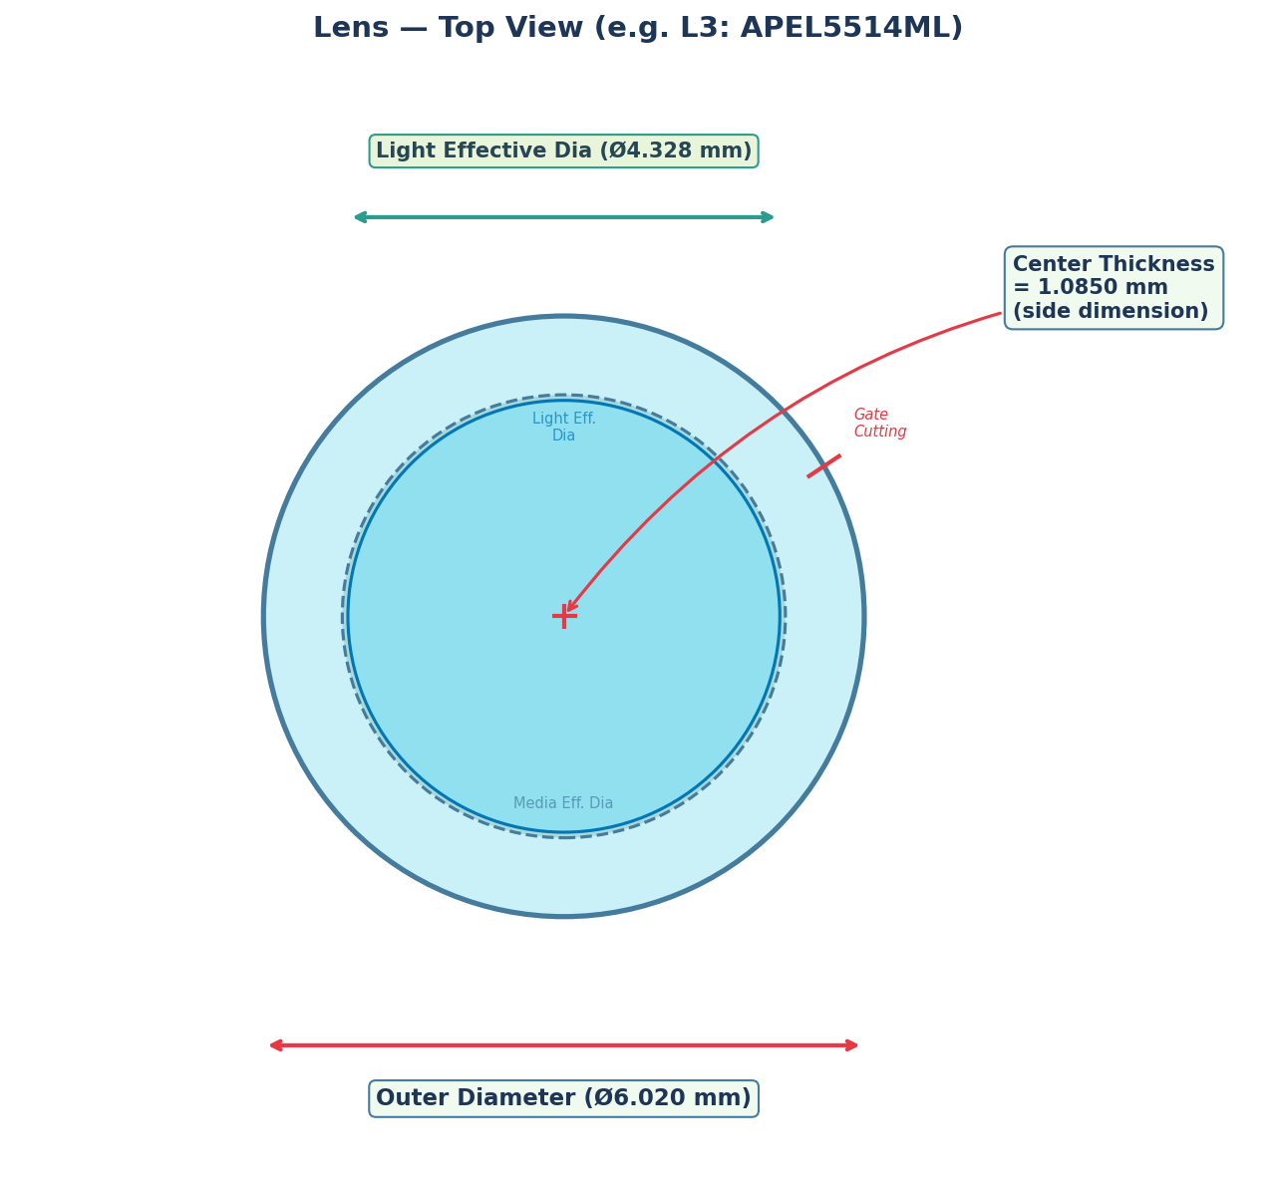

Lens
This view opens when user clicks a lens in the barrel diagram.
Base Parameters:
• Outer Diameter
• Light Effective Diameter
• Center Thickness

Spacer Ring — Top View
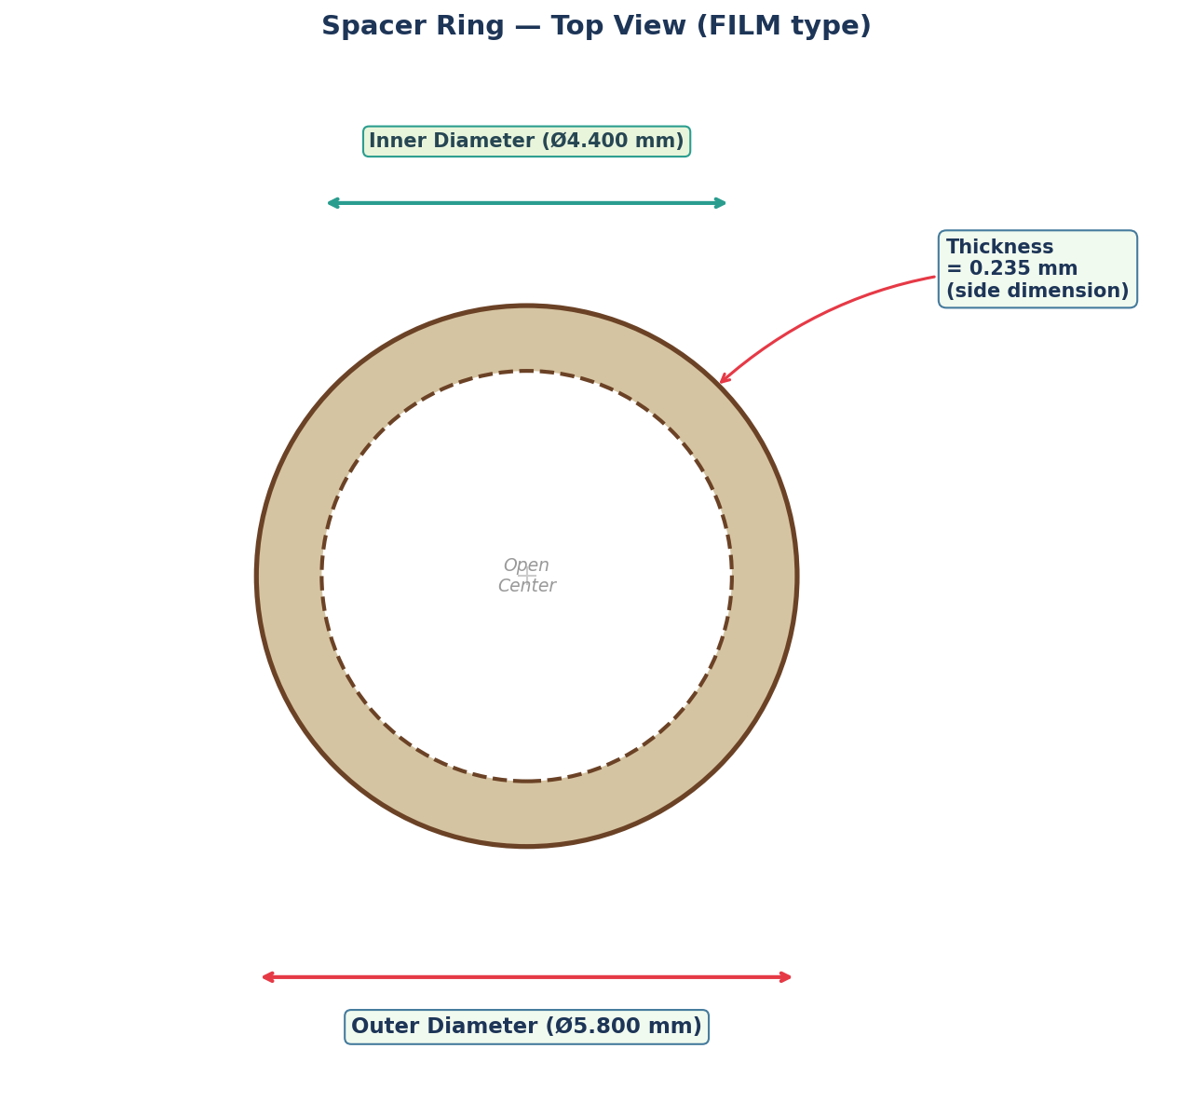

Spacer
Base Parameters:
• Outer Diameter
• Inner Diameter
• Thickness

