TITANIC DATA ANALYSIS USING R
Data Cleaning, Preprocessing and Exploratory Data Analysis
PROJECT REPORT
Submitted By
Pragashree B
Department of Electronics and Communication Engineering
Meenakshi Sundararajan Engineering College
Software Used
R 4.6.1 and RStudio
Academic Year: 2026–2027

Contents
1. Introduction
2. Objectives
3. Dataset Description
4. Software and Tools Used
5. Methodology
6. Data Cleaning and Preprocessing
7. Exploratory Data Analysis
8. Numerical Variable Analysis
9. Correlation Analysis
10. Findings and Discussion
11. Conclusion
12. Project Files

1. Introduction
The Titanic dataset is a commonly used dataset for learning data analysis and statistical programming. It contains information about passengers who travelled on the Titanic, including their passenger class, age, sex, fare, family-related variables, and survival status.
This project uses R and RStudio to perform a practical data analysis workflow. The work begins with loading and inspecting the raw CSV file, followed by checking the structure of the data, identifying missing values and blank entries, cleaning selected variables, checking duplicates, converting categorical fields into factors, and examining numerical variables.
The analysis also includes basic visualisation and correlation analysis. The purpose is not only to obtain numerical results, but also to understand how the quality and structure of a dataset affect the analysis performed on it.

2. Objectives
- Load the Titanic passenger dataset into RStudio.
- Understand the structure and dimensions of the dataset.
- Identify missing and blank values.
- Summarise missing values by variable.
- Handle selected missing values using suitable imputation methods.
- Check for duplicate records and duplicate Passenger IDs.
- Verify and convert appropriate categorical variables to factors.
- Examine numerical variables using descriptive statistics.
- Identify potential outliers using the IQR method.
- Study relationships among numerical variables using correlation analysis.
- Create simple plots to support interpretation of the data.
- Save a cleaned version of the dataset for further use.

3. Dataset Description
The analysis was carried out using the Kaggle Titanic training dataset. After loading the CSV file, R reported 891 observations and 12 original variables.
Variable | Type / Role | Description
PassengerId | Integer | Unique passenger identifier
Survived | Integer / categorical | Survival status (0 = No, 1 = Yes)
Pclass | Integer / categorical | Passenger class
Name | Character | Passenger name
Sex | Character / factor | Passenger sex
Age | Numeric | Passenger age
SibSp | Integer | Number of siblings/spouses aboard
Parch | Integer | Number of parents/children aboard
Ticket | Character | Ticket identifier
Fare | Numeric | Passenger fare
Cabin | Character | Cabin information
Embarked | Character / factor | Port of embarkation
The dataset includes both numerical and categorical information. This mixture makes it useful for demonstrating common preprocessing tasks in R.

4. Software and Tools Used
- R 4.6.1 – statistical computing and data analysis.
- RStudio – integrated development environment used to write and execute the R script.
- Base R functions – data loading, summaries, missing-value checks and basic plotting.
- R plotting functions – histograms and other exploratory visualisations.
- The project is organised as an RStudio project with a separate data folder.

5. Methodology
The project followed a step-by-step data preparation and exploratory analysis workflow. The major stages are shown below.
- Create the RStudio project and organise the dataset in a data folder.
- Load train.csv using read.csv().
- Inspect the first records and dataset structure.
- Generate summary statistics and check the dimensions.
- Count missing values and blank character entries.
- Prepare a missing-value summary table.
- Impute missing Age values using the median.
- Handle missing Embarked values and represent cabin availability using CabinKnown.
- Check complete-record duplicates and duplicate Passenger IDs.
- Verify data types and convert categorical variables to factors.
- Check categorical value frequencies.
- Examine numerical variables using summary statistics.
- Detect potential outliers using the IQR rule.
- Calculate a correlation matrix for numerical variables.
- Create visualisations and save the cleaned dataset.

6. Data Cleaning and Preprocessing

6.1 Missing Value Analysis
The first missing-value check showed that Age had 177 missing observations. Cabin had 687 missing observations and Embarked had 2 missing observations. The remaining original variables did not show missing values in the initial check.
Variable | Missing Count | Percentage
Age | 177 | 19.87%
Cabin | 687 | 77.10%
Embarked | 2 | 0.22%

6.2 Age Imputation
The missing Age values were handled using median imputation. The median Age calculated from the available observations was 28. The missing Age entries were then replaced with this value. This approach keeps all 891 observations available for subsequent analysis.

6.3 Cabin Information
Cabin contained a large number of missing entries. Instead of treating the missing cabin code as a specific cabin value, a derived variable named CabinKnown was created. It indicates whether cabin information was available (Yes) or not available (No).

6.4 Duplicate Checks
The complete-record duplicate check returned 0 duplicate records. The duplicate Passenger ID check also returned 0, so no duplicate passenger identifiers were found in the dataset.

6.5 Categorical Variables
Survived was converted to a factor with labels No and Yes. Pclass, Sex and Embarked were also converted to factors. CabinKnown was converted to a factor as well. The updated structure was verified using str(data).

7. Exploratory Data Analysis

7.1 Age Distribution
The age histogram shows that the largest concentration of passengers is in the young-adult age range, particularly around the 20–30 range. The distribution gradually decreases for older age groups, with relatively few passengers near the upper end of the observed age range.
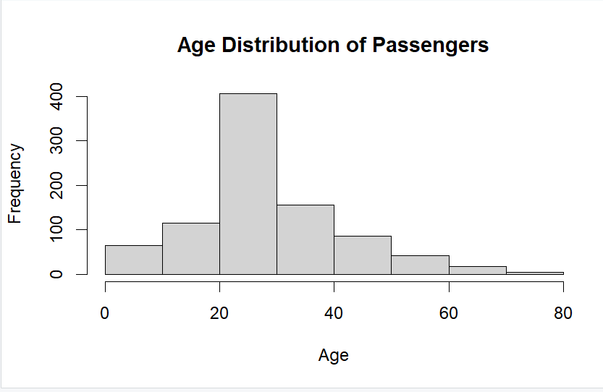
Figure 1. Age Distribution of Passengers

7.2 Fare Distribution
The fare histogram is strongly right-skewed. Most passengers paid relatively low fares, while a small number of passengers paid substantially higher fares. The maximum recorded fare in the summary statistics was approximately 512.33.
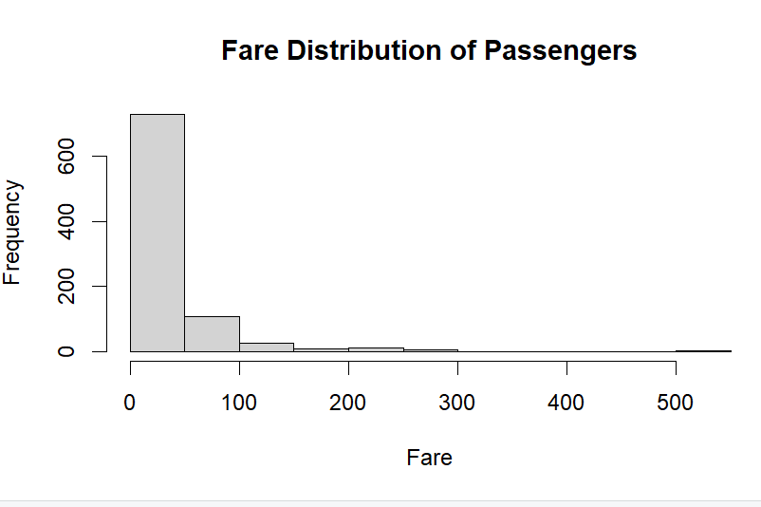
Figure 2. Fare Distribution of Passengers

8. Numerical Variable Analysis
Descriptive statistics were generated for Age, Fare, SibSp and Parch. The results provide a quick view of the central tendency and spread of the numerical variables.
Variable | Min | Median | Mean | 3rd Quartile | Max
Fare | 0.00 | 14.45 | 32.20 | 31.00 | 512.33
SibSp | 0.00 | 0.00 | 0.523 | 1.00 | 8.00
Parch | 0.00 | 0.00 | 0.3816 | 0.00 | 6.00
The Fare variable has a mean considerably higher than its median, which agrees with the right-skewed histogram. SibSp and Parch have medians of zero, indicating that many passengers did not have a recorded sibling/spouse or parent/child travelling with them.

8.1 Outlier Detection
Potential outliers were checked using the interquartile range (IQR) rule. For each numerical variable, the first quartile (Q1), third quartile (Q3), IQR, lower limit and upper limit were calculated. Values outside the limits were counted as potential outliers. This method was used as a screening step rather than automatically deleting observations.

9. Correlation Analysis
A correlation matrix was calculated for Age, Fare, SibSp and Parch using complete observations. The resulting matrix is shown below.
 | Age | Fare | SibSp | Parch
Age | 1.0000 | 0.0967 | -0.2333 | -0.1725
Fare | 0.0967 | 1.0000 | 0.1597 | 0.2162
SibSp | -0.2333 | 0.1597 | 1.0000 | 0.4148
Parch | -0.1725 | 0.2162 | 0.4148 | 1.0000
The strongest positive relationship among these four variables is between SibSp and Parch, with a correlation of approximately 0.415. Age and SibSp show a moderate negative relationship of about -0.233. Age and Parch are also negatively related at about -0.173. The relationship between Age and Fare is weak and positive at about 0.097.
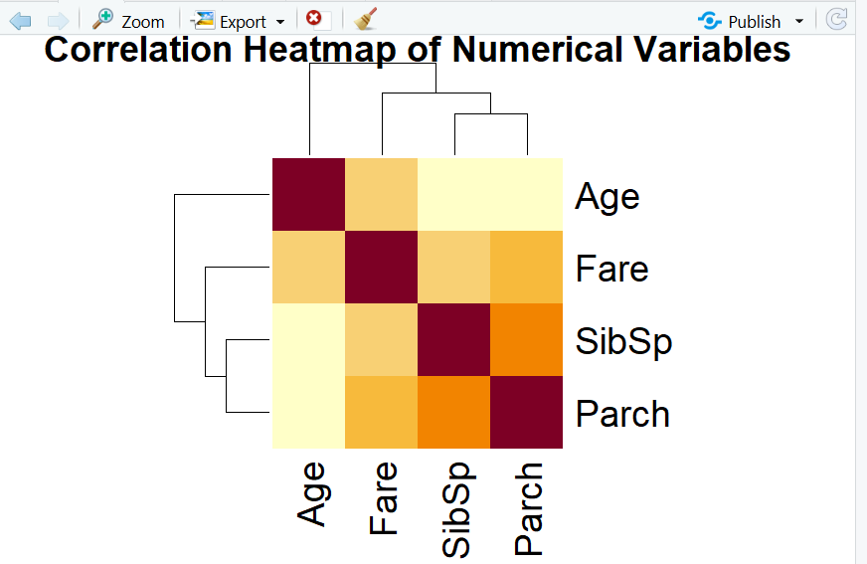
Figure 3. Correlation Heatmap of Numerical Variables

9.1 RStudio Analysis Output
The following screenshot records the RStudio output used during the analysis. It shows the correlation matrix in the console alongside the fare distribution plot, providing a direct record of the analysis performed in RStudio.
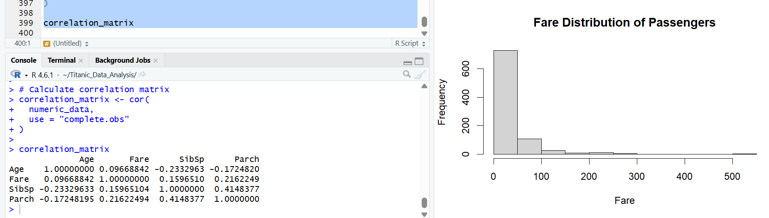
Figure 4. RStudio Console Output and Fare Distribution Plot

10. Findings and Discussion
- The dataset contains 891 passenger records and was successfully loaded into RStudio.
- Age had 177 missing values, corresponding to 19.87% of the observations.
- Cabin had 687 missing values, corresponding to 77.10% of the observations.
- Embarked had only 2 missing values, corresponding to 0.22% of the observations.
- The median Age was 28 and was used for Age imputation.
- No duplicate complete records were detected.
- No duplicate Passenger IDs were detected.
- The fare distribution is strongly right-skewed, with most fares concentrated at the lower end.
- SibSp and Parch both have a median of zero.
- The strongest correlation among the analysed numerical variables is between SibSp and Parch (approximately 0.415).
- The correlation between Age and Fare is weak (approximately 0.097).
These observations show why data preparation is important before statistical interpretation. Missing values, categorical representations, and skewed numerical variables can affect how results are understood. The analysis therefore combines numerical summaries with visual inspection rather than relying on a single measure.

11. Conclusion
The Titanic dataset was successfully analysed using R and RStudio through a structured data cleaning and exploratory analysis workflow. The project covered dataset inspection, missing-value analysis, imputation, duplicate checking, categorical conversion, numerical summaries, outlier screening, correlation analysis and visualisation.
The cleaned dataset was saved separately so that the original data remains available for reference. The analysis also produced visual evidence in the form of age and fare distributions and a numerical correlation heatmap. Overall, the project demonstrates a complete introductory data-analysis workflow using R on a real-world dataset.

12. Project Files
The final project folder is organised as follows:
Titanic_Data_Analysis/
├── data/
│ ├── train.csv
│ └── titanic_cleaned.csv
├── analysis.R
├── README.md
├── Titanic_Data_Analysis.Rproj
└── Titanic_Data_Analysis_Report.docx
The R script contains the analysis steps, the data folder contains the original and cleaned datasets, the README provides a short project overview, and this report documents the methodology and findings.

— End of Report —

