**PHASE 3: DEVELOPMENT PART 1**

**Introduction:**

* Building upon the foundation laid in Phase 1 and Phase 2, we move forward to Phase 3, focusing on development for our project, "Image Recognition with IBM Cloud Visual Recognition." In this phase, we aim to start building the image recognition using IBM cloud Visual Recognition and create a simple web interface.

**Create an IBM Cloud account:**

1. 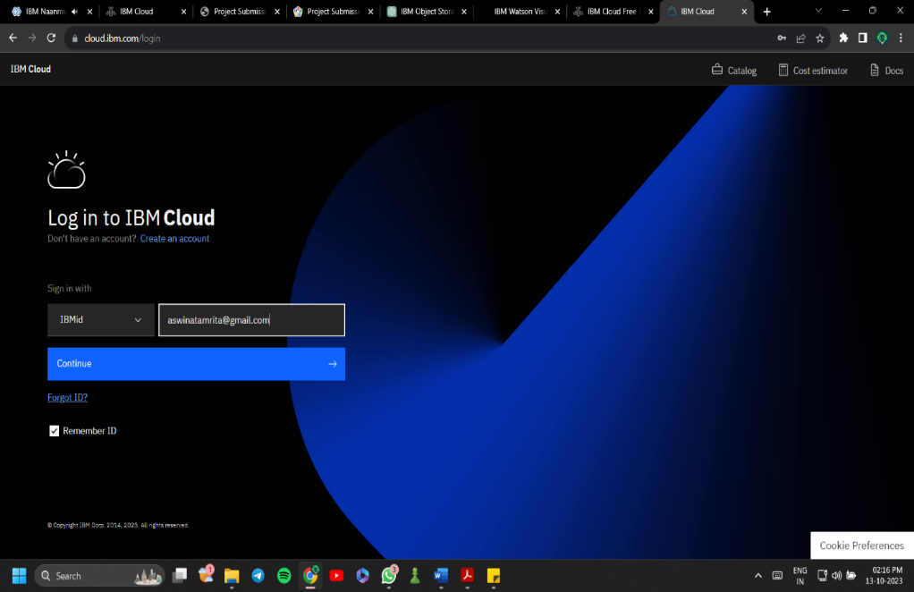Visit the IBM Cloud registration page at <https://cloud.ibm.com/registration>.
2. Provide your email address and create a strong password.
3. Complete your personal information, including your first name, last name, and country.
4. Verify your email by entering the verification code sent to your inbox.
5. Agree to IBM's terms and conditions and privacy policy.
6. Access your IBM Cloud dashboard using your registered email and password.

**Set Up IBM Cloud Visual Recognition:**

1. 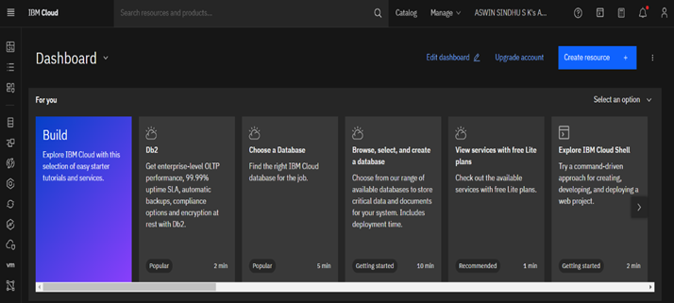In the IBM Cloud Dashboard, click "Create Resource" or "Create Service."
2. Search for "Visual Recognition" or "Watson Visual Recognition" and select it.
3. 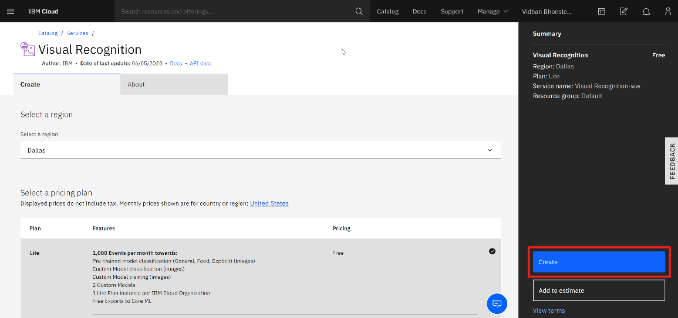Choose a pricing plan (Lite plan is free) and configure other options as needed.
4. 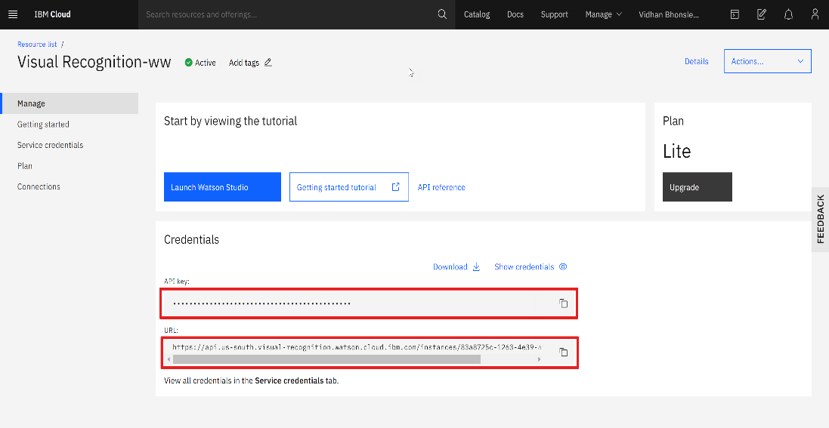Click "Create" to provision the Visual Recognition service.
5. Once your service is created, click on it to access your service credentials. You will need the API key and URL for later.

**Design the Web Interface:**

* 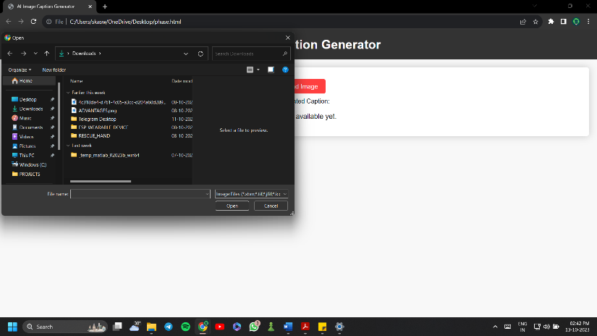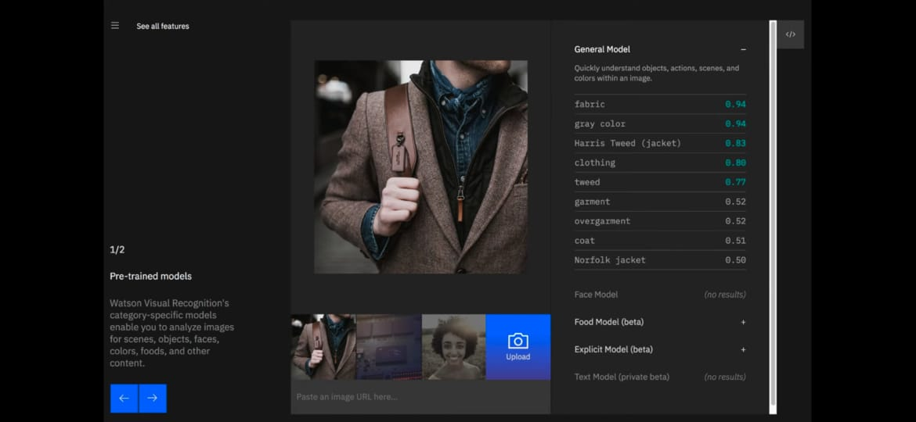To design a simple web interface where users can upload images and view AI-generated captions, we will need to create a web application. You can use HTML, CSS, and JavaScript to create the front-end and integrate it with IBM Cloud Visual Recognition for the back-end.