**EX-4 Check Stationary of a Time Series Data**

**AIM :** To check the stationary of a time series data.

**PROCEDURE AND CODE:**

**STEP 1 :** We choose the variable to check the seasonality. Here we choose the “volume” variable.

plt.figure(figsize = (12, 5))

plt.plot(df['Volume'])

plt.show()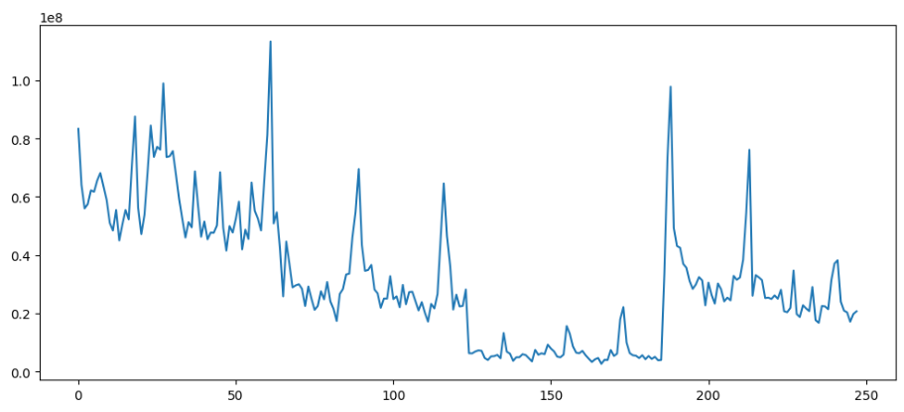

**STEP 2 :** Now we apply the dickey fuller test on the variable by using adfuller() function.

from statsmodels.tsa.stattools import adfuller

def adfuller_test(Volume):

    result = adfuller(Volume)

    labels = ['ADF test statistics', 'P-value', '#Lags used', 'Number of observation used']

    for value, label in zip(result, labels):

        print(label+' : '+str(value))

    if result[1] <= 0.05:

        print('Strong evidence against the null hypothesis (Ho), Reject the null hypothesis, Data has no unit root and is stationary')

    else:

        print('Weak evidence against the null hypothesis (Ho), time series has a unit root, indicating it is non stationary. ')

adfuller_test(df['Close'])

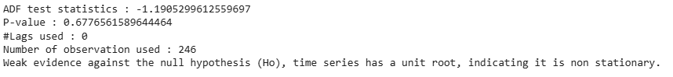

**STEP 3:** Now we have to make the non-stationary variables to stationary variable by shifting their values.

df['seasional_first_difference'] = df['Volume'] - df['Volume'].shift(12)

df['seasional_first_difference'].fillna(0, inplace=True)

df

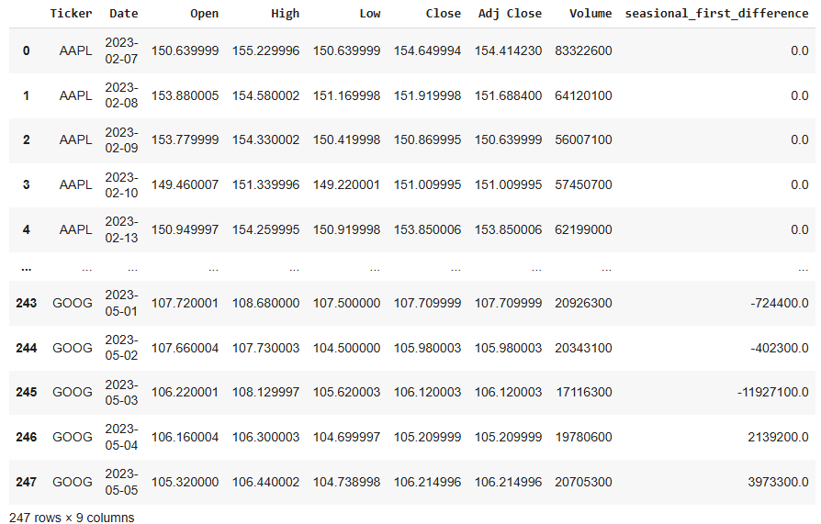

**STEP 4:** Now we check the seasonality.

plt.figure(figsize = (12, 5))

plt.plot(df['seasional_first_difference'])

plt.show()

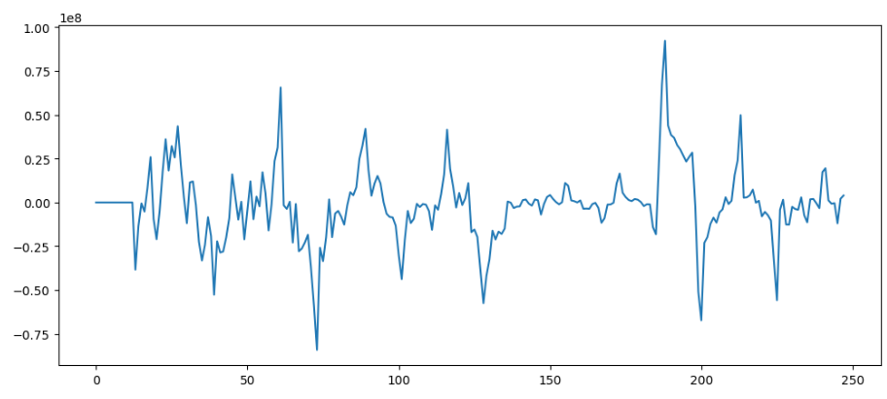

**STEP 5:** Now again we check using adfuller() function.

adfuller_test(df['seasional_first_difference'].dropna())

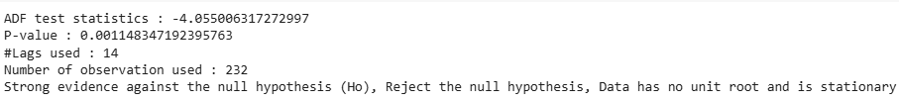

**RESULT:**

The program for finding stationary is successfully executed.