EXPERIMENT - 1

**AIM:** To implement a program for time series data cleaning, loading, handling and preprocessing techniques.

**PROCEDURE AND CODE:**

**Steps 1:** Import the necessary libraries # Data

import json

import numpy as np= import pandas as pd

from sklearn.preprocessing import LabelEncoder= from sklearn.preprocessing import StandardScaler # Visual

import matplotlib.pyplot as plt import seaborn as sns

import warnings warnings.filterwarnings("ignore")

**Steps 2:** Load the CSV (data) file.

df = pd.read_csv("/content/stocks.csv") df.head()

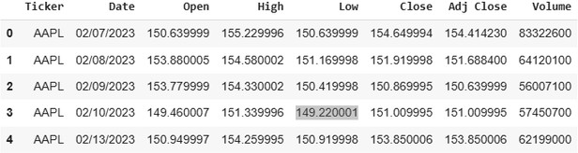

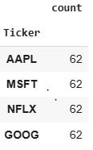**Steps 3:** Counting the no. of values df.Ticker.value_counts()

**Steps 4:** Fixing the date value. df['Date'] = pd.to_datetime(df['Date'])

**Steps 5:** Visualizing the stocks prices over time

fig, axs = plt.subplots(3, 2, figsize=(15, 16)) fig.suptitle('Data by ticker type')

cols = ['Close', 'Adj Close', 'Open', 'High', 'Low', 'Volume'] for i, col in enumerate(cols):

row = i // 2 col = i % 2

for ticker, data in df.groupby('Ticker'):

axs[row, col].plot(data['Date'], data[cols[i]], label=ticker) axs[row, col].set_title(cols[i])

axs[row, col].set_xlabel('Date') axs[row, col].set_ylabel('Price') axs[row, col].legend(loc='right')

axs[row, col].tick_params(axis='x', rotation=45)

plt.tight_layout() plt.subplots_adjust(wspace=0.3, hspace=0.8) plt.show()

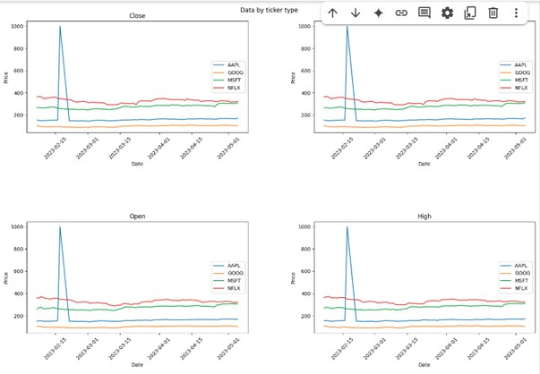

**Steps 6:** As we discovered outlier, we gonna minimize them using data cleaning techniques

Q1 = df['Close'].quantile(0.25) Q3 = df['Close'].quantile(0.75)

IQR = Q3 - Q1

df = df[(df['Close'] >= (Q1 - 1.5 * IQR)) & (df['Close'] <= (Q3 + 1.5 * IQR))]

**Steps 7:** Repeat the step 5.

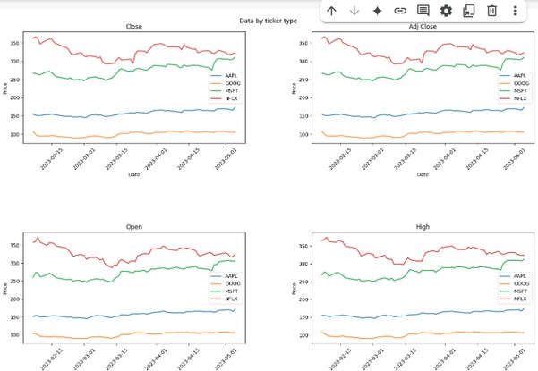

**Result:** The program to implement a program for time series data cleaning, loading, handling and preprocessing techniques is successfully completed.