**Project report**

**1.Introduction**

**1.1** overview

An ATS is a software application that helps you manage the entire recruitment process, right from receiving resumes to hiring employees. The software helps you automate the process of screening & shortlisting candidates, applicant evaluation, scheduling interviews, managing the hiring process, background verification, and completing new-hire paperwork. ATS helps in sorting through resumes, to determine which ones are the best fit for the open positions.

1.2 ***purpose***

An ATS creates opportunities to automate manual processes, increase visibility into the hiring cycle for the entire recruiting team, and increase opportunities for communication throughout the candidate journey. 78% of recruiters using an ATS report that it has improved the quality of the candidates they hire.

Every organization is unique, but each one thrives on attracting, hiring, and maximizing top talent. Many businesses face major challenges at some point in the hiring or onboarding process. An [ATS can offer a variety of capabilities](https://blogs.oracle.com/oraclehcm/post/why-you-should-use-an-applicant-tracking-system) that can help the organization find, hire, and retain the best candidates. Some of the benefits of an ATS include the following:

Some organizations lack the reach to connect with top job seekers or to a cast a wide enough net in the marketplace. Others are missing critical data on the right channels to find specific candidates; other organizations may lack brand recognition and the means to develop it. An ATS can help address these critical candidate challenges. Some systems can be enriched with artificial intelligence (AI) and machine learning to create a profile of an ideal candidate, assess and identify skills, and predict success factors to maximize each hire.

Moving a candidate through the journey from first contact to start date can be a high-touch process. It can be all too easy to lose a top candidate because of slow response times or poor engagement around interview schedules. An ATS creates greater visibility across the applicant lifecycle, so touchpoints don’t fall through the cracks.

As of 2019, 99% of the Fortune 500 companies used an ATS in their hiring process.1 These companies already have the brand recognition and resources to compete for top talent; an ATS can level the playing field by creating better, quicker access to candidates.

1. **problem definition and design thinking 2.1 empathy map**

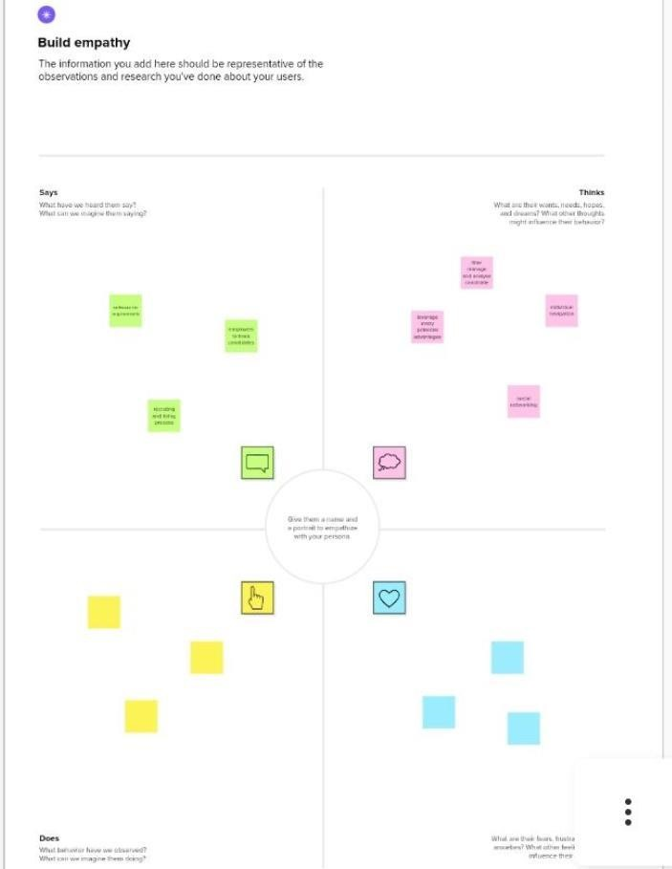

**2.2 idea thinking and brain stroming map:**

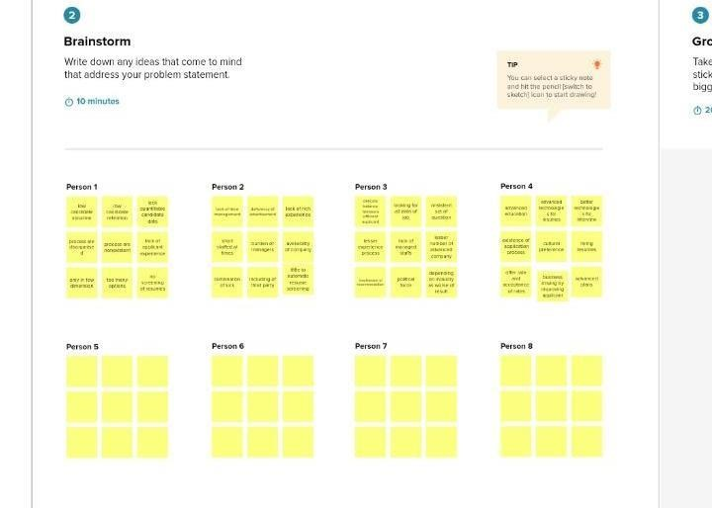

# Result

**3.1 Data model**

|  |  |  |  |  |
| --- | --- | --- | --- | --- |
| **Object** **Name** | **Fields** **In** **The** **Object** | | | |
|  |  | **Field** **lable** | **Data type** |  |
| Job title | Text |
| Recruiters | Master detail relationship |
| Description | Text area |
| Location | Text |

**Project Activities**

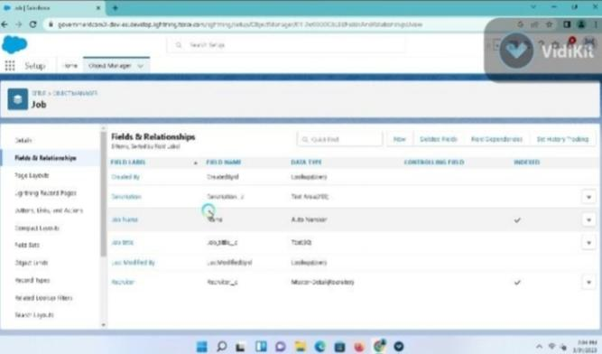

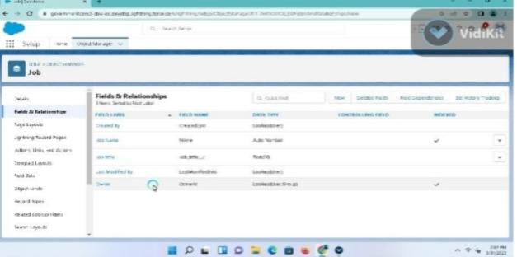

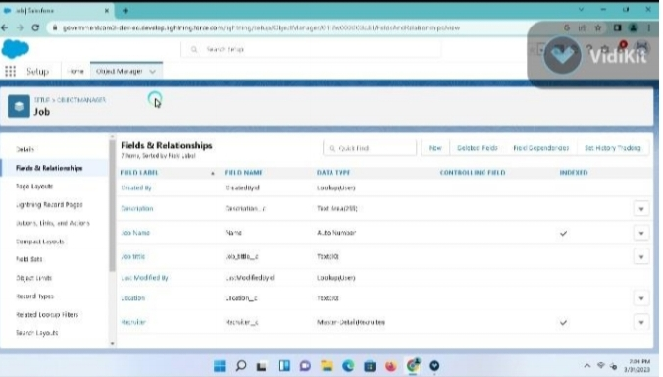

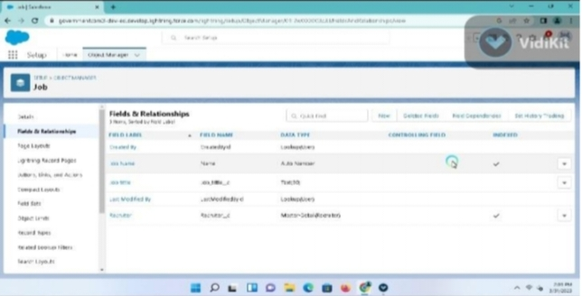

**Trailhead Profile public URL:**

Team leader: <https://trailblazer.me/id/ppriyanka42>

Team member 1: <https://trailblazer.me/id/spsktb>

Team member 2: <https://trailhead.salesforce.com/today>

Team member 3: <https://trailhead.salesforce.com/today>

ADVANTAGES

* Automates processes.
* Streamlines the billing process.
* Supports professional development.
* Helps you recognise top employees or clients.
* Increases productivity.
* Job progress analysis.
* Team tracking.
* Syncing across devices

**DISADVANTAGES**

* Automatic elimination of every resume (even great ones) that the system can't read and interpret.
* Missing out on potential great hires and great pipeline talent when resumes are eliminated.
* Misread resumes in PDF format.
* The inability to read most, if not all, graphics.

## CONCLUSION

Project management is the primary tool for executing the business plan, installing the businesses processes, and achieving the strategic ambitions of the entrepreneur.Project management helps to detail what tasks will be accomplished, who will be involved in completing the tasks, and when tasks should start and finish.Typically, projects progress in steps or incremental stages; however, other approaches for rapid, interactive project management are also widely used.Several tools can be used to manage the project and communicatetiming and status, including task diaries, WBSs, and Gantt charts

### FUTURE SCOPE

The world is moving into automation and AI, and leads way to the new age Applicant Tracking System(ATS). Read further to understand what the future might be like for the ATS. Until a few years, staffing agencies were all using their manual expertise or outdated tools to track potential candidates for vacant positions. Even if few agencies used ATS tools, they would use it only to post job ads to job boards or social channels manually. In addition, the agencies would manually go through all the job boards and candidate databases, and call them individually to inform them about the posting or set up interview dates and times. It was highly time-consuming and tiring.