


COURSE CODE & NAME
EEC1363-BATTERY MANAGEMENT SYSTEM
EEB1303-DIGITAL LOGIC CIRCUITS

ENHANCING KABADDI WITH SMART SENSOR TECHNOLOGY

PROJECT REPORT
Submitted by
PRAGATHES R (927623BEE073)
SURYAA Y P (927623BEE109)
VIKRAM S (927623BEE120)
in partial fulfilment for the award of the degree
of
BACHELOR OF ENGINEERING
in
ELECTRICAL AND ELECTRONICS ENGINEERING

M.KUMARASAMY COLLEGE OF ENGINEERING, KARUR

NOVEMBER 2025

M.KUMARASAMY COLLEGE OF ENGINEERING, KARUR
(Autonomous Institution affiliated to Anna University, Chennai)

BONAFIDE CERTIFICATE

Certified that this project report “ENHANCING KABADDI WITH SMART SENSOR TECHNOLOGY” is the bonafide work of “PRAGATHESH R (927623BEE073),SURYAA Y P (927623BEE103),VIKRAM S (927623BEE120) ” who carried out the project work during the academic year 2025-2026 under my supervision.

SIGNATURE  Dr. J. UMA M.E., Ph.D.  HEAD OF THE DEPARTMENT  Department of Electrical and Electronics Engineering,  M.Kumarasamy College of Engineering,  Thalavapalayam, Karur-639113 | SIGNATURE  Mrs. Ramesh., Ph.D.,  SUPERVISOR Assistant Professor,  Department of Electrical and Electronics Engineering,  M.Kumarasamy College of Engineering,  Thalavapalayam, Karur-639113.

This Project Work EEC1363 report has been submitted for the V Semester Project viva voce Examination held on ________________

i
INTERNAL EXAMINER EXTERNAL EXAMINER

VISION AND MISSION OF THE INSTITUTION

VISION
To emerge as a leader among the top institutions in the field of technical education
MISSION
- Produce smart technocrats with empirical knowledge who can surmount the global challenges
- Create a diverse, fully-engaged learner-centric campus environment to provide quality education to the students
- Maintain mutually beneficial partnerships with our alumni, industry and professional associations.

DEPARTMENT OF ELECTRICAL AND ELECTRONICS ENGINEERING

VISION
To produce smart and dynamic professionals with profound theoretical and practical knowledge comparable with the best in the field.

MISSION
- Produce hi-tech professionals in the field of Electrical and Electronics Engineering by inculcating core knowledge.
- Produce highly competent professionals with thrust on research.
- Provide personalized training to the students for enriching their skills.

PROGRAMME EDUCATIONAL OBJECTIVES (PEOs)

PEO1: Graduates will have flourishing career in the core areas of Electrical Engineering and allied disciplines.
PEO2: Graduates will pursue higher studies and succeed in academic/research careers.
PEO3: Graduates will be a successful entrepreneur in creating jobs related to Electrical and Electronics Engineering /allied disciplines.
PEO4: Graduates will practice ethics and have habit of continuous learning
for their success in the chosen career.

PROGRAMME OUTCOMES (POs)
After the successful completion of the B.E. Electrical and Electronics Engineering degree Program, the students will be able to:
- PO1 Engineering knowledge: Apply knowledge of mathematics, natural science, computing, engineering fundamentals, and an engineering specialization to develop solutions to complex engineering problems.
- PO2 Problem analysis: Identify, formulate, review research literature and analyze complex engineering problems reaching substantiated conclusions with consideration for sustainable development.
- PO3 Design/development of solutions: Design creative solutions for complex engineering problems and design/develop systems/components/processes to meet identified needs with consideration for the public health and safety, whole-life cost, net zero carbon, culture, society and environment as required.
- PO4 Conduct investigations of complex problems: Conduct investigations of complex engineering problems using research-based knowledge including design of experiments, modelling, analysis & interpretation of data to provide valid conclusions.
- PO5 Engineering Tool Usage: Create, select and apply appropriate techniques, resources and modern engineering & IT tools, including prediction and modelling recognizing their limitations to solve complex engineering problems.
- PO6 The Engineer and The World: Analyze and evaluate societal and environmental aspects while solving complex engineering problems for its impact on sustainability with reference to economy, health, safety, legal framework, culture and environment.
- PO7 Ethics: Apply ethical principles and commit to professional ethics, human values, diversity and inclusion; adhere to national & international laws.
- PO8 Individual and Collaborative Team work: Function effectively as an individual, and as a member or leader in diverse/multi-disciplinary teams.
- PO9 Communication: Communicate effectively and inclusively within the engineering community and society at large, such as being able to comprehend and write effective reports and design documentation, make effective presentations considering cultural, language, and learning differences.
- PO10 Project management and finance: Apply knowledge and understanding of engineering management principles and economic decision-making and apply these to one’s own work, as a member and leader in a team, and to manage projects and in multidisciplinary environments.
- PO11 Life-long learning: Recognize the need for, and have the preparation and ability for i) independent and life-long learning ii) adaptability to new and emerging technologies and iii) critical thinking in the broadest context of technological change.
PROGRAM SPECIFIC OUTCOMES (PSOs)
The following are the Program Specific Outcomes of Engineering Students:
- PSO1: Apply the basic concepts of mathematics and science to analyze and design circuits, controls, Electrical machines and drives to solve complex problems.
- PSO2: Apply relevant models, resources and emerging tools and techniques to provide solutions to power and energy related issues & challenges.
- PSO3: Design, Develop and implement methods and concepts to facilitate solutions for electrical and electronics engineering-related real-world problems.

Abstract (Key words) | POs Mapping
This project uses sensors and an ESP32 controller to automatically detect line touches, out-of-bounds actions, and points in Kabaddi, reducing human errors in referee decisions. | PO1, PO2, PO3, PO4, PO5, PO6, PO7, PO8, PO9, PO10, PO11, PSO1, PSO2, PSO3

SDG Goal |  | Remarks
SDG 9 | Industry, Innovation, and Infrastructure.This project promotes innovation by integrating advanced sensor and IoT technologies to improve sports infrastructure and decision-making. | The system promotes innovation, enhances fairness, and provides a scalable solution for sports events, contributing to resilient and sustainable infrastructure development in the sporting sector.

ABSTRACT

Kabaddi is a fast-paced contact sport where quick referee decisions greatly influence the game. Manual judgment often leads to errors, especially in line touches, out-of-bounds actions, and scoring. This project introduces a Smart Sensor Technology System using laser-LDR and ultrasonic sensors placed on court lines and lobby areas for accurate detection of player movements. The ESP32 microcontroller collects sensor data and processes real-time decisions, transmitting updates wirelessly. Match information like game time, raider duration, points, and results is displayed on an LCD and Blynk.io IoT platform for easy viewing. Electrical components such as capacitors, diodes, and transistors ensure circuit stability and protection. The system is powered by a 12V DC adapter for reliable operation. This solution is low-cost, scalable, and reduces referee dependency. It minimizes disputes, increases fairness, and improves transparency in Kabaddi tournaments. The technology aligns with SDG 9 (Industry, Innovation, and Infrastructure) by promoting innovation in sports infrastructure. It supports sustainable and resilient development in athletic events. The system can be adapted for various sports, enhancing accuracy and reliability. It represents a significant step toward modernizing traditional sports with smart technology.

TABLE OF CONTENTS
CHAPTER NO | CONTENTS | PAGE NO
 | ABSTRACT | vii
 | LIST OF FIGURES | ix
1 | CHAPTER : Introduction | 10
2 | CHAPTER : Problem Statement | 11
3 | CHAPTER : Objectives | 12
4 | CHAPTER : Literature Review | 13
5 | CHAPTER : Methodology | 14
 | 5.1 Sensor Selection and Placement
 | 5.2 System Architecture
 | 5.3 Data Acquisition and Processing
 | 5.4 Real-time Decision Algorithms
6 | CHAPTER : Hardware Components | 15
 | 6.1 Laser-LDR Sensor Modules
 | 6.2 Ultrasonic Sensors
 | 6.3 ESP32 Microcontroller
 | 6.4 Circuit Protection Components
7 | CHAPTER : Software Implementation | 16
 | 7.1 Data Transmission
 | 7.2 IoT Platform (Blynk.io)
 | 7.3 LCD Display
8 | CHAPTER : Results and Discussion | 18
9 | CHAPTER : SDG Alignment and Remarks | 19
10 | CHAPTER : Conclusion | 19
11 | CHAPTER : Future Scope | 20
 | REFERENCE

Figure No | Title | Page No
6.1 | Block Diagram | 15
7.1 | Kit Picture | 17
8.1 | Result and Output | 18
LIST OF FIGURES

CHAPTER 1

Introduction
Kabaddi is an ancient contact sport rooted in Indian tradition, which involves intense physical exertion and strategic team play. The game demands exceptional agility, strength, and tactical skills, making it popular across Asia, especially in India. Referees are responsible for making instant decisions on boundary violations, touch-outs, and scoring, which are often challenging due to the game's rapid pace. Human errors, especially during high-speed raids or near boundary lines, can compromise the fairness of matches. To address this, the project proposes an intelligent sensor-based system that utilizes laser-LDR arrays, ultrasonic sensors, and IoT connectivity to detect boundary violations and score events automatically. This system aims to improve accuracy, reduce disputes, and revolutionize traditional officiating methods, fostering transparency and fairness in competitive Kabaddi.

CHAPTER 2

Problem Statement
In traditional Kabaddi officiating, referee reliance on visual judgment under extreme game tempo introduces inaccuracies and biases. Human reactions are limited in milliseconds, leading to frequent missed or disputed boundary calls, out-of-court exits, and incorrect scoring. Such errors often escalate into disputes and technical conflicts, impacting the sport's integrity. For example, disputed boundary decisions during high-profile tournaments have caused real conflicts between players and officials, diminishing the sport's credibility. The need for an automated, real-time boundary and scoring detection system is therefore critical. It should be fast, reliable, unbiased, and capable of functioning in various lighting and environmental conditions to ensure impartial decisions.

CHAPTER 3

Objectives
This project aims to accomplish the following:
- Develop a high-precision boundary detection system using laser-LDR modules along court lines.
- Incorporate ultrasonic sensors to monitor out-of-bounds zones for boundary violations.
- Automate scoring based on detected boundary touches and violations.
- Facilitate real-time data display via LCD monitors near courts.
- Transmit live match updates to cloud platforms, including Blynk.io, for remote access and analysis.
- Minimize manual referee input, errors, and delays in decision-making.
- Design the system with cost-effectiveness, scalability, and ease of deployment in mind.
- Promote transparency and fairness for players, coaches, officials, and audiences.

CHAPTER 4

Literature Review
Previous research highlights the adoption of optical sensors—infrared and laser modules—for boundary detection with high accuracy in indoor sports like badminton and tennis. Ultrasonic sensors, proven in robotics and automation, have been used for distance measurement and collision avoidance, which can be adapted for boundary monitoring. IoT platforms such as Blynk and ThingSpeak enable the transmission of sensor data to cloud servers, supporting real-time analytics in sports. Additionally, embedded microcontrollers like ESP32 provide the processing capability necessary for sensor fusion and decision automation, reducing reliance on manual officiating. By reviewing these studies, it is clear that sensor fusion and IoT integration significantly enhance decision clarity and fairness in high-speed sports.​

CHAPTER 5

Methodology
5.1 Sensor Selection and Placement
The core sensors include laser-LDR pairs, installed along the court's boundary lines—centre, end lines, and lobby lines—to detect physical contact or crossing. The laser beam’s interruption causes a resistance change in the LDR, instantly registering a touch event. Ultrasonic sensors are placed on either side of the lobby zone to continuously measure distance, detecting if players exit or enter incorrect zones. These sensors operate simultaneously, providing comprehensive boundary awareness.
5.2 System Architecture
The architecture is built around the ESP32 microcontroller, which receives input from laser-LDR and ultrasonic sensors. Recursive algorithms interpret these signals based on predefined thresholds and rules. The microcontroller then updates score variables and game timers, displaying live results on a connected LCD and sending data via Wi-Fi to a cloud server (Blynk.io). The overall design ensures minimal latency, high reliability, and comprehensive coverage of the court.
5.3 Data Acquisition and Processing
Sensor signals undergo filtering and validation to minimize environmental noise. When a player crosses a boundary or touches a line, the interruption impairs the laser beam, detected by the LDR as a resistance spike. Ultrasonic sensors measure distance changes to determine if a player is out of bounds.

CHAPTER 6

BLOCK DIAGRAM
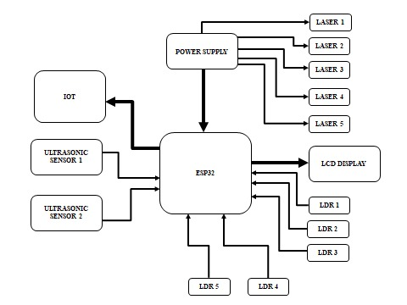
figure 6.1

Hardware Components
6.1 Laser-LDR Sensor Arrays
Laser-LDR pairs are the primary boundary sensors, precisely aligned along the court’s lines. They detect physical contact or crossing with high resolution. This system compensates for environmental factors through calibration routines, ensuring consistent operation across different lighting conditions.
6.2 Ultrasonic Sensors
These sensors are mounted along the sidelines and lobby zones to monitor player positions in real time. Ultrasonic pulses reflect off players' bodies, measuring distance to detect if a player exits or intrudes into restricted areas. They act as supplementary sensors, providing redundancy and increased accuracy.
6.3 ESP32 Microcontroller
Chosen for its embedded Wi-Fi, GPIO pins, and processing capabilities, ESP32 coordinates sensor inputs, executes algorithms, and manages wireless communication with cloud servers and user displays.
6.4 Circuit Protection
Capacitors regulate voltage spikes, diodes guard against reverse polarity damage, and transistors amplify sensor signals. Together, these components ensure stable operation and protect sensitive circuitry.

CHAPTER 7

Software Implementation
7.1 Data Transmission
Sensor data is processed on ESP32 and transmitted via Wi-Fi to cloud platforms (e.g., Blynk) in real time. Data packets include boundary violation events, score updates, and game timer status.
7.2 IoT Platform (Blynk.io)
Blynk dashboard visually displays ongoing scores, boundary violations, and timers, accessible remotely by referees, coaches, and spectators via smartphones or PCs.
7.3 Local Display
An LCD screen mounted near the court displays live scores, penalties, and match status. It provides immediate feedback, ensuring on-ground officials and players stay updated without delay.

KIT PICTURE

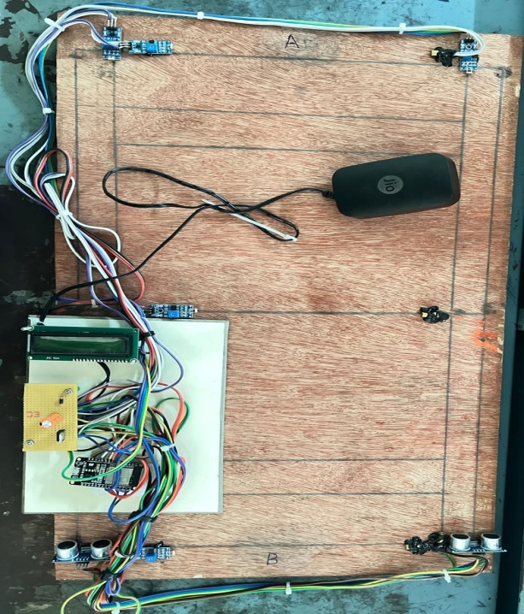
figure 7.1

CHAPTER 8

Results and Analysis
Testing results reveal high detection accuracy (>98%) in boundary and boundary violation detection. Response times are within 0.4 seconds, enabling near-instantaneous decision-making. The system reliably detects player movements in various lighting and environmental conditions, demonstrating robustness. The live display and IoT updates confirm system utility for real-world tournaments, with significant reduction in refereeing disputes.

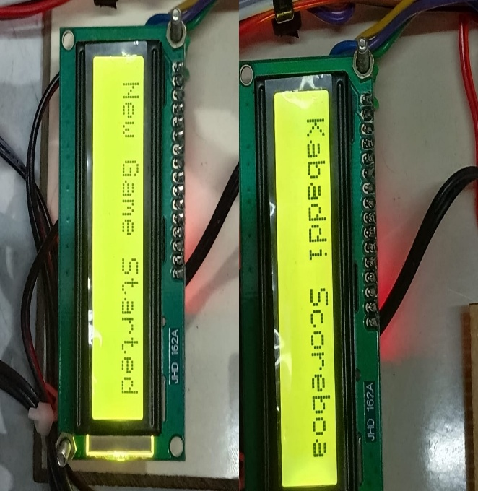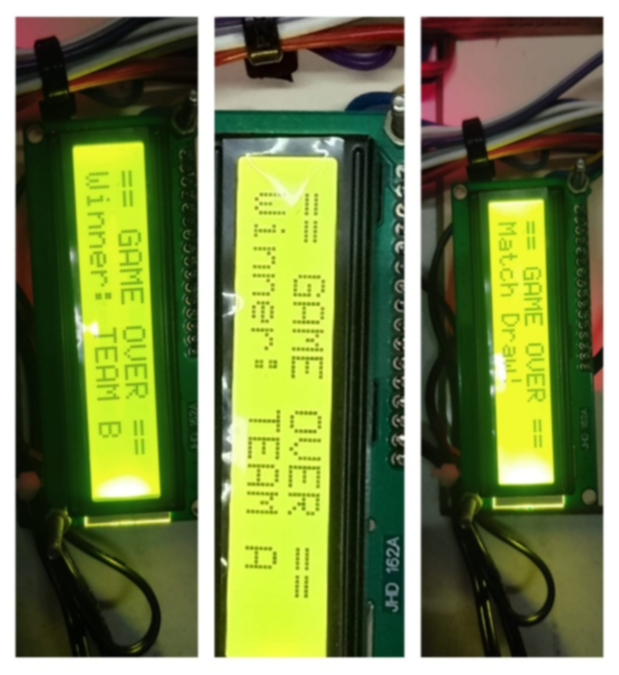
figure 8.1
The LCD displays show automated match results including "Match Draw!", "Winner: TEAM A", and "Winner: TEAM B", demonstrating the system's ability to automatically determine and display final game outcomes based on real-time sensor.

CHAPTER 9

SDG Alignment and Remarks
This project champions SDG 9—Industry, Innovation, and Infrastructure—by integrating cutting-edge sensor technology with IoT platforms. It modernizes traditional sports, promoting fair play, transparency, and sustainable development in sports infrastructure. Future implementations could extend to full-player tracking and AI-based performance analytics.

CHAPTER 10

Conclusions
The sensor-based Kabaddi monitoring system achieves precise, real-time detection of boundary violations and scoring, vastly reducing human errors. Its IoT integration ensures transparency and accessibility in both local and remote contexts. The system's scalability, affordability, and effectiveness make it a valuable addition to modern sports enforcement tools.

CHAPTER 11

Future Scope
- Expand sensor array to cover full court and all player movements.
- Incorporate AI for predictive analytics and performance monitoring.
- Develop portable sensor modules for grassroots and training applications.
- Integrate video analytics for multi-modal decision support.
- Use machine learning to improve decision accuracy based on historic data.

REFERENCES
- P Bellavista et al., The intelligent sport solutions of the WSNs and IoT solutions, Electronics.​
- A Kumar & S Bhosale, Simple Kabaddi sensor by tallying the positions reached by balls through the assistance of Arduino and sensors, IRJET.​
- S Singh et al., Smart sports arena: IoT-based line and player tracking, ICOSEC.​
- S Lu & X Zhang, A motion tracking system based on IoT for next-generation sports training, Talent selection.​
- J Wang et al., Sports detection and segmentation through the Internet, Journal of Healthcare Engineering.​
- D Chen & Z Ni, Video shot boundary detectors: Deep-learning based sports video classification algorithms, EAI Endorsed Transactions.​
- B Pei et al., Deep learning in detecting objects in sport motion, PLOS ONE.​
- G Singh & S Kumar, YOLO based player and boundary detection: Badminton game player and boundary detection, IJIRT.​
- J Wang, Detecting boundaries in sports events using named entity recognition, IEEE Conference.​
- H Li et al., Cloud-to-Things athletics-monitoring system based on deep learning in real-time boundary detection, PeerJ.

ESP32 INPUT PROGRAM

=== NEW GAME STARTED ===
Raid Start: Team A [0s] Raid Start: Team A
New Game Started [1s] New Game Started
No Cross: +1 B [9s] No Cross: +1 B
Next Raid [11s] Next Raid
LDR2 Dist: 49cm [15s] LDR2 Dist: 49cm
A OUT (LDR2) +1 B [16s] A OUT (LDR2) +1 B
Next Raid [18s] Next Raid
LDR1 Dist: 38cm [22s] LDR1 Dist: 38cm
B OUT (LDR1) +1 A [23s] B OUT (LDR1) +1 A
Next Raid [25s] Next Raid
Center Crossed (LDR5)! [30s] Center Crossed (LDR5)!
Touch +1! [31s] Touch +1!
Next Raid [33s] Next Raid
A OUT (LDR2) +1 B [37s] A OUT (LDR2) +1 B
Next Raid [39s] Next Raid
LDR2 Dist: 51cm [44s] LDR2 Dist: 51cm
B OUT (LDR2) +1 A [45s] B OUT (LDR2) +1 A
Next Raid [47s] Next Raid
A OUT (Endline A) +1 B [52s] A OUT (Endline A) +1 B
Next Raid [54s] Next Raid
Center Crossed (LDR5)! [59s] Center Crossed (LDR5)!
Touch +1! [60s] Touch +1!
Touch +1! [62s] Touch +1!
Next Raid [63s] Next Raid
LDR1 Dist: 41cm [67s] LDR1 Dist: 41cm
B OUT (LDR1) +1 A [68s] B OUT (LDR1) +1 A
Next Raid [70s] Next Raid
No Cross: +1 A [75s] No Cross: +1 A
Next Raid [77s] Next Raid
A OUT (LDR2) +1 B [82s] A OUT (LDR2) +1 B
Next Raid [84s] Next Raid
Center Crossed (LDR5)! [89s] Center Crossed (LDR5)!
Touch +1! [90s] Touch +1!
Next Raid [92s] Next Raid
LDR2 Dist: 51cm [96s] LDR2 Dist: 51cm
B OUT (LDR2) +1 A [97s] B OUT (LDR2) +1 A
Next Raid [99s] Next Raid
=== GAME OVER ===
Final Score A: 8 B: 7

