**NAMDU1RADIO**

**HARDWARE AND SOFTWARE INTERFACE DESIGN DOCUMENT**

|  |  |
| --- | --- |
| **Version #** | **Reason** |
| 1.0 | Initial Document Creation |
|  |  |

**Hardware interface details:**

**Hardware used:** Raspberry pi3 board

The Raspberry pi3 board contains total 40pins. In that few of the pins are reserved For power and ground. Refer below fig.

**GPIO’s Pin mapping details for Categories 1 to 9:**  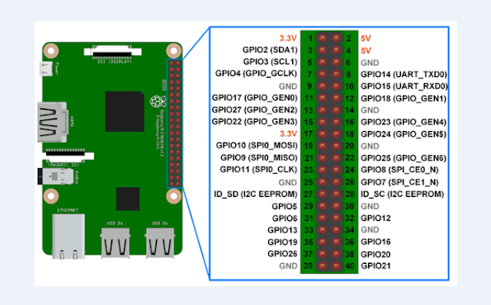

Currently total 18 pins used for recording, uploading and indication of different categories status. Please refer below table for pins details:

|  |  |  |  |
| --- | --- | --- | --- |
| **Buttons (GPIO’s)** | **Use case** | **LED’s (GPIO’s)** | **Indication** |
| Button1 = GPIO17 | Rec. Cat1 | LED1=GPIO18 | Cat1 |
| Button2 = GPIO19 | Rec. Cat2 | LED2=GPIO23 | Cat2 |
| Button3 = GPIO22 | Rec. Cat3 | LED3=GPIO24 | Cat3 |
| Button4 = GPIO10 | Rec. Cat4 | LED4=GPIO25 | Cat4 |
| Button5 = GPIO9 | Rec. Cat5 | LED5=GPIO8 | Cat5 |
| Button6 = GPIO11 | Rec. Cat6 | LED6=GPIO7 | Cat6 |
| Button7 = GPIO5 | Rec. Cat7 | LED7=GPIO12 | Cat7 |
| Button8 = GPIO6 | Rec. Cat8 | LED8=GPIO16 | Cat8 |
| Button9 = GPIO13 | Uploading | LED9=GPIO20 | upload |

**Software interface details:**

We have used total 18 GPIO’s for recording, uploading and indication (LED’s).

First 8 GPIO’s are used for recording and 1 GPIO is used for Uploading info, Remaining 9 GPIO’s are used for indications different categories current active status.

Below are the GPIO’s details and its use cases:

**GPIO 17 – Button1:**

This GPIO is connected to pin 11 and it is used for recording and backup playing of category1.

If This GPIO pin is pressed for morethan 2 sec, then longpress is activated to record the voice data from the user. Once recording for started user will be continuously recording the audio and parallely monitoring of continuously GPIO17 is monitored to stop recording. Once GPIO17 is pressed then recording will be stopped.

The recorded audio file is stored with the .wav file format. This .wav file will converted to .mp3 file once after the recording for stopped.