

**Course: Database Management System**

**Course Code: 15ECSC208**

**Lab: Database Applications Lab**

**Lab Code: 15ECSP204**

**Course Instructor: Prof. Rajashekharaiah K M M**

**STRUCTURED ENQUIRY**

**Topic: Toll Plaza**

**Name: Pragathi Pujari**

**Roll No: 405**

**USN: 01FE20BCS189**

**SEM: III**



**Miniworld Description**

NETC enables a device known as fastag as a payment mode on any toll plaza. fastag is attached on the windscreen of a vehicle and employs Radio frequency Identification technology (RFID) for making toll payments directly from prepaid or savings account linked to it.

This database keeps track of the citizens who has an account int the bank, who has a car. Each car has its details and each car has fastag. It contains the locations of the toll plaza and the details of the vehicles passed through these toll plazas.

* Every owner has unique Aadhar number, bank account number and the owner details in owner entity.

*Every owner has an account in the bank and the account entity contain about the details of account.

*The vehicle entity contains the vehicle details like colour, model, unique vehicle number and the vehicle type.

*Toll plaza entity contains about the location, its id, the employee working in it and its contractor and every toll plaza has different amount.

*Contractors and employee details are in the contractor and employee entity which has unique contractor id and employee id respectively.

*The fastag contains the unique fastag id associated with each vehicle and the id issued date.

* The vehicle passes entity gives the details of the vehicles passed through toll plaza and the date of passing.

*The amount deducted from the owners account to the toll plaza account if the vehicle is passed

through any of the toll plaza.

In this way the database model fulfils all the data storing and its management.



**ER Diagram**

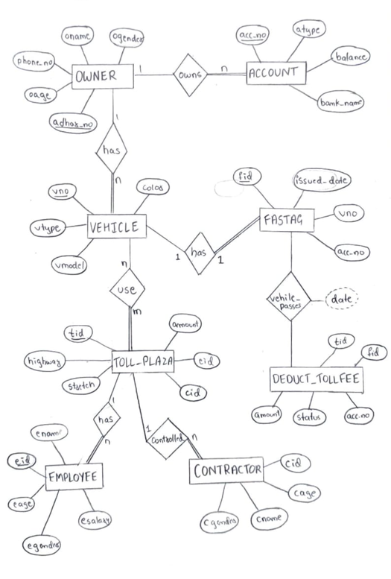



**Relational Schema**

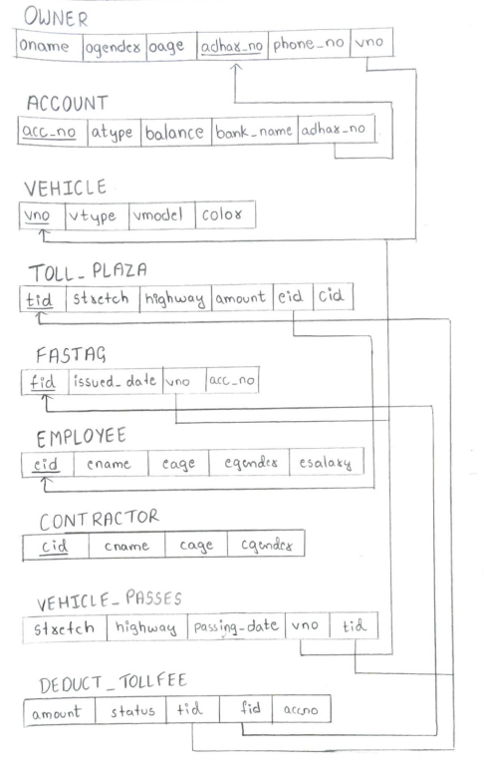



**SQL script for create table and data insertion statements**

drop table owners cascade constraints;

drop table accounts cascade constraints;

drop table vehicle cascade constraints;

drop table toll_plaza cascade constraints;

drop table fastag cascade constraints;

drop table vehicle_passes cascade constraints;

drop table deduct_tollfee cascade constraints;

drop table employee cascade constraints;

drop table comtractor cascade constraints;

select * from owners;

select * from accounts;

select * from vehicle;

select * from toll_plaza;

select * from fastag;

select * from vehicle_passes;

select * from deduct_tollfee;

select * from employee;

select * from contractor;

create table owners

(

oname varchar(20),

ogender varchar(2),

oage number(3),

adhar_no varchar(20) primary key,



phone_no number(10),

vno varchar(20) references vehicle(vno)

);

create table accounts

(

acc_no number(20) primary key,

atype varchar2(20),

balance number(10),

bank_name varchar2(20),

adhar_no varchar(20) references owners(adhar_no)

);

create table vehicle

(

vno varchar(20) primary key,

vtype varchar(20),

vmodel varchar(20),

color varchar(10)

);

create table toll_plaza

(

tid number(10) primary key,

stretch varchar(30),

highway varchar(10),

amount number(10),



eid number(10) references employee(eid),

cid number(10) references contractor(cid)

);

create table fastag

(

fid number(10) primary key,

issued_date date,

vno varchar(20) references vehicle(vno),

acc_no number(20) references accounts(acc_no)

);

create table vehicle_passes

(

stretch varchar(30),

highway varchar(20),

passing_date date,

vno varchar(20) references vehicle(vno),

tid number(10) references toll_plaza(tid)

);

create table deduct_tollfee

(

amount number(10),

status varchar(10),

tid number(10) references toll_plaza(tid),

fid number(10) references fastag(fid),



acc_no number(20) references accounts(acc_no)

);

create table employee

(

eid number(10) primary key,

ename varchar(30),

eage number(3),

egender varchar(10),

esalary number(10)

);

create table contractor

(

cid number(10) primary key,

cname varchar(30),

cage number(3),

cgender varchar(10)

);

insert into owners values('Piyush Jaggi','m',25,'2344-6574-3465',9880034275,'KA 23 5432');

insert into owners values('Pranjal Sharma','f',37,'4366-7644-2806',8975560045,'KA 23 3094');

insert into owners values('Kuldeep Patil','m',43,'5488-7335-9006',7864335047,'KA 05 6537');

insert into owners values('Arun Roy','m',28,'7005-3574-7664',9664882604,'KA 27 5409');

insert into owners values('Deepak Singh','m',35,'4375-2375-8043',8653440062,'KA 27 2463');

insert into owners values('Abhinav Pandey','m',54,'6508-8445-7092',9553552684,'MH 03 6085');

insert into owners values('Sammed Mishra','m',39,'5499-2683-1784',8463006882,'KA 46 7609');



insert into owners values('Rani Guptha','f',32,'5696-4673-8051',7844600395,'AP 25 3572');

insert into owners values('Ramesh Arvind','m',46,'8500-3657-0652',9463380662,'MH 23 2674');

insert into owners values('Sheela Jhoshi','f',24,'4005-3755-6532',8564490888,'KA 01 8005');

insert into vehicle values('KA 23 5432', 'car','maruti suzuki','white');

insert into vehicle values('KA 05 6537','bus','tata bus','yellow');

insert into vehicle values('KA 27 2463','truck', 'cargo','yellow');

insert into vehicle values('KA 46 7609','car','shift dzire','red');

insert into vehicle values('KA 01 8005','car','maruti ertiga','grey');

insert into vehicle values('MH 23 2674','bus','red bus','white');

insert into vehicle values('AP 25 3572','car','innova cresta','black');

insert into vehicle values('MH 03 6085','truck','tata 912','red');

insert into vehicle values('KA 27 5409','bus','traveller','white');

insert into vehicle values('KA 23 3094','car','tata nexon','blue');

insert into accounts values(34523762,'current',20000,'canara bank','2344-6574-3465');

insert into accounts values(6548763327,'savings',15000,'sbi','4366-7644-2806');

insert into accounts values(43568446,'savings',10000,'canara bank','5488-7335-9006');

insert into accounts values(674895202,'current',17550,'union bank','7005-3574-7664');

insert into accounts values(4987643594,'current',12550,'sbi','4375-2375-8043');

insert into accounts values(876450932,'savings',23573,'union','6508-8445-7092');

insert into accounts values(6800653784,'current',17653,'sbi','5499-2683-1784');

insert into accounts values(76654900,'savings',29764,'canara bank','5696-4673-8051');

insert into accounts values(744560092,'current',34095,'union bank','8500-3657-0652');

insert into accounts values(65439551,'savings',9765,'canara bank','4005-3755-6532');

insert into toll_plaza values(54,'Tumkur-Chitradurga','NH 48',80,101,06);



insert into toll_plaza values(76,'Kundapur-Surathkal','NH 66',85,134,04);

insert into toll_plaza values(67,'Hattargi-Hirebagewadi','NH 4',90,127,03);

insert into toll_plaza values(82,'Belgaum-Dharwad','NH 4',105,115,02);

insert into toll_plaza values(69,'Hungund-Hospet','NH 13',95,107,01);

insert into toll_plaza values(95,'Bangalore-Kolar','NH 75',100,123,05);

insert into toll_plaza values(79,'Bijapur-Hungund','NH 50',75,137,01);

insert into toll_plaza values(88,'Hassan-Devihalli','NH 75',90,129,04);

insert into toll_plaza values(94,'Bangalore-Pune','NH 4',95,136,05);

insert into toll_plaza values(53,'Neelamangal-Tumkur','NH 4',85,120,03);

insert into fastag values(1284,'23-dec-2020','KA 23 5432',34523762);

insert into fastag values(1076,'17-jul-2020','KA 23 3094',6548763327);

insert into fastag values(1352,'05-mar-2020','KA 05 6537',43568446);

insert into fastag values(1279,'10-feb-2020','KA 27 5409',674895202);

insert into fastag values(1004,'16-sep-2020','KA 27 2463',4987643594);

insert into fastag values(1384,'22-nov-2020','MH 03 6085',876450932);

insert into fastag values(1437,'13-oct-2020','KA 46 7609',6800653784);

insert into fastag values(1548,'30-apr-2020','AP 25 3572',76654900);

insert into fastag values(1020,'07-jan-2020','MH 23 2674',744560092);

insert into fastag values(1295,'06-nov-2020','KA 01 8005',65439551);

insert into deduct_tollfee values(80,'success',54,1284,34523762);

insert into deduct_tollfee values(85,'success',76,1076,6548763327);

insert into deduct_tollfee values(90,'fail',67,1352,43568446);

insert into deduct_tollfee values(105,'success',82,1279,674895202);

insert into deduct_tollfee values(95,'success',69,1004,4987643594);

insert into deduct_tollfee values(100,'success',95,1384,876450932);



insert into deduct_tollfee values(75,'fail',79,1437,6800653784);

insert into deduct_tollfee values(90,'success',88,1548,76654900);

insert into deduct_tollfee values(90,'success',67,1437,6800653784);

insert into deduct_tollfee values(75,'success',79,1279,674895202);

insert into deduct_tollfee values(105,'success',82,1384,876450932);

insert into deduct_tollfee values(85,'fail',76,1004,4987643594);

insert into deduct_tollfee values(90,'success',88,1279,674895202);

insert into vehicle_passes values('Tumkur-Chitradurga','NH 48','21-nov-2021','KA 23 5432',54);

insert into vehicle_passes values('Kundapur-Surathkal','NH 66','21-nov-2021','KA 23 3094',76);

insert into vehicle_passes values('Hattargi-Hirebagewadi','NH 4','21-nov-2021','KA 05 6537',67);

insert into vehicle_passes values('Belgaum-Dharwad','NH 4','22-nov-2021','KA 27 5409',82);

insert into vehicle_passes values('Hungund-Hospet','NH 13','22-nov-2021','KA 27 2463',69);

insert into vehicle_passes values('Bangalore-Kolar','NH 75','23-nov-2021','MH 03 6085',95);

insert into vehicle_passes values('Bijapur-Hungund','NH 50','24-nov-2021','KA 46 7609',79);

insert into vehicle_passes values('Hassan-Devihalli','NH 75','24-nov-2021','AP 25 3572',88);

insert into vehicle_passes values('Hattargi-Hirebagewadi','NH 4','25-nov-2021','KA 46 7609',67);

insert into vehicle_passes values('Bijapur-Hungund','NH 50','25-nov-2021','KA 27 5409',79);

insert into vehicle_passes values('Belgaum-Dharwad','NH 4','25-nov-2021','MH 03 6085',82);

insert into vehicle_passes values('Kundapur-Surathkal','NH 66','26-nov-2021','KA 27 2463',76);

insert into vehicle_passes values('Hassan-Devihalli','NH 75','27-nov-2021','KA 27 5409',88);

insert into employee values(101,'Ramesh Arvind',27,'m',17000);

insert into employee values(134,'Suresh Jhoshi',34,'m',23000);

insert into employee values(127,'Manoj Patil',47,'m',24000);

insert into employee values(115,'Rani Bella',38,'f',22000);

insert into employee values(107,'Sammed Shetti',30,'m',21500);



insert into employee values(123,'Abhishek R N','36','m',19500);

insert into employee values(137,'Roopa Akshok',43,'f',23500);

insert into employee values(129,'Vinod Shet',33,'m',21700);

insert into employee values(136,'Zayn Malik',32,'m',24750);

insert into employee values(120,'Rana Rathod',28,'m',21700);

insert into contractor values(02,' Ravi Teja',45,'m');

insert into contractor values(06,'Surya Prakash',38,'m');

insert into contractor values(04,'Ram Charan',41,'m');

insert into contractor values(03,'R Rajkumar',47,'m');

insert into contractor values(01,'Shri Chandra',34,'m');

insert into contractor values(05,'Laxmi Rani',36,'f');

commit;



**SQL query statements and output**

**MULTIPLETABLE JOIN OPERATIONS**

1. **Retrive the contractor name who has control on 'Belgaum-Dharwad**

select cname,ename,highway

from contractor c,toll_plaza tp,employee e

where c.cid=tp.cid and e.eid=tp.eid and stretch='Belgaum-Dharwad';

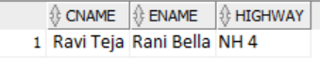

1. **Retrive the stretch name in which female employees are working and salary greater than 22000**

select stretch, ename

from employee e, toll_plaza t

where e.eid=t.eid and egender='f' and esalary> 22000 and stretch like'B%d'

group by stretch,ename;

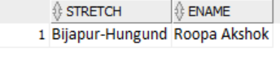

1. **Retrive the contractor name who has more than one contract on toll plaza and age greater than 40**

select cname,count(tid)

from toll_plaza t,contractor c

where t.cid=c.cid and cage>40

group by cname

having count(tid)>1;

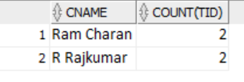

1. **Retrive the owner name , account balance, vehicle number and and fastag issued date and the vehicle is car**

select oname, balance, v.vno,issued_date

from owners o,accounts a, vehicle v, fastag f

where o.adhar_no=a.adhar_no and o.vno=v.vno and v.vno=f.vno and vtype='car';

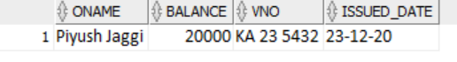



1. **Retrive the toll_plaza details with employee working , the contractor, and vehicle no passed from all the toll plaza**

select tp.stretch, tp.highway,cname,ename,vno

from toll_plaza tp,contractor c, employee e,vehicle_passes vp

where tp.cid=c.cid and e.eid=tp.eid and vp.tid=tp.tid;

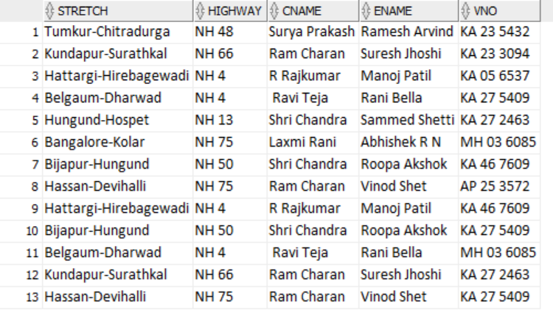

1. **Join the vehicle_passes and deduct_tollfee table and transaction is success and passing date is 22-nov-2021**

select * from vehicle_passes natural join deduct_tollfee

where status='success' and passing_date='22-nov-2021';

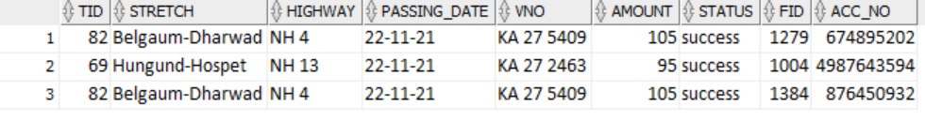

**ARTHEMATIC AND LOGICAL OPERATIONS**

1. **Retrive mimimum balance,average balance,total balance and maximum balance of the accounts in bank**

select min(balance) as "minimum balance" ,

max(balance) as "maximun balance",

sum(balance) as "total balance",

avg(balance) as"average balance"

from accounts;

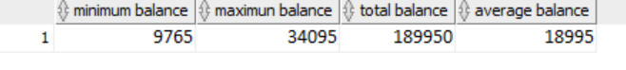



1. **Update the salary of the employee by 15%**

update employee

set esalary=esalary*0.08+esalary

where eage in (select eage from employee

where eage >40);

[note: Before updation]

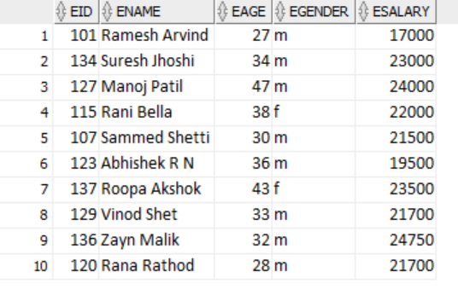

[After updation]

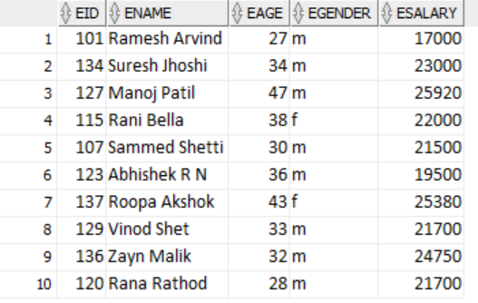

1. **Retrive employee name whose age is minimum**

select e.ename,e.eage

from employee e

where e.eage=(select min(eage)

from employee);

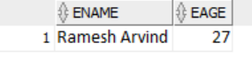



1. **Retrive the amount collected by each toll plaza on each day**

select tp.stretch,passing_date,sum(dt.amount)

from toll_plaza tp, deduct_tollfee dt, vehicle_passes vp

where tp.tid=dt.tid and vp.tid=dt.tid and status='success'

group by tp.stretch,passing_date

order by (passing_date) asc ;

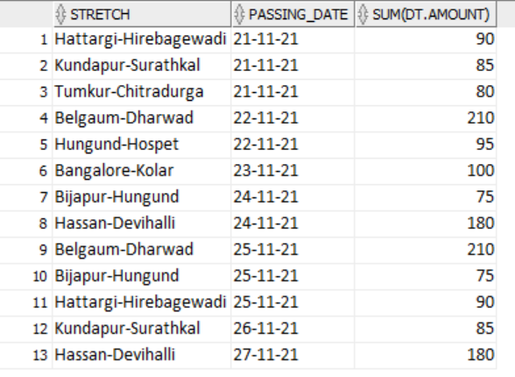

1. **Retrive the name of employee whose salary is greater than average salary and equal to minimun salary**

select ename,esalary

from employee

where esalary = (select min(esalary)

from employee

where esalary > (select avg(esalary)

from employee));



**DIFFERENT CLAUSES AND FUNCTIONS**

1. **Retrive the no of toll plaza located in particular highway**

select highway ,count(tid)

from toll_plaza

group by highway;



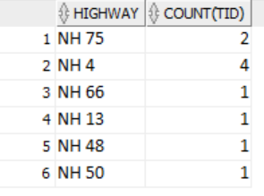

1. **Retrive the number of contracts taken by each female contractor**

select cname,count(tid)

from contractor c,toll_plaza tp

where c.cid=tp.cid and cgender='f'

group by cname

having count(tid)>1;

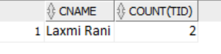

1. **Retrive the no of vehicles passed on each day**

select passing_date,count(vno) as "no of vehicles passed"

from vehicle_passes

group by passing_date

order by count(vno) desc;

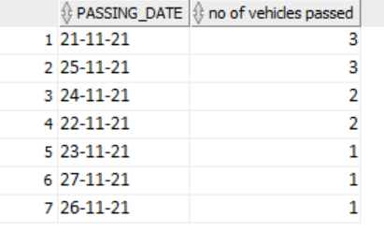

1. **Retrive the number of accounts in each bank**

select bank_name,count(adhar_no)

from accounts

group by bank_name

order by 2 desc;

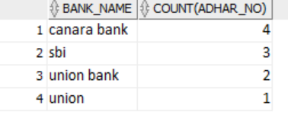



1. **Retrive the number of vehicles which passed in each stretch**

select stretch,count(vno) as "number of vehicles passed"

from vehicle_passes vp

group by stretch

order by count(vno) asc;

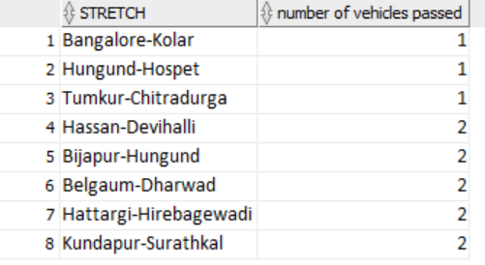

1. **Name the highway which has more than 2 toll plaza**

select highway,count(stretch)

from toll_plaza

group by highway

having count(stretch)>1;

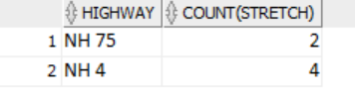

**SUB QUERIES( NESTED QUERIES)**

1. **Retrive the vehicle number which passed in toll id 88 but not in 53**

select vno

from vehicle_passes

where tid in( select tid

from vehicle_passes

where tid=88) and tid not in

(select tid from vehicle_passes

where tid=53);

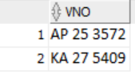



1. **Retrive the toll_plaza whose amount is maximum**

select *

from toll_plaza

where tid in( select tid

from toll_plaza where tid in (select tid

from toll_plaza

where amount=(select max(amount) from toll_plaza)));

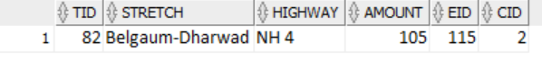

1. **Retrive the owner name who has balnace greater than average balance**

select oname,accounts.adhar_no, balance

from accounts,owners

where balance > ( select avg(balance)

from accounts ) and accounts.adhar_no=owners.adhar_no;



1. **Display the 2nd highest salary of and employee**

select ename,eage

from employee where esalary=(select max(esalary) from employee

where esalary not in

(select max(esalary) from employee));



1. **Retrive the vehicle details which did not pass from any of the toll plaza**

select *

from vehicle

where vno not in (select vno

from vehicle_passes);

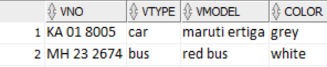



1. **Retrive the toll plaza name where no vehicle passed**

select stretch from toll_plaza

minus select vp.stretch

from toll_plaza tp, vehicle_passes vp

where tp.tid=vp.tid;

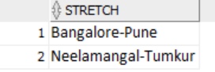

1. **Retrive the toll plaza name in NH 4 highway 0r have contractor id is 4**

select stretch,highway

from toll_plaza, contractor c

where highway ='NH 4'

union

select stretch, highway from toll_plaza tp, contractor c

where tp.cid=c.cid and c.cid=4;

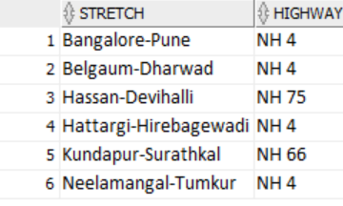

1. **Retrive the toll plaza who have same toll amount of toll id 88**

select *

from toll_plaza t1

where exists (select *

from toll_plaza t2

where t1.amount=t2.amount and t2.tid=88);

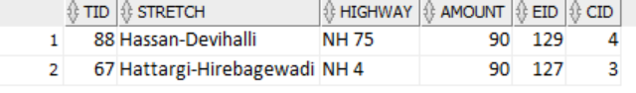

1. **Retrive the highway and the vehicle number passed in the 'Hattargi-Hirebagewadi** toll plaza in decsending order of the passing date of a vehicle

select vno,passing_date,highway

from vehicle_passes vp

where vp.tid in ( select vp.tid

from vehicle_passes vp

where stretch='Hattargi-Hirebagewadi')

order by passing_date desc;



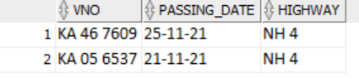

1. **Retrive the toll plaza which is located in the same highway of toll id 82**

select stretch,highway

from toll_plaza t1

where exists (select stretch, highway

from toll_plaza t2

where t1.highway=t2.highway and t2.tid=82);

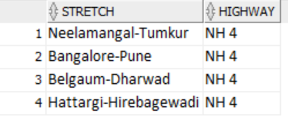

1. **Retrieve the toll plaza name where no vehicle is passed and not even the amount is collected**

select stretch

from toll_plaza tp

where tp.tid not in (select tid from vehicle_passes

union

select tid from deduct_tollfee);

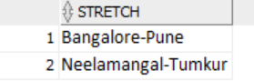

1. **Retrieve the toll plaza where the toll plaza amount is not between 80 to 100**

select stretch,tid,amount

from toll_plaza

group by stretch,tid,amount

having tid in(select tid

from toll_plaza

where amount not between 80 and 100)

order by tid;

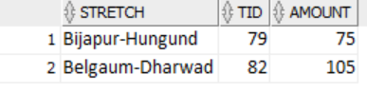

1. **Retrive the no of vehicles based on vehicle type and color of the vehicle**

select vtype,color,count(vno)

from vehicle

group by vtype,color;



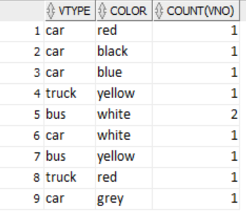

1. **Retrieve the fastag and the vehicle number which is issued the fastag on 05-mar-2020 and also passed in the only one toll plaza**

select fid,f.vno

from fastag f

where f.issued_date='05-mar-2020' and f.vno in(select vno

from vehicle_passes

group by vno

having count(*) =1);

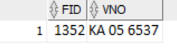

**VIEWS**

1. create view deduct_tollfee_view as

select a.acc_no,a.bank_name,dt.amount

from deduct_tollfee dt, accounts a

where dt.acc_no=a.acc_no and dt.status='fail';

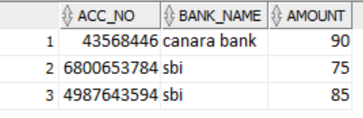

1. create view toll_plaza_view as

select stretch,tid,highway,esalary,cname

from toll_plaza tp,employee e, contractor c

where e.esalary>20000 and tp.eid=e.eid and c.cid=tp.cid and cgender='f';

