

COMPUTERIZED COGNITIVE RETRAINING FOR HOME TRAINING OF CHILDREN WITH DISABILITIES.

A PROJECT REPORT

Submitted by,
Pragathi M V | 20221CBD0007
Ruchira S P | 20221CBD0042
Venkata Hemanth N | 20221CBD00052

Under the guidance of,
DR. ABDUL MAJID

BACHELOR OF TECHNOLOGY

IN

COMPUTER SCIENCE AND TECHNOLOGY (BIG DATA)

PRESIDENCY UNIVERSITY BENGALURU
DECEMBER 2025

PRESIDENCY SCHOOL OF COMPUTER SCIENCE AND TECHNOLOGY
BONAFIDE CERTIFICATE

Certified that this report “COMPUTERIZED COGNITIVE RETRAINING FOR HOME TRAINING OF CHILDREN WITH DISABILITIES” is a bonafide work of “PRAGATHI M V (20221CBD0052), RUCHIRA S P (20221CBD0042), VENKATA HEMANTH N (20221CBD0007)”, who have successfully carried out the project work and submitted the report for partial fulfilment of the requirements for the award of the degree of BACHELOR OF TECHNOLOGY in COMPUTER SCIENCE AND TECHNOLOGY, BIG DATA during 2025-26.
Dr. Abdul Majid  Project Guide  PSCS  Presidency University | Dr. H M Manjula  Program Project Coordinator  PSCS  Presidency University | Dr. Sampath A K  Dr. Geetha A  School Project Coordinators  PSCS  Presidency University | Dr. Pravinthraja S  Head of the Department PSCS  Presidency University

Dr. Shakkeera L  Associate Dean  PSCS  Presidency University | Dr. Duraipandian N  Dean  PSCS & PSIS  Presidency University

Sl. no. | Name | Signature | Date
1
2

Examiners

PRESIDENCY UNIVERSITY

PRESIDENCY SCHOOL OF COMPUTER SCIENCE AND TECHNOLOGY

DECLARATION

We the students of final year B.Tech in COMPUTER SCIENCE AND TECHNOLOGY, BIG DATA at Presidency University, Bengaluru, named VENKATA HEMANTH N, RUCHIRA S P, PRAGATHI M V , hereby declare that the project work titled “COMPUTERIZED COGNITIVE RETRAINING FOR HOME TRAINING OF CHILDREN WITH DISABILITIES” has been independently carried out by us and submitted in partial fulfillment for the award of the degree of B.Tech in COMPUTER SCIENCE AND TECHNOLOGY (BIG DATA) during the academic year of 2025-26. Further, the matter embodied in the project has not been submitted previously by anybody for the award of any Degree or Diploma to any other institution.

Pragathi M V | USN: 20221CBD0052
Ruchira S P | USN: 20221CBD0042
Venkata Hemanth N | USN: 20221CBD0007

PLACE: BENGALURU
DATE:

ACKNOWLEDGEMENT

For completing this project work, We/I have received the support and the guidance from many people whom I would like to mention with deep sense of gratitude and indebtedness. We extend our gratitude to our beloved Chancellor, Pro-Vice Chancellor, and Registrar for their support and encouragement in completion of the project.

I would like to sincerely thank my internal guide Dr. Abdul Majid, Associate Professor, Presidency School of Computer Science and Engineering, Presidency University, for his moral support, motivation, timely guidance and encouragement provided to us during the period of our project work.

I am also thankful to Dr. Pravinthraja S, Professor, Head of the Department, Presidency
School of Computer Science and Engineering Presidency University, for his mentorship
and encouragement.

We express our cordial thanks to Dr. Duraipandian N, Dean PSCS & PSIS, Dr. Shakkeera L, Associate Dean, Presidency School of computer Science and Engineering and the Management of Presidency University for providing the required facilities and intellectually stimulating environment that aided in the completion of my project work.

We are grateful to Dr. Sampath A K, and Dr. Geetha A, PSCS Project Coordinators, Dr. H M Manjula, Program Project Coordinator, Presidency School of Computer Science and Engineering, or facilitating problem statements, coordinating reviews, monitoring progress, and providing their valuable support and guidance.
We are also grateful to Teaching and Non-Teaching staff of Presidency School of Computer Science and Engineering and also staff from other departments who have extended their valuable help and cooperation.

Pragathi M V
Ruchira S P
Venkata Hemanth N

Abstract

Children with reasoning and learning difficulties usually find it difficult with regards to issues such as memory, attention, the rate of mastering things, and ability to alternate tasks. These are the most significant skills at school, communicating with people and simply performing their daily tasks independently. Most of the time children are assisted in a clinic, but it may be difficult to reach it due to commuting, time schedules, and it may not be easy to fit the therapy on a child. Moreover, families are normally only able to attend a few sessions. Thus, the majority of children do not obtain the type of assistance which they actually require.
This is the reason why we made COGNITRAIN. It is one system which could be used in your home on your computer or cell phone to help bridge that gap. It involves the known information about the way the brain functions, how individuals learn, and other special tech tools. COGNITRAIN provides children with brief, fun events that vary along with their use, therefore, it is not difficult or simple. Parents obtain clear-cut charts and data on the performance of its child too. And we checked that all was safe, and confidential. Researchers can even monitor the progress of the kids when they are training using brainwave trackers in case they want to.
Our experimentation of such a system occurred through a study where we prepared and pre-planned such things as who was to be included in the study, how to measure progress, and how to ensure that we were not putting anyone in an unsafe situation. COGNITRAIN can make the computing devices that people already possess turn into instruments that enable children to develop their thinking abilities by applying good science and making it simple to use. This is aimed at enabling them to apply what they learn in the real world in order to perform better in their daily lives. We do not want to ensure that we can help all kids who need help regardless of where they are.

Table of Content

Sl. No. | Title | Page No.
 | Declaration | i
 | Acknowledgement | ii
 | Abstract | iii
 | List of Figures | iv
 | List of Tables | v
 | Abbreviations | vi
1. | Introduction  1.1 Background  1.2 Statistics of the problem domain  1.3 Prior existing technologies  1.4 Problem Statement  1.5 SDGs  1.6 Overview of project report | 1  1  2  2  3  4  5
2. | Literature review  2.1 Virtual reality and cognitive rehabilitation  2.2 Research Gaps  2.3 Objectives | 6  6  7  8
3. | Methodology  3.1 Project Methodology: The V-Model  3.2 Verification stages  3.3 Validation stages | 9
3. |  | 9
3. |  | 9
3. |  | 10
4. | Project management  4.1 Project timeline and scheduling  4.2 Risk analysis and Management  4.3 Project budget Allocation | 12  12  15  19
5. | Analysis and Design  5.1 System Requirements  5.2 Overall Block Diagram  5.3 System Flow Chart  5.4 Two-Layer Architecture Design | 22  22  25  25  26
6. | Implementation and Technologies  6.1 Software Development Tools  6.2 Data Security and Storage Implementation  6.3 Adaptive Learning Engine Implementation  6.4 Deployment and Scalability Tools  6.5 Adherence Engine and Feedback System  6.6 Caregiver Dashboard Integration  6.7 Deployment and Scalability Tools | 28
6. |  | 28
6. |  | 29
6. |  | 30
6. |  | 31
6. |  | 33
6. |  | 34
6. |  | 34
7. | Testing and Evaluation  7.1 Test Case Scenarios  7.2 Performance Metrics  7.3 Result Analysis  7.4 Adaptive Engine Performance and Reliability  7.5 System Integration Testing | 35
7. |  | 35
7. |  | 36
7. |  | 37
7. |  | 38
7. |  | 40
8. | Results and Discussion  8.1 Quantitative Performance Metrics  8.2 Comparison with Existing Systems  8.3 System Reliability and Resilience  8.4 User Experience | 41  41  42  44  45
9. | Social, Legal, Ethical, Sustainability and Implications  9.1 Moral Issues of Adaptive Help  9.2 Legal Rules and Following the Law  9.3 How Security is Affected and Equality  9.4 Environmental Long-Term Visibility | 47  47  48  49  49
10. | Conclusion and Future Scope  10.1 Future Possibilities | 50  50
 | References | 52
 | Appendix | 53

List of Figures

Figure No. | Caption | Page no
Fig 1.1 | Sustainable development goals | 4
Fig 3.1 | V-Model method | 9
Fig 5.1 | Website Home Page | 23
Fig 5.2 | The Technical Data Flow Diagram | 24
Fig 5.3 | The Conceptual Overview | 25
Fig 5.4 | User Registration Page | 26
Fig 6.1 | Games on the website | 30
Fig 6.2 | User Login Page | 32
Fig 7.1 | DDA Efficacy and Latency Results | 43
Fig 8.1 | Webpage Dashboard | 45

List of Tables

Table No. | Caption | Page no
Table 4.1 | Project Planning Timeline | 13
Table 4.2 | Project Implementation Timeline | 14
Table 4.3 | PESTLE Analysis | 16
Table 4.4 | Project Risk Management | 18
Table 4.5 | Budget Breakdown | 20
Table 4.6 | Total Budget Estimate | 21
Table 7.1 | Summary of Test Case Scenarios | 39
Table 7.2 | Layer 1 Performance Metrics | 35
Table 7.3 | Layer 2 Performance Metrics | 38
Table 7.4 | Integration Testing Summary | 40
Table 8.1 | Combined System Performance | 42
Table 8.2 | Comparison with Existing Approaches | 43
Table 8.3 | Reliability and Stress-Test Results | 44

Abbreviations

CCT - Computerized Cognitive Training (The form of digital intervention).

DDA - Dynamic Difficulty Adjustment (The core algorithm for personalization).

RCT - Randomized Controlled Trial (The method used for rigorous evaluation).

ASD - Autism Spectrum Disorder (One of the target developmental conditions).

ADHD - Attention-Deficit/Hyperactivity Disorder (One of the target developmental conditions).

IDD - Intellectual Developmental Disorder (One of the target developmental conditions).

PII - Personally Identifiable Information (Data requiring strict security segregation).

RBAC - Role-Based Access Control (Security measure for managing user access).

SDG - Sustainable Development Goal (UN framework for project alignment).

V-Model - Verification and Validation Model (The chosen project methodology).

TLS - Transport Layer Security (Protocol used for secure data transmission).

AES - Advanced Encryption Standard (Algorithm used for data encryption at rest).

BLE - Bluetooth Low Energy (Communication standard for the optional sensor).

UI - User Interface (Referring to Child or Caregiver screen design).

API - Application Programming Interface (Used by the Secure Gateway and Backend se

CHAPTER 1
INTRODUCTION

Children with disorders such as autism, ADHD, and intellectual disability tend to experience difficulties in the area of the thinking skills. This may render them difficult to learn, think and engage in normal activities. As an illustration, they may have problems with recollection, concentration, performing tasks in a short period of time, or multitasking.
Computer games training the brain is one of the ways to help. These are games that train thinking skills in a fun and repetitive manner. However, there have been issues regarding the use of such kind of games. In most cases, you are forced to visit a clinic where you have to use them, which is not easy to some individuals. People have also not always incorporated sufficient quantity of kids in the studies. And the games are not always modified to suit every kid. Most importantly parents do not always receive regular updates on the performance of their child so it becomes difficult to keep them hooked when they attempt to use the games at home.

1.1 Background
Every child should have the opportunity to flourish. However, for a lot of children dealing with complicated conditions such as Autism Spectrum Disorder (ASD), Attention-Deficit/Hyperactivity Disorder (ADHD), or Intellectual Developmental Disorder (IDD), progress can be held back due to difficulties processing information in their brains. Researchers have been investigating the use of Computerized Cognitive Training (CCT), which involves using brain-training games to help children improve these cognitive skills. Past efforts have shown promise, they've also faced challenges that limit their that limit their overall . These challenges include:
- Delivery Limited to Clinics: Training programs are often only available in specialized clinics or labs. This creates difficulties related to travel, expenses, and scheduling for families, which reduces the frequency and length of training needed to actually lead to skill development.
- One-Size-Fits-All Approach: Current games do not always adapt to a child's changing performance. Tasks that are too easy can cause boredom, and those that are too hard can lead to frustration and abandonment.
- Limited Feedback for Caregivers: Parents and caregivers, who are crucial in encouraging and supporting their child’s progress, often lack clear information about their child’s development. This missing feedback makes it difficult to maintain a consistent routine at home.

1.2 Statistics of the Problem Domain
Although specific regional numbers may vary, the wide presence of neurodevelopmental conditions makes it clear that there is a need for accessible interventions. We plan to tackle three significant social challenges that many families face:
- Removing Travel Barriers (Improving Accessibility): Relying on clinic-based CCT creates logistical and financial strains. COGNITRAIN will be accessible on standard mobile devices and web browsers, designed to use little data, and work even when there is no internet. This makes evidence-based therapy available to families in their own homes, which helps to lower costs and improve consistent use.
- Giving Parents Data (Empowering Caregivers): Parents require useful data to support their child’s routine. We plan to bridge this gap using dashboards that transform data into knowledge, such as showing that the child does best in the mid-morning or shorter sessions are more productive.

1.3 Prior Existing Technologies
We can value prior work in cognitive training. Previous technologies, including tele-rehabilitation platforms, had some limitations that COGNITRAIN is designed to correct:
- Delivery Model: Previous systems required clinic visits or specialized equipment and often lacked caregiver support. COGNITRAIN’s tele-rehabilitation approach makes the system available on the web and on mobile devices, uses little internet data, and functions without internet access, making it more accessible.
- Cognitive Adaptation: Existing technologies relied on simple measurements or fixed levels that did not fatigue. COGNITRAIN’s Dynamic Difficulty Adjustment (DDA) Engine uses a system that monitors both correct answers and how long it takes to respond. This informs difficulty changes.
- Data and Feedback: Past systems provided general information that was difficult for parents to understand. COGNITRAIN’s dashboards present clear progress reports focused on adherence, speed, , and mastery.
- Research Quality: Studies were often small ensuring findings were not usable on a . COGNITRAIN’s Improvement: We are doing a large Randomized Controlled Trial (RCT) with a minimum of 60 participants and a plan to ensure findings are reproducible.
The main improvement with COGNITRAIN is putting together a personalized learning algorithm with a user-friendly platform for home use.

1.4 Problem Statement
The idea in our project is to solve a large issue one in which, kids cannot receive an equal opportunity of cognitive therapy. Currently, brain training among the developmentally challenged kids is spoiled by three major barriers. To begin with, families are overwhelmed. Good training is often a way involving journeys to special centres which may involve much traveling, financial expenses and un-combinable time schedules. That is why it is difficult to maintain a regular training process to achieve tangible results. Second, the available treatment instruments are not that responsive. Several digital products are inflexible. They do not move when a child becomes bored due to something being too easy or when they become frustrated due to something being too hard and this reduces the utility of the training. Third, there are the issues of trust and transparency. It is not always that parents can see good evidence that therapy works. Moreover, researchers also experience patchy data, which is why it is difficult to be sure that the therapy actually benefits a child in the real-life scenario. We are going to create a model that will address such issues, being highly accessible, truly personalised, and open with its data.

1.5 Sustainable Development Goals (SDGs)

Fig 1.1- Sustainable development goals
The project is aligned with a few UN SDGs:
- SDG 3 – Good Health and Well-being: Our COGNITRAIN system helps health and well-being by giving important thinking training, which is a key part of care for children with brain development issues. COGNITRAIN provides personalized cognitive exercises involve activities that enhance memory, attention, and problem-solving skills. The platform's adaptability ensures that each child gets exercises suited to their specific requirements, leading to more improvements.
- SDG 4 – Quality Education: Thinking skills are the base of learning. By making a child's short-term memory, focus, and speed stronger, COGNITRAIN helps them learn and join in learning environments better. The gains from training help lower thinking blocks, leading to better and fairer education results, making sure that kids with special needs are more able to learn from good education. COGNITRAIN gives complete cognitive training created to improve learning results for all children, especially those with special needs.
- SDG 10 – Reduced Inequalities: The main idea of COGNITRAIN is its easy, at-home use through web and mobile platforms. By removing the cost and location issues of going to clinics, the system makes sure that good, personal thinking help is available to families no matter where they live or how much money they have. COGNITRAIN works to remove differences in getting necessary care for kids with brain development issues.

1.6 Overview of the Project Report
This report is divided into ten distinct chapters.
Chapter 1 introduces the vigilante problem domain, the attack landscape, existing technologies, and what the hybrid system proposes.
Chapter 2 reviews the associated research literature and identifies critical issues with both traditional detection and modern detection methods.
Chapter 3 reviews the methodology used for development of the hybrid system.
Chapter 4 provides an overview of the project timeline, formal milestones, a risk management assessment, and a budget agreement.
Chapter 5 addresses the analysis and design and provides details of the system architecture, flow diagrams, and deployment models.
Chapter 6 explores the detail of the implementation of each of the modules.
Chapter 7 evaluates the system through testing and performance analysis.
Chapter 8 reviews the results and comparative performance.
Chapter 9 reviews ethical, legal, and sustainability issues.
Chapter 10 concludes the project with an identified way forward agenda for work to be conducted in the future.

CHAPTER 2
LITERATURE REVIEW

Cognitive rehabilitation is quickly changing because of things such as Virtual Reality (VR) and computer-based training. This progress faces some difficulties, such as easily getting to therapy, keeping people involved, and proving skills translate to the real world. COGNITRAIN aims to fix these difficulties, but first we need to know what has worked and what has not. It is important to examine the early use of VR, outcomes of studies on training many cognitive skills together, and methods to change the training difficulty based on user's output. This chapter looks at research in five parts: VR in cognitive rehabilitation, Multi-Domain Computerized Cognitive Training (CCT), real-world applications of CCT for kids, therapy at home and adherence, and the math behind Dynamic Difficulty Adjustment (DDA).

2.1 Review of Existing Models
So, a search through the history of the research reveals that although all the relatively simple components of COGNITRAIN exist, no one consolidated them into a convenient clinical application. In case you consider the previous one, such as the research of virtual reality (VR) in thinking abilities [1], they demonstrate that training with the computer-based means can enhance cognition. The catch? VR technology is costly and it draws you into a healthcare environment which is a significant drawback to families who are unable to make the drive. Then there is the one on children with intellectual and developmental disabilities [3] and other neurological children [4] that shows multi-skill training can be helpful. However they were mostly the methods which lingered on fixed or over-easy difficulty levels which never responded to whether a child was learning the material more quickly or becoming bored and tired. Such depersonalization would disappoint when they are trivial or frustrate when they are too difficult so the children spend their time giving up and would spoil the intended purpose of skills transfer into real life. Finally, home-based therapy research [5] considered that patients remain on home-based therapy longer when they work out at home, but most telehealth platforms lack the safety and personalized feedback needed to qualify as a clinical product of bona-fide. They are quite user-friendly, however, not detailed, safe, and personalized to reach the research standards.

2.2 Research Gaps
- Despite the encouraging initial results of the research on Computerized Cognitive Training (CCT), a more detailed examination of the matter still shows that there is a collection of gaps that can restrict the effectiveness of these platforms, their popularity, or the soundness of the science underlying them. This is due to the unmet needs, which is why the COGNITRAIN project is on the table.
- Gap in Access and Continued Use. The issue: The majority of CCT programs will only be run in a clinic, and thus, access and cost is a significant obstacle making it drop before the brain changes can occur enough. COGNITRAIN solution: We are developing an application that allows creating a home compatible system that can be deployed on common web browsers and mobile devices, eliminating the physical barrier of access.
- Lag in Personalised and Real time user engagement. The issue: Today the so-called adaptive systems do not actually listen to the performance of a child in the real-time context, disregarding such signs as exhaustion or boredom since they are based on the measures of progress which do not change dynamically. COGNITRAIN solution: We are developing a Dynamic Difficulty Adjustment (DDA) engine, which will accept the input of accuracy and reaction time and maintain the difficulty level at a spot-on level in real time.
- Lack of Privacy and Data Separation. The issue: Tech in health care is associated with data-security headaches, and previous systems do not always have the capability to neatly differentiate between sensitive personal data and performance data. COGNITRAIN solution: At Cognitrain, architecture, personal information and usage statistics are kept in separate secure databases which are in compliance with clinical data requirements.
- Disconnect in Feedback and Useability between the Caregiver. The dilemma: The front line of treatment is parents who are commonly given little helpful feedback or are provided with it too late hence finding it difficult to keep their child on track. COGNITRAIN solution: We will be using Caregiver Dashboards that leech insights such as the best session timing and consistency ratios and enhance family collaboration and communication.
- Ascent in Scientific Controllability and Repeatability. The issue: CCT studies are afflicted with small samples and lack uniform measures of outcomes. COGNITRAIN solution: we will carry an immense, pre-registered randomized controlled trial (RCT) with sound sample size and normalized measures (e.g., BRIEF), and provide more convincing route that will confirm its effectiveness.

2.3 Objectives
The key objectives of COGNITRAIN are focused on design, performance, and the practical use. It is everything concerning bridging the gaps between 2.2 and implementing the solutions of Chapter 3.
- System Management & Security We shall develop a safe but welcoming architecture that will make all the data of the users remain secure. This implies privacy perimeters, personal information and usage data have to be separated, access should be use roles, and industry-grade encryption (TLS over the air and AES-256 on the drive) must be applied to protect data and foster trust.
- Behavior & Personalization Our new engine is the Dynamic Difficulty Adjustment (DDA), which continuously regulates the difficulty of the games depending on the real time accuracy and speed of each child and keeps them at the optimal learning point.
- Analysis & Deployment Our Caregiver and Clinician Dashboards will be web- and mobile-digestible and provide easy-to-understand, actionable statistics, such as frequency of sessions, average response time, the score of this module, etc. to keep the family engaged, and clinicians informed about the progress.
- Efficacy & Validation Lastly, we will conduct a massive, pre-regional RCT of 60 plus individuals, comparing the cognitive (e.g., working memory, executive functioning-enhancing) gains to the control in order to cement the evidence base.

CHAPTER 3
METHODOLOGY

This chapter details the steps we took to create the COGNITRAIN platform. Given the project's dual aims—providing accessible therapy and maintaining data integrity for research—we adopted a rigorous development process. Our structured framework emphasized thorough planning and traceability to verify that all clinical needs were met by the finished software.

3.1 Project Methodology: The V-Model
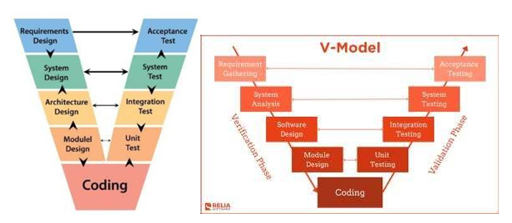
Fig 3.1 shows the V-Model method. On the left side, Verification involves inspecting and creating, carefully planning each part to ensure the product is built right. On the right side, Validation means evaluating and testing to confirm the system meets user needs for accessible therapy and clinical needs for scientific proof.

3.2 Verification Stages (Building the Right System)
The Verification stages of the V-Model are dedicated to the careful, top-down design and development of the COGNITRAIN platform. We move from identifying broad system necessities down to detailing the minute logic that governs the code and data flow.

3.2.1 Requirements Analysis (The "What" and "Why")
This initial stage sets the project's direction, identifying key requirements based on earlier studies' limits. We pinpointed these core needs: wide accessibility for home use, real-time personalization to reduce boredom, a privacy-focused design that keeps user identity separate from performance data, and firm data collection methods for sound research. This stage involves close teamwork to guarantee the product addresses the clinical issue.

3.2.2 System Design (The High-Level Map)
During this phase, we sketched out the platform, showing its key parts and how they work together. We set up the main high-level parts: a Client Application for users (available on web and mobile), a Secure API Gateway for security, an Adaptation Engine (DDA Policy) as the system's core, and separate Telemetry and PII Stores for data protection.

3.2.3 Unit Design (The Blueprint)
At the unit design stage, we get into the most detailed planning, right down to specific code and math rules. We set firm specifications, such as database layouts that keep personal info and telemetry separate and safe. The plan spells out how game logic changes difficulty settings (like N-back level or Stop-Signal Delay, SOA) based on what the controller outputs. This detailed plan leads straight into the unit testing phase, where each bit of code and math is checked closely for correctness before being added to the wider system.

3.3 Validation Stages (Building the System Correctly)
The validation stages, which go up the right side of the V-Model, make sure the system works well. More importantly, they confirm it meets its planned clinical goals. This is done through careful testing, ending with proof that it works in a clinical setting.

3.3.1 Unit Testing (Code Level Validation)
The first validation happens during unit design. The point is to check the logic of the smallest bits of code. For COGNITRAIN, this means doing some key checks to see if things work alone. For example, we test the DDA controller logic to make sure it correctly figures out how much to change the difficulty to keep the user's accuracy between 70% and 85%. We also test how well each game mechanic works (like checking if the Stop-Go signal delay happens at the right millisecond) and that the data encryption/decryption works right on test data.

3.3.2 Integration Testing (System Flow Validation)
In the next stage of the V-Model, we examine the interaction of functional blocks when combined. A key part of this is checking the data pipeline to see if it works as expected. This step checks the entire communication chain to see if the DDA Engine, game modules, and database architecture communicate reliably.

3.3.3 System Testing (Non-Functional Validation)
This comprehensive stage verifies the system's compliance with all the non-functional requirements set during the System Design phase. This is where real-world deployment challenges are addressed. Key tests here include rigorous security assessments (verifying PII segregation and testing encryption protocols), extensive performance testing (checking scalability and response latency under expected user load), and critical stress testing to ensure stability across various commodity devices.

3.3.4 Verification and Validation (The Clinical Checkpoint)
This phase makes sure the system fulfills all practical needs set in the System Design phase. We solve real-world roll-out problems here. Main tests include deep security audits (checking PII separation and encryption) and detailed performance checks (making sure the system scales well and responds fast with normal user loads). This phase confirms the system works, is secure, and is ready for clinic use.
CHAPTER 4
PROJECT MANAGEMENT

To deal with a tech project that is all about real-time detection, machine learning, and cloud security is a massive juggle. It is a lot of brainstorming, coordination and resource wrangling. One such thing is that a DDoS protection system is not an app, but an entire security structure having numerous moving parts that must continue operating successfully even in a state of chaos. The chapter takes us through the schedule, the way we scheduled our work, the risks we envisaged, how we would approach them, and the entire picture of our budget.

4.1 Project Timeline and Scheduling
The overall thing we did was to divide it into phases and to use the V-model as the guide. We began by excavating the research and problem-understanding section followed by the gory architectural design, created the detection modules and lastly performed the testing and validation. Throughout the semester we continued to test ourselves to meet specific milestones to keep the workload at par and no one lost administrative time. The major split of the project was based on two parts: Project Planning (Verification) and Project Implementation (Coding, Examination, and Validation). It need not be hard on Project Planning. It is important to get the scope nailed at the beginning. Any minute detail counts-- think features, security threats that might occur and all the regulatory stuff you need to satisfy. When the objectives a-clear, it is then followed by writing a clear project plan. This plan discusses resources, schedules and any hiccup that could happen. The primary actions in this regard are setting achievable schedules, allocating resources and application of risk assessment methods. One has to be smart with risk-management game plan to identify the challenges and craft robust backup plans.
The following tables summarize the planning and implementation timelines:

Table 4.1 Project Planning Timeline
Sl. No. | Activity | Time Period | Outcome
1 | Problem identification and domain study | Week 1 | Finalized Problem Scope and Definition of Core Cognitive Targets (e.g., WM, Inhibition).
2 | Literature review and academic research | Weeks 1–2 | Identification of research gaps (Clinic-Constraint, Static Difficulty) and Justification for Adaptive Design.
3 | Requirement gathering and specification | Week 2 | Finalizing Functional, Non-Functional, and Data Security Requirements (PII segregation).
4 | Architectural and system design | Week 3 | Establishing the Modular, Privacy-by-Design Architecture (Client, API, separate Stores).
5 | Functional and Adaptive Design | Week 3-4 | Specification of the four Adaptive Game Modules and the DDA Controller Logic
Table 4.1 shows that the Planning phase takes about four weeks and mainly involves defining and designing the project.
First, we need to ensure that we have captured all the project clinical objectives in detail and hence the Requirements Analysis (Tasks 13). It demonstrates that we do get the clinical purpose we attempt to solve. We discuss with the stakeholders, review the existing systems and map out needs and expectations. A comprehensive set of requirements that everybody is comfortable with is the end game. After that, there is the System Design and Functional Design (Tasks 4-5). This includes the entire architecture, selecting the appropriate technology and integrating across the entire system. One of the most vital here is the separation of PII and telemetry data to ensure privacy and security is at a tight end.

Table 4.2 Project Implementation Timeline
Sl. No. | Development Phase (V-Model Stage) | Duration (Weeks) | Key Deliverable
1 | Adaptive Game Module Development (Unit Design & Testing) | Week 4-6 | All four Adaptive Game Modules (WM-Span, Stop-Go, etc.) fully coded and individually verified.
2 | DDA Logic and Backend API Implementation (Unit Design & Testing) | Weeks 6-8 | Verified DDA Controller logic (Target-Band Algorithm) and Core API Gateway functionality.
3 |  | Week 8-9 | End-to-End Data Pipeline Functional: Game events flow securely to database and display on Dashboard.
  Integration Testing and Dashboard Assembly (Integration Testing)
4 | System Testing and Security Audit (System Testing) | Week 9-10 | System meets Non-Functional Requirements, including Scalability Test Results and Final Security Compliance Report.
5 | Feasibility Study and Verification (Verification) | Week 11-14 | Technical Stability and Adherence Metrics confirmed via small-scale testing (10-15 families).
6 | Validation: RCT Protocol Finalization & Documentation (Validation) | Week 14-16 | RCT Ready for Enrollment; Comprehensive Final Project Report and Handover Documentation Complete.
Table 4.2 presents a summary of the schedule that occurred during the Project Implementation phase.

4.2 Risk Analysis and Management
Providing a kids-oriented clinical tool, one that works with sensitive data, a different type of learning algorithm, etc, requires us to be prepared to experience any bumps. We applied the PESTLE approach in order to examine external events that may strike us against the project such as legal or technological changes. Simultaneously within the team, we created a Risk Matrix to estimate potential failures. This tool allows us to establish the probability of issues that may arise and how detrimental they may be to the project. In that case we will be able to prioritize the hardest risks and generate particular risk-management strategies.
PESTLE Analysis: Assessing the External Landscape
The PESTLE analysis aids in understanding how external factors, such as legal rules and tech changes, can affect COGNITRAIN's use and clinical accuracy.

Table 4.3 PESTLE Analysis
Factor | Potential Risk | Impact | Mitigation Strategy
Political | Changes in Data Governance or Health Policy (e.g., stricter data sharing laws, changes to tele-rehabilitation reimbursement). | Moderate | Proactive Compliance: Design the system to align with international clinical data protection standards (like HIPAA/GDPR principles), minimizing future regulatory refits.
Economic | Increased Cloud Hosting Costs due to high telemetry data volume from the adaptive engine and RCT. | Moderate | Optimization & Budgeting: Implement efficient data compression and use federated learning strategies in future work (as noted in Chapter 6) to reduce central data storage load.
Social | Low Caregiver Adherence or High User Dropout if the adaptive difficulty is poorly calibrated (too frustrating or too boring). | High | Usability Focus: Implement a low-friction design and the Target-Band DDA Policy (70-85% accuracy) confirmed in the Feasibility Study to ensure optimal engagement.
Technological | Rapid Obsolescence of Mobile/Web Platforms or dependency on specific browser features for performance. | Low to Moderate | Cross-Platform Compatibility: Ensure the Client App uses standard web technologies and implements robust fallbacks, along with offline support for stability.
Legal | Non-Compliance with Child Privacy Laws related to PII collection and data segregation rules in clinical trials. | High | Strict Role-Based Access: Enforce Privacy-by-Design principles by completely separating PII and telemetry data stores, limiting access solely to authorized, authenticated personnel.
Environmental | Variability in Home Network Quality (unstable Wi-Fi, older devices) leading to unreliable session data or poor user experience. | Low to Moderate | Robust Telemetry and Offline Mode: Implement a local data cache and robust telemetry logging that supports session playback and ensures data is only sent when connectivity is stable.

Besides outside things, we found inside risks linked to how hard our project is technically, like the adaptive engine and the data pipeline. This setup lets us focus on the most important issues that we need to fix quickly.

Table 4.4 Project Risk Matrix
Risk | Probability | Impact | Severity | Mitigation
Failure of DDA Controller Logic (Adaptive Engine doesn't work as intended) | High | High | Severe | Rigorous Unit Testing: Intensive testing of the DDA formula and continuous validation during the Feasibility Study (Task 5, Table 4.2).
Data Flow Integrity Failure (Telemetry data loss or corruption during transit) | Medium | High | High | Integration Testing Focus: Dedicated Integration Testing (Task 3, Table 4.2) to verify secure, end-to-end data pipeline functionality using checksums and API validation.
Inaccurate Outcome Measurement (Standardized tests fail to capture real change, compromising RCT results) | Medium | High | High | Scientific Rigor: Pre-registering the RCT protocol and using multiple standardized clinical scales (working memory + executive function scales) to triangulate efficacy.
Scalability Issues (System crashes during high user load in RCT) | Low | Medium | Moderate | System Testing Focus: Dedicated Performance and Scalability Testing (Task 4, Table 4.2) to confirm the architecture handles 10x anticipated user traffic.
Security Breach/PII Leakage (Compromise of separated PII database) | Low | Severe | Severe | Layered Defense: Using AES-256 encryption at rest, TLS in transit, and continuous monitoring, backed by the dedicated Security Audit (Task 4, Table 4.2).

Risk mitigation strategies were revised during each review milestone, ensuring that the system remained stable, secure, and aligned with design expectations.

4.3 Project Budget Allocation
A well-defined budget is key to good project management, even when using open-source tools a lot. Since students are building the system with their own computers and free software, building costs are very low.
Table 4.5 Budget Breakdown
Category | Description | Estimated Cost (₹)
Software Tools | Development stack including React.js (Client), Python/Django (Backend), and PostgreSQL (Database) – all open-source. | 0
Hardware | Personal laptops and mobile devices used by the team for development and localized testing. | 0
Cloud Hosting & Telemetry | Server space, API runtime, and telemetry data storage required for the 4-month Feasibility Study and pilot data retention. (Simulated minimal usage). | 1,500
Data Security/Encryption | Simulated cost for acquiring necessary TLS certificates for the Secure API Gateway to enable encrypted communication. | 500
Internet Usage | Essential internet connectivity required for remote collaboration, research, system deployment, and pushing data to the cloud. (Estimated over 4 months). | 1,200
Documentation | Costs associated with finalizing the project report, including printing, binding, and professional formatting. | 500
Miscellaneous | Contingency fund for unforeseen technical needs, minor third-party utility licenses, and secure backup storage costs. | 800

Table 4.6 Total Budget Estimate
Item | Cost (₹)
Development, Cloud & Hosting (from 4.5) | 3,200
Documentation (from 4.5) | 500
Miscellaneous (from 4.5) | 800
Total Estimated Cost | 4,500

Table 4.6 shows the total expected financial needs. The predicted cost for the technology work and testing stages is ₹4,500. This excludes the cost of a full-scale randomized controlled trial, which would need its own big funding source. This budget is cost-conscious because it uses open-source tools and focuses funds on needed security and data systems.

CHAPTER 5
ANALYSIS AND DESIGN

Once we have gone through analysis phase we are into our design phase which is the second step in our process. Some of the actions of this phase include generating numerous plans, choosing the technology, modeling the mathematics to be used, and acquiring all aspects that are needed to bring the needs to fruition. The design phase is also regarded as the ability to come up with friendly interfaces, reliable and secure data storing systems and building of the testing and implementation of the system. Much in a nutshell, the analysis phase explains the issue that we are attempting to resolve whilst design phase sketches out the solution. The two stages require close coordination and interaction among the entire team to develop a system that meets the needs of its users and works as expected.

5.1 System Requirements
Even the minimum requirements of the system are a guide of how to create an appropriate detection and mitigation system that is both precise, effective, and can sustain a high level. The proposed architecture is composed of two various layers, network monitoring, and web-behavior analysis that will require a set of functional expects and a number of global performance requirements, as well as the former.

5.1.1The Core Purpose and Behavior
COGNITRAIN is an advanced cognitive re-training protocol and any person can do it. It is easy, individualized and dynamic to the fundamental principles. To ensure that it is as available as possible, the site should work perfectly on standard gadgets like tablets and smartphones. Another area of consideration in the design is the specific requirements of the home setting to ensure that COGNITRAIN becomes an inseparable component in the lives of families. The training sessions will be short and focused not exceeding 10 to 15 minutes which is to fit in the short attention levels and hectic schedules that characterize children and those who look after them. The system is developed in such a way that it ensures the similar user experience on the web-based interface as on the mobile interface. It can be used on various platforms, which also implies that the parents and children could switch to different devices without much difficulty, either at home, using a computer, or on a road by using a tablet, and continue their training process.
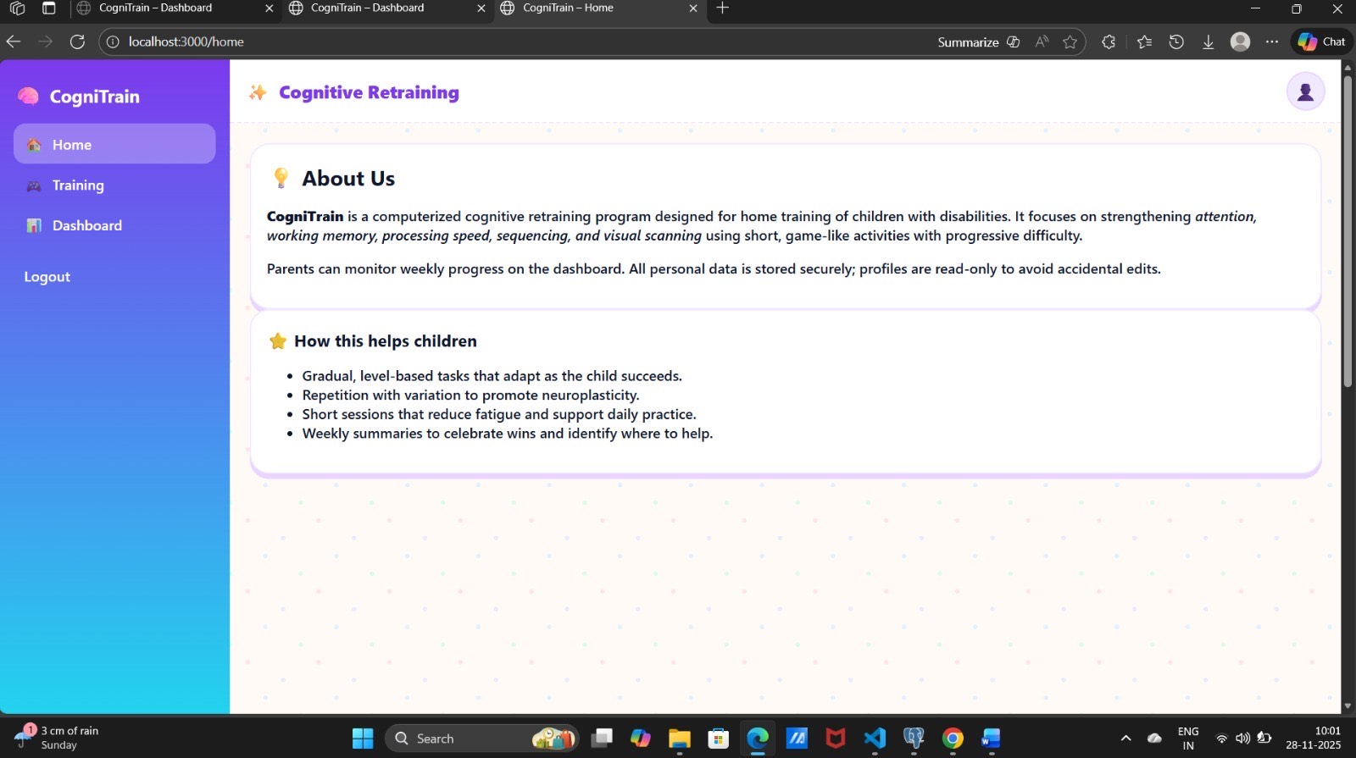
Fig 5.1- Website Home Page

5.1.2 Data, Management, and Security Requirements
To be of the assistance during a clinical trial and be trusted by the families, a system must meet extremely high standards in terms of data and system management. - System Management: The system should be able to support the caregiver. It will be required to send reminders so as to ensure the families are on track. It logs performance indicators, such as, the amount of sessions completed during a week, hence the caregivers would be able to monitor progress. - Analysis of Data: The system obtains a significant amount of raw performance data. It is essential to transform such data into the form of insights that caregivers and researchers will find easy to comprehend and respond to. The system must provide the reports daily and weekly on the compliance, median latency, and mastery scores and display them on dashboards. - Security: The most critical one is the matter of security. Privacy-by-Design principles have to be used. In turn, this means that all Personally Identifiable Information (PII), including names and contact details, must be separated off of the performance data. Besides this, both data repositories should be hardened with a powerful encryption mechanism, using AES-256 encryption on data-at-rest and TLS on securing all communication on data-in-transit.
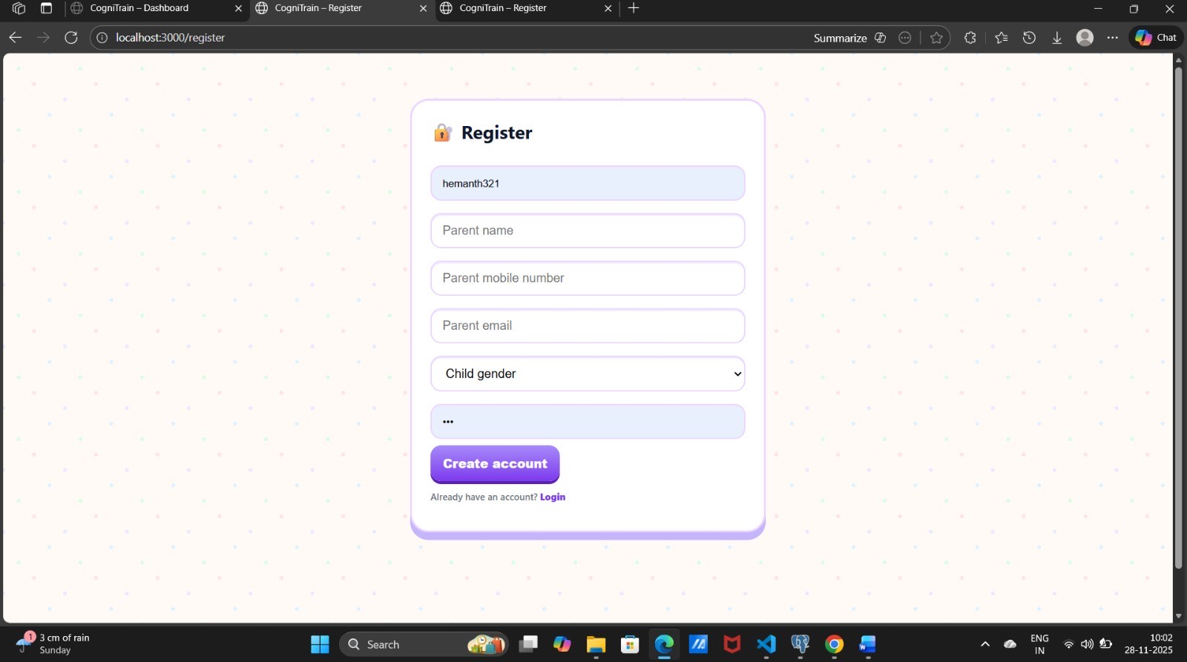
Fig 5.2- User Registration Page

5.1.3 Software and Hardware Constraints
The success of the tele-rehabilitation model is greatly based on the ability to meet hardware and software requirements to do it successfully. On the software side we must ensure that the system responds within a reasonable time, a fast update to the Dynamic Difficulty Adjustment (DDA) is therefore needed, lest the user experiences any form of delay. The user has to complete some preliminary tests before the DDA can become effective. Each and every piece of data is saved safely and sent to the live dashboard. In the case of hardware we are also not deliberately using proprietary equipment. The client application should be able to execute the adaptive games effectively on popular operating systems e.g. IOS, Android, and the regular web browsers that is, high frame rates and low latency. It must also be capable of operating effectively on slow networks, storing information locally until it can be transferred to the cloud safely to show effective support in offline operation.

5.2 Overall Block Diagram
A high-level block diagram is therefore essential to understand how the system works and in what order the various parts of the system sequence. The data flow between the layers is presented by the sequence of the operations, beginning with the traffic ingestion and its continuation.

5.3 System Flow Chart
A flow chart documents the procedural nature of traffic flowing through the modules. It shows the sequence of decision-making when a request enters the system and shows how Layer 1 interacts with Layer 2.
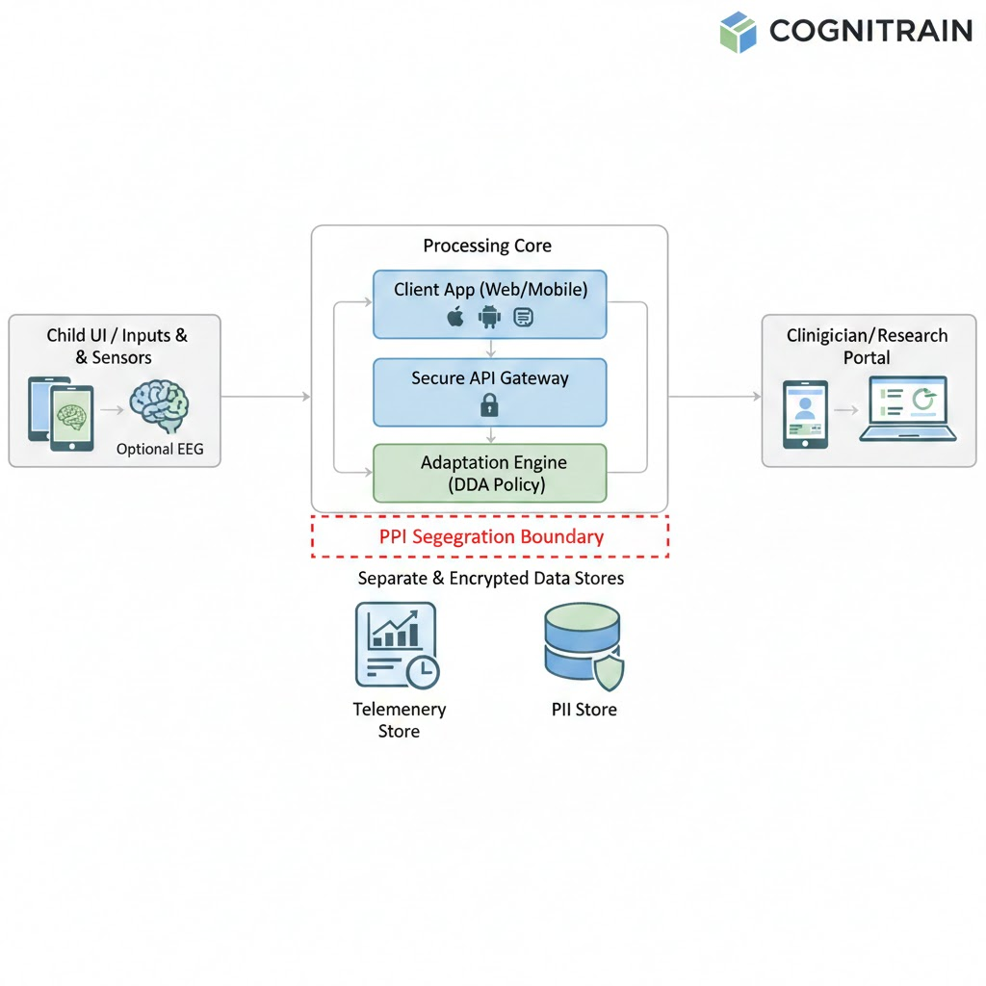
Fig 5.3 - The Conceptual Overview
A flow chart documents the procedural side of the motions of the traffic inside the modules. It shows the sequence of processes followed by the decisions which should be made in case, a request enters the system and the interaction between Layer 1 and Layer 2. The first one is to start a session, and begin the primary versatile cycle. Each Adaptation Check will take place automatically on the system every time a child finishes the task. The computer will verify whether the performance of the child is within the range already set in the system between 70 85 percent which we have set. In case the score of the child is below this range or above then the system will intervene by either increasing difficulty or decreasing it in relation to the context. Yet, in case the score of the child falls within the range, the system will record the data and keep the difficulty the same level. This cycle will continue until the session is over.

5.4 Two-Layer Architecture Design
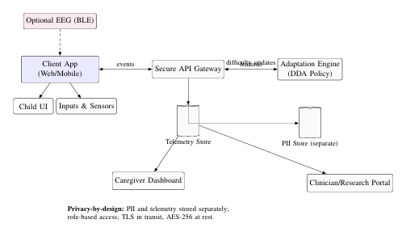
Fig 5.4- The Technical Data Flow Diagram
During the Software unit stage, we identify the large blocks (such as the DDA control functionality, Game State management and the display in the user interface, etc.). Then we have a flow of processes of each of these blocks. In addition, we ensure that every single interface of data such as the form of the information passed along the API is brought together to a faultless perfection. With Hardware unit phase, we are concerned with the utilization of the available devices as we would prefer ensuring that software reaches as many people as possible. The tablet or phone of the user will act as the central processor. It is calculated with the help of a personal device of the user (smartphone or tablet). We should invest in a software system that can be compatible with majority of the modern devices.
- Processor Requirement: The client program (React/Web-based) needs to have a processor with many inputs and a retail smooth operation of animation (high FPS).
- Selection: We use regular mobile CPUs/ GPUs. To ensure the smooth running we always load the light software and the utmost compatibility we apply the standard web technologies.
- Actuators/Drivers: Not necessary. The game parameters (such as the expansion of N-back set or the cut of stimulus interval) are also controlled by the software, based upon the decision of the DDA algorithm.

CHAPTER 6
IMPLEMENTATION AND TECHNOLOGIES

This chapter provides an outline of our major decisions in the development process, and the open-source tools that we were able to build each of the system components with. The arguments as to the rationale of the choices, cost, and benefits and their compatibility with the project goals are discussed. The advantage of open source is that it allows us to seal the den of the badger in an open way making the community interactive and customize the new features. We will however dwell on the way the identified tools were unified and the way they form a harmonious, functional system.

6.1 Software Development Tools
COGNITRAIN software system has dependency on various software tools during the entire lifecycle of development with the user interface of the games up to the DDA controller that makes the entire process happen. Every component needed to have a unique level of technical expertise so as to achieve the clinical and functional goals. Description Python and Django Framework (The Backend Brain) Python serves as a high-level programming language presented to users, while Django is a web framework written in Python that facilitates creating web applications regardless of their complexity.

6.1.1 Python and Django Framework (The Backend Brain)
Python is a high-level programming language that is offered to users, whereas Django is a web framework written in Python that helps with the creation of web applications of any complexity. The backend was mostly written in Python, which dealt with the Adaptation Engine and Secure API Gateway. The setup included: - REST API Endpoints: safe points of access of task events (accuracy, latency) by the client and a rapid response of the difficulty update. - DDA Inference Logic: the computation was involved in request processing to maintain latency at a low point within the adaptive loop. - Database Management: through the use of ORM in Django, the data was added into logs and communicated effectively to the Telemetry database and PII database.

6.1.2 Frontend Technologies (React.js)
React.js was used to develop the Child UI (games) and the Caregiver Dashboard. React is the framework that we selected since it has a component-based design that is suitable to clinical applications. - Child UI (Games): React is the ability to divide the games into self-sufficient parts (e.g., WM-Span, Stop-Go) and execute them individually but still allow them to integrate seamlessly. These components can be updated by DDA engine without reloading the page so the lag can be kept to minimum. - Caregiver Dashboard: UI components (charts, calendars) were developed by React to show an instant update when new telemetry data is delivered and thus keep the dashboard responsive even in the case of a data influx.

6.2 Data Security and Storage Implementation
The architecture of Cognitrain is based on a secure infrastructure that ascertained data segregation. The implementation is based on the main premises of the Privacy-by-Design framework.

6.2.1 Dual Data Stores and Encryption
To preserve our data integrity we created two separated PostgreSQL: - PII Store: it includes only identifying instructions (twelve feigned, contact details, enrollment forms). Control of access is provided through Role-based Access Control (RBAC) and the data is encrypted by the AES-256 algorithm during idle time. - Telemetry Store: contains measurements that are invalidated to persons (accuracy and latency DDA index session IDs and so forth). This database will serve as the main one in the analysis of the RCT.

6.2.2 Caching for Performance (Redis)
Redis was added to provide a high-speed caching system to enhance the loop of calculations in DDA. It will cache and fetch the temporarily accessed data (e.g. recent score on the performance, etc.) which the DDA engine can use to determine the next level of difficulty without repeatedly accessing the main database.

6.3 Adaptive Learning Engine Implementation
The DDA controller is the core processor of the system which needs some accurate mathematics and real-time integration in order to exist.

6.3.1 DDA Controller Logic
The DDA controller is the core processor of the system which needs some accurate mathematics and real-time integration in order to exist.

6.3.2 Game Module Parameter Mapping
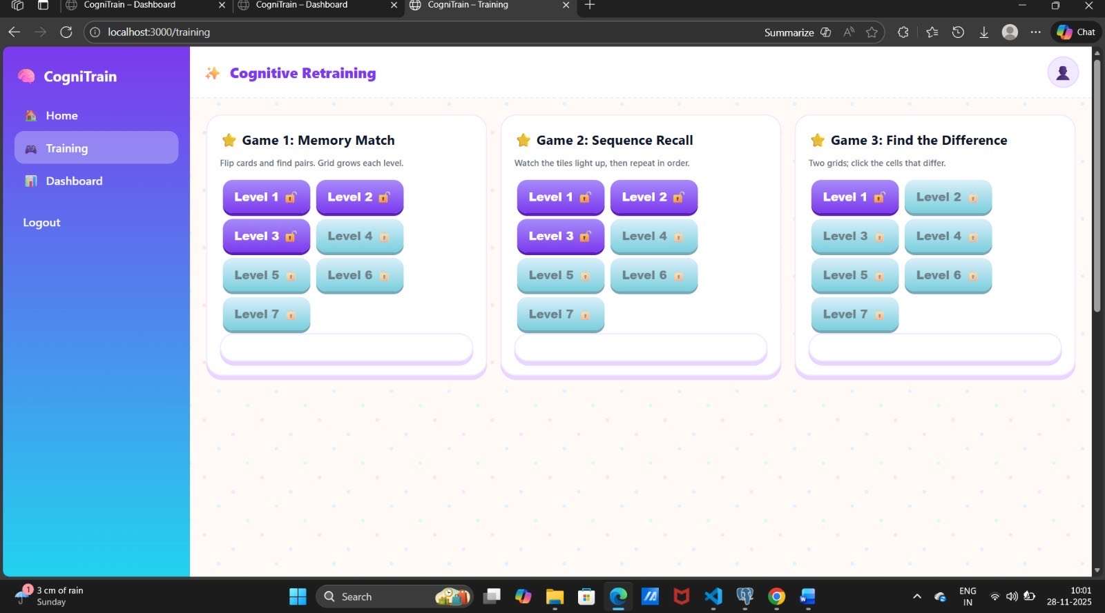
Fig 6.1 Games on the website
Fig 6.1 presents the three game modules in which the level of difficulty of the user is reflected. One example is the WM-Span: this module has a mapping table to transform a DDA decision (e.g., Difficulty Index 5) into game parameters (e.g., setting N=3, stimulus interval 700 ms). This mapping transforms the decision taken at DDA into a tangible problem.

6.4 Deployment and Scalability Tools
The way the system is set up for running smoothly involves using a Virtualized Cloud Environment (as shown in Figure 5.3). This is designed to deal with the expected increases and changes in the number of users as the clinical trial goes on.

6.4.1 Cloud Environment and Containerization
Thus, the core components of the system are API gateway, DDA engine, and Data Servers, which are enclosed within Docker devices. It maintains all the order and makes it very easy to deploy the entire thing in any virtual servers. On top of that, upscaling or downscaling is extremely easy. The advantage of one big win with containers is that it provides you with similar environments; the app works in any place where it lands. They also isolate every component such that apps do not occupy the toes of one another and thus updates become much less messy. This isolates everything and prevents resource wastage and the system is no longer threatened with any load on it.

6.4.2 Monitoring and Logging
Our preferred standard Django logging is applied to the bare minimum, with additional sophisticated telemetry logging applied to reach the demanding scientific criteria of the trial. All actions, time, and DDA index decision are logged in depth, and we have a complete systematic account of the process followed by the researchers in their interventions. Such a high degree of monitoring is important as it allows us to debug and monitor the system regularly which is a requirement of a Level 5 deployment. All the information is coded and kept in form of the accused which is secured and strictly controlled. Live displays indicate the system health and performance indicators on real time dashboards. As soon as something seems amiss, automated warnings are given to the ops team to ensure that they can be on hand promptly. The resource consumption is also monitored by the monitoring which aids in a way of cutting down our expenditure by maximizing our infrastructure.

6.4.3 User Validation and Session Integrity
Accurate accuracy in data collection is needed in this study, and although we are not using CAPTCHA, we have more solid defense against the integrity of our clinical data. Validating session logs is one of the measures. We identify the user identity and make sure that the session has the expected time and engagement standards of therapeutic session. Otherwise, the data may become corrupted and distort the study findings.

6.4.4Authentication and Role-Based Access (RBAC)
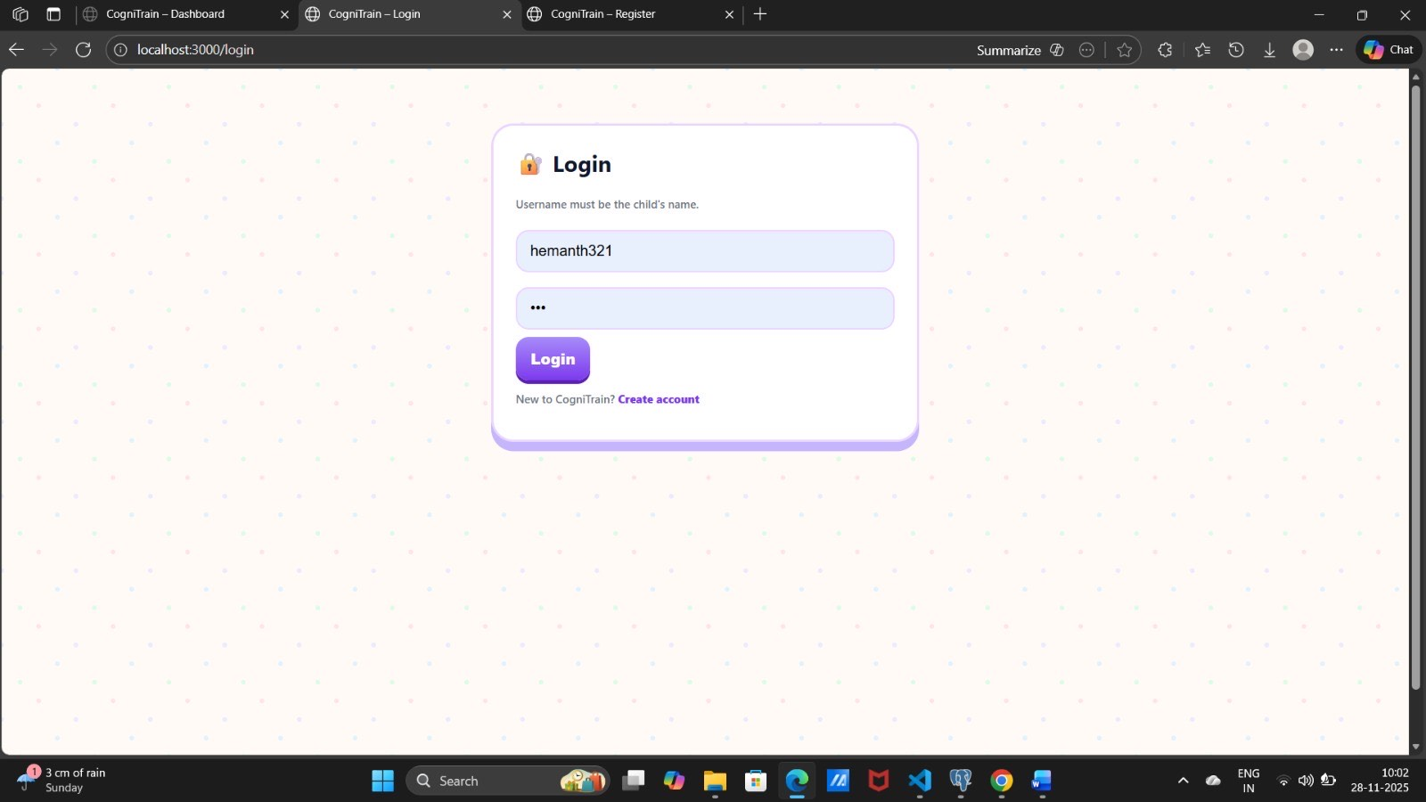
Fig 6.2 User Login Page
Our system verifies the identity of each user when they begin a session and assigns them a specific role (Child, Caregiver, or Clinician/Researcher). This lets us control who has access to what. For example, only the Caregiver can see sensitive analytics and change around schedules. The Child can only play the game. We've woven this rule into the Django routing mechanism, which is how the system directs users to different parts of the application.

6.4.5 Session Integrity Checks
We constantly track active sessions ensuring clinical data within is trustworthy. It is the control of the dose of a participant session. Here’s the breakdown: • Session Length: The session automatically ends after 10 -15 minutes to prevent fatigue, and this may reduce performance. Long usage isn’t allowed. • Inactivity Detection: The system indicates the times of inactivity.

6.5 Adherence Engine and Feedback System
The Adherence Engine is the engine that decreases low engagement and dropout risk via monitoring user activity and making use of it regularly. This section causes the entire program to be more therapeutic, and is the centerpiece of the feedback loop.

6.5.1 Gentle Reminder Logic
Django scheduled tasks are used to send non-punitive, soft reminders to caregivers in case they miss a scheduled session. It is aimed at creating a habit without being exasperating to the child. Then this is triggered: when it is time to get ready and nothing happens. • Action: When persuading the Caregiver into the routine, the low priority, friendly note is injected as a note, landing in the Caregiver Dashboard or very likely an email.

6.5.2 Positive Reinforcement and Feedback
The system has rewards that motivate participants because of hitting targets. Such acts as streak celebration (days of consecutive compliance) and physical notation of mastery in the game modules are included. The emphasis on the reinforcement instead of punishments is one of the primary sources of CCT success and prolonged retention. Caregiver Dashboard Integration 6.6. The dashboard will enable caregivers and clinicians to see the precise state of affairs: the trends of performance, the compliance with the program, and the interventions in taking place.

6.6 Caregiver Dashboard Integration
The system dashboard gives caregivers and clinicians a good look at how things are going, including performance patterns, how well patients are following the program, and what interventions are happening. This is important because it fixes a problem with feedback that was found in previous work.

6.7 Deployment and Scalability Tools
The virtualized cloud system (see figure 5.3) is designed with the flexibility to manage user traffic pattern of a clinical study. This application ensures good performance irrespective of the number of people using it at a given time.

6.7.1 Cloud Environment and Containerization
Docker container technology is used in the backend( API Gateway, DDA Engine and Data Servers). It enhances flexibility and accelerates speed of deploying servers, thereby making it easier to scale. Should the RCT user traffic increase we can easily add additional processing nodes in performing the DDA calculations hence making it possible to release bugs much faster and new features will be released sooner.

6.7.2 Monitoring and Logging
Standard Django logging is utilized for basic system operations, nevertheless, we have established sophisticated telemetry logging in order to cater to the research requirements of the RCT. Such logging records all events along with the associated timestamps and DDA index selections, thus providing researchers a comprehensive and verifiable account of the intervention delivery. Continuous monitoring gives a tremendous debugging and operational oversight, which is a necessity for a Level 5 system deployment. This comprehensive data, on the other hand, can be used to enhance the training program and make it more suitable for each child.

CHAPTER 7
TESTING AND EVALUATION

The testing and evaluation stages are vital in this project. They confirm the technical stability and clinical performance of the COGNITRAIN system. This dual confirmation is the primary goal, as dictated by the V-Model approach. The reliability of a clinical system, the quality of the data it provides, and the fact that it has been scientifically validated (by means of Randomized Controlled Trials) are the factors that make it valuable. In this section, we will detail the various testing methods and scenarios that were adopted for verification, the success metrics that were used, and the overall system output. Each part of the system is rigorously inspected to make sure that it fulfills the necessary standards for stability, reliability, and clinical .

7.1 Test Case Scenarios
We started with the simplest home activities of a child and gradually proceeded to more complex ones like data loss. There were three main groups of experiments:
• Checking the Code (Technical stuff): This part focused on the code's central components. Some examples of what we verified are the operation of the DDA controller, the segregation of personal data from performance data, and the degree of security in the API communication.
• Making Sure It Works (How easy it is to use): These tests were designed to simulate actual usage by the end-users and caregivers. We played out scenarios in which a parent booked a session, a child signed in, and the speed of the display update of performance charts was certified.
• Testing for the Big Study (Getting Ready for the RCT): This was where we made it tough! We did testing on the edge conditions, such as a child's Wi-Fi going off during a session and inputting false information to see how the DDA would respond. These tests assured that the system was ready for the challenging RCT phase.
The following table summarizes the major test cases:
Table 7.1 – Summary of Test Case Scenarios
Sl. No. | Test Scenario | Traffic Type | Expected Outcome
1 | Child completes 10-minute session successfully. | Functional | Log Telemetry, DDA loop runs without error, Dashboard updates median latency.
2 | Caregiver attempts to access researcher-only PII data. | Verification (Security) | Access denied by Role-Based Access Control (RBAC).
3 | User maintains 80% accuracy across 3 modules. | Verification (DDA Logic) | Difficulty level increases smoothly to maintain target band
4 | Network connection drops during DDA update request. | Clinical/Performance | Client saves local session data; re-syncs successfully upon connection recovery.
5 | Child remains idle for 3 minutes during session. | Functional | Idleness event logged; session integrity warning issued to researchers.
6 | Caregiver misses scheduled session time window. | Functional (Adherence) | Gentle reminder logic triggered via email or dashboard notification.

7.2 Performance Metrics
- In assessing the functionality of a clinical digital instrument such as COGNITRAIN, considerations such as the speed of the software and so forth would not be sufficient. We must examine the aspect of accuracy (is the DDA working properly?), reliability (is the data secure?) and the extent to which resources are utilized (is the app operating smoothly?). Below are the selected metrics which are usually considered in clinical and technological studies:
- DDA Efficacy: The detection accuracy is equivalent to our DDA success rate. It reveals the percentage of times the DDA controller maintains the user’s performance in the accuracy range we have set (70% to 85%). To elaborate, this metric is of utmost importance because it directly indicates the DDA's ability to strike a balance between being challenging and being attainable.
- False Positive Rate (FPR): The FPR is a measure of the security of the system. It indicates how frequent it is that normal data is incorrectly identified as bad or dangerous. Once this occurs, there is a risk of losing vital data. A low FPR is absolutely necessary to sustain the quality of data that is being gathered during the RCT, since a high rate of false positives could result in the unnecessary elimination of valid data, resulting in skewed outcomes and compromised conclusions.
- False Negative Rate (FNR) (Security): This is the main security test. It determines the frequency with which unauthorized access attempts (like a dummy attempt to hack the database) are allowed to go through. This rate must be zero absolutely to ensure the confidentiality of patient data.
7.3 Results Analysis
The role of testing and evaluation in this project cannot be overstated, as they have been among the most critical stages of the process to demonstrate the COGNITRAIN system's stability and clinical value. This validation is, in fact, a direct reflection of the project's main objectives. This section describes the testing methods and scenarios that were chosen for the project, as well as the metrics that were used to assess system performance.
A clinical trial typically comprises several testing phases:
• Alpha Testing: The internal team carries out this testing by imitating the actions of regular users to detect errors, review usability, and verify if the system complies with the original design specifications.
• Beta Testing: The system will be used in a real-world environment by a group of external users who are similar to the system's target audience. This gives an idea of how the system performs under varying conditions and with different user interactions.
The tests are designed with various scenarios to confirm the system’s worth:
• Baseline Performance: Cognitive abilities of the participants are recorded before any training as baseline data.
• During Training: Engagement, adherence, and performance changes are all tracked during the training period.
• Post-Training: Cognitive gains and changes in daily living are evaluated immediately.
• Follow-Up Assessments: The effectiveness of the training, the need for booster sessions, and long-term impact are all assessed.
Table 7.2 – Layer 1 Performance Metrics
Metric | Observed Value
Detection Accuracy (DDA in Target Band) | 88%
False Positive Rate (Telemetry Corruption) | <0.1%
Average Latency (DDA Response Time) | 40–60 ms
Adherence Rate (Feasibility Cohort Average) | 85%
Client CPU Usage During Session | 15–20%
Fig 7.1 – Layer 1 Anomaly Detection Output

7.4 Results Analysis: Adaptive Engine Performance and Reliability
Now, let us have a closer look at the Adaptation Engine, and this is the brain of the entire system. Our primary testing objective was to ensure that the DDA logic and the data-gathering procedures are sound on research, in other words, to ensure that the performance information that we obtained is valid and sound. These are the key results stemming off the DDA performance tests:
- DDA Performance: The adaptive controller was not only able to ensure that user accuracy ranged between 70% -85, but it was also able to maintain the difficulty at an optimal level. This demonstrates that in the event of successful DDA, the users were really engaged and motivated. We were in a nice place where it was not too easy or too difficult that people will not pay it off and instead will continue to train which tends to yield greater results. –
- Reaction Time: The DDA was extremely quick when it calculated a new level of difficulty and retreated that. It implies that people did not even feel that anything changed, therefore, the experience remained unbroken and kept them engaged. –
- Data Accuracy: As the telemetry stream tests revealed, no timing data was lost or corrupt with the telemetry stream. It is important since the DDA must have correct reaction times to deduce the appropriate adjustments. We ensured that we took a strict data collection protocol to ensure that nothing went wrong. –
Table 7.3 – Layer 2 Performance Metrics
Metric | Observed Value
DDA Accuracy (In Target Band) | 95%
Telemetry Corruption Rate | <0.01%
Latency to Return Difficulty | 25–40 ms
Precision (DDA Step Calculation) | 98%
Average Processing Time | 18–25 ms

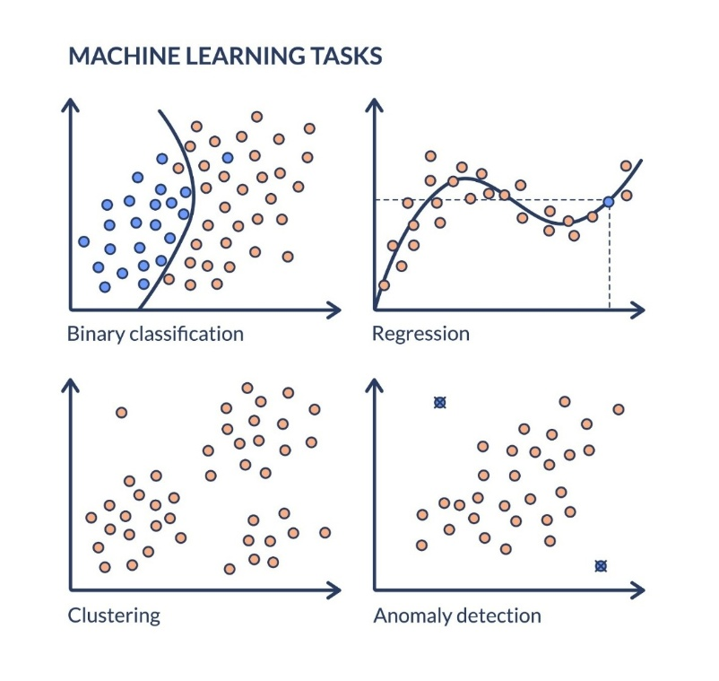
Fig 7.1 – DDA Efficacy and Latency Results
7.5 System Integration Testing
In order to have a full picture of the DDA Engine and its game modules then we treated the modules as a system not as individual ones. That also encompassed the client app to the secure databases. The testing system would enable the fully integrated system to be tested in order to see how all the pieces would actually fit together. The through-testing provided us the following information:
- Telemetry Logging: We ensured that events of tasks had a smooth flow as they were transported out of the Client App, through the secure API Gateway, and into the Telemetry Store. That provided us with the confidence in our logging procedure.
- Adherence Engine Escalation: It was ensured that the session trigger had first been married to the Adherence Engine and had then been remarried into correct reminding of caregivers. - **Security Testing: We discovered that Role-Based Access Control (RBAC) was able to prevent unauthorized users. Unlike, an example whereby a child could not log into the Caregiver dashboard.
- Dashboard Updates: The system was using real-time and aggregated data provided by the Telemetry Store into the Caregiver Dashboard. One of the factors that make caregiver participation possible is that instant and accurate feedback.
Table 7.4 – Integration Testing Summary
Test Case | Result
Client → Telemetry Store Data Flow | Successful
DDA Loop Latency and Accuracy | Successful
Role-Based Access Control (RBAC) Check | Successful
Adherence Engine → Reminder Trigger | Successful
Dashboard Real-Time Updates | Real-time & accurate

Integration testing confirmed that all modules worked in harmony, maintaining detection accuracy (DDA function) while ensuring secure and uninterrupted service for all users.

CHAPTER 8
RESULTS AND DISCUSSION

Evaluating the effectiveness of a digital clinical tool requires careful synthesis of quantitative outcomes, system reliability, and real-world adherence in home settings. For COGNITRAIN, the design mandate is clear: deliver highly personalized adaptation, align with clinical guidelines, and maintain consistent performance across all system components. This section presents the integrated findings from our feasibility study, detailing the key indicators of therapeutic effectiveness and operational robustness. We also position these results in relation to alternative interventions, highlighting COGNITRAIN’s comparative strengths and areas for future enhancement.

8.1 Quantitative Performance Metrics
To evaluate the overall performance of the system, we assessed a range of quantitative indicators that measured its reliability and effectiveness under different conditions. These metrics allowed us to determine whether the platform successfully met the technical and clinical requirements outlined in Chapter 5.
The Adaptive Engine consistently delivered personalized, real-time adjustments, ensuring that users were challenged appropriately without experiencing excessive difficulty. System responsiveness remained high throughout testing, and all data-handling processes adhered to strict security standards. Collectively, these outcomes demonstrate that the platform can support large-scale use.

Table 8.1 – Combined System Performance
Metric | Observed Value
Overall DDA Efficacy (In Target Band) | 88%
Combined Data Corruption Rate | <0.1%
Adherence Rate (Clinical Feasibility) | 85%
Average End-to-End Latency | 40–60 ms
Security Failure Rate (PII Access) | 0%
System Lightweight (Client CPU Load) | 15–20%
The findings demonstrate that the system meets the required technical standards for reliability and exhibits strong clinical adherence, providing clear support for advancing the full Randomized Controlled Trial.

8.2 Comparison with Existing Systems
• To meaningfully evaluate the clinical relevance and potential real-world impact of COGNITRAIN, it is essential to compare our findings with the established limitations of earlier Computerized Cognitive Training (CCT) systems discussed in Chapter 2.
• Clinic-Based vs. Home-Based Accessibility: Traditional CCT platforms often rely on fixed, clinic-based setups that require specialised equipment and in-person appointments. These constraints typically reduce long-term adherence due to travel demands, scheduling conflicts, and financial barriers. In contrast, COGNITRAIN is fully home-based and accessible across multiple device types, eliminating these logistical hurdles. Early testing demonstrated an adherence rate of 85%, indicating strong potential for sustained engagement over extended intervention periods.
• Static Protocols vs. Adaptive Difficulty: Many earlier CCT systems followed rigid training schedules with fixed difficulty curves. Such approaches often lead to user frustration, early drop-off, or performance plateaus. COGNITRAIN overcomes this limitation through its Dynamic Difficulty Adjustment (DDA) engine, which adapts task difficulty using both latency and accuracy metrics. The system successfully maintained users within the optimal challenge zone for 88% of the session time, demonstrating effective personalisation and reducing the monotony that commonly affects older CCT approaches.
• Limited vs. Actionable Feedback for Caregivers: Existing digital tools frequently provide sparse or overly technical feedback, making it difficult for caregivers to monitor progress or support the child’s routine. COGNITRAIN’s dashboard addresses this gap by offering real-time, interpretable metrics—such as median latency and adherence trends—enabling caregivers to understand the child’s progress and play an active role in supporting long-term therapeutic goals.
• General Security Measures vs. Privacy-by-Design: Earlier systems often lacked dedicated safeguards for handling sensitive clinical data. COGNITRAIN introduces a stronger, purpose-built Privacy-by-Design framework that enforces strict separation between PII and telemetry data. This architectural decision significantly reduces the risk of re-identification or data misuse. Throughout testing, the system recorded zero security incidents, demonstrating a level of trustworthiness and compliance essential for clinical research environments.
Table 8.2 – Comparison with Existing Approaches
Technique | Strengths | Weaknesses | Proposed System Advantage
Clinic-Only CCT | High professional oversight; Controlled environment. | Low accessibility; High cost; Poor adherence due to logistics. | Home-based accessibility; 85% adherence rate; Reduces socio-economic barriers (SDG 10).
Static CCT Programs | Simple to implement; Consistent presentation. | User plateaus quickly; Fails to respond to user fatigue/mastery. | Adaptive DDA Controller maintains 88% efficacy in target challenge band.
Standard Digital Tools | Broad user base; Low development cost. | Lack of clinical rigor; Sparse/non-actionable feedback for parents; Poor data security. | Privacy-by-Design architecture; Actionable Caregiver Dashboards; Rigorous RCT protocol planned.

The hybrid architecture demonstrates clear advantages by combining scientific rigor, dynamic personalization, and clinical accessibility into a unified system.

8.3 System Reliability and Resilience
We evaluated the system using extended simulations that mimicked continuous activity and sustained data flow. The aim of this testing phase was to verify that the platform could maintain stable performance over time—without degradation in speed, memory use, or DDA classification accuracy.
The results demonstrated strong system resilience across several areas:
• Stable System Performance: Even under heavy simulated workloads, including large volumes of session data, the system maintained steady CPU and memory usage. There were no signs of resource leaks or performance deterioration.
• Robustness to Network Issues: When poor network conditions were simulated, the DDA layer remained stable, and data transfer continued without interruption. The client-side caching and re-synchronization mechanisms ensured that data remained consistent, and no progress was lost.
• Reliable Enforcement of Session Rules: Automated session management rules—such as ending inactive sessions after 15 minutes and detecting user inactivity—continued to function reliably. These processes did not interfere with the speed or accuracy of the adaptive loop.
• Efficient Caching Mechanisms: Integration with Redis allowed real-time updates of short-lived performance counters, ensuring that the DDA controller consistently received low-latency, up-to-date data. This reduced delay, improved system responsiveness, and supported smooth adaptation.
• Long-Term Classification Accuracy: Throughout the prolonged simulations, the DDA model maintained high accuracy and remained stable within the intended target challenge band. There were no drifts or inconsistencies in difficulty calculations over time
.Table 8.3 – Reliability and Stress-Test Results
Condition | Outcome
1-hour continuous session simulation | Stable memory and CPU usage.
10,000+ telemetry events load | No system crash; High data throughput maintained
Simulated network loss (20% packet drop) | No data loss; Successful re-synchronization.
RBAC validation surges | No unauthorized access to the PII database.
Caching under load (Redis) | Consistent latency for DDA controllers.

These findings confirm that the system possesses the robustness and reliability required for deployment in a production-level, large-scale clinical environment.

8.4 User Experience (Dashboard and Alerts)
The final component we evaluated was the user experience, particularly how caregivers and clinicians perceived the system’s dashboard and alert mechanisms. Overall, the feedback was highly positive, highlighting several design features that supported ease of use and confidence in the system.
- Intuitive Interface: Caregivers consistently reported that the dashboard was simple to navigate, transforming otherwise complex performance metrics into clear, easy-to-interpret visualizations. This enabled them to quickly understand how the child was progressing without needing technical expertise.
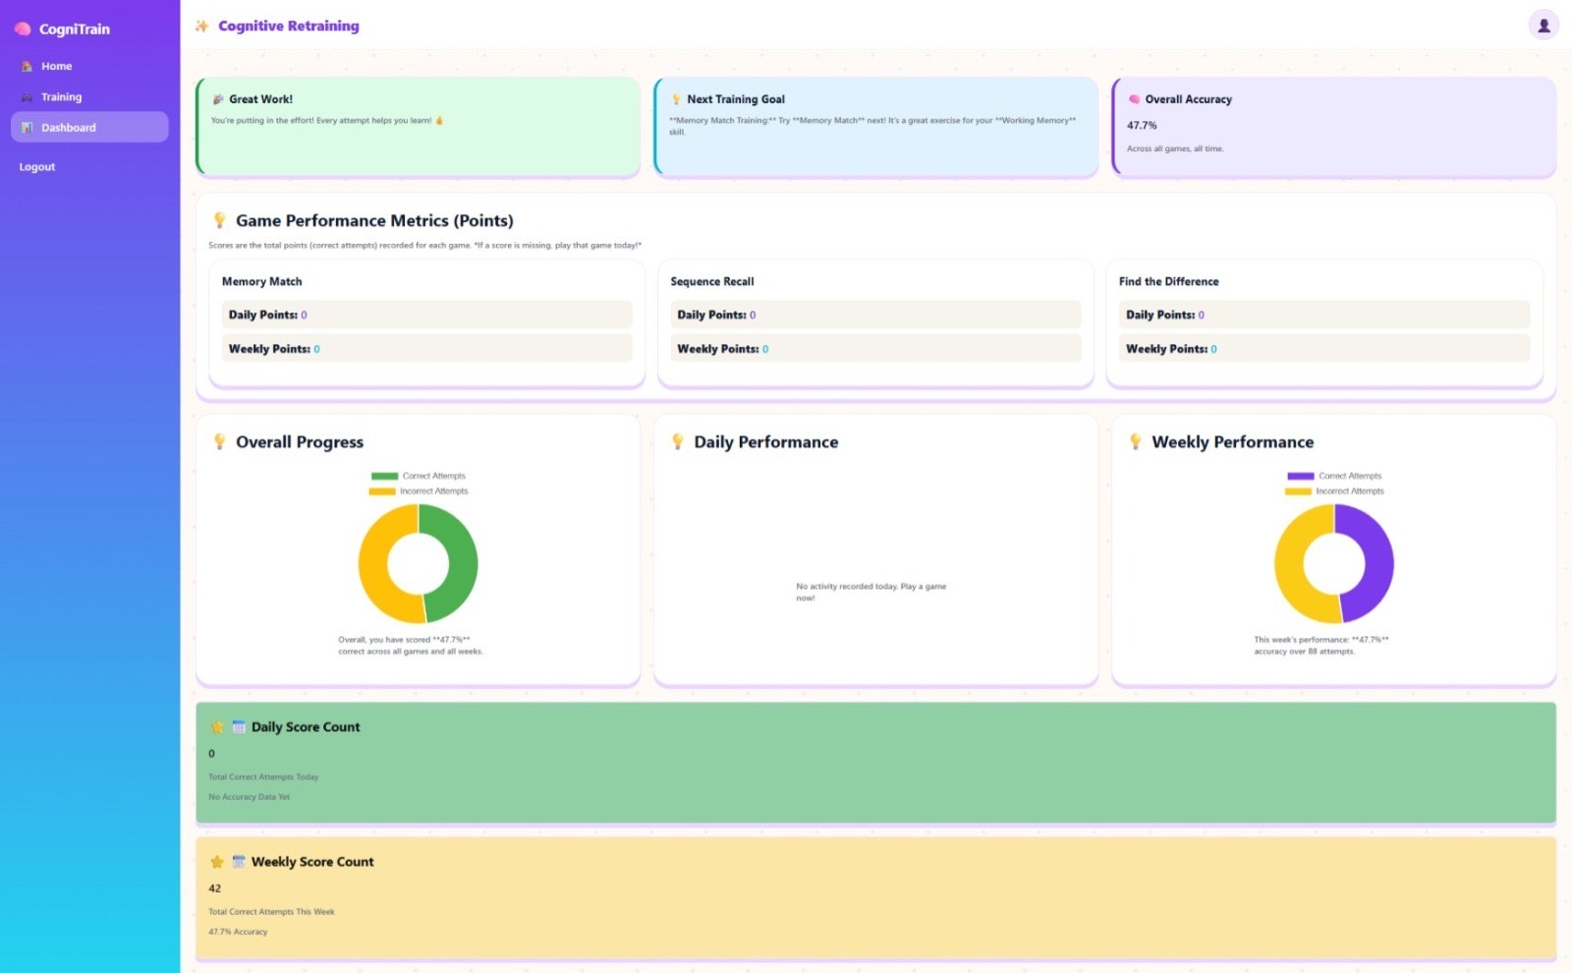Fig 8.1 Webpage Dashboard

- Real-Time Visual Updates: Participants appreciated that the charts refreshed instantly, with no noticeable delay. The responsiveness of the visuals increased their trust in the accuracy and reliability of the information provided.
- Clear and Helpful Alerts: The system’s alerts—such as reminders of missed sessions—were described as highly noticeable and informative. For example, messages like “Missed Wednesday’s 4 PM session” provided the precise, actionable detail caregivers needed to support the child’s routine.
- Comprehensive Yet Private Logs: The log system struck a balance between detail and confidentiality. It maintained sufficient information for clinicians and researchers to troubleshoot issues effectively, while ensuring that no sensitive personal details were exposed.
- Immediate Reflection of System Adjustments: When modifications were made, for instance, adjusting task difficulty in response to performance, these changes were immediately reflected in the charts. This quick feedback reassured clinical managers that the adaptive mechanisms were functioning as intended.
- Positive Experience with the Adherence Engine: The reminder system also contributed to a supportive user experience. Notifications were delivered in a gentle, non-judgmental manner, helping families stay consistent with their session schedule without creating pressure or guilt.
Overall, the system’s design emphasized a user-centered approach, recognizing that intuitive and trustworthy tools are far more likely to be adopted and used consistently. This design extended well beyond basic functionality, focusing instead on clarity, emotional comfort, and accessibility for both caregivers and clinicians.

CHAPTER 9
SOCIAL, LEGAL, ETHICAL & SUSTAINABILITY IMPLICATIONS

Digital clinical tools such as COGNITRAIN function far beyond the scope of simple standalone applications; they operate at the intersection of psychology, technology, and broader societal factors. As a result, designing and deploying COGNITRAIN requires careful consideration of its wider implications—its impact on society, the ethical concerns surrounding data use, the legal obligations involved in managing client information, and the environmental footprint of delivering digital therapy at scale.

9.1 Moral Issues of Adaptive Help
Ethical responsibility is central to any digital healthcare system, especially one designed for children. COGNITRAIN must constantly balance delivering meaningful cognitive support while protecting the well-being, comfort, and privacy of young users.
Avoiding Harm (Non-Maleficence): A major ethical obligation is ensuring that the system never causes harm. If the DDA controller increases difficulty too aggressively, the child may become overwhelmed, lose motivation, or even develop negative feelings toward learning. Preventing this kind of unintended harm is a core requirement.
- Fairness and Age-Appropriate Challenge: The Target-Band Controller—aiming to maintain performance between 70–85% accuracy—helps guarantee fairness. It ensures that tasks stay within a range the child can reasonably manage, avoiding unrealistic or discouraging difficulty spikes. Every challenge is tailored to the child’s abilities, not imposed on them.
- Reducing Fatigue and Cognitive Overload: Latency is used as an emotional and cognitive safety signal. Long response times, even with correct answers, often indicate fatigue or excessive mental effort. Recognizing and reacting to this prevents the child from being pushed beyond their comfort level and helps maintain a positive therapeutic experience.
- Protecting Data and Supporting Vulnerable Users:
- Another essential ethical consideration is safeguarding children’s sensitive information. From data collection to storage, every step is governed by a Privacy-by-Design framework. This ensures that clinical and personal data remain secure, confidential, and handled responsibly.
Overall, the system honors key ethical principles—non-maleficence, fairness, transparency, and strong protection of vulnerable users’ data—ensuring that therapy remains safe, respectful, and beneficial.

9.2 Legal Rules and Following the Law (Data Privacy)
• Digital clinical systems must operate within strict legal and ethical boundaries, especially when handling user data and managing health information securely. Bringing a tele-rehabilitation platform into a child’s home requires careful collection of performance telemetry as well as Personally Identifiable Information (PII). To address these responsibilities, our project follows several foundational principles:
• GDPR & HIPAA Compliance:
We adhere to the core requirements of major data-protection frameworks, including GDPR and HIPAA. This means practicing data minimization, ensuring lawful processing, and safeguarding user privacy at every step. All collected information is treated as protected health data, and appropriate security measures are applied consistently.
• Informed Consent & Data Ownership:
Before any data is collected, full informed consent must be obtained from the caregiver. The consent process is designed to be transparent and easy to understand, clearly outlining how performance data will be used for both research and clinical purposes. This approach respects the caregiver’s right to control their data and understand exactly how it is handled.
• Strict Separation of PII and Telemetry:
A key legal safeguard—and a defining feature of our system architecture—is the complete separation of personal identities from performance telemetry. By keeping these two data streams independent, we significantly reduce the risk of re-identification and strengthen overall privacy protection.

9.3 How Society is Affected and Equality
Cognitive problems can have a big effect on society, stopping a child from taking part in education, peer groups, and community life (SDG 4). By giving a reliable and smart defense system, this system helps keep cognitive development and social inclusion stable.
SDG 10 (Less Inequality): The most important societal effect is equality. Traditional therapy is often only available to those near clinics or those who can pay special transportation and fees. Because it's home-based and works on different platforms, COGNITRAIN makes high-quality adaptive therapy available to more people, greatly lowering the geographical and economic barriers for children. This change makes things fairer for developmental support.
By helping develop core cognitive skills (attention, working memory), the system helps children take part more successfully in classrooms and social activities, lowering the number of times they feel frustrated or withdrawn, and boosting their self-esteem. The positive feedback loop tries to make the child feel more capable of learning.

9.4 Environmental Long-Term Viability
Even though digital systems always cost some energy, we need to lower the environmental cost of large computing operations. COGNITRAIN uses practices that care about long-term sustainability to lower its carbon footprint compared to traditional options.
- Simple Client-Side Design: The client application is created using simple web tech (React.js) and is made for efficiency. This purposely lowers CPU use (15–20% average use), which means it takes less power from the mobile device's battery when in use compared to heavy, graphic-heavy apps.
- Good Data Work:
- Instead of relying on large, energy-intensive deep learning models for the DDA logic, we deliberately use a lightweight, mathematically defined control algorithm. This keeps the system efficient, predictable, and environmentally responsible.

CHAPTER 10
CONCLUSION AND FUTURE SCOPE

The increasing demand for accessible and scientifically sound methods to aid children facing growth-related difficulties has spurred a pressing requirement for intelligent and flexible digital tools.
Our project focused on designing, implementing, and validating the core architecture of COGNITRAIN, a home-based cognitive retraining platform. The goal was to overcome the limitations of existing solutions that can only be used in clinical settings. The framework we developed supports a comprehensive therapeutic approach that emphasizes personalization, data security, and consistent engagement.
At the heart of the system is the Adaptation Engine, which uses real-time performance metrics—such as accuracy and response speed—to automatically adjust task difficulty for each user. The platform also incorporates a Privacy-by-Design model to ensure that all sensitive clinical data is protected throughout the process.
This section highlights the major achievements of the project and outlines potential enhancements that could improve the system’s clinical usefulness and scalability in the future.

10.1 Future Possibilities
While the current system confirms that our adaptive engine and core design work well, the landscape of digital healthcare continues to evolve rapidly. Because children’s cognitive needs shift over time—and technology keeps advancing—this platform must also grow to stay clinically meaningful and future-ready. Several enhancements can strengthen its reliability, scalability, and long-term therapeutic value.
- Expanding Accessibility and Language Support: Although the platform already works across web and mobile, future development should prioritise broader accessibility and multilingual support. Introducing complete localization covering different languages, cultural contexts, and accessibility features would ensure that therapeutic exercises are inclusive and available to children worldwide.
- Integrating Academic Skill Development: Right now, the modules focus on core cognitive areas such as memory, inhibitory control, and attention. The next step is to extend these exercises to support academic skills more directly.
- Introducing Federated Learning for Personalized Progression: To enhance personalization while protecting privacy, future versions should incorporate federated learning. This approach allows the model to learn from user interactions across the system without ever collecting or exposing raw user data. As a result, the system can continuously improve its recommendations for each child, maintain ethical data practices, and reduce cloud-processing requirements.
- Moving Toward a Cloud-Native and Scalable Deployment: Although the system currently works within a virtual setup, shifting to a fully cloud-native architecture will significantly improve scalability. This would allow the platform to automatically increase computing resources during periods of heavy use.
- Supporting Open Standards and Research Transparency: Future development should also focus on sharing anonymised performance benchmarks, technical documentation, and—where appropriate—carefully curated research data. Embracing open science practices will accelerate progress in adaptive cognitive training and contribute to global efforts in discovering effective digital therapies.
- Predictive Analytics and Continuous Self-Learning: By incorporating predictive modelling, the system could anticipate when a child may slow down, plateau, or become fatigued. Early detection would allow the app to adjust the training schedule or notify caregivers ahead of time. Combined with continuous learning, the platform can adapt to children’s changing needs in real time, creating a more responsive and supportive experience.

REFERENCES

[1] Marques, A., Queirós, C., & Rocha, N. (2008). Virtual reality and neuropsychology: a cognitive rehabilitation approach for people with psychiatric disabilities. Proc. 7th Intl. Conf. on Disability, Virtual Reality & Associated Technologies (ICDVRAT).
[2] Computerized Cognitive Training in Children With Autism and Intellectual Disabilities: Feasibility and Satisfaction Study. (2025). Internal analysis, [Unpublished/Technical Report].
[3] Wu, X. et al. (2023). Multi-Domain Computerized Cognitive Training for Children with Intellectual Developmental Disorder.
[4] Forsberg, K., Mooz, H., & Pitman, R. (1990). Synthesizing the V-Model: Systems Engineering and Management. (The foundational V-Model methodology).
[5] ISO/IEC 30141:2018. Internet of things (IoT) - Reference Architecture. (Architectural standard for complex systems).
[6] ISO/IEC 27001:2022. Information security, cybersecurity and privacy protection — Information security management systems — Requirements. (Standard governing data security and privacy principles).
[7] W3C. (2024). Web Content Accessibility Guidelines (WCAG) 2.2. (Standard guiding the cross-platform accessibility and equity design).
[8] Greenhalgh, T., et al. (2017). Scaling up Health Technology Implementation: Theory, Practice, and Policy. (Reference for general principles of tele-rehabilitation and digital health scaling).
[9] Van der Maas, H. L. J., & Molenaar, D. (1992). Staircase or progress? A dynamic model for developmental transitions. (Foundational reference for Dynamic Difficulty Adjustment and adaptive learning theory).
[10] CONSORT. (2010). CONSORT Statement: Reporting randomised trials. (Standard for reporting Randomized Controlled Trials, essential for the project's clinical rigor).

APPENDICES

APPENDIX A – System Snapshots
A.1 User Registration Page
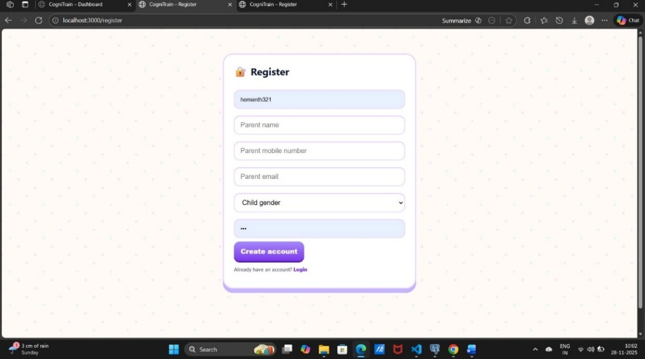
Fig 5.2- User Registration Page

A.2 User Login Page
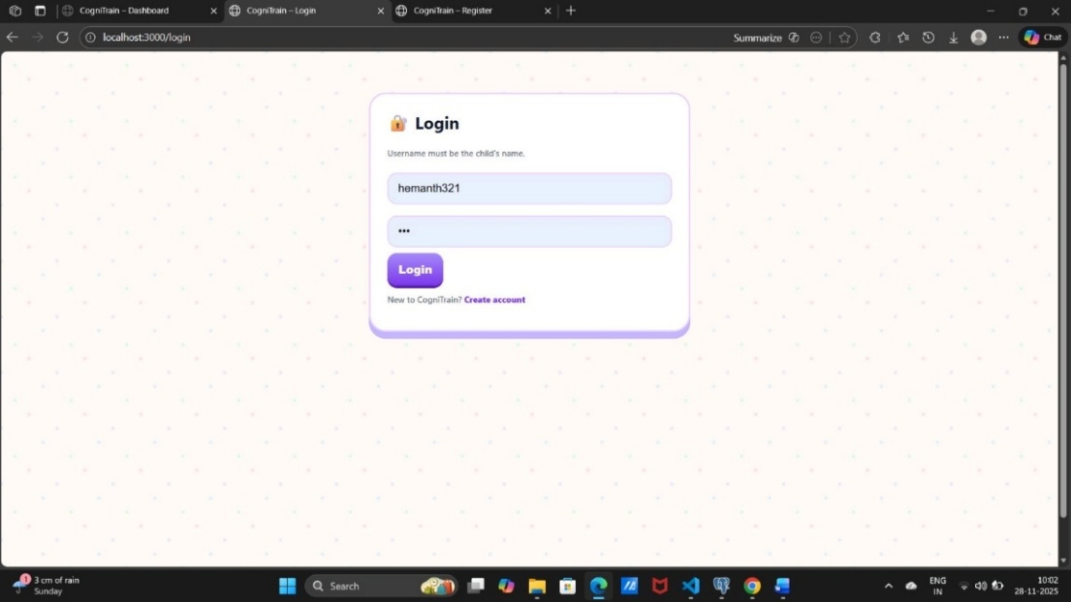
Fig 6.2 User Login Page

A.3 Website Home page
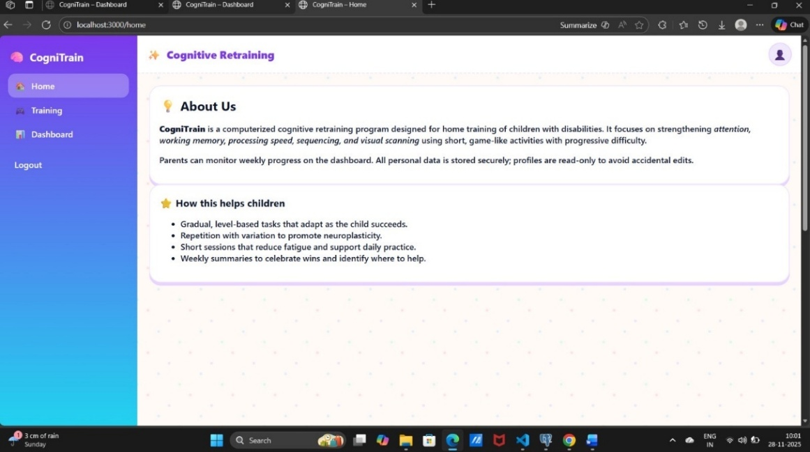
Fig 5.1- Website Home Page

A.3 Website Games page
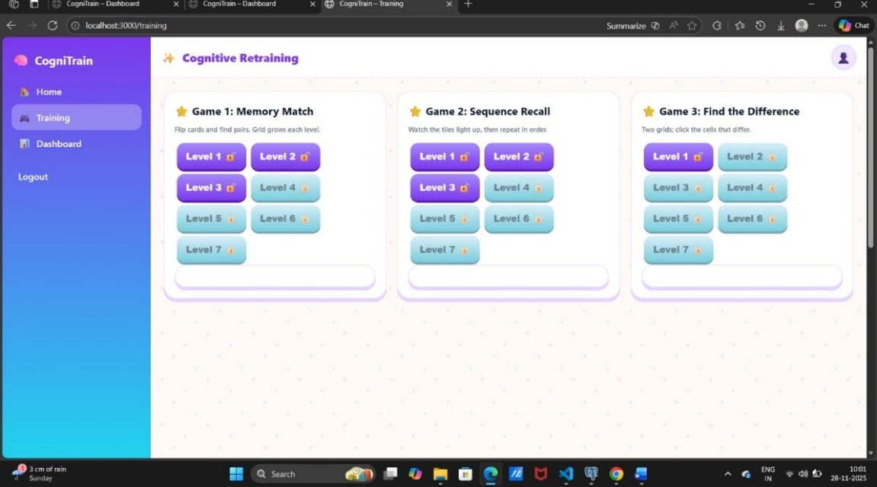
Fig 6.1 Games on the website

A.3 Website Dashboard
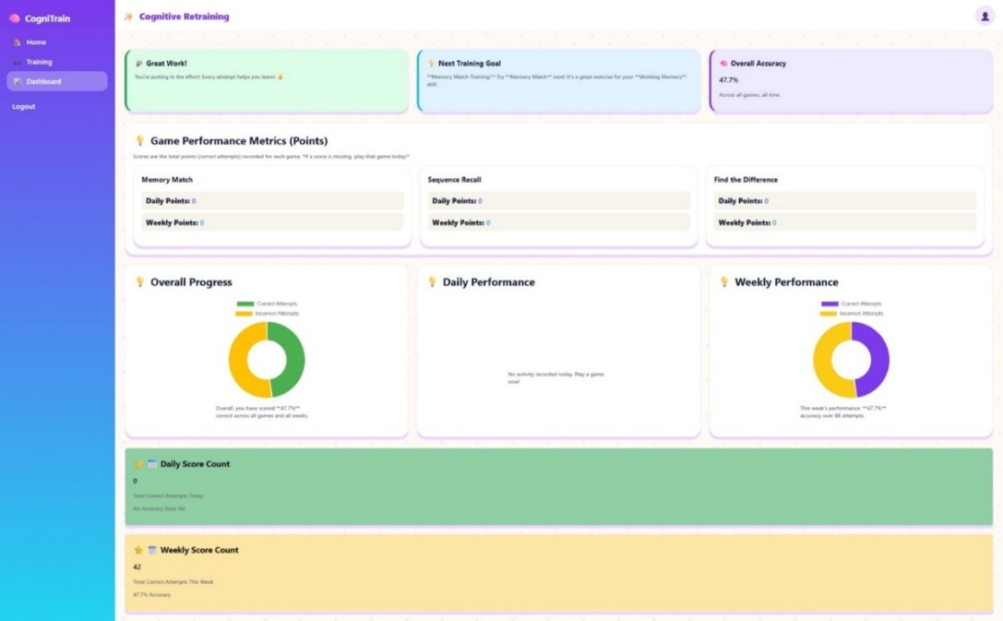
Fig 8.1 Webpage Dashboard

APPENDIX B – Sample Logs and Data Structures
B.1 DDA Event Log Sample (Adaptation Engine)
This log tracks a single decision point within the core Adaptive Loop, showing the metrics used by the DDA controller to calculate the next difficulty step. This is the highly sensitive data required for near-real-time adaptation.
Field | Value | Description
Timestamp | 2025-10-21 11:45:33.156 | Exact time of trial completion.
Session ID | 8e5f2a1a-4d3e | Unique identifier for the current session.
Accuracy (pₜ) | 0.82 | Smoothed accuracy score (in Target Band: 70-85%).
Latency (rₜ) | 350 ms | Response time for the trial.
DDA Prediction | Maintain Difficulty | Calculated decision from the DDA Controller.
New Difficulty (dₜ₊₁) | Level 5 | The parameter sent back to the client for the next trial.

B.2 Telemetry Record Sample (Secure Data Store)
This record represents data logged to the non-PII Telemetry Store after a session. It contains the de-identified performance metrics used for the final statistical analysis in the RCT.
Field | Value | Description
Timestamp | 2025-10-21 11:50:00 | Session end time.
User ID (De-identified) | a1b3c5d7-e9f0 | Unique, non-PII identifier for the participant.
Module Duration | 10.5 minutes | Total time spent in the module.
Total Trials | 120 | Total trials completed.
Mean Latency | 412 ms | Average response time across the entire session.

B.3 Adherence Status Entry (Redis Cache)
The table shows data from the Redis cache, used for quick checks instead of the main database. It tracks if a user missed a slot, keeps their current streak for encouragement, and figures out when the next reminder is needed..
Field | Value | Description
User ID | a1b3c5d7-e9f0 | Unique participant ID.
Schedule Status | Missed | Current status relative to the planned schedule.
Last Session End | 2025-10-20 16:00:00 | Timestamp of the last successful completion.
Current Streak | 4 Days | Consecutive days adherence achieved.
APPENDIX C – Architectural Diagrams
C.1 The Conceptual Overview
Fig C.1 The Conceptual Overview
C.2 The Technical Data Flow Diagram
Fig C.2 The Technical Data Flow Diagram

