Car Dataset Analysis Using Python
1. Introduction

Data analytics plays a crucial role in understanding patterns and extracting meaningful insights from raw data. In this project, we perform an exploratory data analysis (EDA) on a car dataset to understand the factors influencing car prices and performance.

The analysis is carried out using Python libraries such as Pandas, NumPy, and Matplotlib. The objective is to identify trends, relationships, and potential insights that can support decision-making in the automotive domain.

2. Dataset Description

The dataset consists of approximately 11,900 records and multiple features describing different cars.

Key Features:

Make: Car manufacturer (e.g., BMW, Toyota)

Model: Car model name

Year: Manufacturing year

Engine Fuel Type: Type of fuel used

Engine HP: Horsepower of the engine

Engine Cylinders: Number of cylinders

Transmission Type: Automatic or Manual

Driven Wheels: Type of drivetrain

Number of Doors: Number of doors

Market Category: Car category (Luxury, Performance, etc.)

Vehicle Size: Compact, Midsize, Large

Vehicle Style: Sedan, SUV, Coupe, etc.

Highway MPG / City MPG: Fuel efficiency

Popularity: Popularity score

MSRP: Manufacturer Suggested Retail Price

3. Data Cleaning

Data cleaning is an essential step to ensure accuracy and reliability.

Steps Performed:

Removed duplicate records

Handled missing values:

Filled missing Engine HP with mean

Filled missing Engine Cylinders with median

Filled missing Number of Doors with mode

Checked data types and consistency

4. Exploratory Data Analysis (EDA)

EDA was performed to understand the distribution, relationships, and patterns in the dataset.

4.1 Summary Statistics

Basic statistical measures such as mean, median, and standard deviation were calculated.

Observations:

Average car price (MSRP): 4.192593e+04

Maximum horsepower: 1001.000000
Minimum MPG: 7.000000

4.2 Distribution of Car Prices

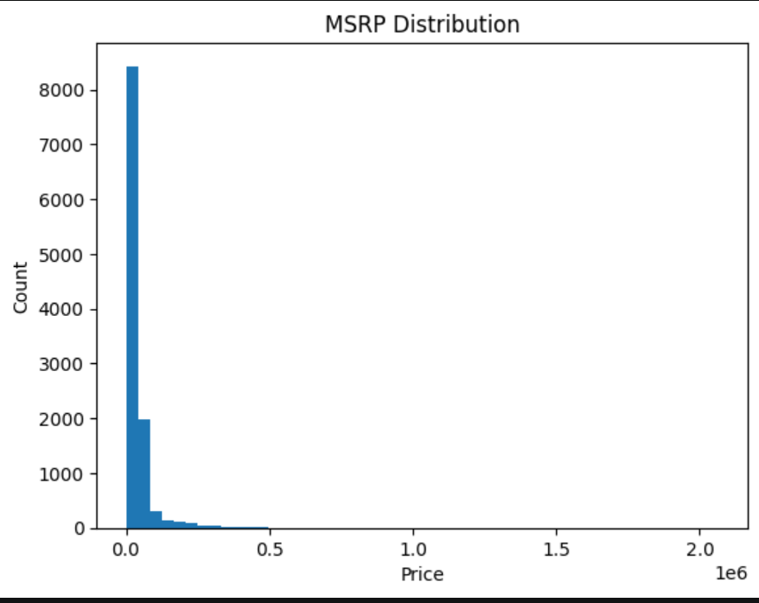
Observation:

The distribution of car prices is right-skewed, indicating that most cars are in the lower to mid-price range, with a few high-end luxury cars.

4.3 Top Car Manufacturers

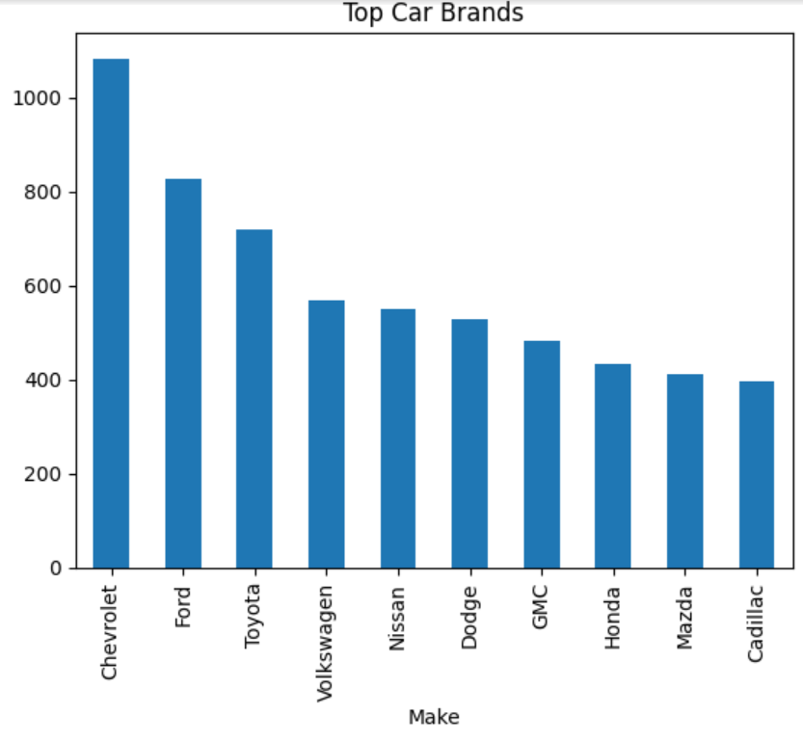
Observation:

Some manufacturers dominate the dataset, indicating higher production or popularity.

4.4 Relationship Between Horsepower and Price

(Insert Scatter Plot Here)

Observation:

There is a positive correlation between engine horsepower and price, suggesting that more powerful cars tend to be more expensive.

4.5 Relationship Between MPG and Horsepower

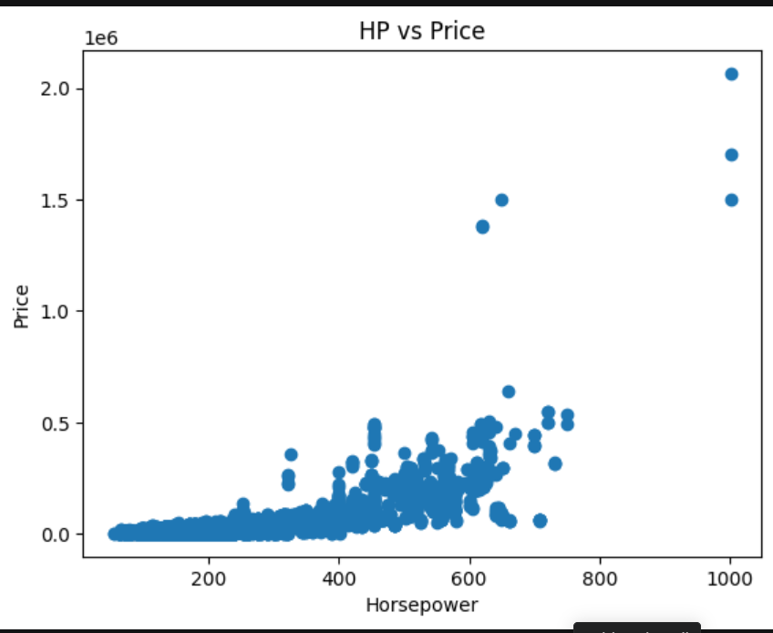
Observation:

An inverse relationship is observed, where cars with higher horsepower tend to have lower fuel efficiency.

4.6 Correlation Analysis

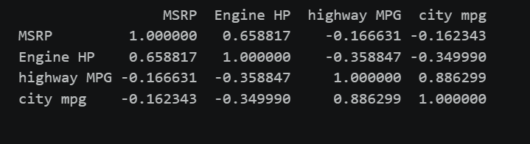
Observation:

MSRP is positively correlated with Engine HP

MPG is negatively correlated with Engine HP

5. Problem Statement

The objective of this analysis is:

To identify the key factors affecting car prices (MSRP) and analyze how engine performance and fuel efficiency influence pricing.

6. Hypotheses

H1: Cars with higher horsepower have higher prices

H2: Cars with better fuel efficiency have lower horsepower

H3: Luxury brands have higher average MSRP

7. Analysis Plan

To address the problem, the following methods will be used:

Data Cleaning and Preprocessing

Descriptive Statistics

Data Visualization using Matplotlib

Correlation Analysis

Grouping and Aggregation (e.g., average price by brand)

8. Limitations

Some missing values may affect accuracy

Dataset may not reflect current market trends

Popularity metric definition is unclear

External factors like brand reputation are not fully captured

9. Conclusion

This exploratory analysis provides insights into the automotive dataset, highlighting key relationships between price, performance, and efficiency. The findings suggest that horsepower significantly impacts price, while fuel efficiency tends to decrease as engine power increases.

Further analysis using advanced techniques such as regression models can provide deeper insights and predictive capabilities.

10. Tools Used

Python

Pandas

NumPy

Matplotlib

