1.UML Class-Diagram for Airline Reservation System:

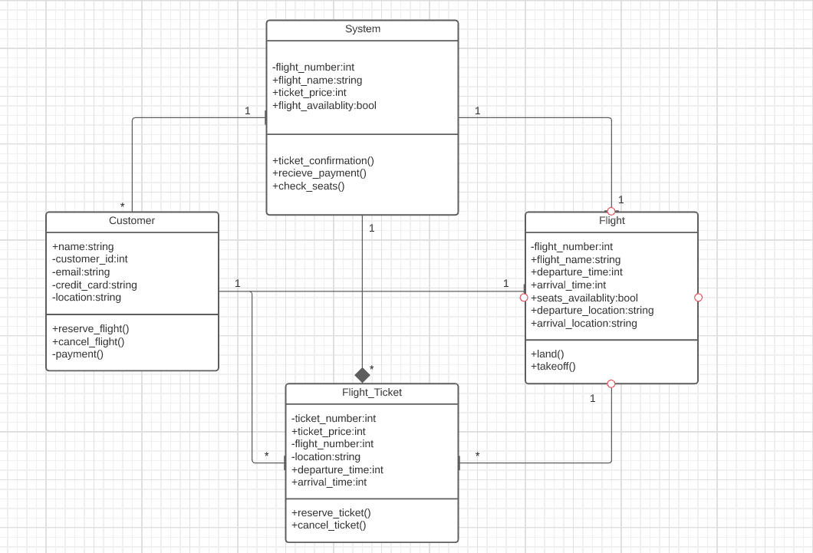

2.UML Class Diagram for University:

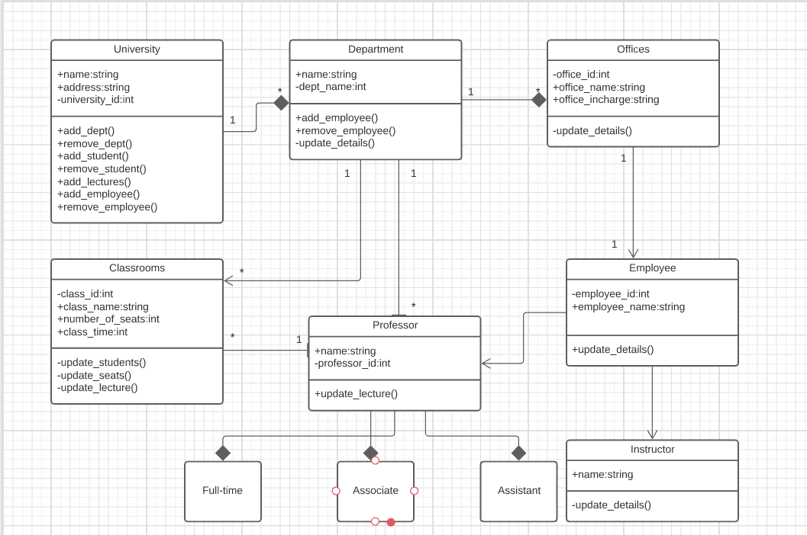

3.UML Activity Diagram:

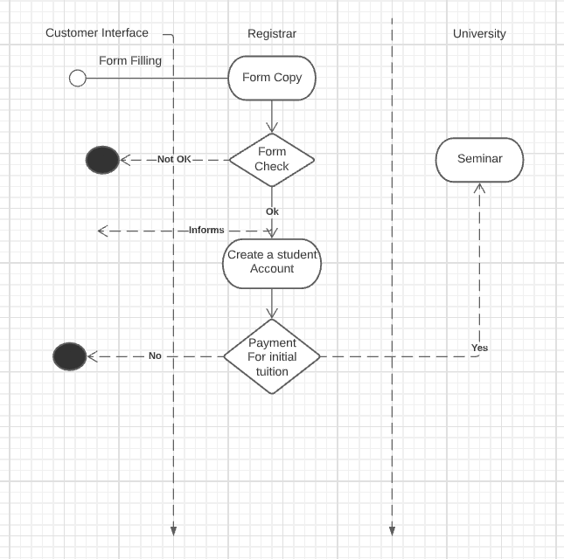4.UML Sequence Diagram for Library System:

