# **Zomato Analysis**

**Objective Questions**:

1. What is the total no. of tables present in the data?

Ans - The workbook contains 4 worksheets. This table is located in the "Raw Data" worksheet and country description, so the total number of tables is **two**.

1. What is the total no. of attributes present in the data?

Ans - The total number of attributes in the cleaned dataset, after creating new columns, is **22**

Steps-

* We hide Cuisines as new column Cusinies_updated is present
* We hide datekey_opening, as new datekey_updated is preset
* We calculate only the attributes or features that are present

1. How many categorical columns are there in the data? [Search about categorical and continuous data, and try to answer this question]

Ans **-** Categorical columns are those with discrete and finite values. In this data,there are **14** categorical columns in the data: RestaurantName, CountryCode, City, Address, Locality, LocalityVerbose,Cuisines_Updated, Currency, Has_Table_booking, Has_Online_delivery, Is_delivering_now, Updated_Datekey_Opening, Switch_to_order_menu, Price_range,Country.

1. The data consists of some inconsistent and missing values so ensure that the data used for further analysis is cleaned.

Ans -

* Format the "DateKey_Opening" Format and added new column Updated_DateKey_Opening. Use a formula **=TEXT(DATEVALUE(SUBSTITUTE(T2,"_","-")),"dd-mm-yyyy")** to correct the date format without creating extra columns.
* Fill in Missing Values in the "Cuisines" Column.Identify and fill in blank spaces with the mode of the "Cuisines" based on the country using formula **=if(ISBLANK(J2),”Mexican”,J2)**.

Explanation:

* The "DateKey_Opening" column had inconsistent formats. While there were multiple ways to address this, such as using the "Text to Columns" feature, I opted for a formula-based approach: **=TEXT(DATEVALUE(SUBSTITUTE(T2,"_","-")),"dd-mm-yyyy")** to convert the dates into the correct format.
* Created a **pivot table with "Cuisines"** in the row and their repetition in value to identify the most frequent cuisine type for that country.Identified "Mexican" as the most common cuisine in the United States and used the formula **=IF(ISBLANK(J2),"Mexican",J2)** to fill the blanks with "Mexican.".
* Sort the cities in increasing order from A to Z

1. Using the LookUp functions, fill up the countries in the original data using the country code.

Ans -

* Used the VLOOKUP function to create a new column, "Country," in the "Raw Data" worksheet by matching the country code with the corresponding country name.

Explanation:

* The "Raw Data" and "Country Description" worksheets both contain a "Country Code" column, which can be used to match data. By using the VLOOKUP function, I successfully created a new "Country" column in the "Raw Data" worksheet
* The formula used is: **=VLOOKUP(C2,'country description'!$A$1:$B$16,2,0)** where C2 is country code

1. Create a table to represent the number of restaurants opened in each country.

Ans - Create a table to represent the number of restaurants opened in each country using a pivot table.

Explanation:

* Step 1: Select all the cells in the "Raw Data" worksheet.
* Step 2: Click on Insert -> Pivot Table and specify the location where you want to insert the pivot table.
* Step 3: Once the pivot table is created, drag the "Country" field into the Rows section.
* Step 4: Drag the "RestaurantID" (or another unique identifier for each restaurant) into the Values section. By default, it might display as a sum, so change it to Counta to get the number of restaurants.

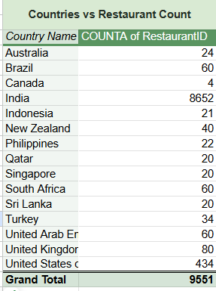

1. Also, the management wants to look at the number of restaurants opened each year, so provide them with something here.

Ans -

* + Extract the Year from Dates. Create a new column that extracts the year from the "DateKey_Opening" using the YEAR function.Use the formula **=left(U2,4)** to extract the year from the "DateKey_Opening" column
  + Use a Pivot Table to represent the number of restaurants opened each year by creating a pivot table.

Explanation:

* + Select all the cells in the "Raw Data" worksheet.
  + Click Insert -> Pivot Table, specify the location where you want to place the pivot table.
  + In the pivot table, drag the "Year" field (from the new column) into the Rows section.
  + Drag the "RestaurantID" (or another unique identifier for each restaurant) into the Values section. By default, it may show as a sum, so change it to Count to display the number of restaurants.

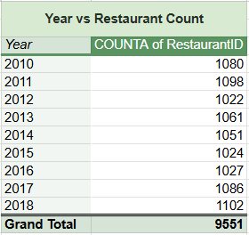

This process will generate a table that shows the number of restaurants opened each year, providing the management with a clear view of yearly restaurant openings.

1. What is the total number of restaurants in India in the price range of 4?

Ans - To determine the total number of restaurants in India with a price range of 4, we use the COUNTIFS function.

Explanation:

* The formula **=COUNTIFS('Raw Data'!$P$2:$P,"4",'Raw Data'!$Z$2:$Z,"India")** counts the rows where column P (price range) is 4 and column Z (country) is "India".
* The result is **388**, indicating there are 388 restaurants in India with a price range of 4.

1. What is the average number of voters for the restaurants in each country according to the data?

Ans - To calculate the average number of voters for restaurants in each country, create a pivot table.

Explanation:

* Select all cells in the "Raw Data" sheet.
* Go to Insert -> Pivot Table, and specify the location for the pivot table.
* Drag "Country" to the Rows section and "Votes" to the Values section. By default, it will show the sum; change this to average.

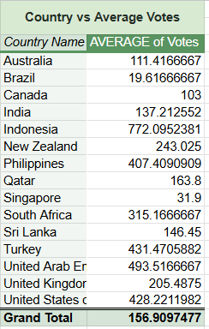

This process will display the average number of votes for restaurants in each country.

1. Calculate the average rating for all the restaurants that have price_range < 4 and provide online delivery. Use only the “IF” function, Logical Operators, and Aggregation functions to solve this problem. **[Note: Don’t use Conditional aggregation in this question.]**

Ans - To calculate the average rating for restaurants with a price range less than 4 and that offer online delivery, use the IF function along with logical operators and aggregation functions.

Explanation

* Using AVERAGE , IF and ARRAYFORMULA
* The formula is **=ARRAYFORMULA(AVERAGE(IF(('Raw Data'!$P:$P<4)*('Raw Data'!$M:$M="Yes"),'Raw Data'!$T:$T)))** where P(Price Range) , M(online_delivery) and T(Rating)

The result is an average rating of **3.27381151** for all restaurants

1. Using Conditional formatting highlight the rows of restaurants that are located in the countries or cities that you’ve suggested to the management for opening new restaurants.

Ans- To highlight the rows of restaurants located in the countries or cities suggested for new restaurant openings, use conditional formatting.

* Select the "RestaurantName" column.
* Go to Home -> Conditional Formatting -> New Rule.
* Choose Use a formula to determine which cells to format.
* Enter the formula: =$AA1="Indonesia", then click Apply and OK.
* And again repeat the same for “Turkey”,”South Africa”, “USA” ,“Sri Lanka” and “Brazil”

1. Create a new customized price column that consists of the abbreviation/symbol of the currency along with the Average_cost_for_two value. [Use string operations to do this task]

Ans -

* Create a new column Price that combines the currency abbreviation/symbol with the "Average_cost_for_two" value, use the following formula **=MID(K3,FIND("(",K3)+1,FIND(")",K3)-FIND("(",K3)-1)&" "&R3**
* This formula extracts the currency symbol from the "Currency" column (K) and combines it with the "Average_cost_for_two" value from column R

1. How can you create an array formula in Excel or Google Sheets to count the number of restaurants listed that do not offer online delivery, are in the lowest price range, and have an average cost for two people less than or equal to 250 Indian Rupees?

Ans -

* Array formula Used:**=ARRAYFORMULA(SUM(('Raw Data'!$M:$M="No") * ('Raw Data'!$P:$P=1) * ('Raw Data'!T:T<=250)))**
* The Result count is 1694

**Subjective Question:**

1. Suggest a few countries where the team can open newer restaurants with lesser competition. Which visualization/technique will you use here to justify the suggestions?

Ans - We analyze the data , based on count of restaurant in each country,average of rating and average cost of two.

The most suitable countries for opening new restaurants are those where:

* The average ratings are higher than 3.9.
* The total number of restaurants is less than 50.
* The average cost of two is less than 820 rupees.

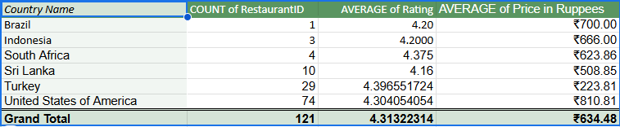

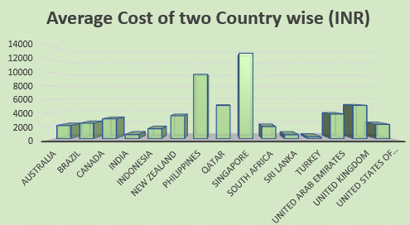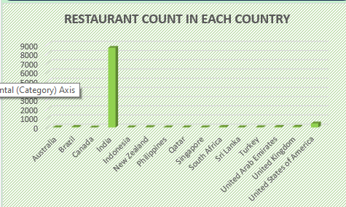

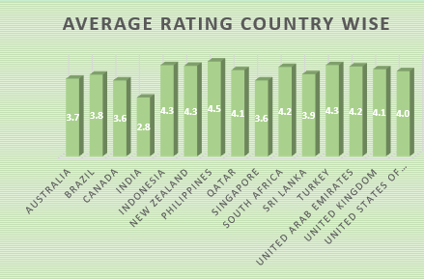

Insights -

* Countries with fewer than 50 restaurants present lower competition, making them ideal for expansion.Brazil, Indonesia, and South Africa have relatively lower restaurant counts
* Higher average ratings (above 3.9) indicate strong customer satisfaction
* Analyzing the "Average Cost for Two" metric helps identify markets where affordability aligns with customer purchasing power.Countries with costs under ₹820, like South Africa and Sri Lanka, indicate a favorable balance between affordability and profitability.

Recommendations -

* Focus on Cost Efficiency: Target locations where the average cost for two is low to maximize profitability.
* Minimize Competition: Prioritize cities with fewer restaurants to establish a strong market presence.
* Enhance Customer Experience: Choose locations with higher average restaurant ratings to attract and retain customers.
* Ideal Expansion Countries: Based on these criteria, Brazil, Indonesia, South Africa, the USA, and Turkey are the most suitable for opening new restaurants.

Conclusion - To Maximize profit , we need to find the location with minimum cost of average person of two and to lower the competition we need to find the city with less number of restaurant count and to enhance the restaurant rating we need to find restaurant with higher ratings.Thus,

Countries that are suitable for opening restaurants are -

* Brazil
* Indonesia
* South Africa
* United States of America
* Turkey

1. Come up with the names of States and cities in the suggested countries suitable for opening restaurants.

Ans- Suitable names of States and cities are as follows

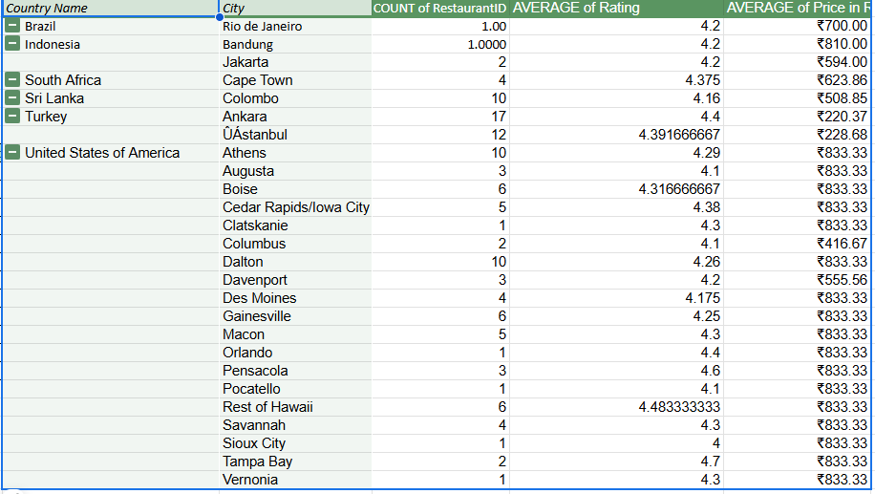

Insights and Recommendations-

* High-Rated & Low-Cost Locations: Cities like Ankara (Turkey) and Columbus (USA) have high average ratings (4.4+), while maintaining low average prices (₹220–₹416), making them prime locations for new restaurant openings.
* Emerging Markets with Less Competition: Cities such as Rio de Janeiro (Brazil), Bandung (Indonesia), and Cape Town (South Africa) have very few restaurants but strong average ratings (above 4.2), indicating a gap in supply and an opportunity for market entry.
* Affordable & Growing Demand Locations: Colombo (Sri Lanka) and Istanbul (Turkey) have relatively low dining costs (₹228–₹508) and decent average ratings, making them suitable for cost-efficient expansion.
* Premium Market Opportunities in the USA: Cities like Tampa Bay, Rest of Hawaii, and Pensacola have the highest average ratings (above 4.4), but higher dining costs (₹833), suggesting potential for premium restaurant chains.
* Strategic Entry Recommendation: Focus on Ankara, Colombo, Jakarta, and Cape Town for cost-efficient expansion, while targeting Tampa Bay, Rest of Hawaii, and Pensacola for premium dining opportunities.

1. According to the countries you suggested, what is the current quality regarding ratings for restaurants that are open there?

Ans -

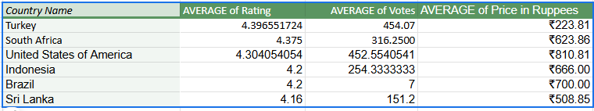

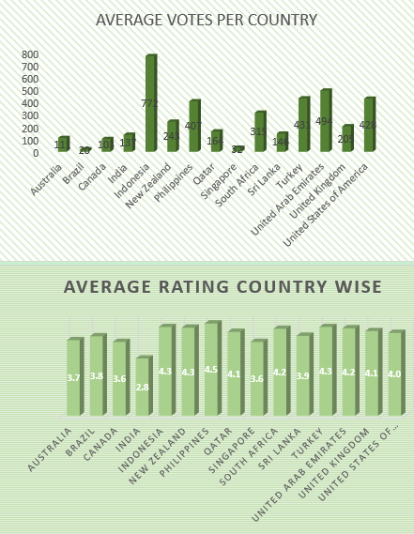

Insights

* High-Quality Dining in Turkey & South Africa: Turkey (4.40) and South Africa (4.38) have the highest average ratings, indicating strong customer satisfaction and potential for high-end or mid-range restaurant expansion.
* Strong Customer Engagement in Turkey & USA: Turkey and the USA have the highest average votes (~450), suggesting an active dining culture and reliable customer feedback, which helps in assessing market demand.
* Affordable Dining in Turkey & Sri Lanka: Turkey (₹223) and Sri Lanka (₹508) have the lowest average dining costs, making them attractive for budget-conscious consumers and potential fast-casual restaurant chains.
* Lower Competition in Brazil: Brazil has a lower average vote count (7), indicating either limited customer engagement or fewer established restaurants, making it a potential untapped market for new entrants.

### Recommendations

* Prioritize Expansion in Turkey & South Africa: Given their high ratings and active dining scene, opening restaurants in these countries can attract loyal customers.
* Target Budget-Friendly Markets: Turkey and Sri Lanka offer the most affordable dining options, making them ideal for cost-conscious expansion strategies.
* Leverage High Engagement in the USA: The USA’s high vote count suggests a strong restaurant review culture, making it an excellent location for premium dining experiences with a focus on quality and marketing.
* Explore Brazil with a Strategic Approach: Due to lower engagement, a strong marketing push and customer education campaigns will be necessary to gain traction in Brazil’s emerging restaurant scene.

1. Also, what is the current expenditure on food in the suggested countries, so we can keep our financial expenditure in control?

Ans - To keep check of our financial expenditure on food on suggested countries we need

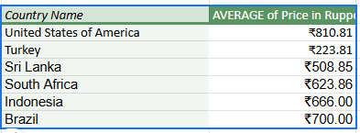

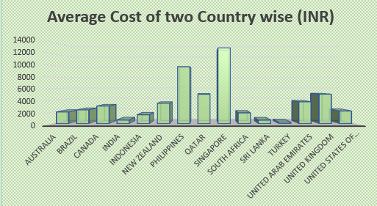

Insights

* Highest Food Expenditure in the USA: The United States has the highest average dining cost (₹810.81), indicating a market suitable for premium restaurants and fine dining experiences.
* Most Affordable Market in Turkey: Turkey has the lowest food expenditure (₹223.81), making it a prime location for budget-friendly or fast-casual dining options.
* Moderate Costs in Other Countries: South Africa (₹623.86), Indonesia (₹666), Brazil (₹700), and Sri Lanka (₹508.85) fall within a moderate price range, providing flexibility for mid-range restaurant models.

### Recommendations

* + Focus on Budget-Friendly Options in Turkey: Given its low dining costs, establishing affordable, high-quality dining options can cater to a wider audience.
  + Leverage Premium Dining in the USA: Since the USA has the highest average price, investing in high-end or unique dining experiences can maximize profitability.
  + Balance Costs in Moderate-Priced Markets: In South Africa, Indonesia, Brazil, and Sri Lanka, a mix of budget and mid-range restaurants can effectively attract diverse customer segments.

1. Come up with the names of restaurants from the recommended states that are our biggest competitors and also those that are rated in the lower brackets, i.e. 1-2 or 2-3.

Ans -To find the restaurant name that are our biggest competitor, list all restaurant name and filter them based on rating .Filter out the restaurant whose rating are less than 3 , are our biggest competitor.

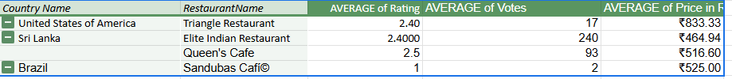

Insights -

* Low-rated competitors exist in key markets: Restaurants like *Triangle Restaurant (USA)*, *Elite Indian Restaurant (Sri Lanka)*, and *Sandubas Café (Brazil)* have ratings between 1-2.5, indicating poor customer satisfaction.
* Low votes suggest limited customer engagement: With low review counts (e.g., *Sandubas Café* with just 2 votes), these restaurants may not have strong customer loyalty or visibility.
* Pricing does not always justify quality: Despite mid-to-high pricing (₹464.94–₹833.33), these restaurants have poor ratings, suggesting service or quality issues.

### Recommendations

* Capitalize on competitor weaknesses: Enter these markets with a strong focus on quality, service, and customer experience to outperform poorly rated competitors.
* Target dissatisfied customers: Invest in marketing, promotions, and customer engagement strategies to attract customers from these underperforming restaurants.
* Optimize pricing strategy: Ensure pricing aligns with the value offered—offering better quality at a similar price point can give a competitive edge.

1. Which cuisines should we focus on in the newer restaurants to get better feedback? Does the choice of cuisines affect the restaurant ratings?

Ans - We need to focus on Cuisines with higher rating.So we create a pivot table and filter out the cuisines based on highest rating (4.9). The results are as follows-

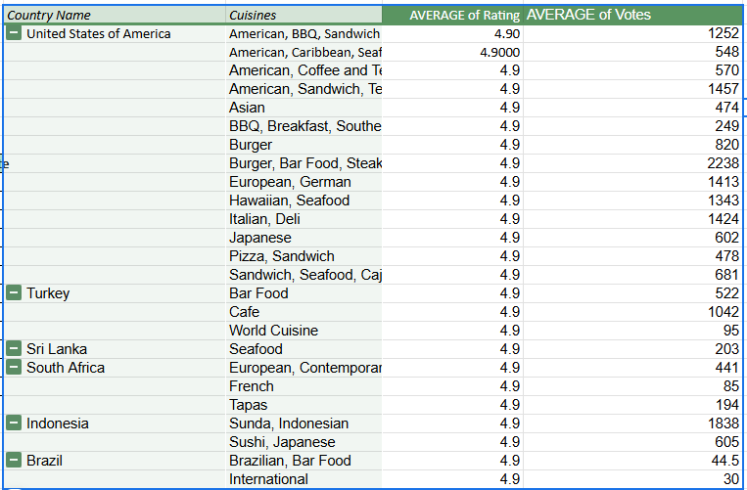

Insights -

* High-rated cuisines have strong customer appeal: Cuisines like *American, BBQ, Sandwich* (USA), *Seafood* (Sri Lanka), and *Sunda, Indonesian* (Indonesia) consistently receive 4.9 ratings, indicating strong customer satisfaction.
* Diverse cuisines perform well across regions: A mix of *local (Sunda, Indonesian, Brazilian)* and *international (European, Italian, Japanese, BBQ)* cuisines receive top ratings, showing broad customer acceptance.
* High engagement through votes: Cuisines such as *Burger, Bar Food, Steak* (2238 votes) and *Sunda, Indonesian* (1838 votes) indicate strong market demand.

### Recommendations

* Focus on top-performing cuisines: Introduce BBQ, Seafood, American, Japanese, and European cuisines in new restaurants to leverage high customer satisfaction.
* Leverage local preferences: Offer Sunda cuisine in Indonesia, Brazilian Bar Food in Brazil, and Seafood in Sri Lanka to align with customer tastes.
* Enhance marketing for niche cuisines: Invest in promotion and themed menus for high-rated but niche options like *Tapas (South Africa)* or *World Cuisine (Turkey)* to attract a wider audience.

1. According to our current data, should we go for online delivery and table booking? Does that affect the customer’s ratings?

Ans-

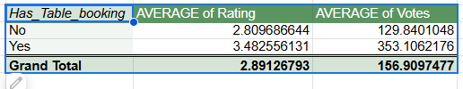

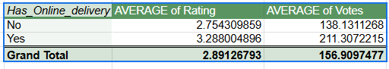

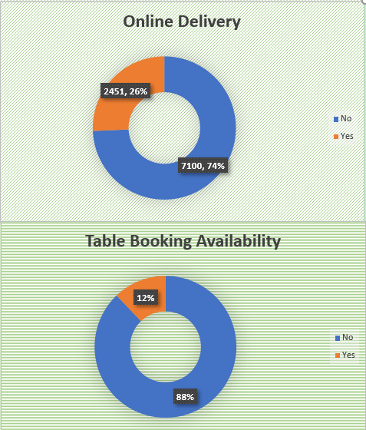

Yes it affect customer rating

Insights

* Online Delivery & Table Booking Can Impact Ratings
* Higher Ratings for Restaurants with Online Services
* Offering both delivery & table booking can increase customer engagement

Recommendations

* if restaurants with online delivery & table booking have higher ratings and votes. If they do, prioritize these features
* Use discounts and loyalty programs for online customers to boost engagement

1. Should the team keep the rate of cuisines higher? Will that affect the feedback? According to our data are the rates of cuisines and ratings, correlated?

Ans - Calculated the correlation coefficient between cuisine rates and ratings using the formula

**=CORREL('Raw Data'!T:T,'Raw Data'!U:U).**



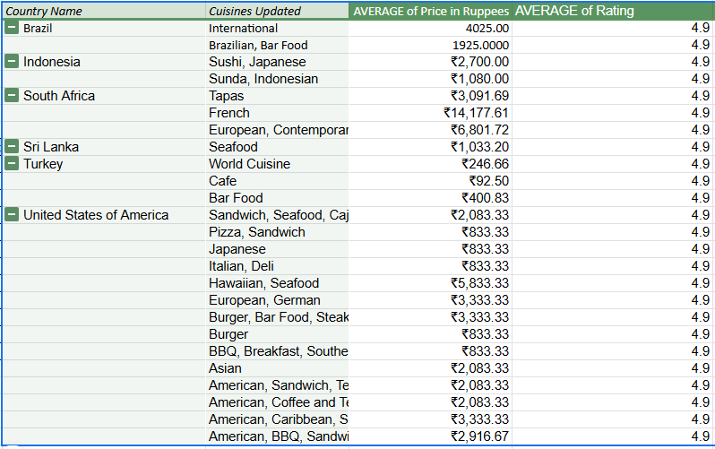

### Insights:

* The positive correlation of +0.31 between price and rating suggests that higher-priced cuisines tend to receive slightly better ratings, but the relationship is not strong.
* Some affordable cuisines, such as Cafe in Turkey (₹92.50, 4.9 rating), receive top ratings, indicating that quality, not just price, influences customer satisfaction.
* Countries like South Africa and Brazil have cuisines with significantly higher prices (₹14,177.61 for French in South Africa) but still maintain a high rating, showing that premium offerings can attract top ratings in certain markets.

### Recommendations:

* + Focus on high-quality yet affordable options in emerging markets, as seen with Turkey’s Café cuisine (₹92.50, 4.9 rating), to attract a broader customer base.
  + Introduce premium-priced offerings strategically, as high-end cuisines (French, European) tend to perform well in select regions like South Africa.
  + Since price and rating are moderately correlated, maintain a balance between affordability and quality to ensure both profitability and high customer satisfaction.

1. What is the distribution of the number of restaurants of different price ranges in all the countries?

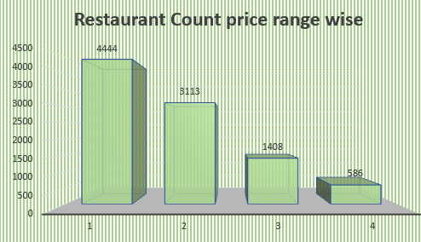

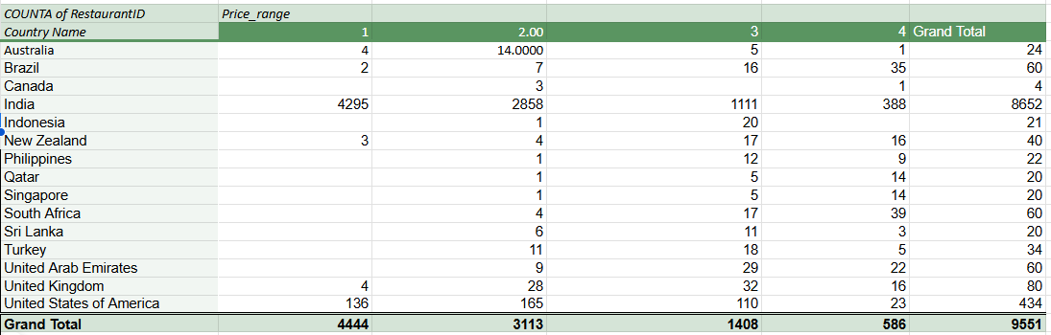

Insights-

* India Dominates the Low-Price Market
* Premium Dining is More Common in Brazil, Qatar, Singapore, and South Africa have a higher proportion of high-end restaurants (Price Range 4).
* Canada, Indonesia, Philippines, Qatar, and Singapore have very few or no restaurants in Price Range 1
* The United States and the United Kingdom show a relatively balanced spread across all price ranges, indicating diverse customer preferences.

Recommendations-

* Affordable Restaurants Expansion: Open more budget-friendly restaurants in Canada, Qatar, Singapore, and Indonesia where Price Range 1 is underrepresented.
* Target High-End Dining Growth: Countries like Brazil, Qatar, and South Africa have a strong high-end dining presence, making them good targets for premium restaurant concepts.
* Market Research for India: Since India's budget segment is highly competitive, focus on unique value propositions such as fusion cuisine, theme-based dining, or improved service experiences.

1. Explain your approach in brief for suggesting countries/cities in order to open new restaurants, if the objective and subjective questions would have not been given to assist you. **[you have to give bullet pointers in order to answer this question]**

* Identify key questions: Determine what questions need to be answered to make informed decisions about new restaurant openings. Document these questions to guide the analysis process.
* Clean the data: Ensure that the raw data is accurate and consistent by addressing any issues such as missing values, formatting errors, or inconsistencies.
* Create pivot tables: Use pivot tables to dynamically analyze and summarize the data. This allows for easy exploration of different dimensions and metrics.
* Build charts: Visualize the data with charts derived from pivot tables to identify trends, patterns, and insights more effectively.
* Compile into a dashboard: Assemble the charts and insights into a comprehensive dashboard. This centralizes information and facilitates a more holistic analysis to support decision-making.