Name-Pragati Kabra

email-id-kabrapragati345@gmial.com

**Student-management Project**

**Problem Statement: Students Reporting System**

**- Add Students with Marks in Multiple Subjects for multiple Semester**

**Solution-**

**–added feature of add and delete**

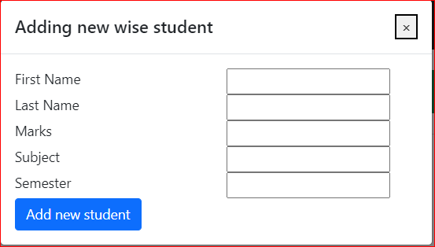

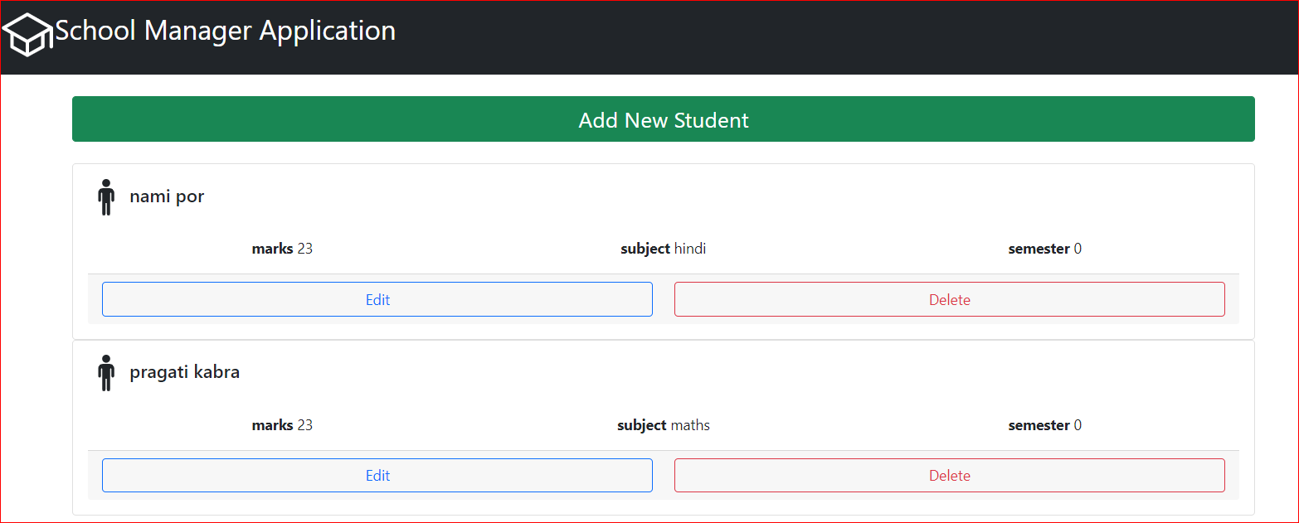

**For backend-**

**We use mongodb with database name -student_db**