- 9 Top Tourist Places to Visit in Vaishno Devi:

Vaishno Devi Temple / Bhavan, Vaishno Devi - Timings, Festivals, History, Darshan, Pooja Timings
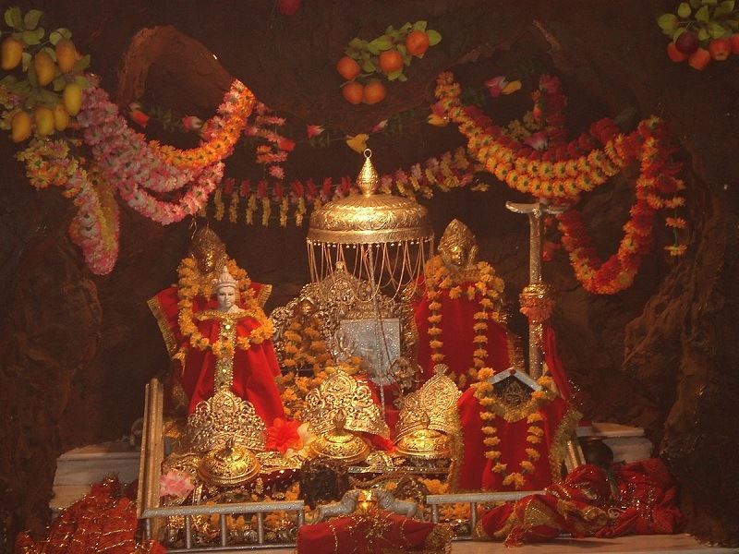
Photo Credit: Flickr
India | Jammu & Kashmir | Vaishno Devi
#1 of 9 Places to Visit in Vaishno Devi
Distance (From Vaishno Devi): 0.2 Kms
Trip Duration (Including Travel): 2-3 Hours
Place Location: On The Slopes Of Trikuta Hills
Transportation Options: Walk/Trek
Travel Tips: One needs to book Helicopter Ride, Battery Car Ride, and accommodation at least two months in advance.
At a distance of 18 km from Katra Railway Station, Vaishno Devi Temple is a sacred Hindu temple situated in the temple town of Vaishno Devi near Katra in Jammu & Kashmir, India. It is one of the most popular places of pilgrimage in Jammu & Kashmir, and among the must include places Vaishno Devi Yatra.
Located on the slopes of Trikuta Hills, the Vaishno Devi Temple is dedicated to Maa Vaishno Devi, a folk manifestation of the Hindu Mother Goddess, Durga. Popularly known as Mata Rani, Vaishnavi, and Trikuta, goddess Vaishnavi was formed from the combined energies of Parvati, Lakshmi, and Saraswati. Vaishno Devi is said to be Moonh Maangi Muradein Poori Karne Wali Mata (the mother who fulfills the wishes of her children). Vaishno Devi Temple is one of the richest temples in India with annual receipts of almost 16 billion dollars and is also among the top places to visit near Jammu.
According to legend, Vaishno Devi was an ardent devotee of Lord Vishnu and she used to meditate in a cave. It is said that Bhairon Nath, a famous Hindu Tantric, saw the young Vaishno Devi at an agricultural fair and fell madly in love with her. Vaishno Devi fled into Trikuta hills to escape his amorous advances, later she assumed the form of Mahakali and cut off his head with her sword in a cave. His body was held at the entrance to the cave, and his head landed further up the mountain at a place where a Bhairon Nath temple is now located. Bhairo then repented and pleaded for forgiveness. Vaishno Devi blessed him by saying that if pilgrims did not have darshan of his head, their pilgrimage will not be fruitful.
To escape him, Vaishno Devi ran away stopping at various places on the trail up Trikuta mountain. These places are now known as Banganga, Charan Paduka, Ardh Kunwari, the place where she is said to have remained for nine months in a cave, and finally Bhavan, the cave that is now known as her home. The Holy Cave of the Mother is situated at an altitude of 5200 feet. The Yatris have to undertake a trek of nearly 12 km from the base camp at Katra. At the culmination of their pilgrimage, the yatries are blessed with the darshans of the Mother Goddess inside the Sanctum Sanctorum- the holy Cave. These Darshans are in the shape of three natural rock formations called the pindies. These pindies manifest the three forms of the goddess as Maha Kali, Maha Saraswati, and Maha Lakshmi.
Vaishno Devi is one of the most visited pilgrimage sites in India. This renowned shrine allures millions of devotees from all over the world. During festivals like Navaratri, the footfall increases to as high as one crore. Devotees believe the goddess herself calls the devotees to reach here. The temple was included in the Jammu and Kashmir state government Act No. XVI/1988 and is known as Shri Mata Vaishno Devi Shrine Act. The committee nominated by the state government administers the temple and has nine members on its board.
The procedure of 'Aarti' is a very sacred and lengthy one here. The 'Aarti' of the Goddess is performed twice a day first time in the morning just before the sunrise and the second time in the evening immediately after the sunset. It is believed that during the pooja and aarti, Goddesses arrive at the Holy cave to pay their respect to Mata Rani. The most prominent festivals held at Vaishno Devi Temple are Navaratri, a nine nights festival celebrating Devi's victory over evil demons, and Diwali, a festival of lights symbolizing the victory of light over darkness, good over evil, and knowledge over ignorance.
The shrine itself is located at a height of 5300 feet and one has to climb up steep hills and cliffs which require a lot of endurance. The entry gate to the Vaishno Devi Yatra is called Darshani Darwaza and is located 2 km from the Katra Railway Station. To reach the holy shrine, pilgrims have to trek 13-kilometers uphill from Katra. There are horse and palanquin services for the elderly and weak. One can also take a Battery Car ride from Ardhkuwari - Bhavan - Ardhkuwari. There is also the option of taking a helicopter ride to Sanjichhat and walking 2.5 km from there to reach the shrine.
The most important activity that a pilgrim has to undertake on reaching Katra is getting registered for the Yatra. Yatra Registration is carried out at the Yatri Registration counter (YRC) near the Bus Stand Katra. Yatra Registration is also possible online. One needs to book Helicopter Ride, Battery Car Ride, and accommodation at least two months in advance.
Timings: 5 AM - 12 PM & 4 PM - 9 PM, 6.30 AM - 10 PM for Battery Car
Entry: Free, Rs. 1800 for Helicopter Ride (One way), Rs. 350 for Battery Car(One way)

Ban Ganga, Vaishno Devi - Timings, Festivals, History, Darshan, Pooja Timings
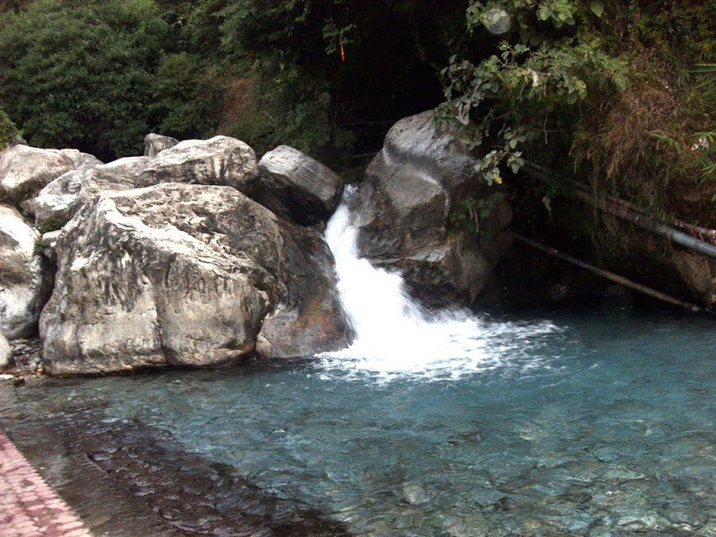
Photo Credit: Flickr
India | Jammu & Kashmir | Vaishno Devi
#2 of 9 Places to Visit in Vaishno Devi
Distance (From Shri Mata Vaishno Devi Katra): 6 Kms
Trip Duration (Including Travel): 30 Mins - 1 Hr
Place Location: Near Katra
Transportation Options: + Walk/Trek
Travel Tips: None
At a distance of 6 km from Katra Railway Station, and 10 km from Vaishno Devi Temple, Ban Ganga is a sacred place situated near Vaishno Devi, Katra in Jammu & Kashmir, India. Located on the way to Vaishno Devi Temple from Katra, it is one of the holy places to visit in Vaishno Devi.
Ban Ganga is a sacred river where devotees in Katra like to take a dip before continuing the Mata Vaishno Devi Yatra. Originating from the southern slope of the Shivalik Range of the Himalayas, Ban Ganga River has two ghats where a large number of Hindu devotees take a holy dip. Ban Ganga is an important tributary of the Chenab River and got its name from two words, Ban meaning Arrow, and Ganga which stands for the sacred river of India, Ganges.
The river has spiritual significance for Hindu Vaishnava and other devotees. According to the legend, Once Mata Vaishnavi was going towards her abode in the cave when the monkey accompanying her felt thirsty. With no water around, the goddess shot an arrow in the earth, out of which the Ganga sprang up. That gave it the name Ban (arrow) Ganga. Interestingly, it is also called Bal (hair) Ganga, as it is believed that Maa washed her hair in it. Ban or Bal Ganga offers relaxation to devotees while on the trek to the Bhawan, the holy cave. Take a dip and feel fresh and blissful before continuing the journey to other tourist places in Katra.
The location of the Banganga temple is splendid as the tourists can get to see the enchanting landscape and stunning hills that offer a mesmerizing experience. There is water in the river all through the year except when there is an acute shortfall of rain or snow during the monsoon and winter respectively.
Timings: 5 AM - 9 PM
Entry: Free

Charan Paduka, Vaishno Devi - Timings, Festivals, History, Darshan, Pooja Timings
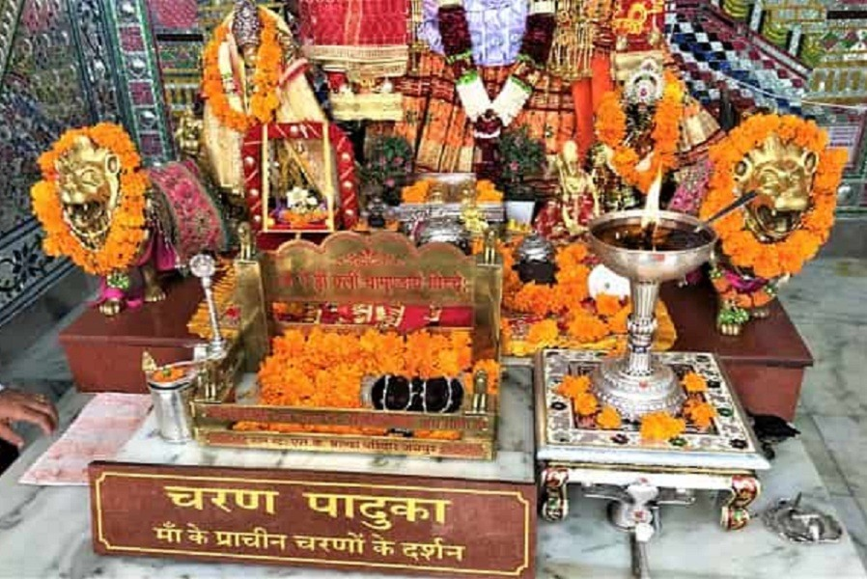
Photo Credit: Flickr
India | Jammu & Kashmir | Vaishno Devi
#3 of 9 Places to Visit in Vaishno Devi
Distance (From Shri Mata Vaishno Devi Katra): 6 Kms
Trip Duration (Including Travel): 1 Hour
Place Location: On The Way To VaishnoDevi Bhavan
Transportation Options: Walk/Trek
Travel Tips: None
At a distance of 6 km from Katra Railway Station, and 9 km from Vaishno Devi Temple, Charan Paduka is a sacred place situated near Ban Ganga in Katra, Jammu & Kashmir, India. Located on the way to Vaishno Devi Temple from Katra, it is one of the popular Vaishno Devi places to visit.
Charan Paduka is the second stop of the trek that takes you to the Mata Vaishno Devi Temple, also known as Bhavan. While Banganga is the first stop. Situated about 1.5 km from Banganga, the temple houses the footprints of Mata Vaishno Devi. Legend says that this white temple is believed to be the place where Mata Vaishno Devi stopped over to check if she was still being chased by Bhairon Nath, the disciple of Mahayogi Guru Goraksh Nathji. She stood on a rock to look at Bhairav Nath before her escape and this rock supposedly contained her footprints.
Located at an altitude of 3380 feet, the temple was earlier a small shrine but now it has been transformed into a scenic and large temple. In the main sanctum sanctorum of the Charan Paduka temple, an idol of the mother is seated and under that stone which contains Mata's footprints, is also placed. The darshan at Charan Paduka Temple does not take more than a few minutes on a normal day. One pays obeisance at the footprints of Mata engraved on a rock slab and proceeds further. Symbolically, it means touching the feet of Mata and seeking Her blessings at the start of Mata Vaishno Devi Yatra.
A medical unit of the Shrine Board is also located here, which is equipped with all necessary medical facilities and is attended by trained medical staff.
Timings: 5 AM - 9 PM
Entry: Free

Ardhkuwari, Vaishno Devi - Timings, Festivals, History, Darshan, Pooja Timings
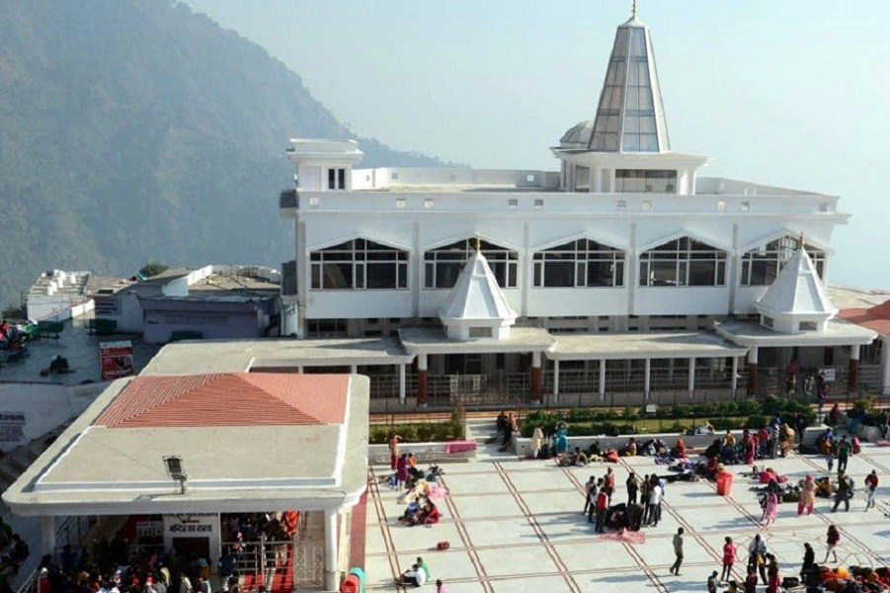
Photo Credit: Flickr
India | Jammu & Kashmir | Vaishno Devi
#4 of 9 Places to Visit in Vaishno Devi
Distance (From Shri Mata Vaishno Devi Katra): 12 Kms
Trip Duration (Including Travel): 1-2 Hours
Place Location: On The Way To Vaishno Devi
Transportation Options: Walk/Trek
Travel Tips: None
At a distance of 4 km from Charan Paduka, 6 km from Vaishno Devi Temple, and 12 km from Katra Railway Station, Ardhkuwari is a cave temple situated in Katra, Jammu & Kashmir, India. Located on the way to Vaishno Devi Temple from Katra, it is one of the popular places to visit during Vaishno Devi Tour.
After having darshan of Charan Paduka, pilgrims come across the Ardha Kunwari Temple. Perched at an altitude of 4800 feet, Adkuwari is the halfway point of the Mata Vaishno Devi trek as it is situated at a distance of nearly 6 km from Katra town, and the Holy Cave as well. Adkuwari is one of the most important temples in Katra, second only to the main Cave Bhavan. The word Adkuwari is believed to have come from Adi kumari, which means 'The Eternal Virgin'.
According to the legend, Mata Vaishno Devi took shelter in this cave while meditating for nine months. The exact spot where she is believed to have meditated is located at the right-hand side inside the cave and is shaped like a womb. Since Vaishnavi had spent 9 months in a womb-shaped cave, this cave is also known as Garbh Joon. When he found her, she created an exit at the other end with Her trident and proceeded towards the Holy Cave.
One has to crawl on the knees to reach the other side of the 52 feet Ardhkuwari cave. Since the cave is very narrow, only one person can pass through it at a time. It is generally believed that by merely passing through this cave, a devotee's sins are cleansed and his soul becomes pious again. A battery car service is available from Ardhkuwari to Bhawan for the devotees.
Timings: 5 AM - 9 PM, 6.30 AM - 10 PM for Battery Car
Entry: Free, Rs. 350 for Battery Car (One way)

Himkoti, Vaishno Devi - Timings, Entry Fee, Best Time to Visit
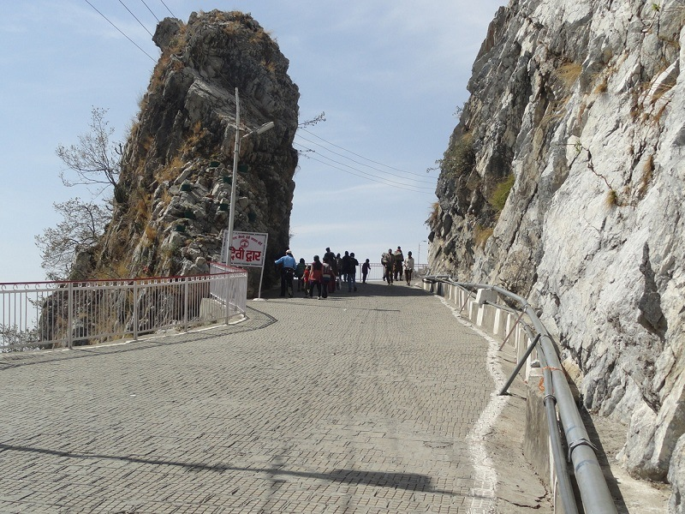
Photo Credit: Flickr
India | Jammu & Kashmir | Vaishno Devi
#5 of 9 Places to Visit in Vaishno Devi
Distance (From Shri Mata Vaishno Devi Katra): 15 Kms
Trip Duration (Including Travel): 30 Mins - 1 Hr
Place Location: On The Way ToVaishno Devi
Transportation Options: Walk/Trek
Travel Tips: None
At a distance of 2.5 km from Ardhkuwari, 4 km from Vaishno Devi Temple, and 15 km from Katra Railway Station, Himkoti is a viewpoint situated near Ardhkuwari on a new route. Located on the way to Vaishno Devi Temple from Katra, it is one of the popular tourist places in Vaishno Devi.
Himkoti doesn't have any religious significance. It is visited by the tourists because Himakoti viewpoint provides a view of the entire valley, a view that every visitor loves and cherishes on his way back home. The spot is very clean and beautiful. Take some time out from your pilgrimage and admire the natural beauty of Himkoti. It is also a great place to relax and have a picnic with the family.
Himkoti is being developed with picturesque gardens, an artificial lake, and a meditation center by the Shrine Board as this vantage point falls on the new route to the holy cave from Katra. The new track starts from just below Ardhkuwari and terminates just short of Bhavan Complex. This route is 0.5 km shorter than the old route to the cave, and hence pilgrims prefer it the most. Also, the way is less steep and has no rush of horses. This place offers the devotees enough space to relax rest and enjoy the scenic beauty of the lush green valley.
One should start the yatra to the temple during the daytime rather than at night. The shrine board has set up restaurants, dosa counters, cooked meal shops, and cassette counters as well. Other facilities like oxygen cylinders and medical care are also available here. The battery vehicle is run on this track from Ardhkuwari. The booking facility is subject to availability.
Timings: 5 AM - 9 PM, 6.30 AM - 10 PM for Battery Car
Entry: Free, Rs. 350 for Battery Car (One way)

Bhairavnath Temple, Vaishno Devi - Timings, Festivals, History, Darshan, Pooja Timings
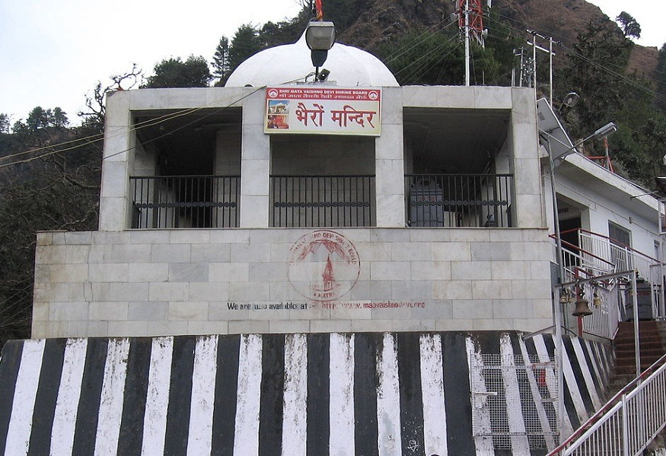
Photo Credit: Flickr
India | Jammu & Kashmir | Vaishno Devi
#6 of 9 Places to Visit in Vaishno Devi
Distance (From Shri Mata Vaishno Devi Katra): 17 Kms
Trip Duration (): Not Available
Transportation Options: Walk/Trek
Travel Tips: None
At a distance of 5 km from Ardhkuwari, 5 km from Vaishno Devi Temple, and 17 km from Katra Railway Station, Bhairavnath Temple is a sacred place in Vaishno Devi. Located on the way to Vaishno Devi Temple from Katra, it is one of the must include places in the Vaishno Devi trip.
No journey to Vaishno Devi, Katra is complete without having visited Bhairavnath Mandir. The cave temple of Bhairavnath is dedicated to Baba Bhairavnath and is constructed at the site where he is believed to have breathed his last. The temple is situated at the adjacent hill of Trikuta at an elevation of 2017 m. A havan kund marks as an important attraction at Bhairon Temple, the ashes of which are considered holy.
According to legend, Vaishno Devi was an ardent devotee of Lord Vishnu and she used to meditate in a cave. It is said that Bhairon Nath saw the young Vaishno Devi at an agricultural fair and fell madly in love with her. Vaishno Devi fled into Trikuta hills to escape his amorous advances, later she assumed the form of Mahakali and cut off his head with her sword in a cave. His body was held at the entrance to the cave, and his head landed further up the mountain at a place where a Bhairon Nath temple is now located. Bhairo then repented and pleaded for forgiveness. The goddess forgave him and said that no pilgrimage to Vaishno Devi will be complete without visiting the Bhairav Temple.
A steep 5 km journey from the Bhavan leads you to Bhairavnath temple and the culmination of the Vaishno Devi Yatra. The one-hour trek from Vaishno Devi Mandir to Bhairavnath Mandir is tough and not suitable for the elderly. It can be covered in 5 minutes with the ropeway. The air-conditioned cable car can carry 45 people at a time and is operational one way only. The panoramic aerial view of Bhairo Valley from the ropeway is stunning. Ponies are also available for the up-down journey for those who can not climb the steep stairs.
Timings: 5 AM - 12 PM,& 4 PM - 9 PM , 8 AM - 5 PM for Ropeway
Entry: Free, Rs. 100 for Ropeway

Dera Baba Banda Bahadur, Vaishno Devi - Timings, Festivals, History, Darshan, Pooja Timings
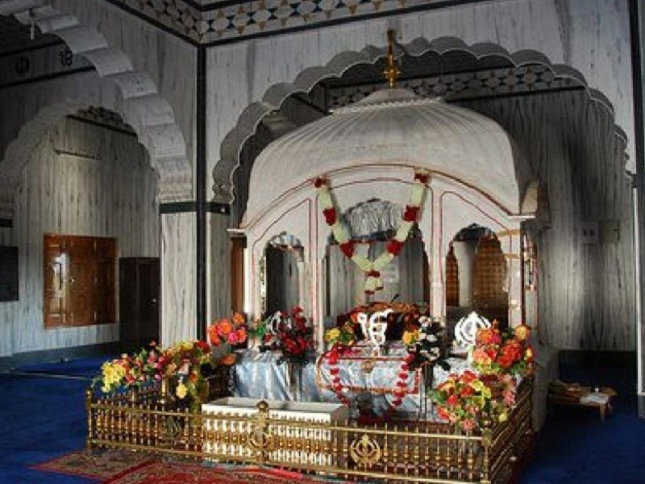
Photo Credit: Flickr
India | Jammu & Kashmir | Vaishno Devi
#7 of 9 Places to Visit in Vaishno Devi
Distance (From Vaishno Devi): 28 Kms
Trip Duration (Including Travel): 2-3 Hours
Place Location: At Dera Baba Banda Village
Transportation Options: Bus / Cab
Travel Tips: None
At a distance of 28 km from Katra Railway Station, Dera Baba Banda Bahadur is a guudwara situated at Dera Baba Banda village near Katra. Located on the banks of River Chenab, it is one of the popular places to visit near Katra.
Dera Baba Banda Bahadur is a historical Gurudwara dedicated to Guru Gobind Singh's favorite Baba Banda Bairaagi. The complex is 300 years old and houses the ashes of the Baba Banda Singh Bahadur. Baba Banda was the commanding soldier of the Guru Gobind Singh's army. He was rewarded with a bow, an arrow, and a sword by Guru Sahib. He spent his last days here. The place houses these historical relics of the saint soldier.
Built with white marbles, the architectural designs and layout of the monastery are really appreciable. The interior walls of the Gurudwara are beautifully textured with golden shades. The Gurudwara also has a Nishan Sahib made of deodar tree which is about 48 feet tall. The scenic beauty and lush green landscapes of the village attract visitors to the site.
Devotees from all over India visit this holy shrine to seek the blessings of the divine soul during the annual Mela held here on Vaisakhi in April every year. The fair continues for three days and is celebrated with great affection to commemorate the martyred soldier. The Ragis recite the Shabad Kirtan and prayers during the eve, and the Dera is illuminated with lights.
Timings: 5 AM - 12 PM,& 4 PM - 9 PM
Entry: Free

Baba Dhansar, Vaishno Devi - Timings, Festivals, History, Darshan, Pooja Timings
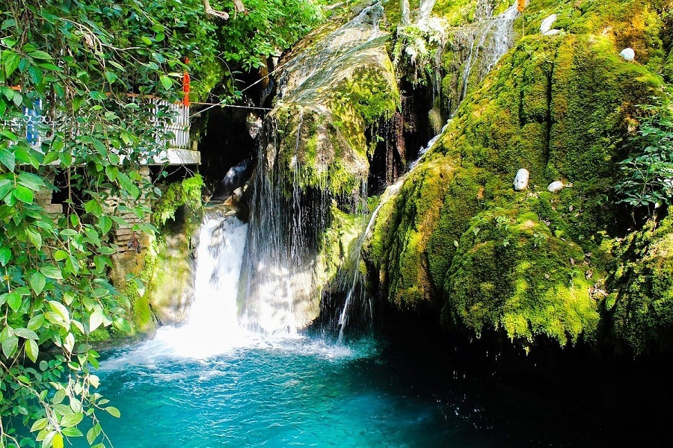
Photo Credit: Flickr
India | Jammu & Kashmir | Vaishno Devi
#8 of 9 Places to Visit in Vaishno Devi
Distance (From Vaishno Devi): 14 Kms
Trip Duration (Including Travel): 2 Hours
Place Location: At Karua Village
Transportation Options: Bus / Cab
Travel Tips: None
At a distance of 14 km from Katra Railway Station, Baba Dhansar is a religious place situated at Karua village near Katra. Located on the way to Salal Dam, it is one of the top places of pilgrimage in Jammu & Kashmir, and among the must-visit places as part of the Vaishno Devi tour.
Situated right by the beautiful Karua Jheel, Baba Dhansar temple is dedicated to serpent god Dhansar Baba. As per the legend, there was a demon who lived near Karua Jheel(lake) in ancient times and created havoc and destruction in their lives. The villagers sought the help of Baba Dhansar, the son of Vasudev, the serpent king. When the villagers asked for help from Baba, he prayed to Lord Shiva, who in turn agreed to help him kill the demon. After the demon was killed, the villagers constructed a Nag temple and a Cave temple in honor of Baba Dhansar, and Lord Shiva respectively.
Apart from the beautiful temple, there is a huge spring that emerges from the rocks in a thick grove of trees and forms several small cascading waterfalls before ultimately flowing into the rivulet that merges with the Chenab River. There is a naturally formed Shivling on which water droplets fall at a constant pace all the year-round. Washing oneself in the Karua Jheel is considered holy but is not allowed. However, devotees are allowed to bathe downstream, where the water flows out. It is believed that if you pray with complete conviction and wash your sins in the Karua Jheel, all your wishes will be fulfilled. A large number of devotees visit the place every year on the day of Mahashivratri when an annual mela is organized.
One has to trek about 200 m from the main road to reach the temple.
Entry: Free

Shiv Khori, Vaishno Devi - Timings, Festivals, History, Darshan, Pooja Timings
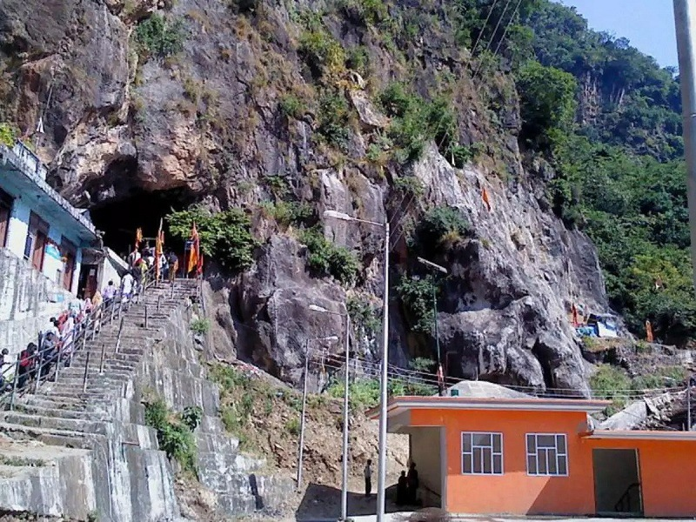
Photo Credit: Flickr
India | Jammu & Kashmir | Vaishno Devi
#9 of 9 Places to Visit in Vaishno Devi
Distance (From Vaishno Devi): 80 Kms
Trip Duration (Including Travel): Half Day to Full Day
Place Location: Near Sangar
Transportation Options: + Walk/Trek
Travel Tips: None
At a distance of 80 km from Katra, and 140 km from Jammu, Shiv Khori is a temple situated at Sangar village in the Reasi district of Jammu and Kashmir, India. It is one of the famous pilgrimage sites in Jammu & Kashmir, and among the best places to visit near Jammu.
Dedicated to Lord Shiva, Shiv Khori is one of the famous Hindu cave shrines devoted to Lord Shiva. Khori means cave (Guffa) and Shiv Khori thus denotes Shiva's cave. This natural cave is about 200 meters long and only a meter in width, with a ceiling of 2 to 3 meters in height. Only one or two people can walk in a file in this cave and at the end of it, there is a 4 feet high Swayambhu Lingam, which constantly baths in a milky lime fluid dripping from the ceiling.
The cave is a real wonder to be seen which according to the people is unending and believed to have led to Swami Amarnath Cave in Kashmir. As per the assessment of local people, it measures nearly half a kilometer in length but Yatries are allowed to go only up to 130 meters. The rest part of the cave is still a mystery as no one could go further due to lack of oxygen. It is believed that some Sadhus who dared to go ahead never returned. The cave is in the shape of Lord Shiva's Damroo i.e. wide at the two ends while very congested at the center. The width of the cave is so less at a certain place that a person can barely crawl through whereas at places it is over a hundred feet wide and quite high too. The cave is full of natural impressions & images of various Hindu deities & full of divine feelings.
The opening of the cave is a mammoth hall that is nearly 20 feet wide and 22 feet high. It is nearly 80 feet in length. While entering into this mesmerizing hall one can see the natural depiction of a gigantic snake-like formation believes to be Sheshnag. Pigeons are also seen here like Amarnath cave. After crossing the narrow passage, yatries reach the main cave area where the sanctum sanctorum is situated. The open part of the cave has a four feet high naturally formed Shiv-lingam at the heart of the sanctum sanctorum. Just above the shiva lingam a cow-like formation is visible believe to be Kamdhenu and can be identified by her udders. The natural water dripping from the nipples of udders on the Shivlingum symbolizes the eternity of the holy river Ganga. It is believed that milk used to ooze out during the old days but turned into water in Kaliyuga.
To the left of Shivlingam, Maa Parvati is sitting whose image can be identified by the impression of her holy feet. Along with the image of the goddess, Gauri Kund is also visible which is always full of holy water. The image of Kartikeya is also seen on the left of Shivlingam. At nearly 2.5 feet above the Kartikeya, an image of five-headed Ganesha is visible. To the right side of Shivlingam, one can see Ramdarbar having images of Lord Ram, Lakshman, Sita, and Hanuman. The whole cave is abounding with many other natural images which have been described as images of 33 crores Hindu deities and their vehicles. The cave roof is etched with snake-like formations, the water trickles through these in the cave. The main part of the cave roof has a round-cutting mark signifying the construction of the cave by Sudarshan Chakra of Lord Vishnu. In the second half of the main chamber, Mahakali & Maha Sarswati is present. Little above the Mahakali, Panch- Pandava are present in natural rock form (pindies). In front of the Mahakali on another wall of the cave, a natural rock image of Lord Shiva lying down on the floor is visible. A holy foot of Maa Kali is also visible on the body of Lord Shiva.
Visitors need to trek 4 km from Ransoo to reach Shiv Khori. The trekking route is so breathtakingly lovely that one will not find it hard to walk in such an atmosphere. This 4 km-long trek can be done either on foot or by hiring a pony.
A 3-day Shiv Khori mela takes place annually on Maha Shivratri and thousands of pilgrims from different parts of the state and outside visit this cave shrine to seek blessings of Lord Shiva. Maha Shivratri festival is usually held in February or during the first week of March every year.
Timings: 7 AM to 5 PM
Entry: Free

- 17 Top Tourist Places to Visit in Jammu

Raghunath Temple, Jammu - Timings, Festivals, History, Darshan, Pooja Timings
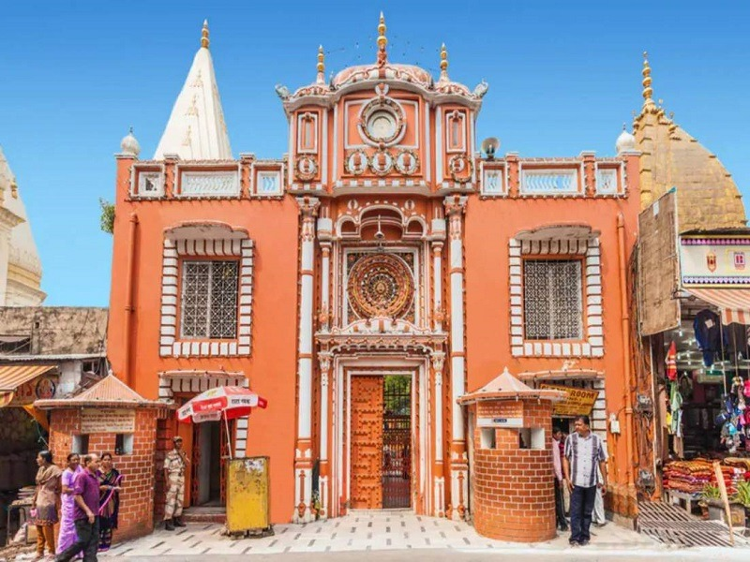
Photo Credit: Flickr

India | Jammu & Kashmir | Jammu

#1 of 17 Places to Visit in Jammu

Distance (From Jammu Tawi): 10 Kms

Trip Duration (Including Travel): 1 Hour

Place Location: In The Old City

Transportation Options: Cab / Auto

Travel Tips: None
At a distance of 10 km from Srinagar Railway Station, Raghunath Temple is an ancient Hindu temple located in Jammu City. Situated in the old city area of Jammu, it is believed to be the largest shrine complex in North India and among the popular places to visit in Jammu.
The Raghunath Temple is an extremely popular and revered shrine in the union territory of Jammu & Kashmir. The majestic temple is dedicated to Lord Rama, who is believed to be the eighth incarnation of Lord Vishnu. The construction of the temple was started in 1835 AD by Maharaja Gulab Singh, who was the founder of the Kingdom of Jammu & Kashmir and was completed by his son Maharaja Ranbir Singh in 1860 AD. The temple also began to be used as the center of Sanskrit teachings during the reign of Ranbir Singh. Later, the temple was attacked by terrorists in 2002 and was shut down for some time. Finally, the gates of the temple were once again opened for the devotees in the year 2013.
The temple is an amalgamation of both Mughal and Sikh architectural styles. The temple complex consists of seven temples, each of which is topped with lofty spires, called shikaras. A portrait of Maharaja Ranbir Singh sits at the entrance of the temple, along with a portrait of Lord Hanuman. The niches in the walls of the shrines are decorated with 300 well-crafted icons of gods and goddesses, but most are particularly related to the life stories of Rama and Krishna. The paintings in the 15 panels of the main shrine are based on themes from Ramayana, Mahabharata, and Bhagavad Gita.
The presiding deity of the temple is Lord Raghunath. Apart from the main shrine, the other shrines encompass various incarnations of Lord Vishnu. There is another remarkable shrine of Lord Surya (Sun God), which houses different forms of the Lord. Other shrines inside the temple house colossal statues of the Hindu gods and goddesses. Also, there is a gallery inside the temple that houses various lingams, or phallic-shaped forms of Lord Shiva, and on top of them, saligrams are placed. Besides, the temple premises include a school and a library that preserves over 6,000 manuscripts in many Indian languages, with a notable collection of Sanskrit manuscripts.
Rama Navami, the birthday of the Lord, is the main festival celebrated in this temple with great enthusiasm that draws people from far and wide to pay their respects to the Lord and seek his blessings.
Timings: 6 AM - 8 PM
Entry: Free

Bahu Fort, Jammu - Timings, History, Architecture, Best Time to Visit
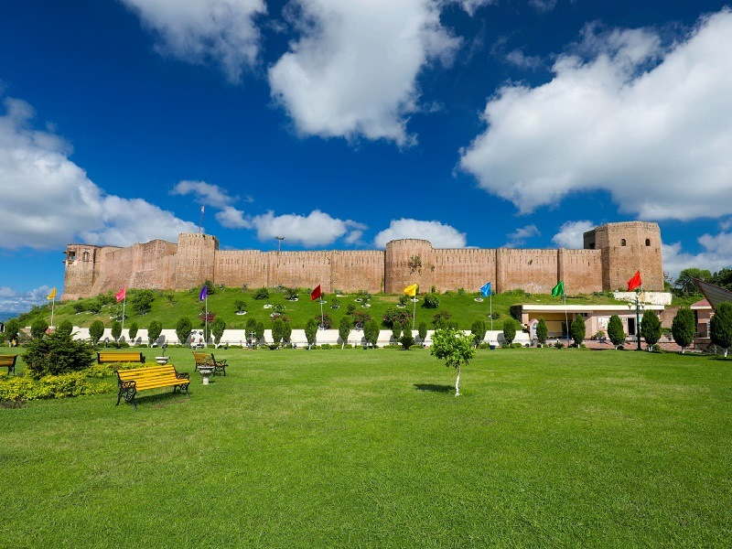
Photo Credit: Flickr
India | Jammu & Kashmir | Jammu
#2 of 17 Places to Visit in Jammu
Distance (From Jammu Tawi): 4 Kms
Trip Duration (Including Travel): 1-2 Hours
Place Location: On The Left Bank Of The Tawi River
Transportation Options: Cab / Auto
Travel Tips: None
At a distance of 4 km from Jammu Railway Station, Bahu Fort is a historic fort located in the city of Jammu, Jammu & Kashmir. Stands tall and sturdy on the left bank of the Tawi River, it is one of the popular places of heritage in Jammu & Kashmir, and among the must-visit places as part of forts Jammu tour packages.
Perhaps the oldest fort and edifice in Jammu, Bahu Fort is believed to be constructed around 3,000 years ago by Rajput Raja Bahulochan, the brother of the traditional founder of Jammu, Jambu Lochan. The earlier structure of the fort was rebuilt in 1585 CE by Autar Dev, the grandson of King Kapoor Dev. The grand fort has been reconstructed, renovated, restored, and repaired by many rulers from different dynasties from time to time. However, the current and final version of Bahu Fort was built by Maharaja Gulab Singh in the 19th century and was further refurbished by Maharaja Ranbir Singh during his rule.
Perched at an elevation of 325 m, Bahu Fort was built in a Mughal style of architecture and is decorated with terraced gardens, waterfalls, and flowers. The entrance of the fort is magnanimous, so intimidating and massive that it can allow the passage of elephants into the fort. The fort was equipped with a royal stable, an enormous lake for boating, and a cable car system. The thick and sturdy walls of the fort are connected by eight octagonal towers that are hollowed with an enclosed space for the use of house guards. The fort also houses a beautiful 15 feet deep pond which lies adjacent to a pyramidal structure, which was mainly used to store arms and ammunition. The fort is also equipped with an underground prison chamber and a secret passageway.
Besides, the fort also acts as a religious place, and within its precincts has a temple dedicated to the Hindu goddess Kali, the presiding deity of Jammu. The temple is known locally as the 'Bawe Wali Mata' temple. Raised on a 3.9 feet high platform, it is built entirely of white marble. In the past, animal sacrifice was practiced at this temple, which has since been discontinued. Today, a priest sprinkles holy water over the animal (usually a sheep or goat) and then lets it go free. Many devotees firmly believe that it is the deity residing in the Bahu Fort that protects the city of Jammu from Pakistani air attacks. One can also see a large group of Rhesus monkeys in the temple precincts.
Also, the forest area that surrounds the fort has been developed into a well-laid-out park called the 'Bagh-e-Bahu', from where one can get a panoramic view of Jammu city. The terraced garden is full of beautiful fountains, an artificial waterfall, dense tall trees, and colorful flowers. The garden is decorated with aesthetic stone sculptures that fit in perfectly with the green background. Besides, one can also visit the Aquarium located near the fort. It is the largest underground aquarium in the country and exhibits an impressive collection of around 400 species of fish.
The fort hosts a popular Hindu festival known as 'Bahu Mela' that is celebrated twice a year, during March/April and September/October. During this event, special stalls are opened near the fort area selling sweets, flowers, incense, coconuts, red cloth, and so forth, to make special offerings to the deity in the temple. Tuesday and Sunday are the special days to worship at the temple which attracts a large number of pilgrims.
Timings: 10 AM - 5 PM
Entry: Rs. 10 for Person & Rs. 50 for Camera

Peer Kho Cave Temple, Jammu - Timings, Festivals, History, Darshan, Pooja Timings
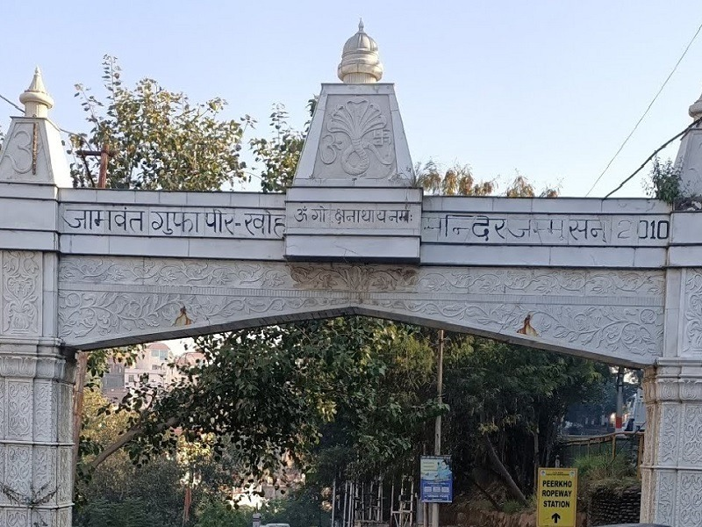
Photo Credit: Flickr
India | Jammu & Kashmir | Jammu
#3 of 17 Places to Visit in Jammu
Distance (From Jammu Tawi): 5 Kms
Trip Duration (Including Travel): 1 Hour
Transportation Options: Cab / Auto
Travel Tips: None
At a distance of 5 km from Jammu Railway Station, Peer Kho Cave Temple is an ancient Hindu temple located in the city of Jammu. Situated amid an acacia forest, it is one of the oldest temples in the city and among the must-visit religious places in Jammu.
Overlooking the Tawi River, the Peer Kho Cave Temple is dedicated to Lord Shiva. During the reign of Raja Biram Dev of Jammu (1454 - 95) a famous saint Guru Garib Nath belonging to the Guru Gorakh Nath order came to Jammu and resided at Peer Kho. Kho means cave in the local dialect. He came to be known as Peer-i-Kho and thus with time, the cave got its name. The cave is also known as the Jamwant Cave as it is believed to be the place where the bear God Jamvant, a prominent character in the Ramayana meditated. Another interesting part is that the locals even believe that the cave does not just lead to other caves but parts outside the country.
With an ensemble of three shikharas, the temple has a large-sized courtyard and three caves dedicated to Lord Shiva, Navadurga, and Jambavant. The dome of the temple is an inverted lotus that serves as an entrance to the cave and is ornamented with beautiful paintings on the ceilings which resemble a strong and stark Mughal and Dogra influence with floral motifs at the center of the dome. There is a small opening from the domed entrance leading to a passage with a low ceiling to the Jambavant Cave on the right which also has a temple of Lord Shiva. It is said that there is an opening of a cave dug by Jambavant during his time here which leads to Amarnath Cave. The temple houses a swayambhu lingam and the people of Jammu worship this lingam with a lot of reverence.
An opening on the left side leads to the Navadurga shrine which further leads to the Navadurga Cave. There are beautiful statues of Devi in her nine glorious forms dressed in bright red sarees. There is an eternal Gorakhnath dhunni placed in the center of the temple courtyard. There is a Shani Devata temple within the complex which is revered by locals. A huge Shivlingam has been constructed on the lawns outside the main temple. This entire temple is built on an elevated platform to safeguard it from possible floods.
Maha Shivratri is the main event celebrated every year with much fervor. Besides, people throng this sacred place on Amavasya, Ekadashi, Purnima, and in the month of Shravan. Locals say that the morning and evening aarti is a divine visual spectacle and not to be missed.
Timings: 5 AM - 7 PM
Entry: Free

Amar Mahal Palace, Jammu - Timings, History, Architecture, Best Time to Visit
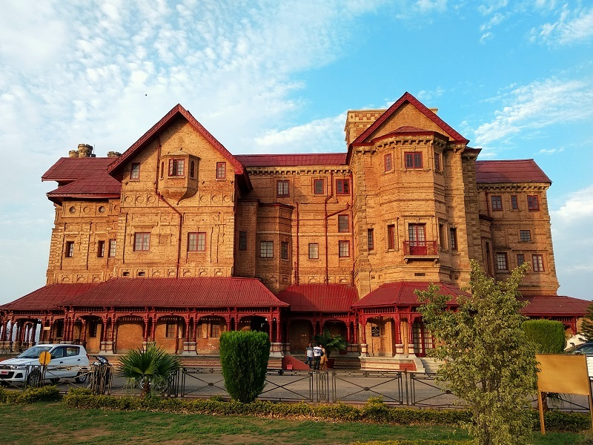
Photo Credit: Flickr
India | Jammu & Kashmir | Jammu
#6 of 17 Places to Visit in Jammu
Distance (From Jammu Tawi): 8 Kms
Trip Duration (Including Travel): 1-2 Hours
Transportation Options: Cab / Auto
Travel Tips: None
At a distance of 8 km from Jammu Railway Station, Amar Mahal Palace is a royal palace situated on the banks of the Tawi River in Jammu and Kashmir. It is one of the best places to visit in Jammu for those who want to know the history of the erstwhile Kingdom of Jammu and Kashmir.
Amar Palace was built in the 19th century by Raja Amar Singh, a Dogra king. The palace was the last official residence of the Dogra dynasty and the last king of the kingdom Maharaja Hari Singh. Maharani Tara Devi, wife of the late Maharaja Hari Singh (son of Raja Amar Singh) lived in this palace till her death in 1967. Subsequently, her son Karan Singh and his wife Yasho Rajya Lakshmi converted the palace into a museum to house rare books and works of art, with the they transferred the palace property to a trust named the 'Hari-Tara Charitable Trust'.
Built with red bricks and red sandstone, this imposing building was planned by a French architect in the European castle style. It has long passages on three sides, which are covered by sloping ridged tin roofs and the passages are supported on columns with a wooden framework. The first floor of the palace building has French windows with a connected balcony and the top floor has a bay window. The windows also depict triangular projections in classical Greek architectural style, which are fitted over ornate false columns. When built during the reign of Raja Amar Singh, it was the tallest building in Jammu.
Inaugurated in 1975 by Indira Gandhi, the former Prime Minister of India, the museum has several exhibits including a golden sofa of the Dogra rulers, weighing 120kg, a Pahari miniature, Kangra miniature paintings, a library of 25,000 antique books, many rare art collections, and a large collection of portraits of the Dogra rulers. Hindu epic scenes from the Mahabharata and epic stories like Nala Damayanti are depicted in the paintings of this museum. An exclusive chamber in the museum, once the living quarters of the Maharani Tara Devi, is conserved and exhibited in its original form where a silver bedspread, period furniture, photographs, and the decoration of the Crown of India which was presented to her in 1945, her personal items of clothing and the unique Victorian bathroom are on display.
Timings: 9 AM - 1 PM & 2 PM - 5 PM, Closed on Mondays & National Holidays
Entry: Rs. 20 for Adults & Rs. 10 for Children, Rs. 100 for Special Admission

Mubarak Mandi Palace, Jammu - Timings, History, Architecture, Best Time to Visit
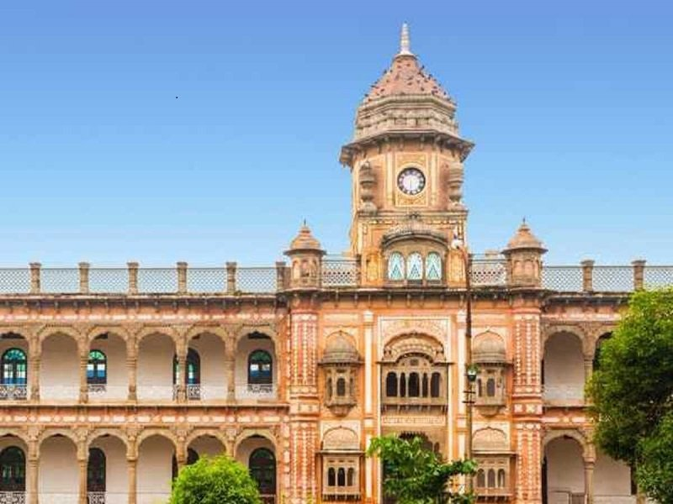
Photo Credit: Flickr
India | Jammu & Kashmir | Jammu
#7 of 17 Places to Visit in Jammu
Distance (From Jammu Tawi): 6 Kms
Trip Duration (Including Travel): 1-2 Hours
Transportation Options: Cab / Auto
Travel Tips: None
At a distance of 6 km from Jammu Railway Station, Mubarak Mandi is a heritage palace situated in the heart of the walled city of Jammu. Overlooks the Tawi River, it is one of the famous places of heritage in the Union Territory of Jammu & Kashmir, and among the must-visit tourist places in Jammu.
Mubarak Mandi Palace complex was built by Raja Dhruv Dev (1707-1733) of Jammu. Maharaja Gulab Singh ( 1792-1856) added three mansions on the northeastern side of this complex. Maharaja Ranbir Singh (1856-1885) built his palace and a palace for his Queens on the northeastern side. He got Gol Ghar completed apart from building Sheesh Mahal, and three palaces for his three sons Partap Singh, Amar Singh, and Ram Singh. He constructed many official buildings with large halls and galleries for administration and public events. Thereafter, Maharaja Partap Singh built a palace for his queen Maharani Charaki on the eastern side. Maharaja Partap Singh also ordered extensive renovations of Pink Hall, Green Hall, and the Central Pavilion.
Mubarak Mandi Palace was the royal residence of the Kings of the Dogra dynasty who ruled Jammu & Kashmir till 1925 when Maharaja Hari Singh moved to the Hari Niwas Palace in the northern part of Jammu. This palace is believed to be more than 150 years old. It stands tall with the history of Jammu being spilled from each nook and corner of the palace. Many parts of the palace are in ruins as the palace has more than 36 times been the victim of fires. Furthermore, the building suffered from earthquakes in the 1980s and 2005.
The architecture of the palace is an elaborate blend of Rajasthani, Mughal, and European styles. The whole complex is very vast and comprises many palaces, other buildings, and also courtyards. The palace has different sections such as Darbar Hall, Pink Hall, Gol Ghar, Rani Charak Palace, Hawa Mahal, Toshakhana Palace, Sheesh Mahal, etc. Just as the name suggests, Sheesh Mahal has been made entirely of glass. Gol Ghar is a circular building and a part of it has been damaged during the earthquake in 2005 but still retains its former grandeur.
A part of the palace, known as the Pink Hall, has now been converted into a museum called the Government Dogra Art Museum. The specialties of this museum are the miniature paintings belonging to the Kangra, Jammu, and Basholi art schools. There are contributions from art schools like Kangra and Kashmir too. The most prized possession is the golden bow and arrow believed to have belonged to Mughal emperor Shah Jahan. Numerous manuscripts have been preserved here including a few Persian manuscripts believed to be a part of Sikandernama and Shahnama. The collection also has sculptures, costumes, jewellery, an armory, etc. belonging to the Dogra dynasty.
Toshakhana Palace is believed to be the treasure house of the Dogra dynasty when they ruled. Naya Mahal, Hawa Mahal, and Rani Charak Palace are situated in the same complex and were built by different kings for their queens and themselves to show their uniqueness. The halls and galleries of the palace were used for official functions and ceremonies. Nowadays, the sections of the palace house government offices, and courts.
Timings: 10.30 AM - 4.30 PM, Closed on Mondays
Museum Entry: Rs. 20 per Person

Ranbireshwar Temple, Jammu - Timings, Festivals, History, Darshan, Pooja Timings
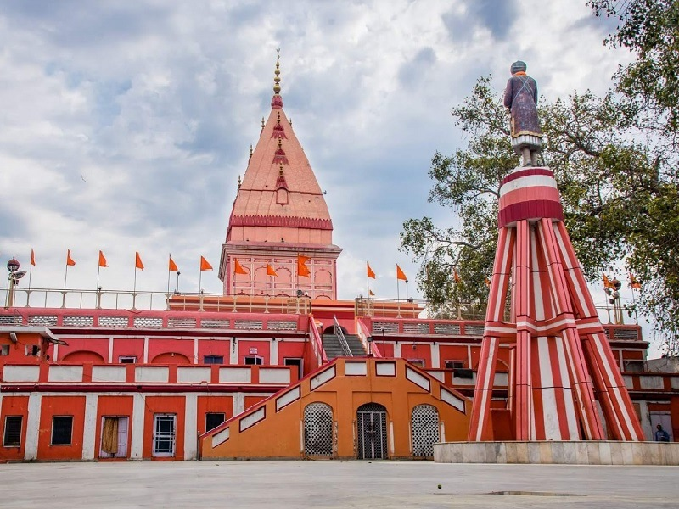
Photo Credit: Flickr
India | Jammu & Kashmir | Jammu
#8 of 17 Places to Visit in Jammu
Distance (From Jammu Tawi): 5 Kms
Trip Duration (Including Travel): 1 Hour
Place Location: Near The New Secretariat
Transportation Options: Cab / Auto
Travel Tips: None
At a distance of 5 km from Jammu Railway Station, Ranbireshwar or Ranveereshwar Temple is an old Hindu temple located in Jammu city. Situated on Shalimar Road near the New Secretariat, it is one of the biggest Shiva temples in North India and among the prime Jammu places to visit.
Situated on the busy street of Shalimar Road, Ranbireshwar Temple was built by the Maharaja Ranbir Singh of the Dogra dynasty, and was named after him. Dedicated to Lord Shiva, this 200-year-old temple is reflecting the classic Nagara style of architecture. The highlight of the temple is the mammoth 8-feet tall black marble stone Shiva lingam standing high in the central sanctum sanctorum of the temple and is regarded as the biggest in north India.
There are 12 more Shivlingas in the temple which are made of crystal. These Shivalingas are 18 inches high and 12 inches wide. There is a slab inside the temple that has around 1.25 lakhs of Shivalingas that were brought from the Narmada River. There are also idols of Lord Ganesha, Kartikeya, and Nandi in the temple. Within the shrine, one can find a great brass idol of Nandi, said to weigh over 1000 kg. The walls of the temple are adorned with beautiful marble images of Lord Shiva and Goddess Parvati. A wonderful garden surrounds the temple, complementing this religious visit with some pleasing imagery of the landscape of Jammu.
The best time to visit this temple is during the aarti in the morning and evening. Maha Shivaratri is the main festival celebrated in this temple with much fervor and a huge number of devotees and tourists pay homage to the lord during this auspicious occasion.
Timings: 6 AM - 8 PM
Entry: Free

Mahamaya Temple, Jammu - Timings, Festivals, History, Darshan, Pooja Timings
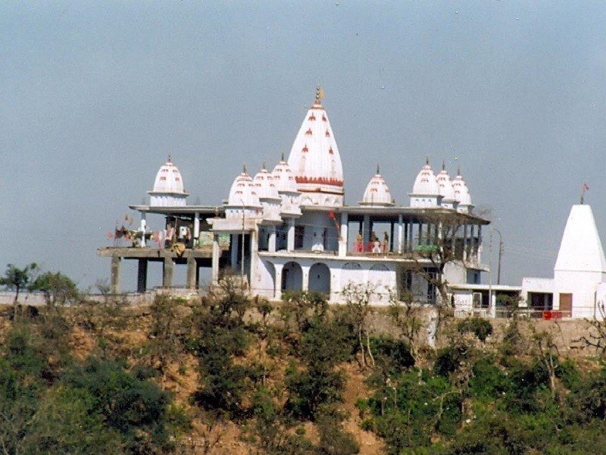
Photo Credit: Flickr
India | Jammu & Kashmir | Jammu
#15 of 17 Places to Visit in Jammu
Distance (From Jammu Tawi): 6 Kms
Trip Duration (Including Travel): 2-3 Hours
Transportation Options: Cab / Auto
Travel Tips: None
At a distance of 6 km from Jammu Railway Station, Mahamaya Temple is an ancient temple located on the top of a hill in Jammu. Situated behind the majestic Bahu Fort, it is one of the important religious places in Jammu.
Mahamaya Temple is situated on the banks of the Tawi River on the outskirts of Jammu City. Unlike other temples in India, this temple is not dedicated to any presiding Hindu deity but to Mahamaya, a local freedom fighter of the Dogra community, who sacrificed her life about 14 centuries ago to save her region from foreign invaders. The temple was built to laud her courage, and people honor her sacrifice to this day. The temple is a unique construction with a rich backstory that attracts scores of devotees throughout the year who come to pay their respects to the great heroine.
The white-topped temple surrounded by lush green forests lies in attractive contrast to the glamorous blue sky and the Trikuta mountain ranges in the background. From this spot, one gets a panoramic view of Jammu, the imposing structure of the Bahu Fort, and the meandering Tawi River. The serene vibe of the location helps visitors receive an authentic experience of tranquillity.
One can reach this temple by hiring a taxi from the city or through a ropeway.
Timings: 6 AM - 8 PM
Entry: Free
Ropeway:
Section I (Peerkho to Mahamaya): Rs. 150 per Person (Both ways)
Section II (Bahu Fort to Mahamaya): Rs. 500 per Person (Both ways)

Jammu Ropeway, Jammu - Timings, Trekking, Camping, Best Time to Visit
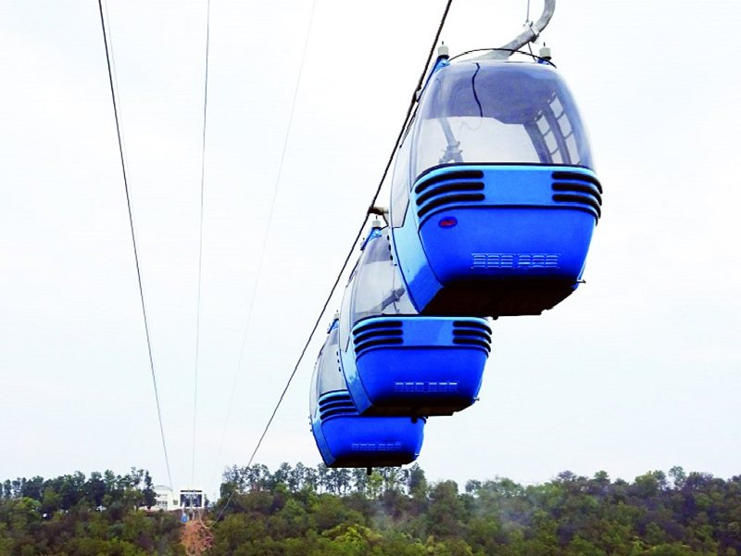
Photo Credit: Flickr
India | Jammu & Kashmir | Jammu
#16 of 17 Places to Visit in Jammu
Distance (From Jammu Tawi): 4 Kms
Trip Duration (Including Travel): 2 Hours
Place Location: Near Bahu Fort
Transportation Options: Cab / Auto
Travel Tips: None
At a distance of 4 km from Jammu Railway Station, Jammu Ropeway is a famous cable car ride located in Jammu City. Situated near Bahu Fort, it is one of the popular cable car rides in India, and among the must to do things as part of the Jammu Tour.
Built for JKCCC, this 1.66 km long Jammu Cable Car project has two sections. The first section is from Peer Kho to the Mahamaya Temple and goes over the Tawi River while the second section is from the Mahamaya Temple to the Bahu Fort. The project was planned back in 1995 with an estimated cost of INR 75 crore. The project faced dozens of delays in its start, execution, and date of completion. Finally, the project has completed after 25 years and opened in the year 2020.
The ropeway from Bahu Fort to Mahamaya has 8 cabins and from Mahamaya to Peer Kho section has 14 cabins and 3 or 4 persons are allowed in one cabin. The cable car project provides people with an international standard experience and transportation facility, connecting important tourist sights and providing a beautiful and picturesque view of the River Tawi and the numerous temples situated on both banks of the River Tawi.
Timings: 11 AM - 6 PM
Cost for Cable Car Ride:
Section I (Peerkho to Mahamaya): Rs. 150 per Person (Both ways)
Section II (Bahu Fort to Mahamaya): Rs. 500 per Person (Both ways)

Raghunath Bazaar, Jammu - Timings, Things to Buy

Photo Credit: Flickr
India | Jammu & Kashmir | Jammu
#17 of 17 Places to Visit in Jammu
Distance (From Jammu Tawi): 5 Kms
Trip Duration (Including Travel): 2-3 Hours
Place Location: Adjacent To Raghunath Temple
Transportation Options: Cab / Auto
Travel Tips: None
At a distance of 5 km from Jammu Railway Station, Raghunath Bazaar is a shopping area in Jammu. Located adjacent to the famous Raghunath Temple, it is one of the most popular, and old marketplaces of Jammu.
Raghunath Bazaar is named after the famous Raghunath Temple which sits on the same road. The bazaar is around 160 years old and serves as a symbol of the spiritual and cultural heritage of Jammu. This market has many things to shop from old to new, antiques to modern, and local to exported items. This place is crowded most of the time with locals, and tourists.
The bazaar is distinguished for its long-standing dry fruit shops. This market is also renowned for the wide spread of traditional Dogra Jewelleries and Kashmiri handicrafts. Some of the other shopping items available here, and which can prove to be great souvenirs and gifts for the people back home are woolen carpets, handloom, shawls, phirans, tweeds, silk and embroidery works, vases, bowls, wall hangings, furniture, wood carvings, brass and silverware, beautiful show pieces made of walnut wood and other decorative items made of wood. This place is also a must-visit for people who are fond of sweets and one should not miss an opportunity to taste the 'Sweet Barfi ' or 'The Chocolate Barfi' in Raghunath Bazaar.
Timings: 10 AM - 6 PM
Entry: Free

Bhimgarh Fort, Jammu - Timings, History, Architecture, Best Time to Visit
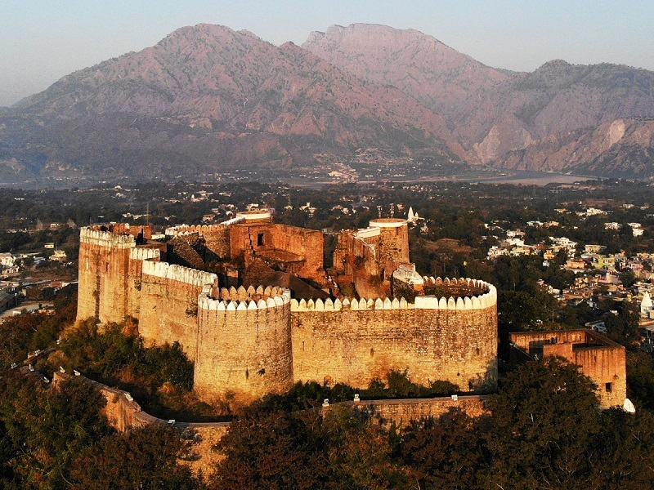
Photo Credit: Flickr
India | Jammu & Kashmir | Jammu
#4 of 17 Places to Visit in Jammu
Distance (From Jammu): 72 Kms
Trip Duration (Including Travel): Half Day to Full Day
Place Location: At Reasi Town
Transportation Options: Bus / Cab
Travel Tips: None
At a distance of 24 km from Katra, and 72 km from Jammu, Bhimgarh Fort is a historical fort situated at Reasi town of Jammu & Kashmir. Also known as Reasi Fort, it is one of the best places of heritage in Kashmir, and among the top places to visit near Mata Vaishno Devi.
Perched atop a 150m high hillock, the Bhimgarh Fort was constructed with clay by Rajput king Bhimdev Rasyal of Reasi in the 8th century. Later, one of the heirs of Raja Rishipal Rana, reconstructed the fort using stone. The Bhim Garh Fort was used by the royal family members for taking shelter during emergencies. The fort was later renovated by Gulab Singh of Jammu and Kashmir in 1817. A new entry gate and a stone wall were built all around, thereby making it less vulnerable to attacks. After the death of Maharaja Gulab Singh, his heirs Maharaja Ranbir Singh and Maharaja Pratap Singh used Bhimgarh Fort as a treasury and armory. During Maharaja Hari Singh's rule, an English minister ordered that the armory be destroyed and shifted the treasury to Jammu.
Until 1988, this beautiful fort was in sturdy condition but later it was handed over to the Jammu and Kashmir State Archaeology Department in 1989 on the orders of the state government. In 1990, the fort was renovated by the Vaishno Devi Shrine Board. The surrounding areas were given a facelift with the construction of gardens and pathways. The fort stands out as an important landmark in the town despite the devastating earthquakes and lack of maintenance.
Stands over the waters of the Anji River, Bhimgarh Fort is an amalgamation of Rajasthani and Mughal architecture. The entrance gate is made entirely from Baluka stones. The front wall has loopholes along with a statue of the Goddess Mahakali and God Hanuman. The fort complex consists of a temple, a pond, rooms of different sizes, an armory, and a treasury.
Timings: 10 AM - 5 PM
Entry: Rs. 100 for Person

Manda Zoo Park, Jammu - Timings, Entry Fee, Safari Cost, Safari Booking, Best Time to Visit
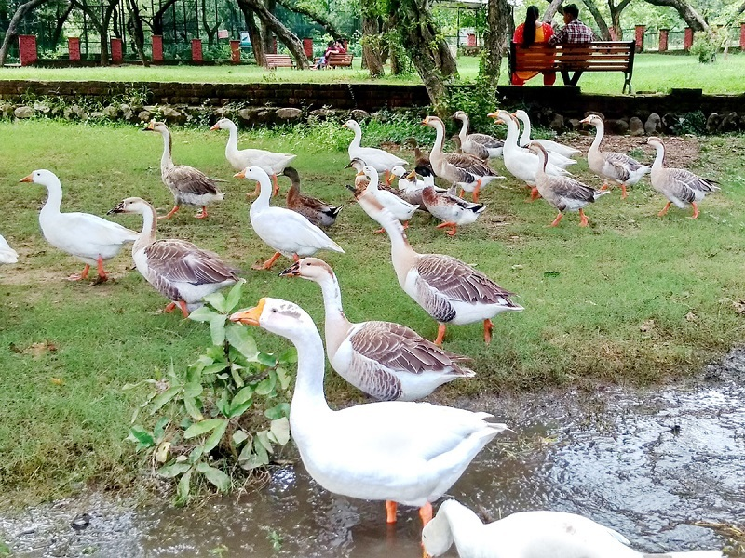
Photo Credit: Flickr
India | Jammu & Kashmir | Jammu
#5 of 17 Places to Visit in Jammu
Distance (From Jammu Tawi): 7 Kms
Trip Duration (Including Travel): 2-3 Hours
Transportation Options: Cab / Auto
Travel Tips: None
At a distance of 7 km from Jammu Railway Station, Manda Zoo is a zoological park situated on palace road near Hari Niwas, in Jammu. It is the only zoo in the only zoo in the whole province and among the best tourist places in Jammu.
Manda Zoo Park is a small zoo with animals in old-school enclosures, such as crocodiles, cobras, deer, and tigers. The primary attraction of the park is an assemblage of butterflies like Peacock Pansy, Blue Pansy, Grass Yellow, Lime Butterfly, Sailor, and Plain Tiger. The park is also home to exotic birds like Turkey and Emu. The greenery of this zoo will soothe the mind. Spectacular views and a great surrounding atmosphere attract a lot of tourists to this zoo.
Manda Zoo Park is a beautiful place to visit on holidays and weekends with family. Winter is the ideal time to visit the zoo. One can reach the zoo by hiring an auto or cab.
Timings: 8.30 AM - 6 PM, Closed on Tuesday
Entry: Rs. 20 for Adults & Rs. 10 for Children

Rajinder Park, Jammu - Timings, Entry Fee, Best Time to Visit
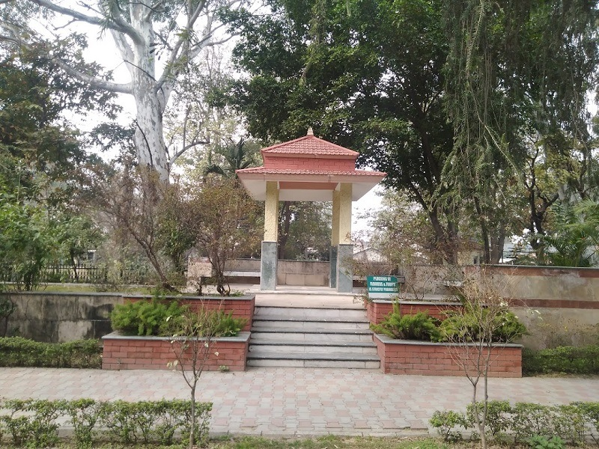
Photo Credit: Flickr
India | Jammu & Kashmir | Jammu
#9 of 17 Places to Visit in Jammu
Distance (From Jammu Tawi): 5 Kms
Trip Duration (Including Travel): 1 Hour
Transportation Options: Cab / Auto
Travel Tips: None
At a distance of 5 km from Jammu Railway Station, Rajender Park is a beautiful park located in Jammu City. It is one of the newly developed tourist places in Jammu.
Rajinder Park of Jammu is gifted with natural beauty and the majestic Himalayan range in the backdrop adds grace to the region. The park derived its name from Dr. Rajinder Prasad, the first President of India. Covered a distance of 1 km, the park is located between two canals and has a huge fountain. The beauty of this fountain is experienced at night when it is lit up. Seeing the popularity of this park, it was recently refurbished and spruced by Jammu and Kashmir Bank.
It is a supreme example of the legacy of the Mughals evident from the artistic style in which lawns here have been designed. Different species of trees, shrubs, and plants are found at Rajinder Park, which adds to the botanical richness here. This park is a favorite getaway for people in the region and also for tourists. Tourists come here during the summers to enjoy the chilling waters of the canal. A children's park adjacent to the main lawn of Rajinder Park is the main highlight of the region.
Timings: 10 AM - 8 PM
Entry: Rs. 5 per Person

Sidhra Golf Course, Jammu - Timings, Entry Fee, Best Time to Visit
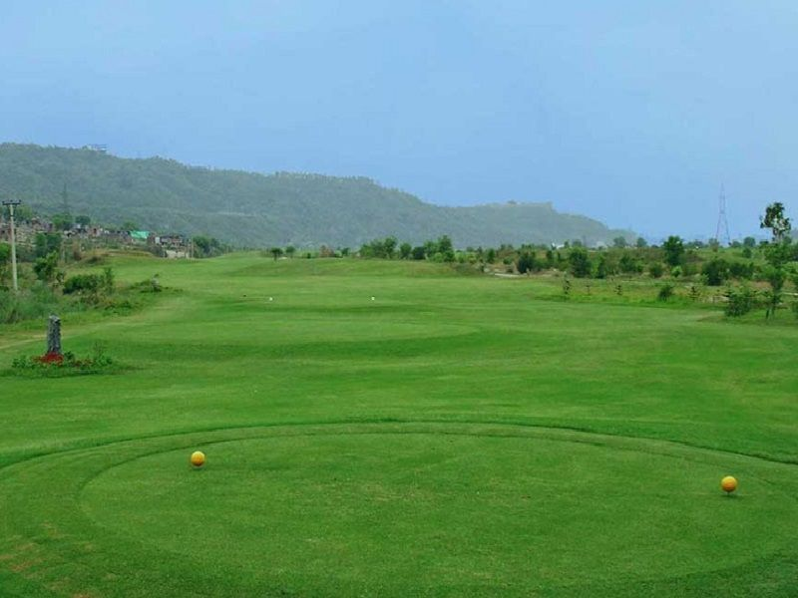
Photo Credit: Flickr
India | Jammu & Kashmir | Jammu
#10 of 17 Places to Visit in Jammu
Distance (From Jammu Tawi): 13 Kms
Trip Duration (Including Travel): 1 Hour
Transportation Options: Cab / Auto
Travel Tips: None
At a distance of 13 km from Jammu Railway Station, Sidhra Golf Course, or Jammu Tawi Golf is located in Sidhra on the outskirts of Jammu City. Situated on the bank of River Tawi at the foothills of the Shivaliks, it is one of the best golf courses in the region, and among the best places to visit in Jammu.
Sidhra Golf Course is a wonderful 18-hole eco-friendly golf course that is spread over an area of about 70 hectares. The Government of Jammu & Kashmir undertook the construction of this prestigious project in 2011 to boost Golf Tourism. It was designed by internationally renowned designer Col. K.D Bagga. It has two big and three small water bodies (lakes) and about 3200 m long water channel. The golf course is equipped with all the modern facilities like a Golf club, Changing rooms, Golf carts, and Pro-shop.
With the impressive backdrop of Trikuta mountains, it opens to a breathtaking panorama of clean waters of River Tawi and affords the charming view of the distant Amar Mahal Palace, Hari Niwas Palace, and Mubarak Mandi Complex on one side and the Bahu Fort and Mahamaya Temple on the other. Besides, a 2 km long promenade bordering the Golf Course along River Tawi is the best place for joggers and a scenic attraction for tourists. One can also visit Dogra Art Museum, which is situated nearby.
Timings: 9 AM - 5 PM

Purmandal, Jammu - Timings, Festivals, History, Darshan, Pooja Timings
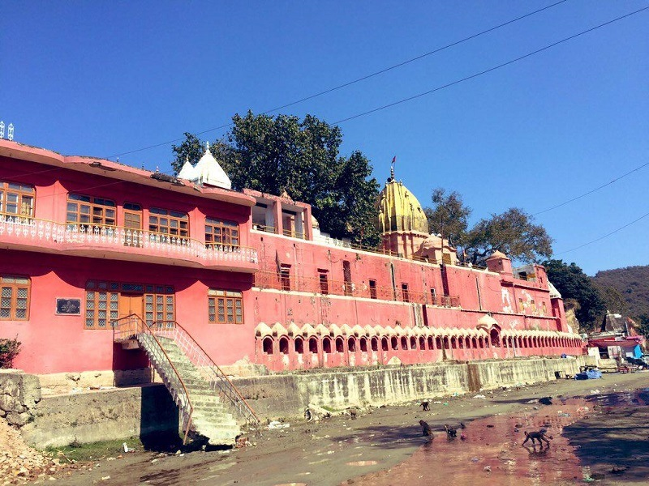
Photo Credit: Flickr
India | Jammu & Kashmir | Jammu
#11 of 17 Places to Visit in Jammu
Distance (From Jammu): 28 Kms
Trip Duration (Including Travel): 3 Hours
Transportation Options: Bus / Cab
Travel Tips: None
At a distance of 28 km from Jammu, Purmandal is a sacred town located in the Samba district of Jammu & Kashmir. Often referred to as Chotta Kashi, it is one of the famous places of pilgrimage in Kashmir, and among must-include places in Jammu tour packages.
Situated on the banks of the Devika River, Purmandal was an ancient center of trade and learning. The Devika River runs down from Purmandal to Uttarvehni (flowing towards the north) through village Mandal. It is one of the rare places where a river flows from south to north. The prime attraction of the village is the Purmandal Temple which is dedicated to Goddess Parvati. There are also several temples built on rocks dedicated to Lord Shiva. The temples in the village area create a very soothing relaxed atmosphere for the people.
One can also visit a large haveli, and several dharamshalas in the village. Many of these structures are decorated with murals dating from between 1813 and 1898. Every month a mela is organized in the Purmandal village during which the devotees take a holy dip in the Devika river and seek blessings from Lord Shiva. There are a total of 12 Mela in a year, and each Mela has assigned a unique name corresponding to the month, i.e. Chaitra Chaudish, Shivraatri Mela, etc.
One can reach the temple by catching a bus or by hiring a cab from Jammu. Regular bus services are also available from the cities situated in and around Jammu.
Timings: 5 AM - 9 PM
Entry: Free

Akhnoor Fort, Jammu - Timings, History, Architecture, Best Time to Visit
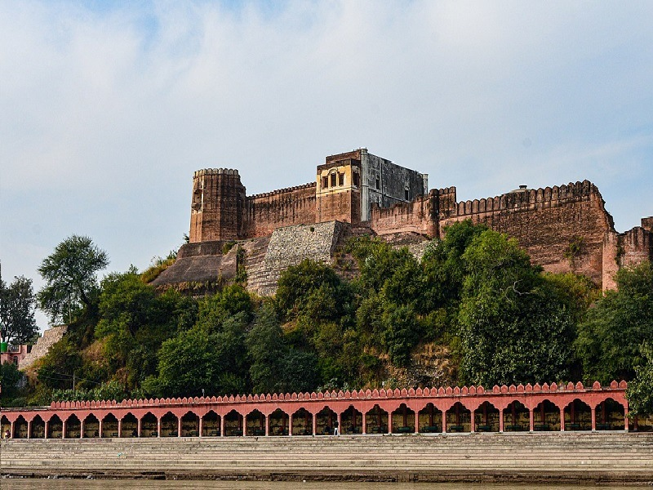
Photo Credit: Flickr
India | Jammu & Kashmir | Jammu
#12 of 17 Places to Visit in Jammu
Distance (From Jammu): 28 Kms
Trip Duration (Including Travel): 3-4 Hours
Transportation Options: Bus / Cab
Travel Tips: None
At a distance of 32 km from Jammu, Akhnoor Fort is an ancient fort in the small pleasing town of Akhnoor. Located on the right bank of the Chenab River, it is one of the popular places of heritage in Kashmir, and among the must-include places in Jammu.
Perched on a cliff, the Akhnoor Fort is a glorious attraction that is said to be built on the ruins of the ancient Archaeological town of Manda, where remains of the Harappan civilization and the Kushana dynasty have been found by Archaeologists. According to history, the construction of the fort was started by Raja Tegh Singh in 1762 CE and was completed by his successor Raja Alam Singh in 1802. Maharaja Ranjeet Singh crowned Maharaja Gulab Singh on the 17th of June 1822 at the fort's Jia Pota Ghat on Chenab's river bank. Due to its historical and cultural significance, it has been deemed a national monument and is protected by the Archaeological Survey of India since 1982.
A great example of fine Indian military architecture, this two-storeyed fort features thick, strong walls with bastions at regular intervals, and two-storeyed watch towers at the corners, which are crowned by battlements and merlons. The fort has two parts which are bifurcated by a wall with a gate leading to the grand palace of Raja Alum Singh on the southern side. The palace is two-storeyed, and the walls facing the courtyard have decorated arches adorned with exquisite mural paintings. One can also see picturesque views of the surroundings from the fort. Tourists can access Akhnoor Fort through both the riversides and the northern side.
Akhnoor Fort, where excavation is still in progress in a phased manner, is perched upon an ancient site depicting three periods of history. Divided into three periods, the first period is represented by the Harappan red and grey earthenware that includes jars, beakers, and goblets, and the second period is marked by the presence of early historic pottery while the third period is represented by Kushana objects and an impressive wall of rubble diaper masonry flanked on both sides by a 3-meter wide street.
Timings: 9 AM - 6 PM
Entry: Free
Oops! Something went wrong.
This page didn't load Google Maps correctly. See the JavaScript console for technical details.

Surinsar Lake, Jammu - Timings, Festivals, History, Darshan, Pooja Timings
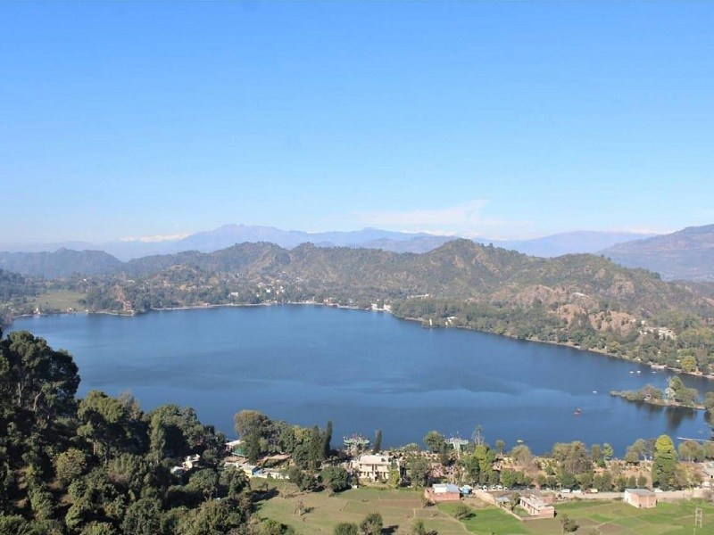
Photo Credit: Flickr
India | Jammu & Kashmir | Jammu
#13 of 17 Places to Visit in Jammu
Distance (From Jammu): 32 Kms
Trip Duration (Including Travel): 2-3 Hours
Place Location: At Blahad Village
Transportation Options: Bus / Cab
Travel Tips: None
At a distance of 32 km from Jammu, Surinsar Lake is a freshwater lake situated at Blahad village near Jammu. It is one of the most beautiful lakes in Kashmir and among the must-visit tourist places in Jammu.
Surrounded by thickly wooded mountain ranges, Surinsar Lake is known for its natural bounty that can be compared with the magnificence of Dal Lake and Nagin Lake of Srinagar. Surinsar Lake is one of the twin lakes in Jammu, the other being Mansar Lake located around 15 km away from it. The Surinsar Mansar Wildlife Sanctuary is nestled amid both the lakes and supports 3 mammalian species and 15 avifauna species including crane.
According to Hindu mythology, the origin of the lake is closely associated with the legendary warrior of Mahabharat, Arjun. According to the mythology, the Pandavas performed the Ashwamedh Yagna to show their superiority post the Kurukshetra war. The horse, which was the symbol of the power of the Yagna, was captured by the erstwhile ruler of the area Babru Vahan. Along with capturing the horse, he killed Arjun and shared his success with his mother by presenting the head of Arjuna to her. She revealed to Babruvahan that he had mistakenly killed his father. After knowing that, he wanted to get Arjuna back for which he had to procure Mani from Sheshnag. It was then that Babar Vahan made a tunnel with his arrow, which was called the 'Surangsar' which is now named Surinsar. After defeating Sheshnag and capturing the Mani, he came out at Manisar which is known as Mansar now, which was the other end of the tunnel. Later, a spring of water forms the lakes.
The perimeter of this lake is surrounded by thick mangroves, looming pine trees, and beautiful hills. An island situated in the middle of this land is home to thousands of bats. A bird sanctuary around the lake is a favorite among bird watchers. Religious taboos do not permit swimming or boating in the lake. In the vicinity of the lake, there is an adventure park having a giant swing, trampoline, artificial wall, etc. Excellent accommodation units with all the facilities near the lake are being provided by the Tourism Department.
Timings: 7 AM - 5 PM
Entry: Free

Mansar Lake, Jammu - Timings, Festivals, History, Darshan, Pooja Timings
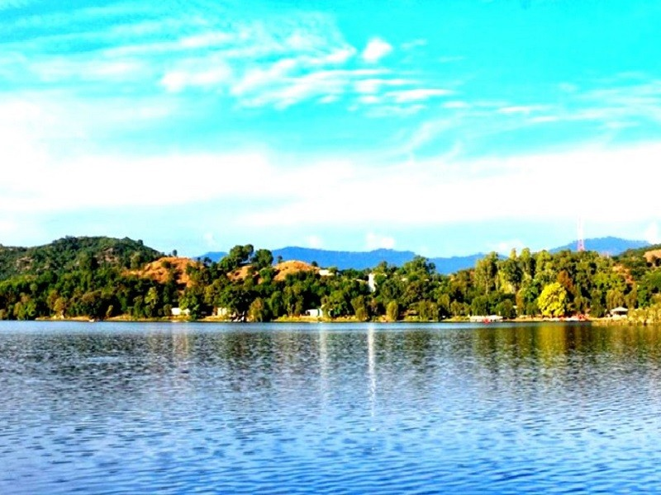
Photo Credit: Flickr
India | Jammu & Kashmir | Jammu
#14 of 17 Places to Visit in Jammu
Distance (From Jammu): 47 Kms
Trip Duration (Including Travel): 3-4 Hours
Place Location: At Buttal Village
Transportation Options: Bus / Cab
Travel Tips: None
At a distance of 47 km from Jammu, Mansar Lake is a sacred lake located at Buttal village near Jammu. It is one of the popular lakes in Kashmir and among the must-visit places during the Jammu Tour.
Fringed by dense forest, small parks, temples, and low-lying hills, the Mansar Lake is a mile in length and half a mile in width. Together with its twin lake Surinsar, it is designated as Ramsar Convention in November 2005. Mansar is primarily fed by surface run-off and partially by mineralized water through paddy fields. The lake is an attractive habitat, breeding, and nursery ground for migratory water folks. Another interesting feature of the lake is the presence of a large number of huge turtles, and fishes.
Besides being a popular picnic spot, Mansar Lake is also a popular pilgrimage site sharing the legend and sanctity of Lake Manasarovar. According to the mythology, the Pandavas performed the Ashwamedh Yagna to show their superiority post the Kurukshetra war. The horse, which was the symbol of the power of the Yagna, was captured by the erstwhile ruler of the area Babru Vahan. Along with capturing the horse, he killed Arjun and shared his success with his mother by presenting the head of Arjuna to her. She revealed to Babruvahan that he had mistakenly killed his father. After knowing that, he wanted to get Arjuna back for which he had to procure Mani from Sheshnag. It was then that Babar Vahan made a tunnel with his arrow, which was called the 'Surangsar' which is now named Surinsar. After defeating Sheshnag and capturing the Mani, he came out at Manisar which is known as Mansar now, which was the other end of the tunnel. Later, a spring of water forms the lakes.
There are several temples located on the periphery of the Lake. There is a shrine dedicated to Sheshnag, a mythological snake with six heads on the eastern bank of the lake. Newlywed couples consider it auspicious to perform three circumambulations (Parikarma) around the lake to seek the blessings of Lord Sheshnag. Two ancient temples of Umapati Mahadev and Narsimha and a temple of Durga are also situated in the vicinity of Mansar Lake. Some communities of Hindus perform the Mundan ceremony (first haircut) of their male children here.
Mansar Lake is a perfect place for a quiet, laid-back picnic. One can take a good walk on the paved walkway that surrounds the lake or sit on the well-maintained lawns, and enjoy the serenity of the lake. The lake is also ideal for boating for which the Tourism Department provides row boat & paddle boat facilities. The lake has a projected view deck which lets you observe seasonal birds, a large number of tortoises, and fishes of different species. There is also a small restaurant where visitors can enjoy some snacks.
Timings: 7 AM - 5 PM
Entry: Free, Rs. 100 for Boating, & RS. 50 for Parking

