

Vidya Pratishthan’s
Kamalnayan Bajaj Institute of Engineering
and Technology, Baramati-413133.
Pune University

A

Project Report on

“Army Management System”

In partial fulfillment of the requirements for award of
The degree of
BACHELOR IN ENGINEERING
BY

AsHWINI BABAR ROLL NO: 2031002
PRAGATI KANGUDE ROLL NO: 2031032
PRERANA RAYKAR roll no: 2031055
SAIMA SHAIKH roll no: 2031057

Project Guide
Mr. S.K.Shah

T.E Computer. (Sem-V) 2020-2021

Certificate

This is to certify that work on the project report “Army management System” presented by “Ashwini Babar , Pragati Kangude , Prerana Raykar , Saima Shaikh” in partial fulfillment of the requirement for the award of Bachelor of Computeer Engineering to the VPKBIET, Baramati has been carried out under my guidance.
To the best of my knowledge and belief the matter presented in this report has not been submitted earlier or copied from anywhere.

Mr. S.K.Shah
Project Guide

ACKNOWLEDGEMENT

In Our endeavor to achieve the success in completing our project “Army Management system ” in the Third Year Engineering in Computer Engineering. We greatly thankful to the people without whose assistance, guidance and efforts we would not be able to complete out project successfully.

We express with our heartfelt gratitude to our guide ‘Mr. S.K.Shah’ who through his experience, encouragement and constant guidance helped us to shape our project to the present stage without his help our project could not be completed.

Finally we would like to thank our college’s teaching and non-teaching staff of our department for co-ordinating with us.

ASHWINI BABAR
PRAGATI KANGUDE
PRERANA RAYKAR
SAIMA SHAIKH

ABSTRACT

As a part of Project we are going to create the software that helps in Army Management. In this project we are trying to implement the software that will help both the Soldier’s & the Army Major to get the information about the Army data.
This project is basically created to reduce the work of Army Major. In this project we are also trying to record the information about the Soldier who have admitted in the Army. This will also help the Army Major. This Project will also hides Details about the records.

INDEX

Sr. No. | Topic Name | Page No.
1. | Introduction | 6
2. | Introduction to Project | 7
3. | Database Design | 8
4. | ER Diagram | 13
5. | Output Screens | 15
6. | User Manual | 24
7. | Conclusion | 25
8. | Bibliography | 26

1 Introduction

Need of computerization
We live in a computer age. Most of our day-to-day activities are beginning influenced by the use of computer; it has become necessary for every one to have basic knowledge of computer. The computer field as a whole continues to experience tremendous growth of personal computer, which were introduced in early 1980’s have become popular and being widely used in offices and homes. The usefulness of computer has growth steadily with the introduction of powerful and versatile computer software programs, while in areas like science and technology improvements are unimaginative.

Some people are enormously believed that computer’s can only work on arithmetic operations. The use can work on any kind of data – text, numeric, images, sound and video clipping etc.

The computer is characterized by incredible speed, great accuracy, high consistency and high amount of storage capacity.

2 Introductions to the Project

I have designed my project “ARMY MANAGEMENT SYSTEM”. The project is used by Army Major to make their work easy. By this project we can create new Soldier accounts, search for a particular soldier,update soldier data,managing all information of soldier also we manage the information of Squad details, Weapon details,War details in it.

One of the facility of this project is that it is more user friendly. In this project we keep the records of all the soldiers and all their infromation required by a Army Major.

This project provides the facilities to the Army Major to manage the Army Headquaters easily; it is time consuming work for them to keep the things in manual registers. In the point of view my project saves a lot of time, which has important to that of money.

In this project access is used as back-end that is for storing data in database. Access is a powerful database management package, so we can efficiently provide security to my data as well as take backup as and when necessary.

3 Database Design

This table gives the detail information of the Soldier

Soldier table
MASTER TABLE1

Field | Type | Size | Description
id | int | 10 | It is unique field,which identifies particular soldier.
fname | varchar | 40 | It store first name of soldier.
lname | varchar | 40 | It store last name of soldier.
Position | varchar | 40 | It stores position of soldier in Army.
dob | date |  | It store date of birth of soldier.
doj | date |  | It store joining date of soldier.
dor | date |  | It stores retirement date of soldier.
squadno | varchar | 100 character | It stores squad name of soldier .
yrno | int | 4 character | It stores soldier join in this squad of soldier .
sex | varchar | 10 | It store soldier gender .
height | varchar | 10 | It store soldier height.
weight | varchar | 10 | It store soldier weight.
chest | varchar | 10 | It store soldier chest.
mobno | varchar | 10 character | It stores soldier mobile no.

This table gives the detail information of the soldier work details.
Work Details
field | type | size | description
id | int | 10 | It is unique field,which identifies particular soldier
type | Varchar | 100 | It stores work type.
salary | Int | 10 | It stores salary of soldier.
date | Date |  | It stores work salary date.

This table gives the detail information of the soldier visited details.
VISITED TABLE

field | type | size | description
id | int | 4 | It is unique field,which identifies particular soldier.
pincode | varchar | 6 character | It is unique field,which identifies particular Pincode
date | date |  | It stores date of visiting.
reason | varchar | 100 | It stores reason of visiting the place.

This table gives the detail information of the soldier posting details.
Posting Details
field | type | size | description
id | Int | 10 | It is unique field,which identifies particular soldier.
pincode | Varchar | 6 character | It is unique field,which identifies particular pincode.
date | Date |  | It stores posting date of soldier.

This table gives the detail information of the soldier reward details.
REWARD TABLE

field | type | size | description
id | Int | 4 | It is unique field,which identifies particular soldier.
medalname | Varchar | 40 character | It stores medal name of soldier.
year | int | 4 | It stores year of getting reward.

This table gives the detail information of the Squads.

Squad table
MASTER TABLE

Field | Type | Size | Description
squadno | varchar | 40 character | It stores squad name.
captain | int | 4 | It stores captains ID of squad.
yrno | int | 4 | It stores year of squad.
totalCapacity | int | 4 | It stores capacity of soldier in the squad.

This table gives the detail information of the location.

LOCATION TABLE
field | Type | Size | Description
pincode | varchar | 6 character | It is unique field,which identifies particular Pincode.
dist | varchar | 40 character | It stores district name.
state | varchar | 50 character | It stores state name.
country | varchar | 30 character | It stores the country name.
This table gives the detail information of the weapon details.
WEAPON TABLE

field | type | size | description
wname | varchar | 70 character | It stores the weapon name
class | varchar | 40 character | It stores the class of weapon
serialno | int | 4 | It stores the serial number of the weapon

This table gives the detail information of the weapon manufacturing details.

MANUFACTURING DETAILS TABLE
field | type | size | descrption
serialno | int | 4 | It stores weapon id
mdate | date | 6 character | It stores manufacturing date of weapon
mlocation | varchar | 100 | It stores manufacturing location the weapon
orgname | varchar | 100 | It stores company orgname.

This table gives the detail information of the war details.
WAR TABLE

field | type | size | description
pincode | varchar | 6 character | It is unique field,which identifies particular Pincode.
status | varchar | 30 | It stores the status of war.
dateno | date |  | It stores war date nos.

This table gives the detail information of the soldier status during war details.
Soldier Status
field | type | size | description
id | Int | 10 | It is unique field,which identifies particular soldier.
alive | Int | 10 | It stores soldier alive status.
wdateno | Int | 10 | It stores war date nos.
pincode | Varchar | 6 character | It is unique field,which identifies particular Pincode

4.ER DIAGRAM

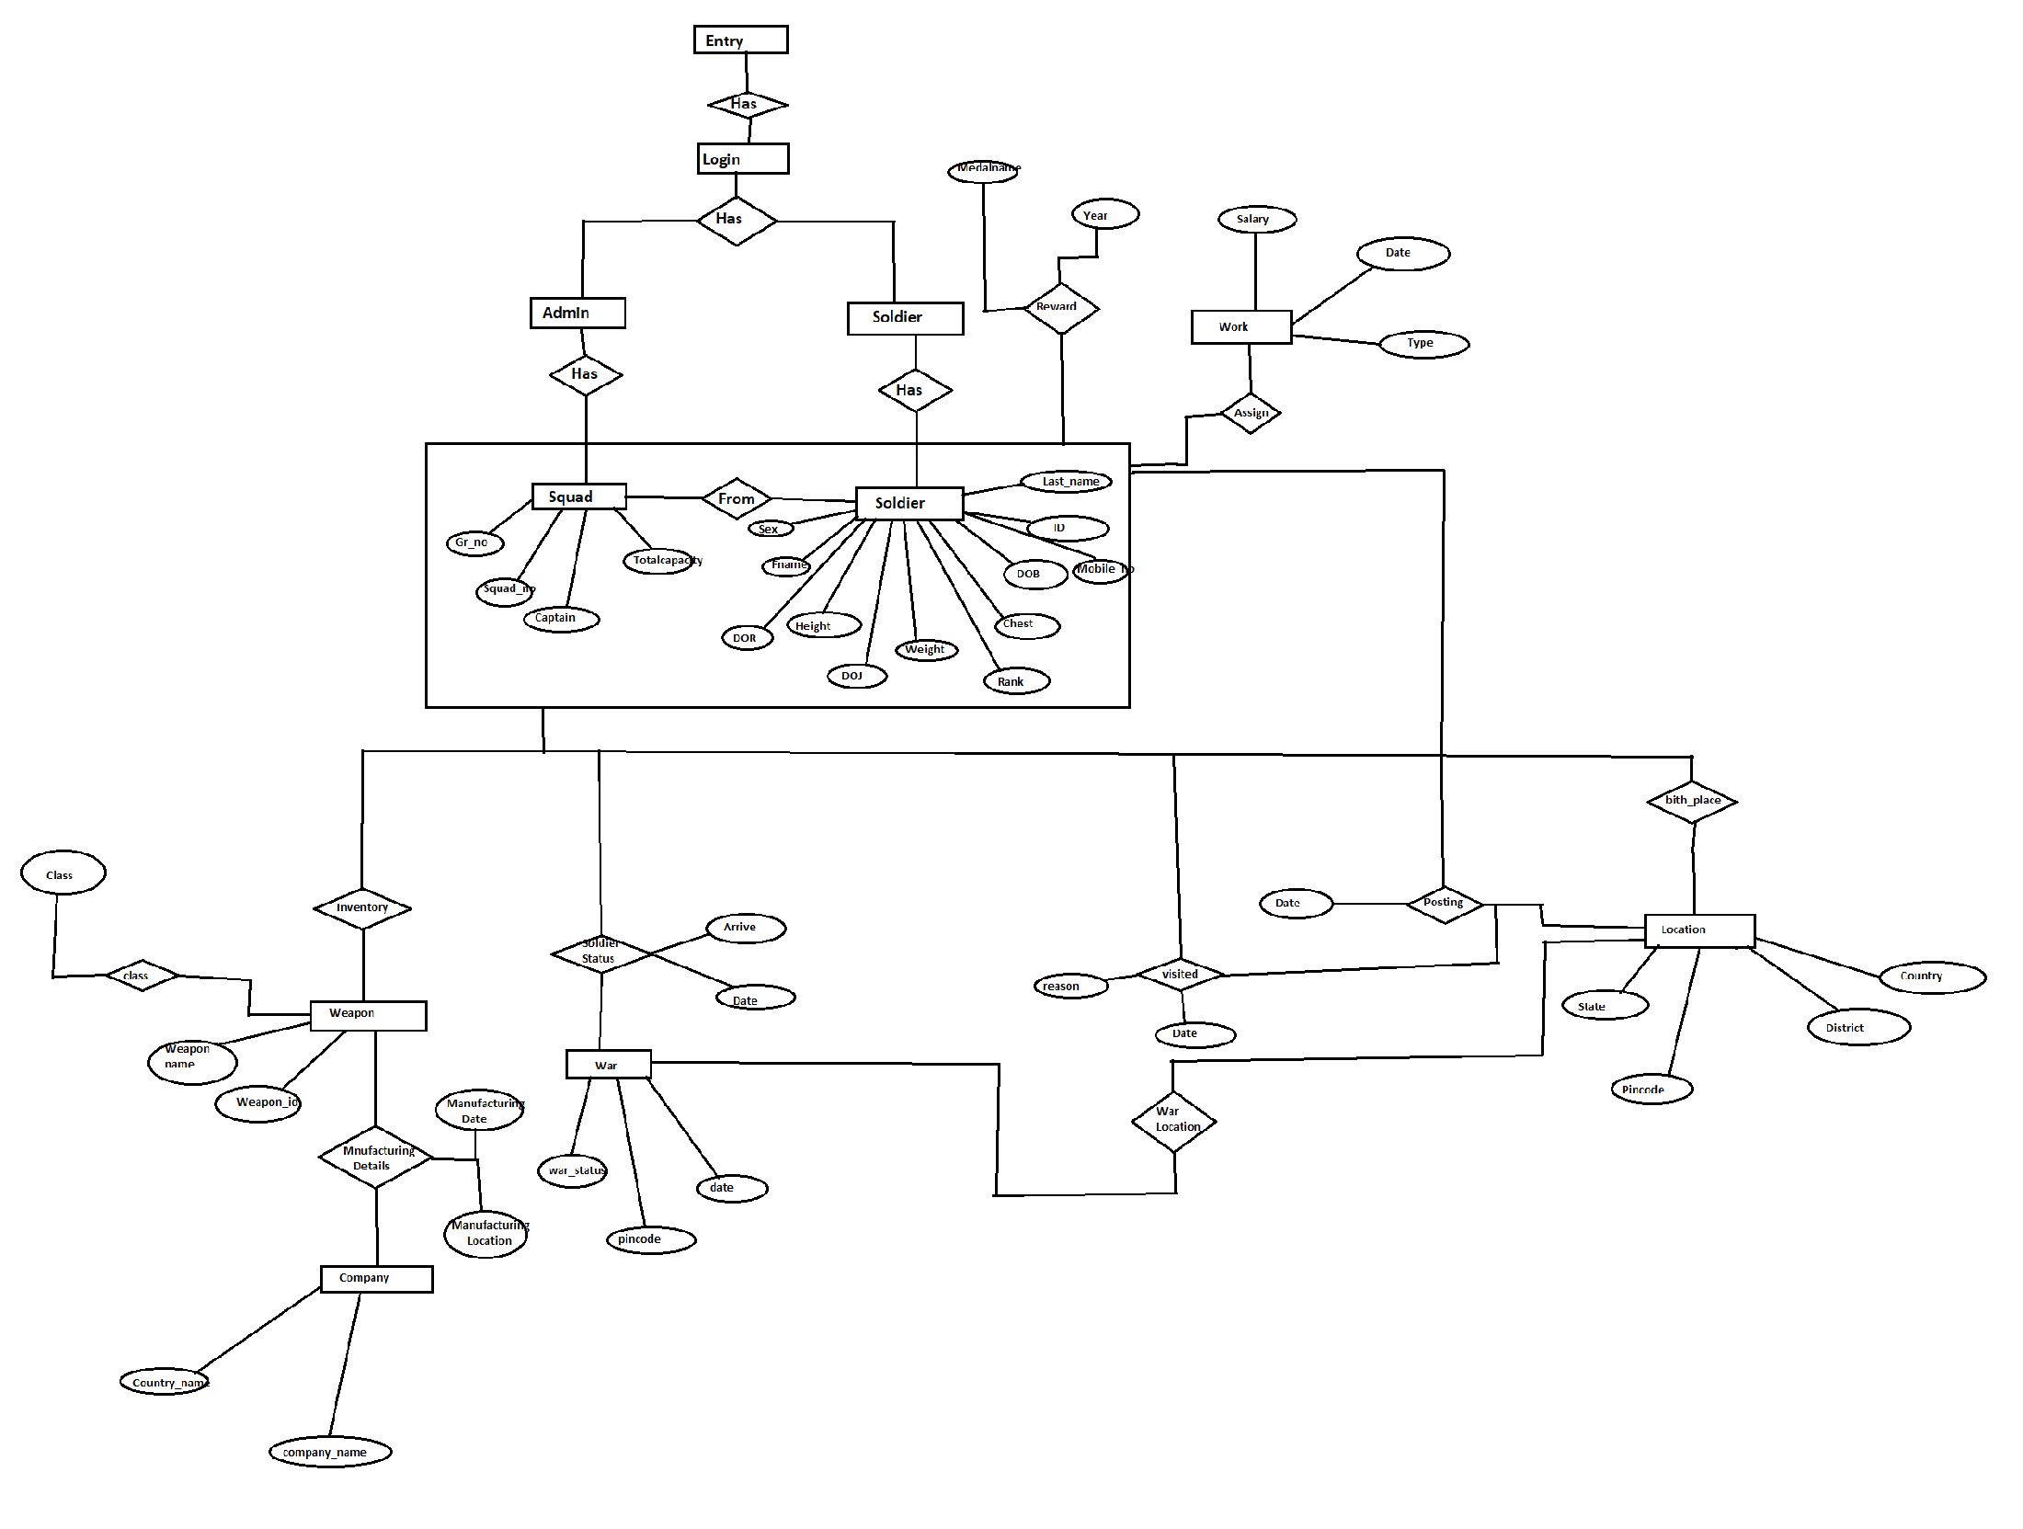

TECHNICAL SPECIFICATION:

HARDWARE REQUIRED:-

- CPU processor :-Intel i5

- RAM -128 MB and above

- Hard Disk -40 GB and above

- Output device:-monitor

SOFTWARE REQUIREMENTS:-

- Operating system:-Windows 10

- Front end:-JAVA

- Back end:- MySQL

5 Output Screens
Entry Screen
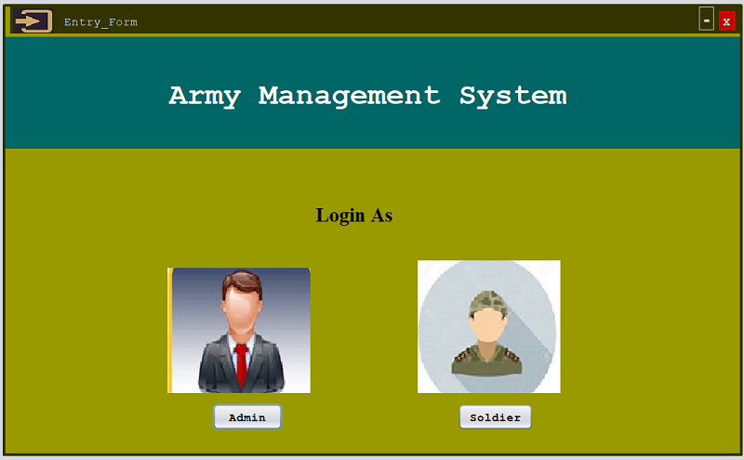

Login Screen
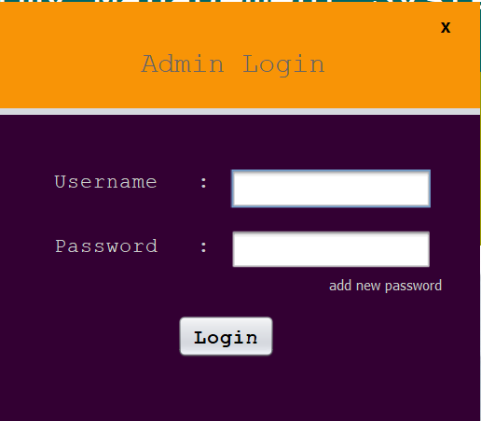
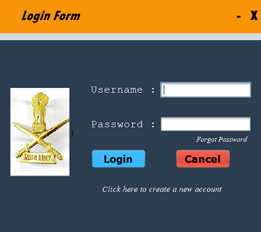
Soldier Registration
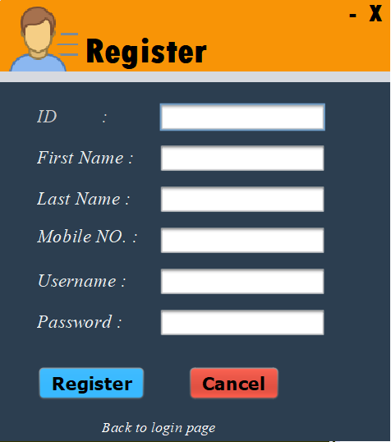

Home Screen
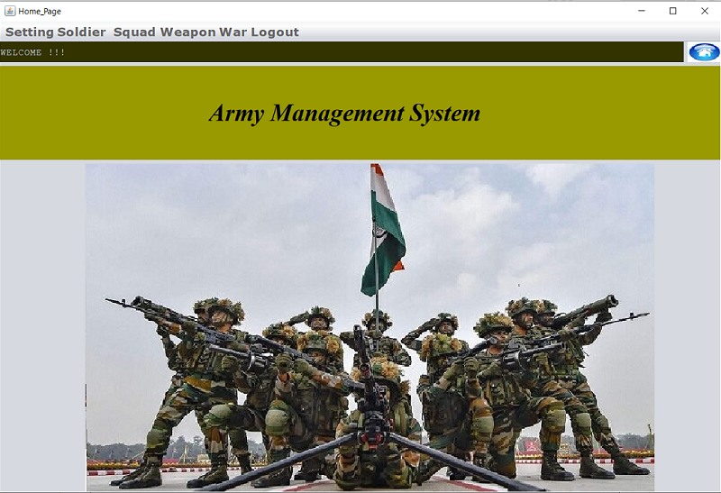

Location Details
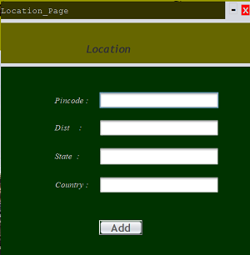

Soldier Details

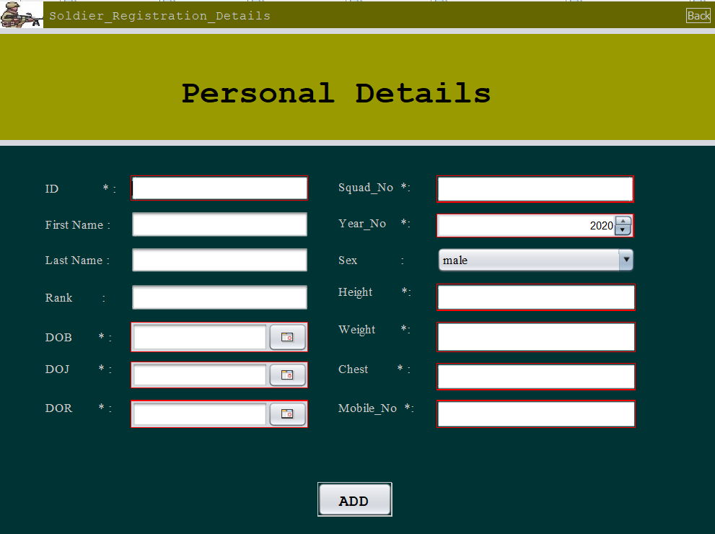
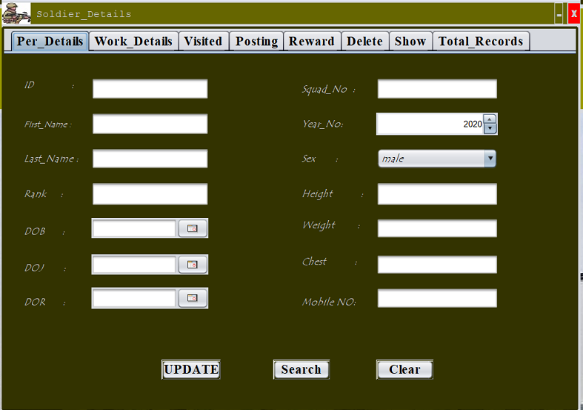
Squad Details
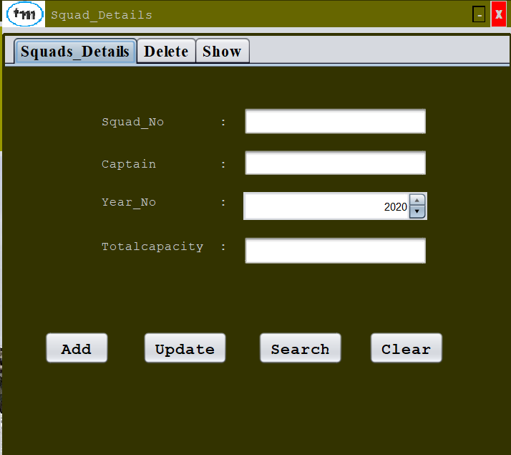
Weapon Details
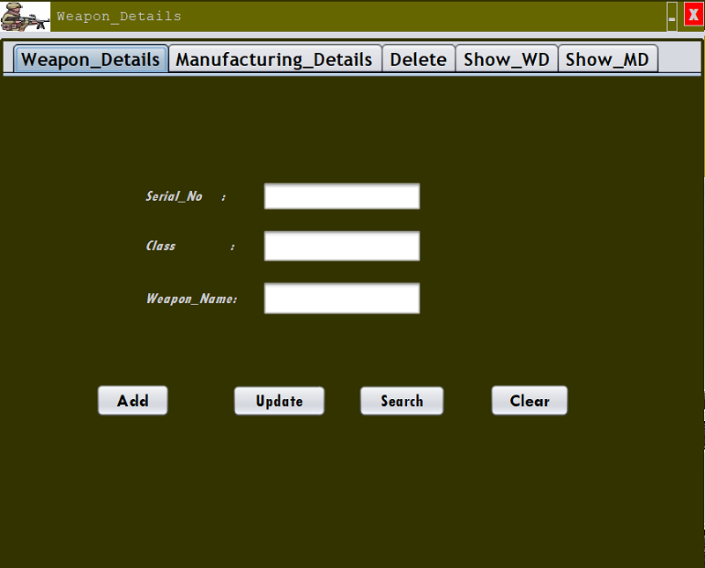
Manufacturing Details
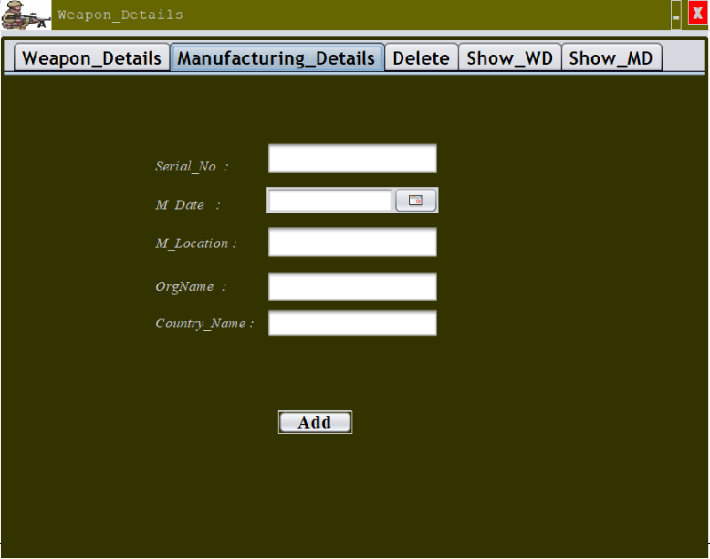
War Details
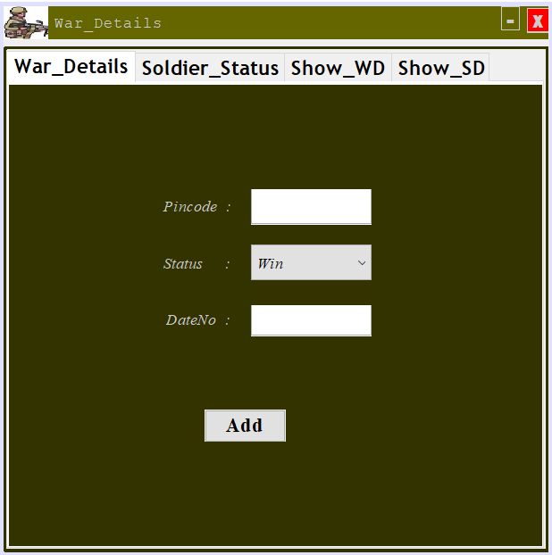
Soldier Status
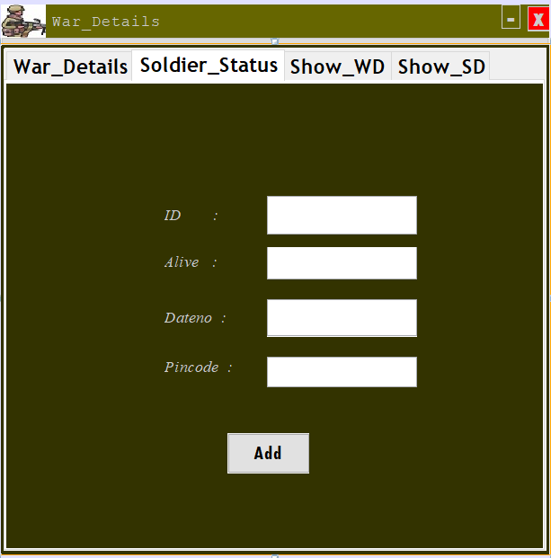

6 USER MANUAL

The application software “ARMY MANAGEMENT SYSTEM” is developed in Java as a front-end and MYSQL as backend.
This chapter introduces you to interact the user with my project. User understanding and satisfaction is the most important issue in the Army management system project.
The Main Menu contains the tabs:
- Setting
- Soldier login
- Soldier Details
- Squad Details
- Weapon Details
- War Details
- Logout

- Setting -
From here we add location details.

- Soldier Login-
From here ,soldier login page appears. Soldier can login and register if not already registered. The registration information gets sturctured in maser table.

- Soldier Details -
This is the form where admin can login into the system and handle all information of on them and perform operation on it like add,delete,update etc...

- Squad Details –
This is the form where the details of the squad .
- Weapon Details-
This is the form where all the details of Weapon and its Manufacturing details also.
- War Details-
This is the form where get all the war details .The status of soldier i.e he is dead or alive in the war & date war .

7 .Conclusion
I designed this project to the best of my ability.
After the development of ARMY MANAGEMENT SYSTEM
Working of the system showed that it deals with
Following aspects:
1. Create account of soldier and enter their registration information.

2. Allot squad to soldier and enter their details like date of joining ,id,name,etc...

3.Get all information of soldier like work,visited,posting,reward etc….

3.Get all details of Army Squads.

4.Get all details of weapon like manufacturing details.

5.Get all details of war and soldier status during war.

8 BIBLOGRAPHY

- Database system concept: Sixth edition. By Henry F. Korth and S. Sudarshan
- Software Engineering: . By Roger S. Pressman.

