DATA STRUCTURE (KCS-301)

LAB PRACTICAL FILE

NAME: PRAGATI SINGH

ROLL NO. :1901610100138

PROGRAM -1

IMPLEMENTATION OF TRAVERSE

INPUT

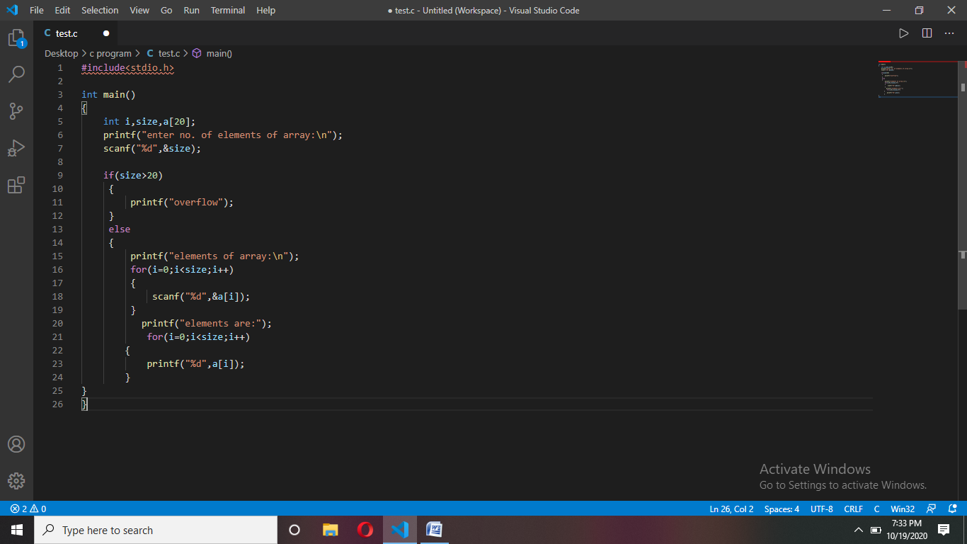

Output:-

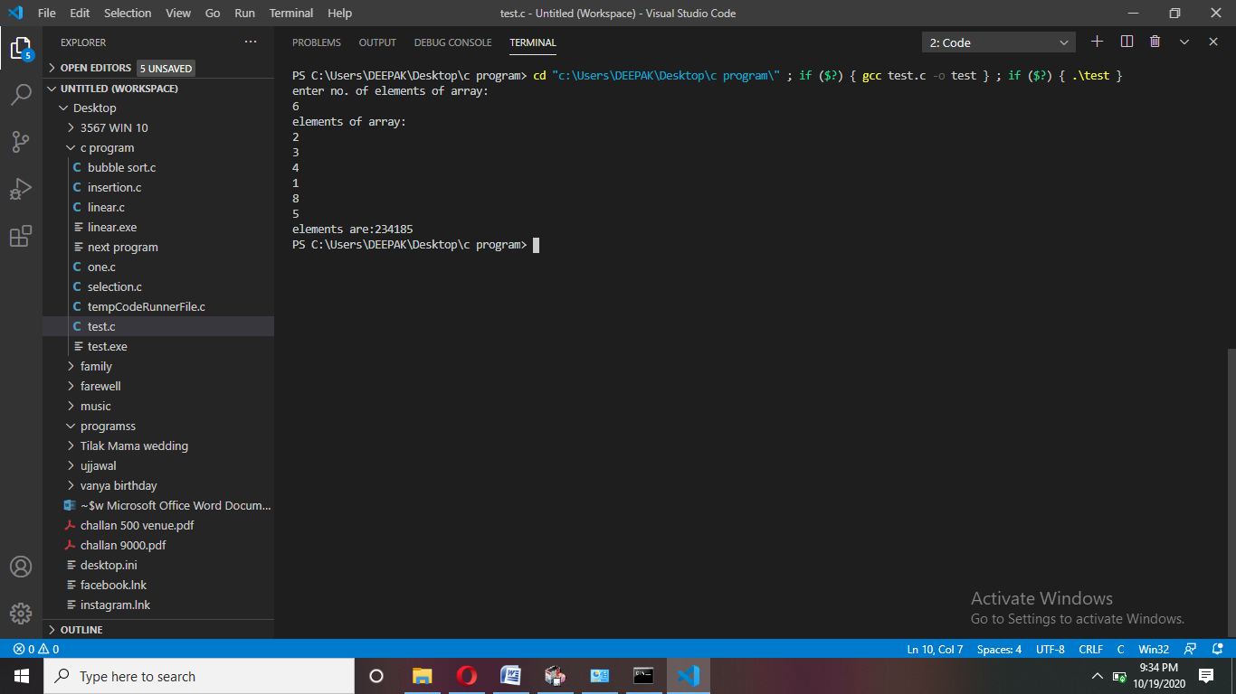

Write a program for binary search.

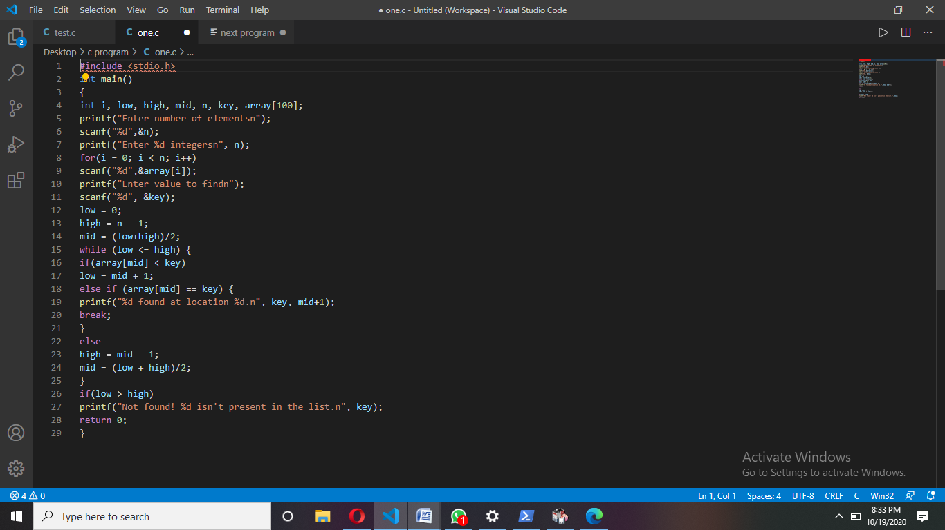

Output:-

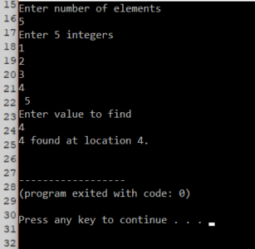

Write a program to linear search.

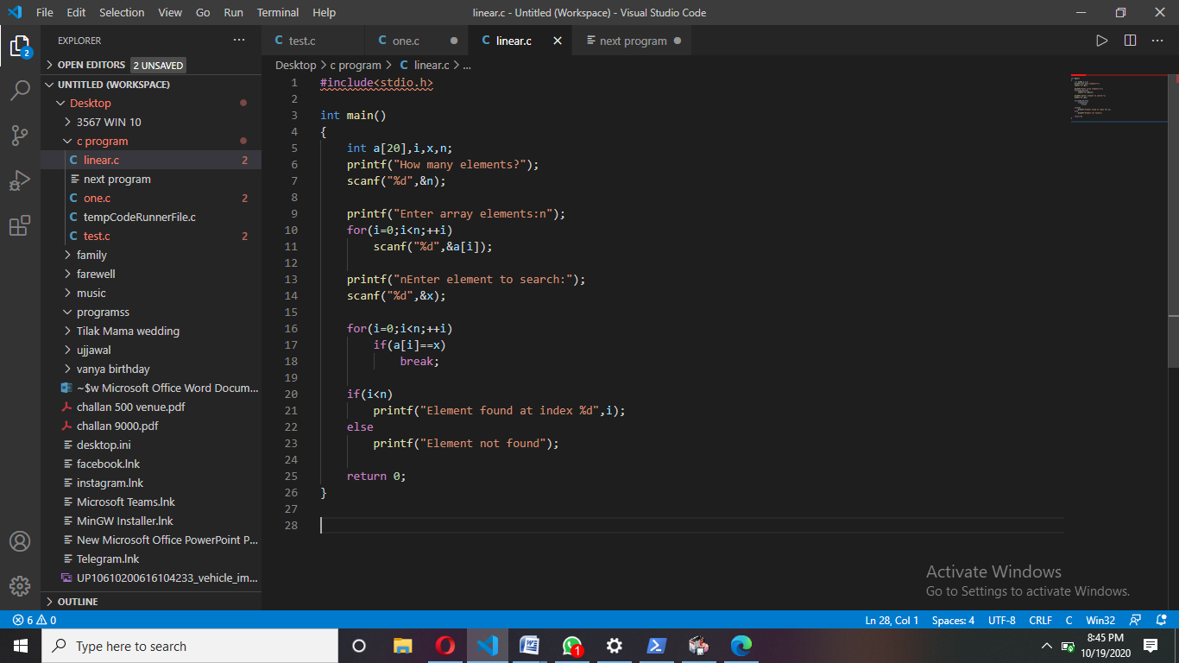

Output:-

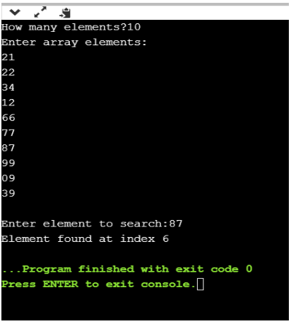

SORTING

Implementation of selection sort

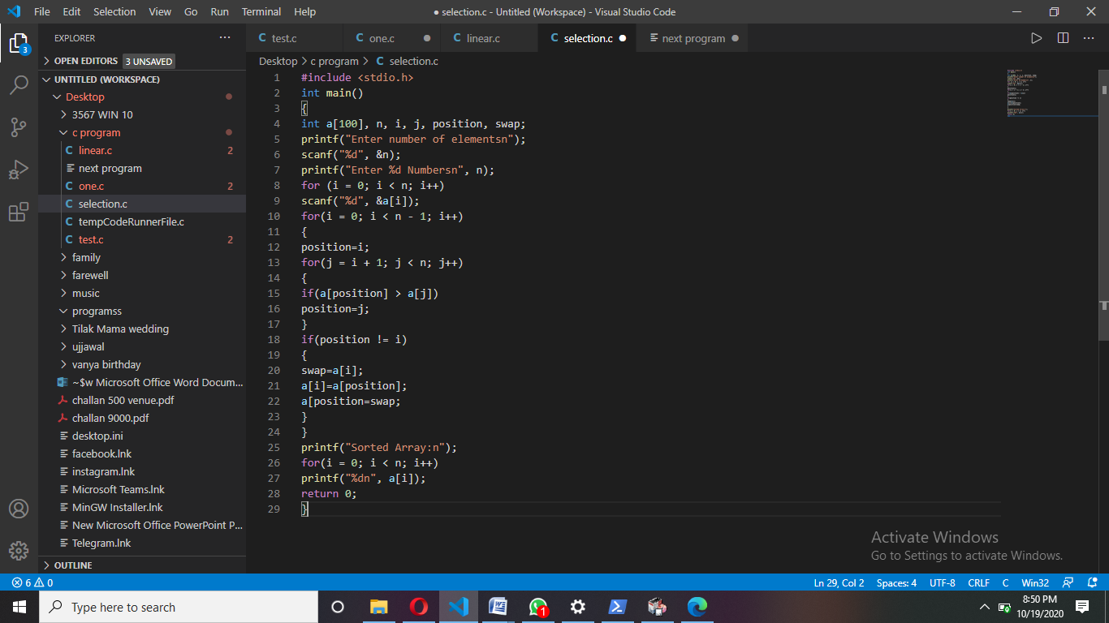

Output:-

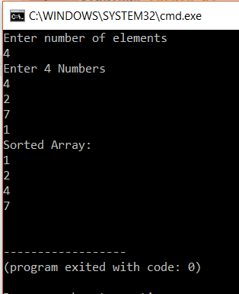

Implementation of bubble sort.

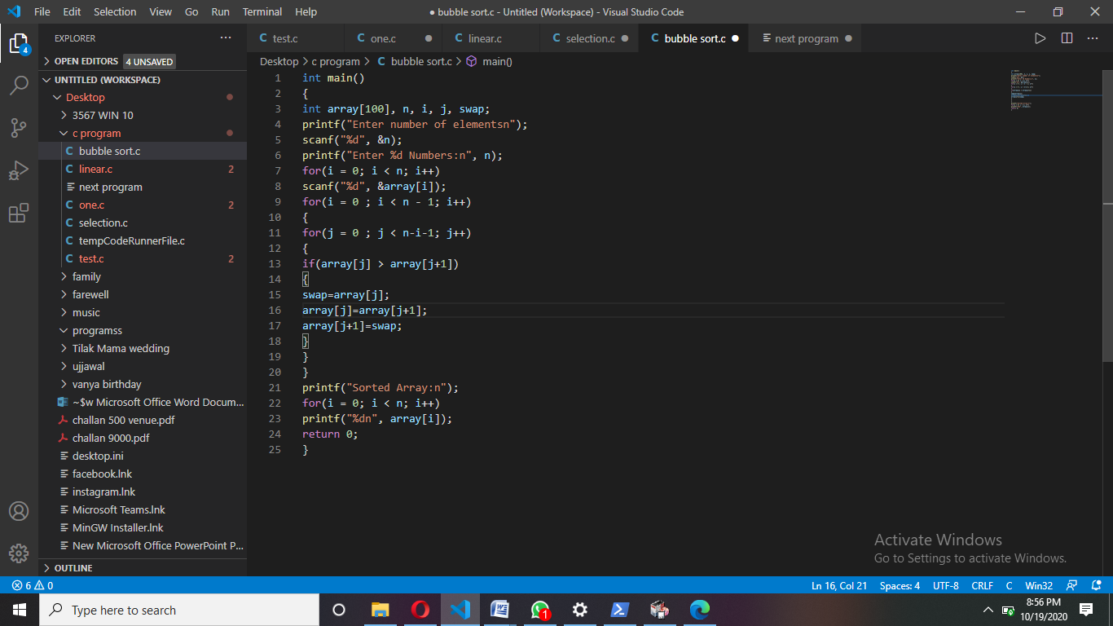

Output:-

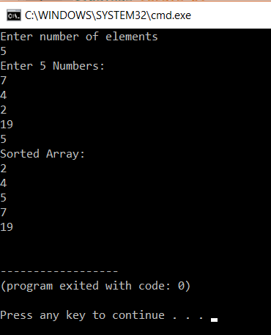

Implementation of insertion sort .

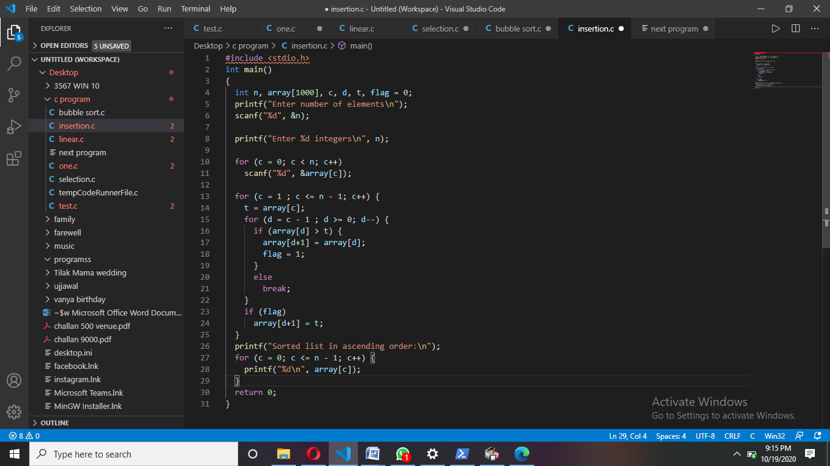

Output:-

