Name: Pragati Gupta
Roll No: 51
AIDS-B
ASSIGNMENT 1
Title: Assignment based on to take dataset from Kaggle.

Theory:
Basic formatting in Excel:
● Number formats: Excel has several number formats, including general, number, currency, accounting, date, time, percentage, and custom.
● Text alignment: By default, text is aligned to the bottom-left of a cell, and numbers are aligned to the bottom-right. You can change the alignment to make your content easier to read.
● Font: You can change the font style, size, and color. You can also bold, italicize, or underline your text.
● Fill color: You can change the fill color of a cell or range of cells.
● Borders: You can add borders to any side of a cell or range of cells.
● Wrap text: You can adjust cell text based on the column width.
● Line break: You can insert a line break within a cell.
● Merging cells: You can merge multiple adjacent cells into one cell.

Definitions:
• Data: Data is information, such as facts or numbers , that can be used to learn about something. It can be used for reasoning, calculating, or planning. Data can be represented in many different ways and there are many different types of data.
• Database: A database is a structured collection of information that's stored electronically in a computer system.
• Real life database: A real-life database is a collection of data that is organized, managed, and stored to be easily accessed, changed, and retrieved. Examples of some real-life database are: Oracle database, MongoDB, Microsoft SQL server, etc.
• Data analysis: Data analysis is the process of examining data to find useful information and make decisions.
APPLICATION I CHOSE:
My chosen application was SPOTIFY, which is a digital music and podcast app.


- It has data in all languages which ever we prefered.
- Spotify offers access to over 100 million tracks, 6 million podcast titles, and 350,000 audiobooks.
- Premium subscribers can download their favorite music and podcasts to play offline.
- There are two versions of Spotify :
- A premium monthly subscription service.
- A free service which is supported by advertise.

I made a data set for SPOTIFY in excel including all the information that according to me is necessary for relaxation, enjoyment . I used Kaggle for collection of the data required. Kaggle is an online website which hots various databases in it.
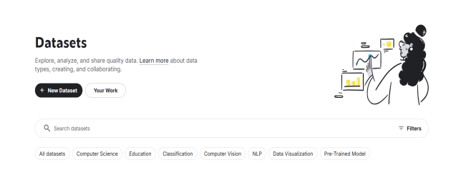

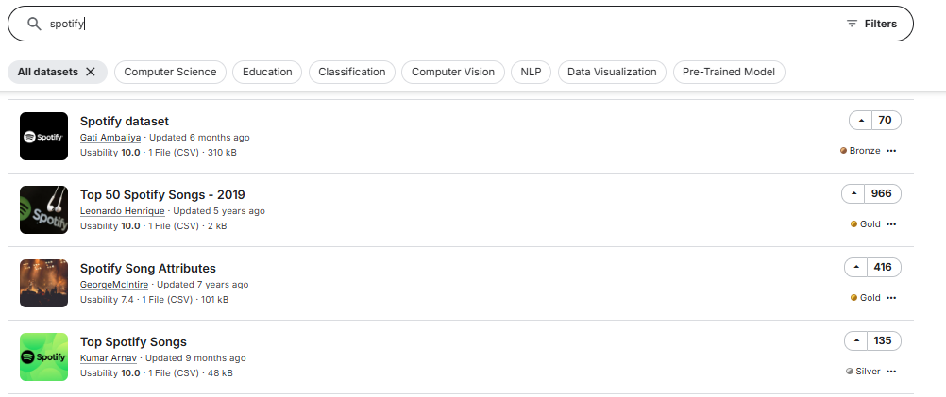

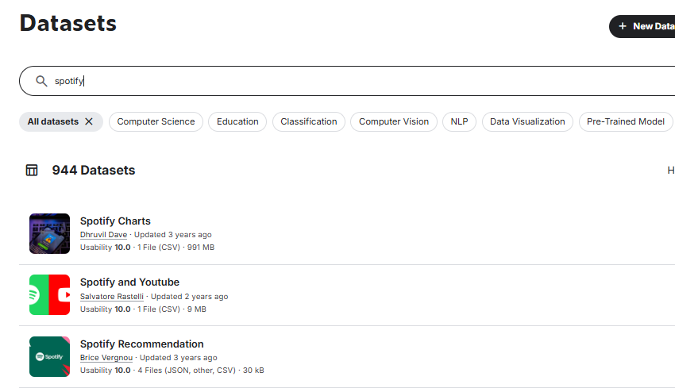

My excel worksheet contains the data set in two parts:
• The App Information

Data requirement:
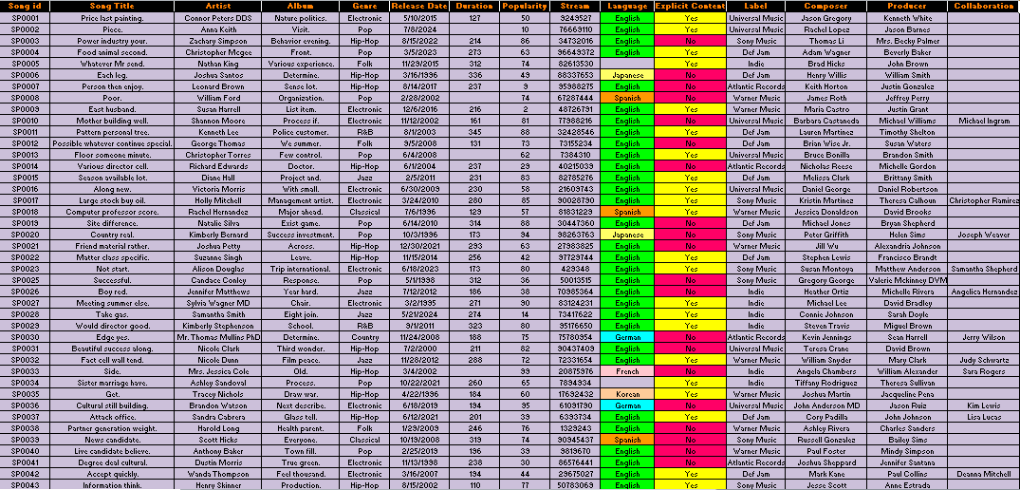


• Customer data:

Data requirement:
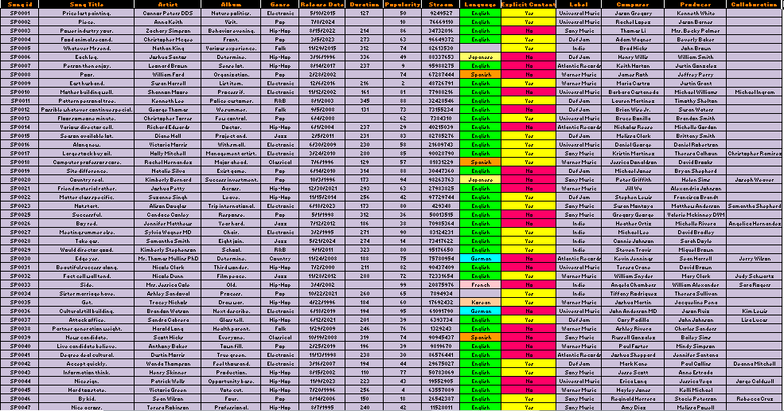

Conclusion: This assignment has provided an opportunity to explore and apply both basic and good knowledge and about techniques in spreadsheets. Through the exercises, students have gained hands-on experience in improving the visual appeal and clarity of data by using fonts and alignment tools like font styles, cell colors, borders, and table forming. It also provided us with an opportunity to explore Kaggle which is an online website which hosts databases.

