**Name :- Pragati Rajaram Shinde**

index.html :-

<!DOCTYPE html>

<html lang="en">

<head>

    <meta charset="UTF-8">

    <meta http-equiv="X-UA-Compatible" content="IE=edge">

    <meta name="viewport" content="width=device-width, initial-scale=1.0">

    <title>Sciqus Infotech</title>

    <link rel="stylesheet" href="CSS/style.css">

    <link rel="stylesheet" media="screen and (max-width: 1170px)" href="CSS/phone.css">

    <link rel="preconnect" href="https://fonts.googleapis.com">

    <link rel="preconnect" href="https://fonts.gstatic.com" crossorigin>

    <link href="https://fonts.googleapis.com/css2?family=Baloo+Bhai+2&family=Bree+Serif&family=Lato:wght@700&family=Lobster&family=Roboto:wght@400;500&display=swap"

        rel="stylesheet">

</head>

<body>

    <!-- Navbar -->

    <nav id="navbar">

        <div id="logo">

            <img src="Image/Logo/Logo.png" alt=CakeFairy" width="80px" height="80px">

        </div>

        <ul>

            <!-- li.item{<a href ="#"></a>}*5 -->

            <li class="item"><a href="#home">Home</a></li>

            <li class="item"><a href="#services-container">Services</a></li>

            <li class="item"><a href="#contact">Contact Us</a></li>

        </ul>

    </nav>

    <!-- Navbar end -->

    <!-- Section Home -->

    <section id="home">

        <h1 class="h-primary">Welcome to Sciqus Infotech</h1>

        <p>Your partner in innovative technology solutions. </p>

    </section>

    <!-- Section Home End-->

    <!-- Section Services -->

    <id id="services-container">

        <h1 class="h-primary center">Our Services</h1>

        <div id="services">

            <div class="box">

                <img src="/Image/Services/img1.png" alt="">

                <h2 class="h-secondary center">Web Development</h2>

            </div>

            <div class="box">

                <img src="/Image/Services/img2.jpg" alt="">

                <h2 class="h-secondary center">Mobile App Development</h2>

            </div>

            <div class="box">

                <img src="/Image/Services/img3.png" alt="">

                <h2 class="h-secondary center">Data Analytics</h2>

            </div>

        </div>

    </section>

    <id id="services-container">

        <div id="services">

            <div class="box">

                <img src="/Image/Services/img4.png" alt="">

                <h2 class="h-secondary center">Angular</h2>

            </div>

            <div class="box">

                <img src="/Image/Services/img5.png" alt="">

                <h2 class="h-secondary center">React</h2>

            </div>

            <div class="box">

                <img src="/Image/Services/img6.png" alt="">

                <h2 class="h-secondary center">cloud Computing</h2>

            </div>

        </div>

    </section>

    <!-- Section Services end -->

    <!-- Contact Section start -->

    <section id="contact">

        <h1 class="h-primary center">Contact Us</h1>

        <div id="contact-box">

            <form action="submit" method="post">

                <div class="form-group">

                    <label for="name">Name: </label>

                    <input type="text" name="name" id="name" placeholder="Enter your name">

                </div>

                <div class="form-group">

                    <label for="email">Email: </label>

                    <input type="email" name="email" id="email" placeholder="Enter your email">

                </div>

                <div class="form-group">

                    <label for="phone">Phone Number: </label>

                    <input type="phone" name="contact" id="phone" placeholder="Enter your phone">

                </div>

                <div class="form-group">

                    <label for="message">Message: </label>

                    <textarea name="message" id="message" cols="30" rows="10"></textarea>

                </div>

                <div class="form-group">

                    <button class="btn">Send</button>

                </div>

            </form>

        </div>

    </section>

    <!-- Contact Section start -->

    <!-- Footer Start-->

    <footer>

        <div class="center">

            Copyright &copy; All rights reserved!

        </div>

    </footer>

    <!-- Footer end -->

</body>

</html>

Style.css :-

/* CSS reset */

*{

    margin: 0px;

    padding: 0px;

}

html{

    scroll-behavior: smooth;

}

/* CSS vaariables */

:root{

    --navbar-height: 59px;

}

/* Navigation bar */

#navbar{

    display: flex;

    align-items: center;

    position: relative;

    top: 0px;

    font-weight: bold;

}

#navbar::before{

    content: "";

    background-color: black;

    position: absolute;

    top: 0px;

    left: 0px;

    height: 100%;

    width: 100%;

    z-index: -1;

    opacity: 0.7;

}

/* Navigation bar: Logo and Image */

#logo{

    margin: 10px 34px;

}

#logo img{

    margin: 3px 6px;

    height: 59px;

}

/* Navigation bar:List Styling */

#navbar ul{

    display: flex;

}

#navbar ul li{

    list-style: none;

    font-size: 1.3rem;

}

#navbar ul li a{

    display: block;

    padding: 3px 22px;

    border-radius: 20px;

    color: white;

    text-decoration: none;     /* Underline remove */

}

#navbar ul li a:hover{

    color: black;

    background-color: white;

}

/* Home Section */

#home{

    display: flex;

    flex-direction: column;

    padding: 3px 200px;

    height: 550px;

    justify-content: center;

    align-items: center;

}

#home::before{

    content: "";

    position: absolute;

    background: url('../Image/Background/bg1.jfif')no-repeat center center/cover;

    max-width: 100%;

    height: 100%;

    width: 100%;

    top: 0px;

    left: 0px;

    z-index: -1;

    opacity: 0.89;

}

#home h1{

    font-weight: lighter;

    color: black;

    text-align: center;

    font-family: 'Lobster', cursive;

}

#home p{

    color: black;

    text-align: center;

    font-size: 1.5rem;

    font-family: 'Bree Serif', serif;

}

/* Services Section */

#services{

    margin: 34px;

    display: flex;

}

#services .box{

    border: 2px solid brown;

    padding: 34px;

    margin: 2px 55px;

    background: #f2f2f2;

    border-radius: 20px;

}

#services .box:hover{

    background-color: #d9d6d6;

}

#services .box img{

    padding-top: 5px;

    height: 160px;

    margin: auto;

    display: block;

}

#services .box p{

    font-family: 'Bree Serif', serif;

}

/* Contact Section */

#contact{

    position: relative;

}

#contact::before{

    content: "";

    position: absolute;

    width: 100%;

    height: 100%;

    z-index: -1;

    opacity: 0.7;

    background: url('../Image/Background/bg1.jfif') no-repeat center center/cover;

}

#contact-box{

    display: flex;

    justify-content: center;

    align-items: center;

    padding-bottom: 34px;

}

#contact-box input, #contact-box textarea{

    width: 100%;

    padding: 0.5rem;

    border-radius: 9px;

    font-size: 1.1rem;

}

#contact-box form{

    width: 40%;

}

#contact-box label{

   font-size: 1.3rem;

   font-family: 'Bree Serif', serif;

}

/* Footer */

footer{

    background: black;

    color: white;

    padding: 9px 20px;

    height: 25px;

}

/* utility classes */

.h-primary{

    font-size: 3.8rem;

    padding: 12px;

    /* font-family: 'Lobster', cursive; */

}

.h-secondary{

    font-size: 2.2rem;

    padding: 12px;

    font-family: 'Lobster', cursive;

}

.btn{

    padding: 6px 20px;

    border: 2px solid black;

    background-color: blue;

    color: white;

    margin: 17px;

    font-weight: bold;

    border-radius: 10px;

    cursor: pointer;

}

.btn:hover{

    background-color: rgb(28, 28, 161);

}

.center{

    text-align: center;

}

Phone.css :-

/* Navigation */

#navbar {

    flex-direction: column;

}

#navbar ul li a{

    font-size: 1rem;

    padding: 0px 7px;

    padding-bottom: 8px;

}

/* Home section */

#home{

    height: 370px;

    padding: 3px 28px;

}

#home::before{

    height: 480px;

}

#home p{

    font-size: 13px;

}

/* Services section  */

#services{

    flex-direction: column;

}

#services .box {

    padding: 14px;

    margin: 2px 0px;

    margin-bottom: 20px;

}

/* Clients section */

#clients{

    flex-wrap: wrap;

}

#clients img{

    width: 66px;

    padding: 2px 6px;

    height: auto;

}

/* Contact us section */

#contact-box form{

    width:80%;

}

/* Utility classes */

.h-primary{

    font-size:26px;

}

.btn{

    font-size: 13px;

    padding: 4px 8px;

}

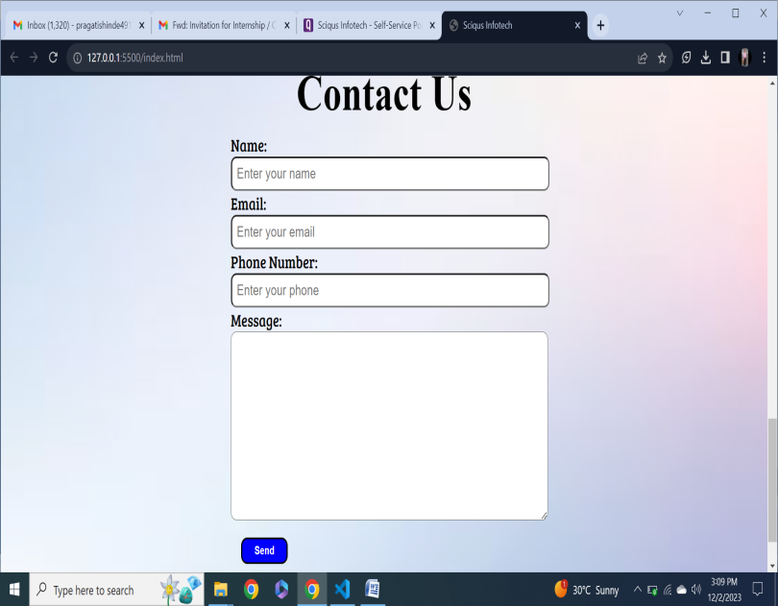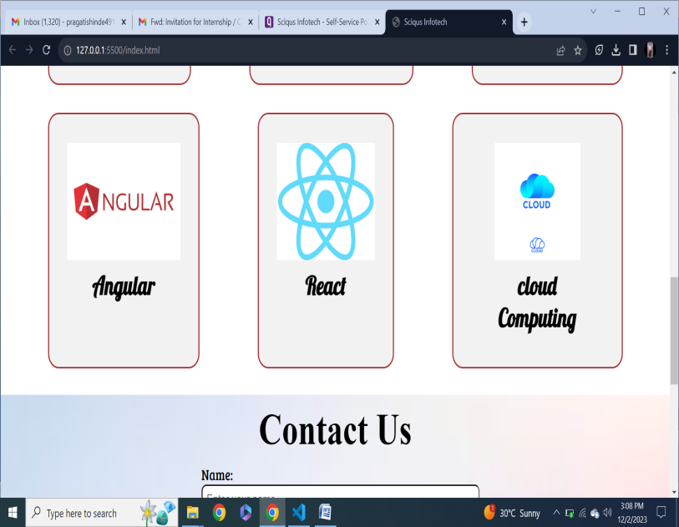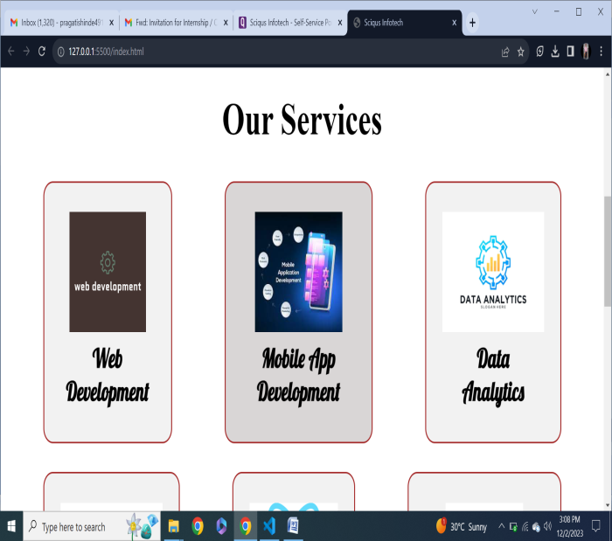

VideoURL:- <https://drive.google.com/file/d/1SU44iZmtOikLdNLzl7qa9ywlF5NAtfqc/view?usp=drivesdk>