1. Create a GitHub Account: If you don't have one already, go to [github.com](https://github.com/) and sign up for a free account.

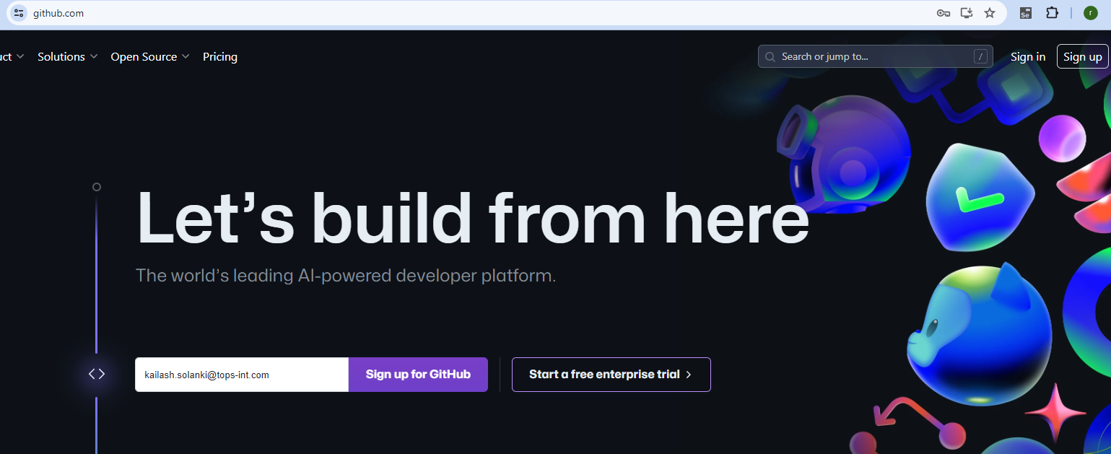

1. Install github desktop also : <https://desktop.github.com/> : download and installed also

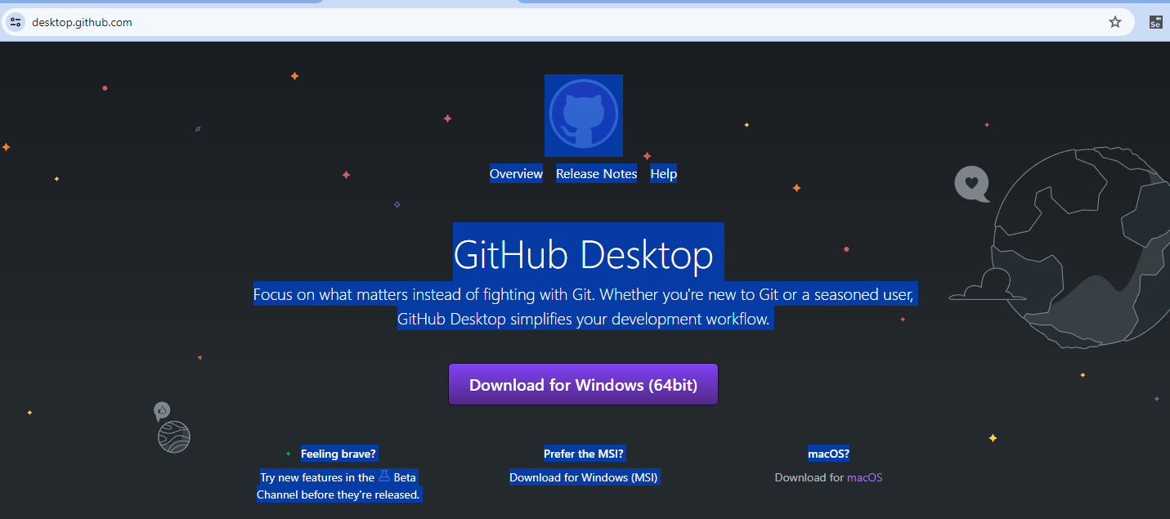

1. Signup in to github with given appropriate details with username and password

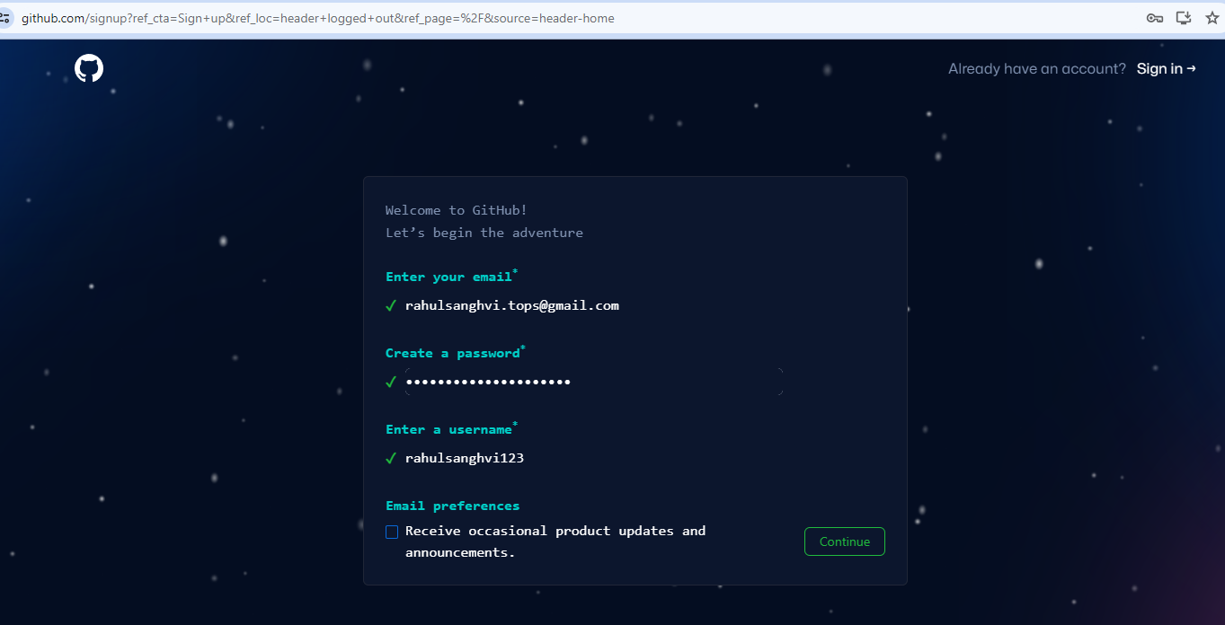

1. Now login with your username and password details

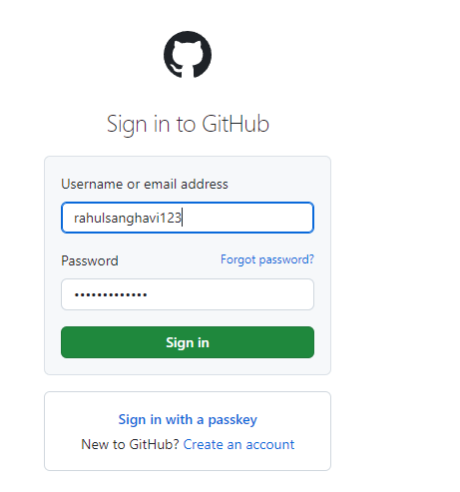

1. Create Repository in your github account (Give your repository a name,Optionally, add a description, Choose whether it's public)
2. After Signin and repository go into your installed desktop github side to open it
3. Then you configure with your email and password to make a clone your repository
4. After clone to open your github desktop properly
5. Now you see on your screen “Show Explorer” button so click on it

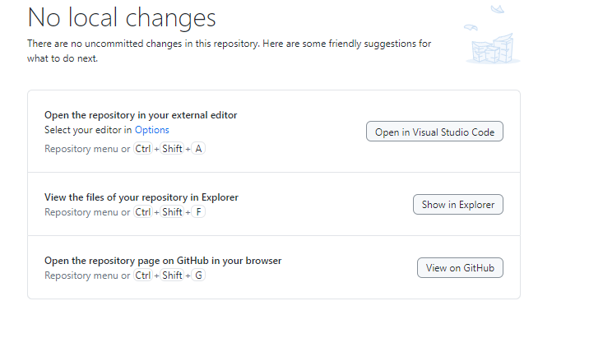

1. Now you create in your folder “Assignment ,Assessment , Project” these three folder in your repository

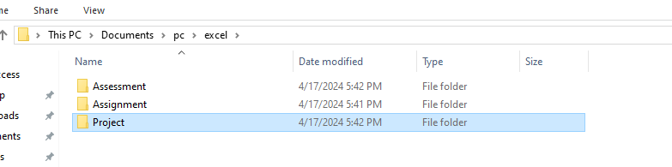

1. Then you open your assignment folder to create module wise folder like module 1, module 2 …..

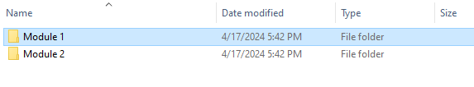

1. Then you putting whole project which you create with from src or create any file like (.java,.php every file you put with in it with extension also) (below Whole file copy from your current folder into your module 1 ,2 any where)

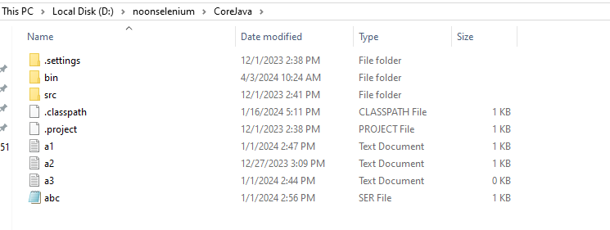

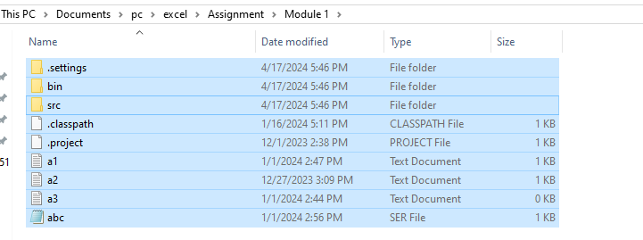

1. After putting your code in your assignment , project , assessment side properly then your do first “commit to main”

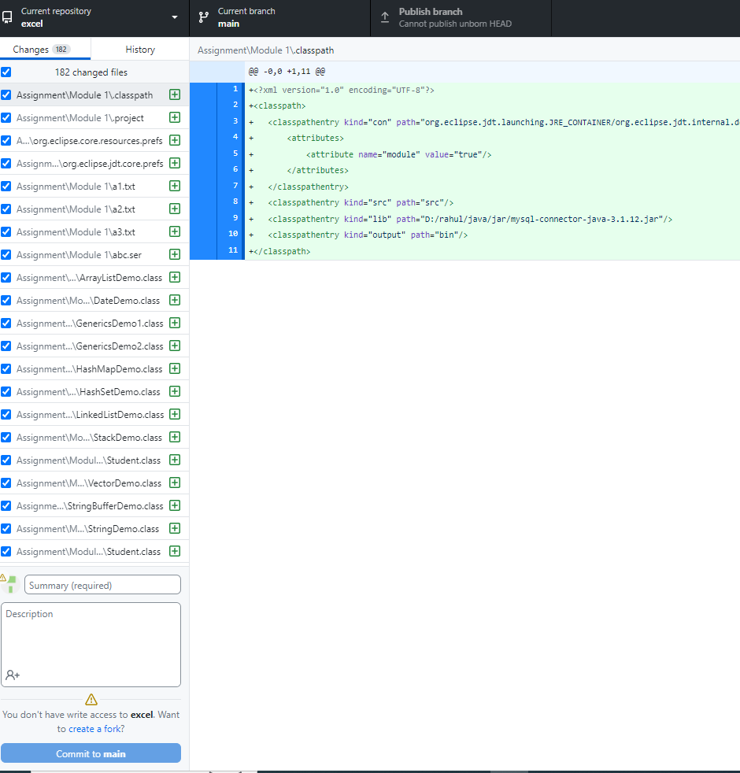

Now Push Origin

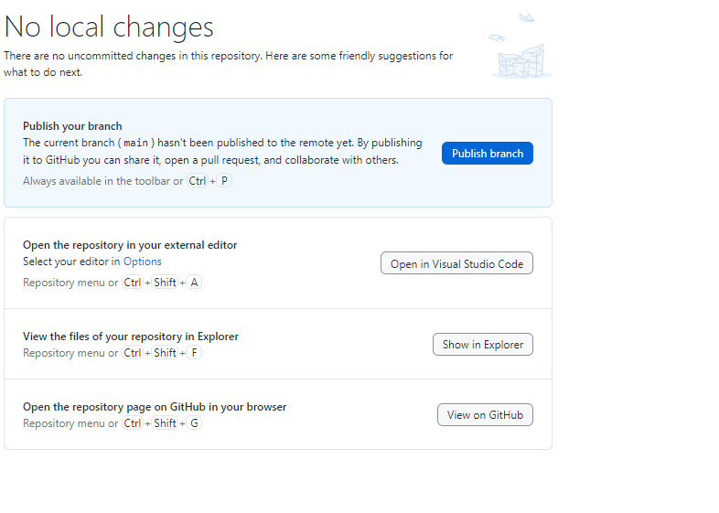

1. Then do “push origin” and click “view on github” then copy your URL and paste in your tops career center submit button