Game Design Document

Fill up the following document

ONE PIECE

1. Write the title of your project.
2. What is the goal of the game?

Destroy the other pirate ships and become the pirate king

1. Write a brief story of your game.

Luffy is a brave yet stupid boy who wants to become a pirate king.So he

Sets on his journey in the sea to become the pirate king.He also has some

Friends who are going to help him become the pirate king

1. Which are the playing characters of this game?

* Playing characters are the ones who respond to the user based on the input from the user.
* Cars, monkeys, dinos, wizards, etc., are the playing characters in the game.

|  |  |  |
| --- | --- | --- |
| Number | Character Name | What can this character do? |
| 1 | PC-LUFFY | Shoot canonball |
| 2 | ZORO | Sense pirates |
| 3 |  |  |
| 4 |  |  |
| 5 |  |  |
| 6 |  |  |
| 7 |  |  |
| 8 |  |  |

1. Which are the Non-Playing Characters of this game?

* Non-Playing characters are the ones that don't have an action or behavior when the user interacts with the game.
* Hurdles, stones, bananas, coins, etc., are non-playing characters in the game.

|  |  |  |
| --- | --- | --- |
| Number | Character Name | What can this character do? |
| 1 | Pirate-1 | Starts shooting when  Luffy ship comes close to him |
| 2 | Pirate-2 | Starts shooting when  Luffy ship comes close to him |
| 3 | Pirate-3 | Starts shooting when  Luffy ship comes close to him |
| 4 | Pirate-4 | Starts shooting when  Luffy ship comes close to him |
| 5 | Pirate-5 | Starts shooting when  Luffy ship comes close to him |
| 6 | Pirate-6 | Starts shooting when  Luffy ship comes close to him |
| 7 | Pirate King | Starts shooting when  Luffy ship comes close to him .(Pirate king is very hard to defeat) |
| 8 |  |  |

Draw your imagination of this game. What does this game look like?

* Draw the game either on your computer or on paper.
* Add images of the game scenes to show each of the playing and non-playing characters at least once.

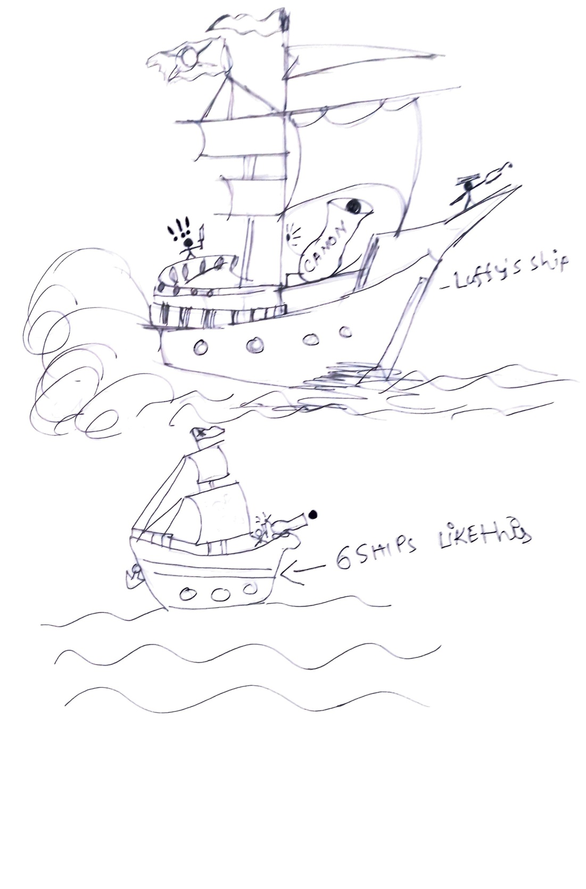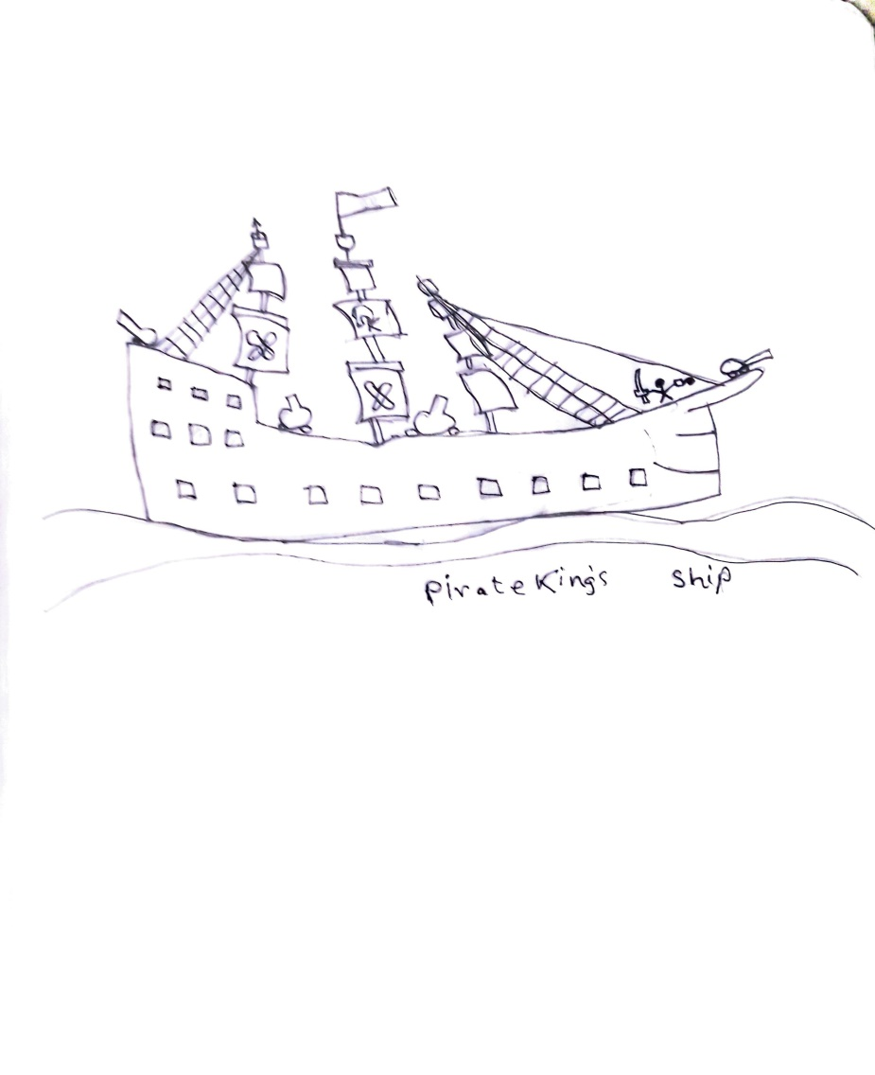

How do you plan to make your game engaging?

Add new maps and new levels