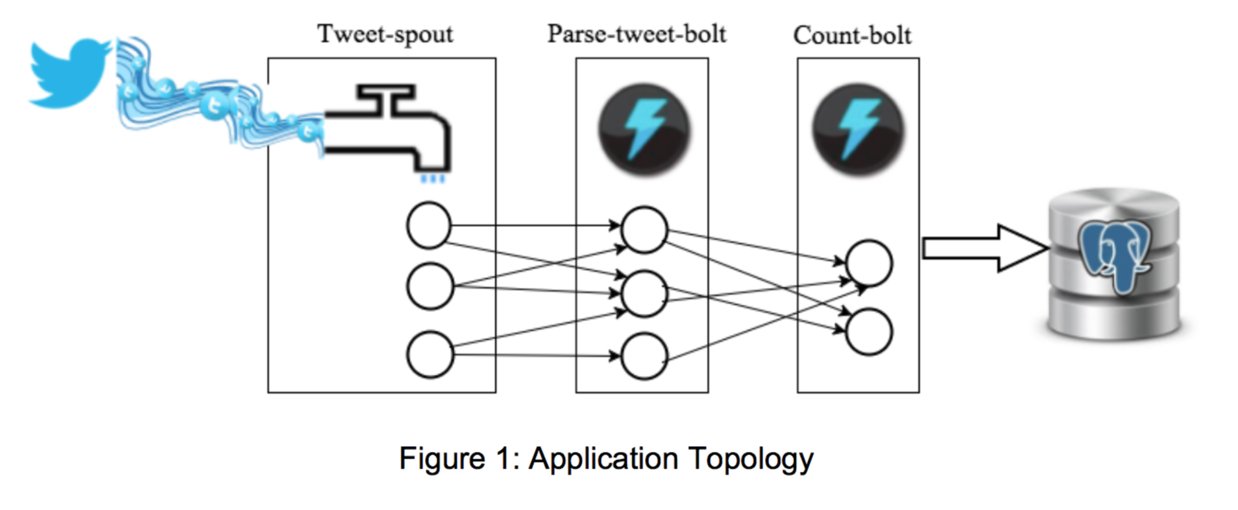

**Introduction**:

* Using the Tweepy library, the application reads the live stream of tweets from Twitter in the tweet-spout component.
* The parse-tweet-bolt parses the tweets, extracts the words from each parsed tweet, and emits the words to the next bolt component (count-bolt) in the topology.
* The count-bolt counts the number of each word in the received tuples, and updates the counts associated with each word in the tweetwordcount table inside the tcount Postgres database.

**Descriptions**:

* tweet-spout - extweetwordcount/src/spouts/tweets.py
  + pulls from twitter stream
* parse-tweet-bolt – extweetwordcount/src/bolts/parse.py
  + parses tweets into words
* count-bolt - extweetwordcount/src/bolts/wordcount.py
  + stores words into the tweetwordcount table