**Media to consume:**

<https://www.youtube.com/user/NatSciDemos>

**Physical:**

Six foot tiger, three foot cage (jawline)

Mew method

Fat and cholesterol

Prescription medication

Ritalin (meth), statin, lipitor,

Corporations funding scientific research to push harmful products

**programming:**

<https://atom.singularity2050.com/>

<https://www.wolfram.com/>

<https://www.wolfram.com/technologies/>

<https://www.wolfram.com/language/>

**Business/marketing:**

There is such a thing as making your company too big too quickly. It’s not always about growth.

**Writing:**

Physics. Alchemy. Theology. Newton made three bets. One of them worked. But they were all risky.

The difference between fault and responsibility. It may be someone else's fault that things are the way they are but it's your responsibility to make them better. It's not about letting someone who hurt you off the hook, it's about taking the power back.

A complex idea explained simply will always be more powerful than a simple idea expressed in lofty and wordy rhetoric. This is why Judith Butler is a fraud. She is a sophist, not a philosopher or an intellectual.

Philosophy should be practical. Don't waste your time arguing philosophy in the same way a person gorges on cheetos while disregarding a well cooked steak.

Gender is not a social construct, gender is an assertion of biological realities that are culturally reinforced. People who reduce gender to a fiction and a performance are deluded and in denial of reality.

The gender dichotomy is essential. You cannot change the fact that you want to, on a biological level, eat food. You can control when you eat and what you eat, you can even control how long you go without eating. But if you delude yourself into thinking the impulse to eat is just socially reinforced and has no basis in biology, we would call that mental illness and help you wake up from your delusions. Insisting that your biological instincts are merely social constructions is just as absurd.

The problem with incels is that they don't want to get into trouble and they fundamentally understand that women are fucking trouble.

The strongest argument against the idea that masculinity and femininity are fictions is the fact that doctors need to treat men and women differently. To disregard biological sex is also to do harmful political procedures on people by disregarding their sex.

We have to separate the idea that our social norms are imperfect and limit our behavior in certain ways that may sometimes be destructive, from the idea that norms are inherently oppressive and should be subverted wherever they are found.

Perceptions determine behavior, perceptions are not reality

Your perceptions are result of your thought patterns, your philosophy and the way that you understand the world

Mostpeople are all bark and no bite. The people who can really bite don't waste too much time talking.

**Cybersecurity:**

CISSP IT certification

PWK OSCP certification

**hardware:**

<https://en.wikipedia.org/wiki/Chorded_keyboard>

setting up a laptop in front of you as if you were selling popcorn



**tech research:**

<https://marsconference.com/>

**Math:**

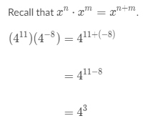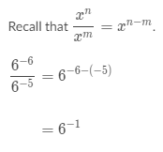

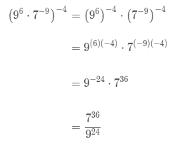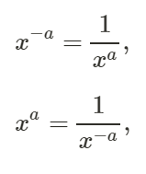

<https://writings.stephenwolfram.com/2019/02/seeking-the-productive-life-some-details-of-my-personal-infrastructure/>