**DATABASE PROJECT** (Summer training)

**NAME : PRAGNA KATRAGADDA**

**BRANCH : ECE (Roll no. 194135)**

**MAIL ID:** [**katrag_871903@student.nitw.ac.in**](mailto:katrag_871903@student.nitw.ac.in)

TOPIC : **HOUSE RENTING SYSTEM DATA BASE**

Introduction :

These days where everything is done through online, it is difficult for a person to search along the streets to rent a house. And we cannot expect the owners to spend their time in this renting process. Over the years this renting process have had a problem in searching for a right house in right location with required features. This process is difficult because :

* In a populated area it takes a lot of time for a tenant to search for a house according to their requirements.
* People cannot be aware whether the house is vacant or not unless the owner advertises about his house.
* Tenants might not have a chance to know the feedback of the house from previous tenants or from the neighbourhood.
* Owners are not completely aware of tenants and their details before renting it to them.
* There can be manipulation of the rental cost details as there won't be any record of the previous rents and other costs.

Problem Statement

So, the primary purpose of this House rental database system is to provide the to-let houses information which is given by the owners to the people who are looking houses for rent. And this data base also contains he information of the previous rent, costs and tenant's details available to the new tenants to avoid manipulation. This data base contains all the information of the new tenants available to the owners to ensure that their house is in right hands. This data base makes easier for tenants to find house according to their requirements.

This data base contains :

* Entities : 6 – **Tenants, Tenant’s Details, Agents, Owners, Houses, Previous Tenant’s Records**

|  |  |
| --- | --- |
| Tables | Attributes |
| Tenants | Tenant_ID, Name, Password, Email_ID, Phone_no, DOB, Age, Address, Occupation |
| Tenant’s Details | Total_no_members, Member details, Children |
| Agents | Agent_Id, Name, Email, Password, Phone_no |
| Owners | Owner_ID, Name, Password, Address, Document_ID |
| Houses | House_ID, Type_of_house, House_description, Rent_cost, Address, Other_cost_details |
| Previous Tenant Details | Tenant_ID, Name, Email_ID, Phone_no, Rent_paid, Other_costs_paid, Maintainence_cost, Review |

* Attributes for each entity, there are key attributes for every entity
* There are also some multivalued attributes and derived attributes.
* Entities are connected by relationships (one to one, one to many, many to one, many to many).
* There are seven relationships in total.

In this data base the Owners can post the house information directly or they can make deals with agents who help in finding the tenants. So, the tenants also can search for a house directly or they can contact agents for better results according to their comfort. Each house contains it previous tenant’s records in order to avoid any conflicts in terms of prices.

Each tenant, owner and agent have their ID. Any detail about them can be searched with their ID.

The ER model of the House renting system data base is:

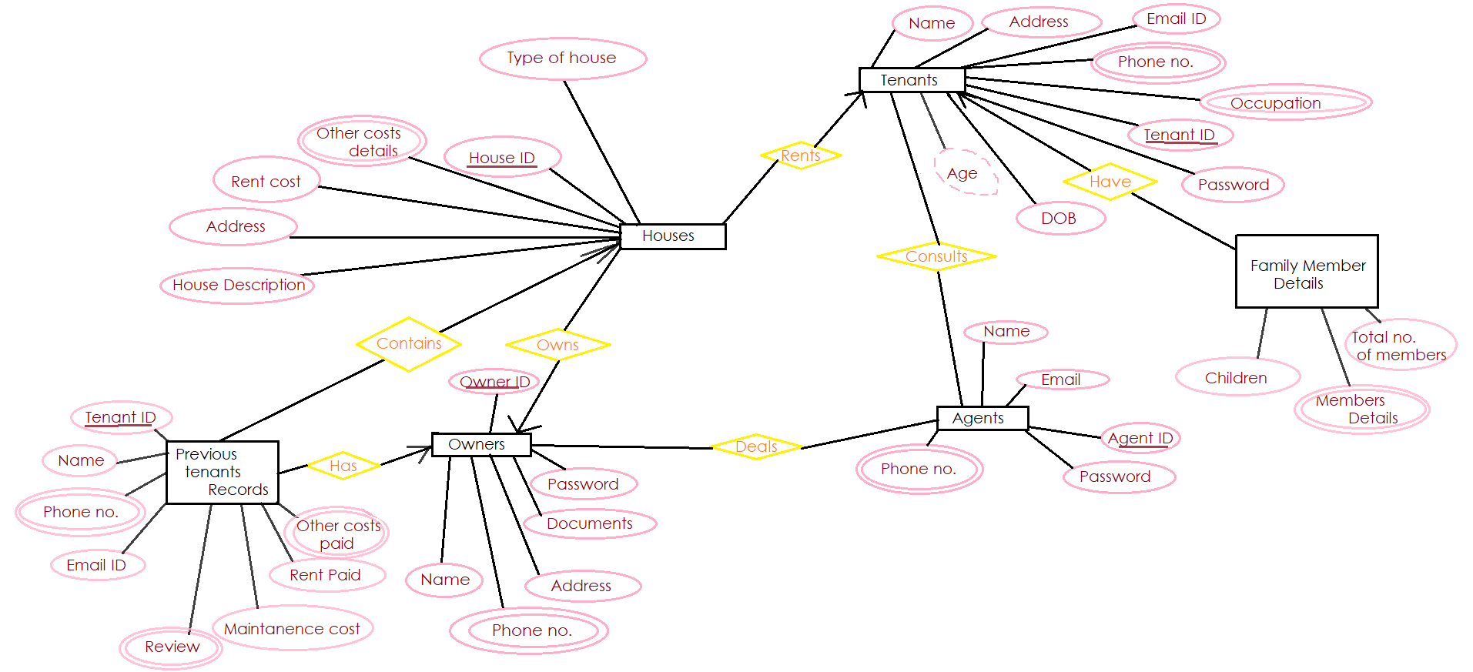

This ER model should be converted into Relational model which can be directly implemented by any RDBMS like MySQL, Oracle etc. Relationship model describes how the tables of the entities relate to each other.

The Relationship model for this house rental er diagram is :

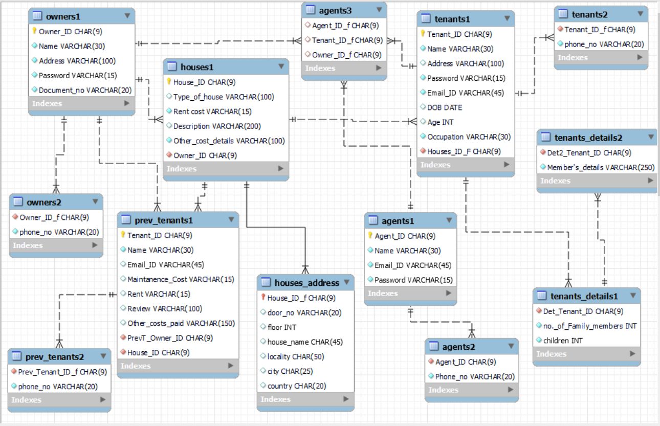

Tables in the Database :

Tenants1 table:

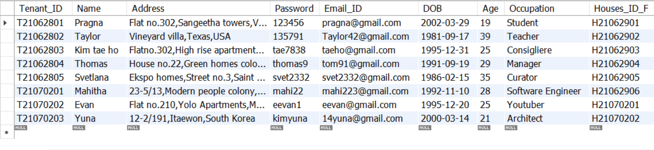

Tenants2 table:

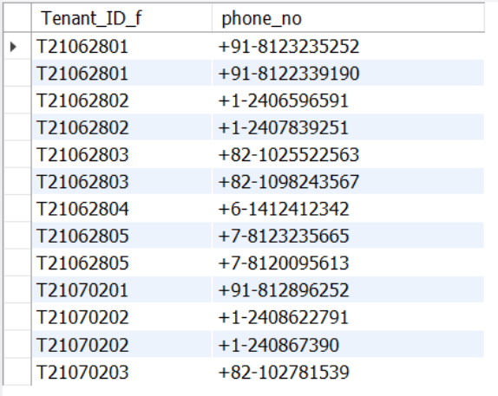

Tenants_Details1 table:

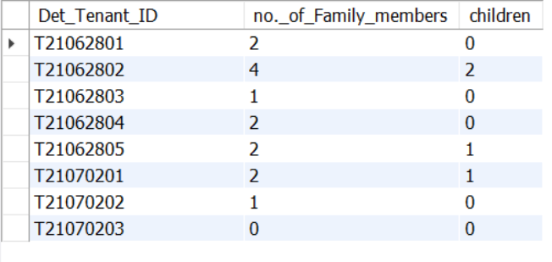

Tenants_Details2 table:

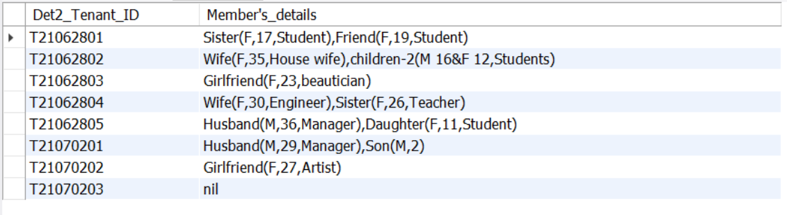

Agents1 table:

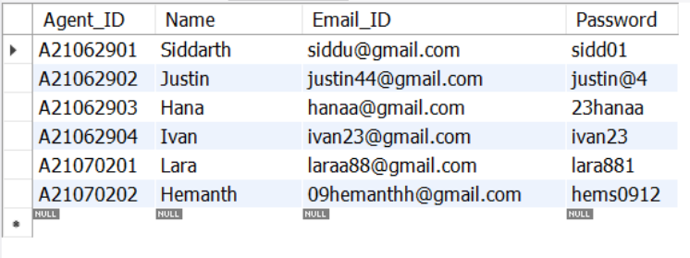

Agents2 table:

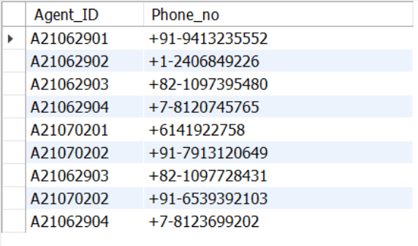

Agents3 table:

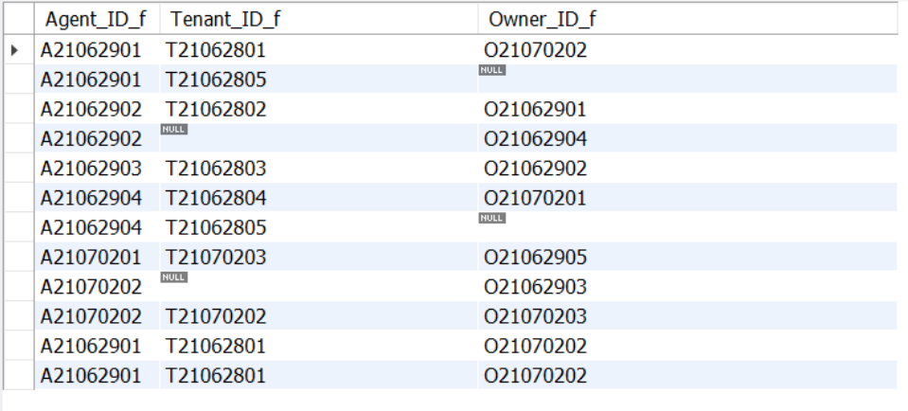

Owners1 table:

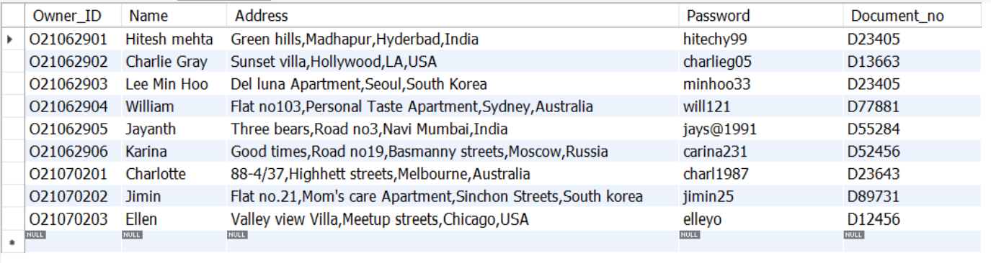

Owners2 table:

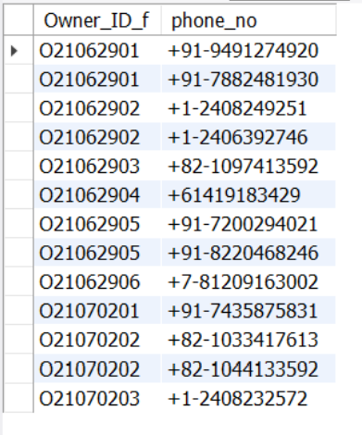

Houses1 table:

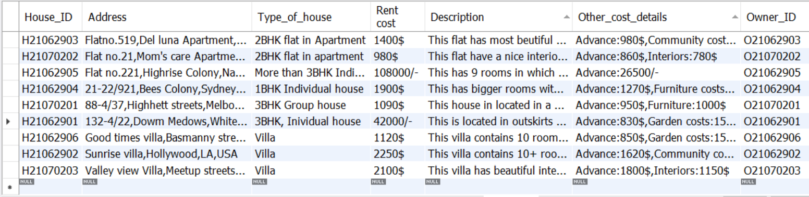

Prev_Tenants1 table:

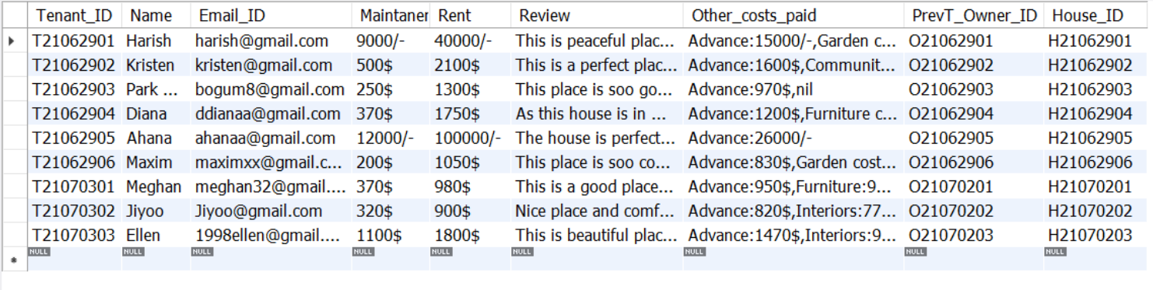

Prev_Tenants2

