CS590 Intro to Blockchain

NFT using Moralis – Pragna Mallikarjuna Swamy

Steps followed:

Step1: Create a virtual environment to run the Flask application and install dependencies

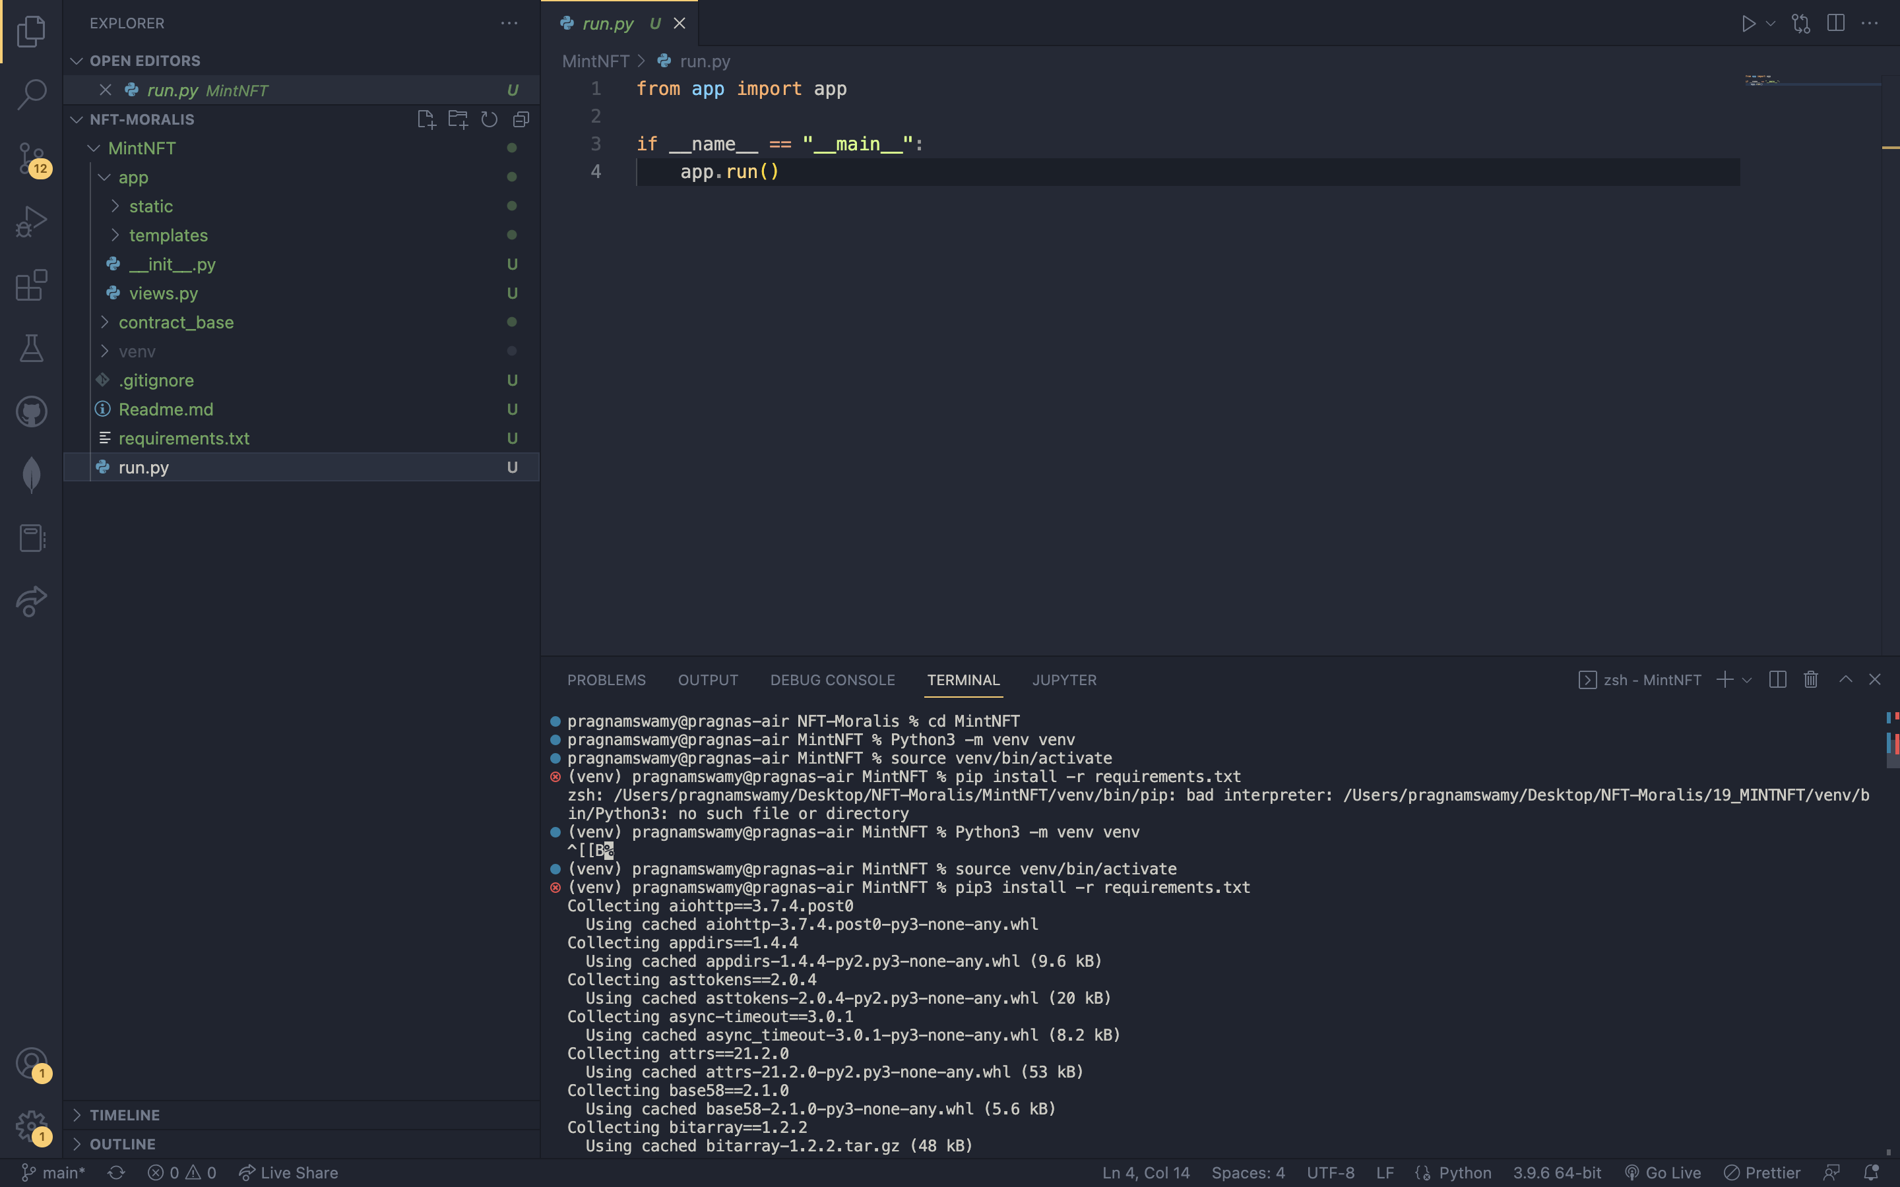

Step 2: Install Flask

Step 3: Add parameters

Step3: Run the program



Step 4: Steps to be followed to use the application:

* Enter username and email for Metamask integration

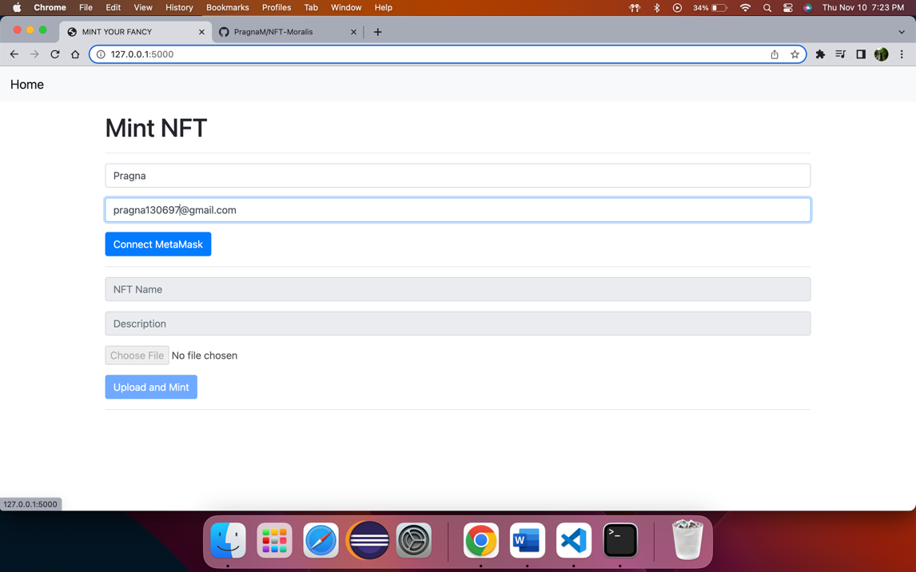

* After logging into Dapp application- upload an image file. (PNG file), Enter NFT name and description, Click on Upload and Mint

