Task2 kernelshark results:
This program is tested on Linux kernel version - 4.4.0-38-generic
(a) Thread is running: The signal handler associated to a running thread will be executed at as shown by the signal generation and signal delivery in the kernelshark output screenshot below,
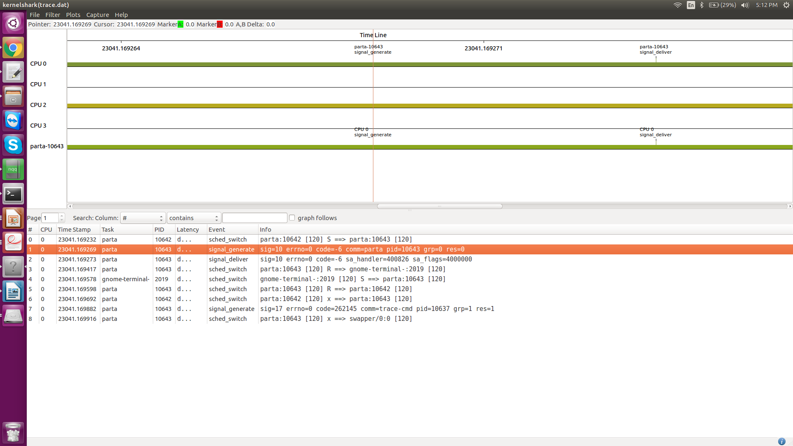
The context switch status in the case of running thread is as shown below, (the green marker in the graph indicates the signal generation)
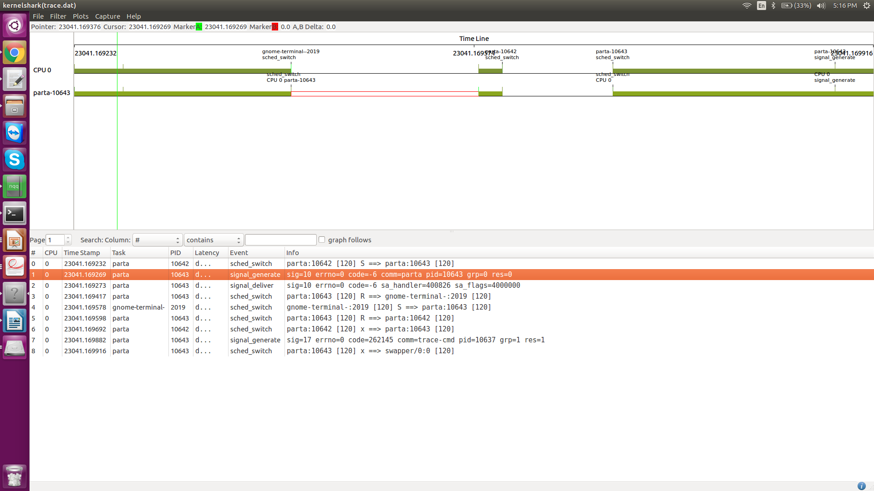
(b) Thread is runnable: The signal handler associated to a runnable thread will be executed at as shown by the signal generation and signal delivery in the kernelshark output screenshot below,
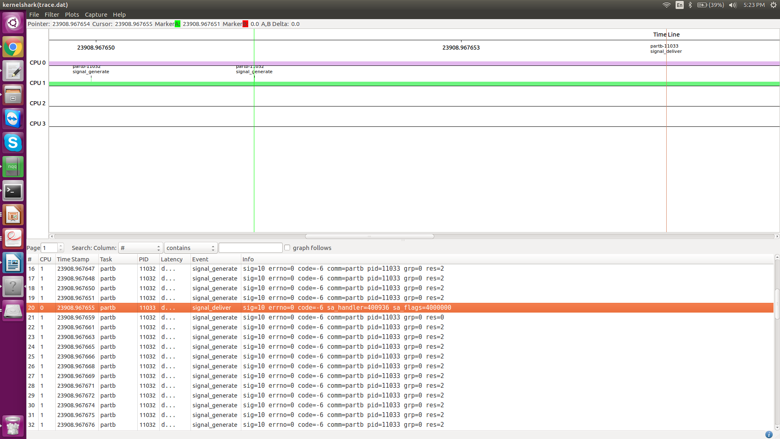
The context switch status in the case of runnable thread is as shown below, (the green marker in the graph indicates the signal delivery)
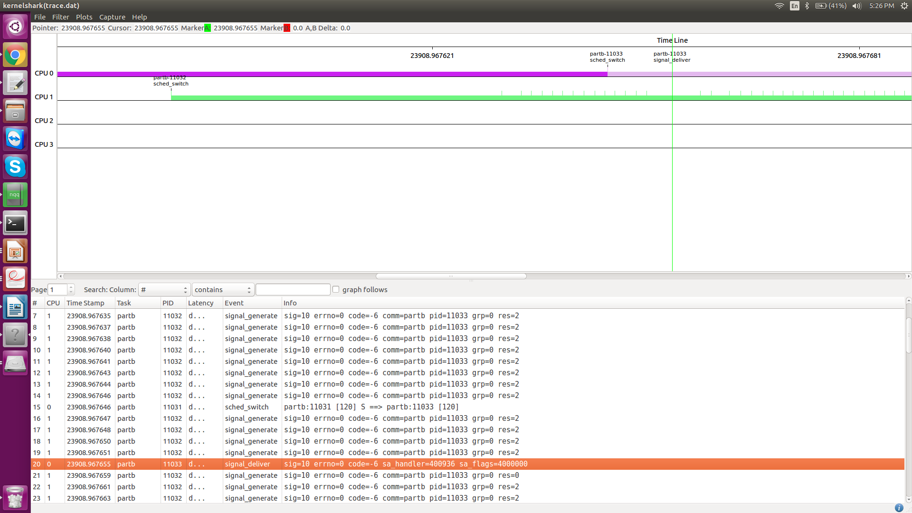
(c) Thread is blocked by semaphore: The signal handler associated to a thread blocked by a semaphore will be executed at as shown by the signal generation and signal delivery in the kernelshark output screenshot below,
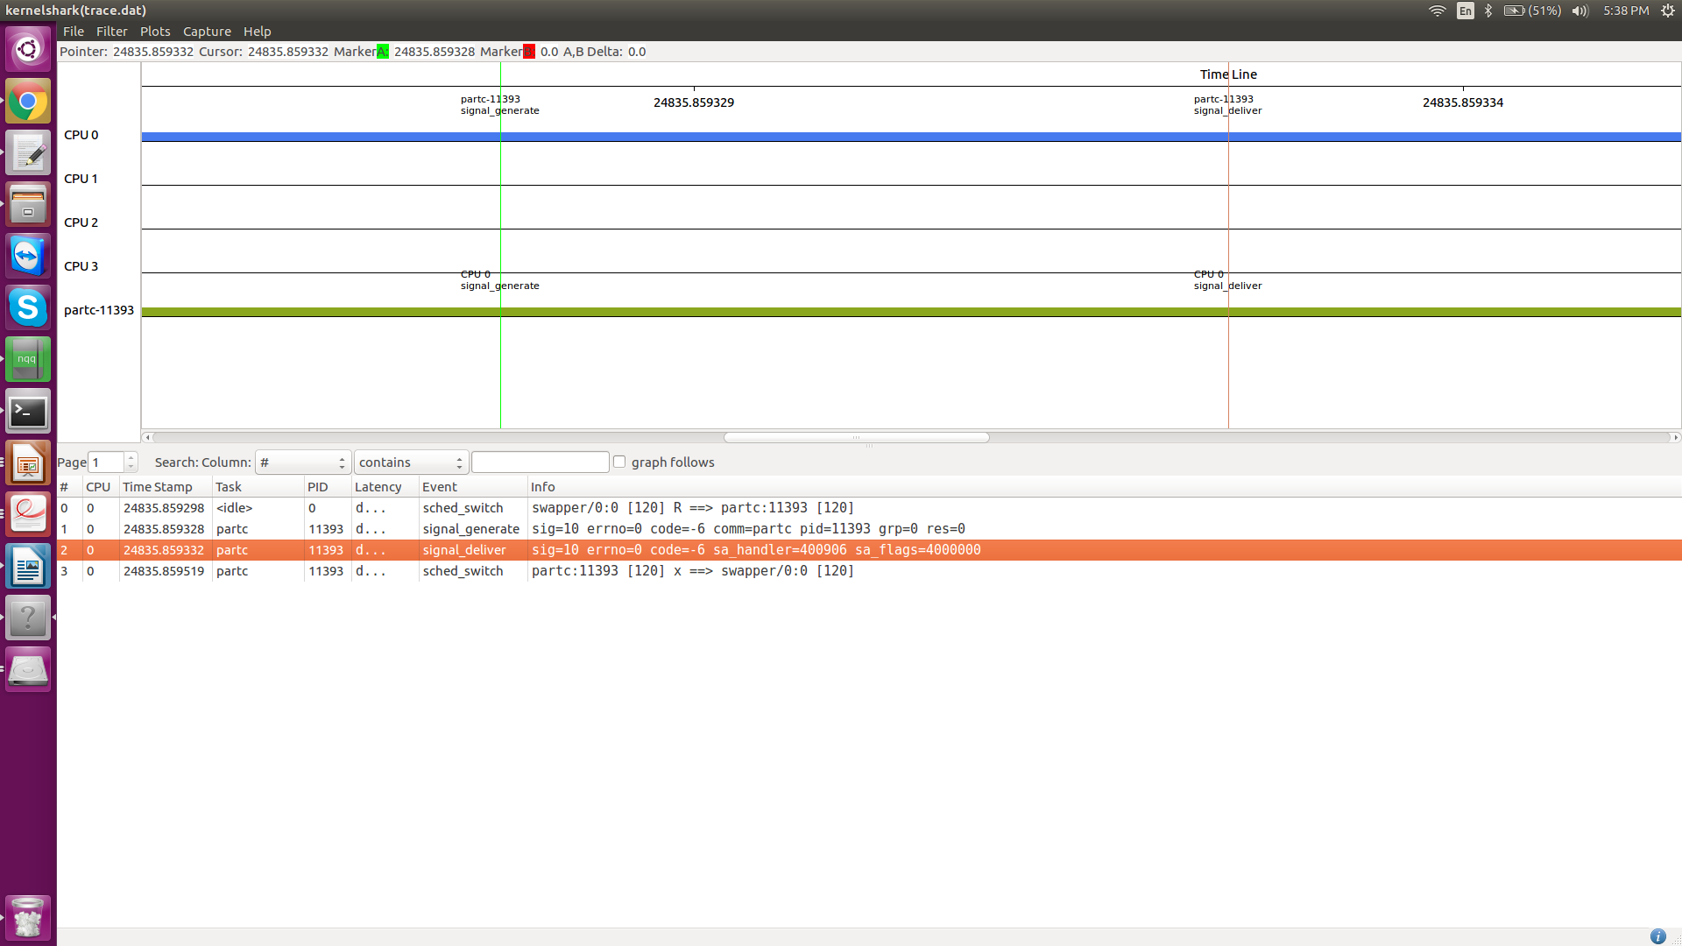
The context switch status in the case of thread blocked by semaphore is as shown below, (the green marker in the graph indicates the signal delivery and red indicates signal generation)
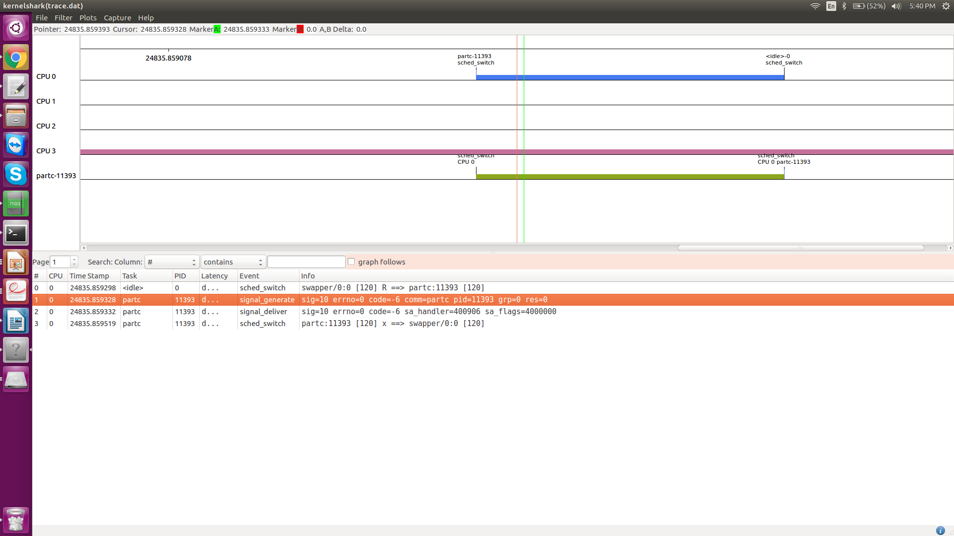
(d) Thread is delayed: The signal handler associated to a delayed thread will be executed at as shown by the signal generation and signal delivery in the kernelshark output screenshot below,
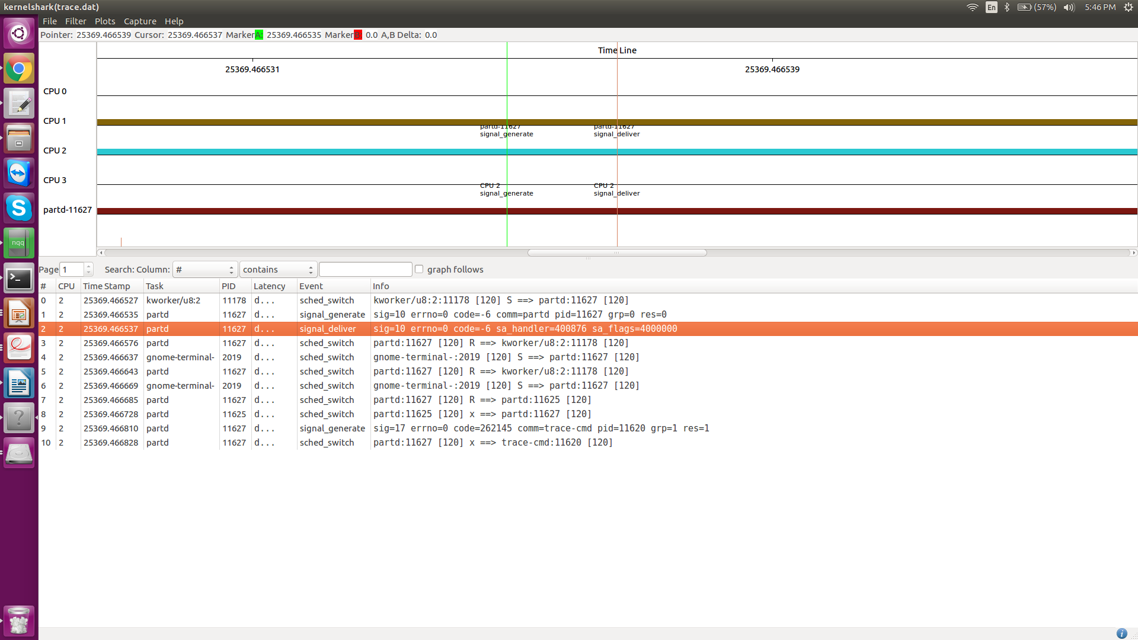
The context switch status in the case of delayed thread is as shown below, (the green marker in the graph indicates the signal delivery and red indicates signal generation)
