kernelshark results:
This program is tested on Linux kernel version – 4.4.0-38-generic

The activation of threads at the same time and running as per threads priority and FIFO scheduled policy can be viewed in the kernelshark output screenshot as shown below:
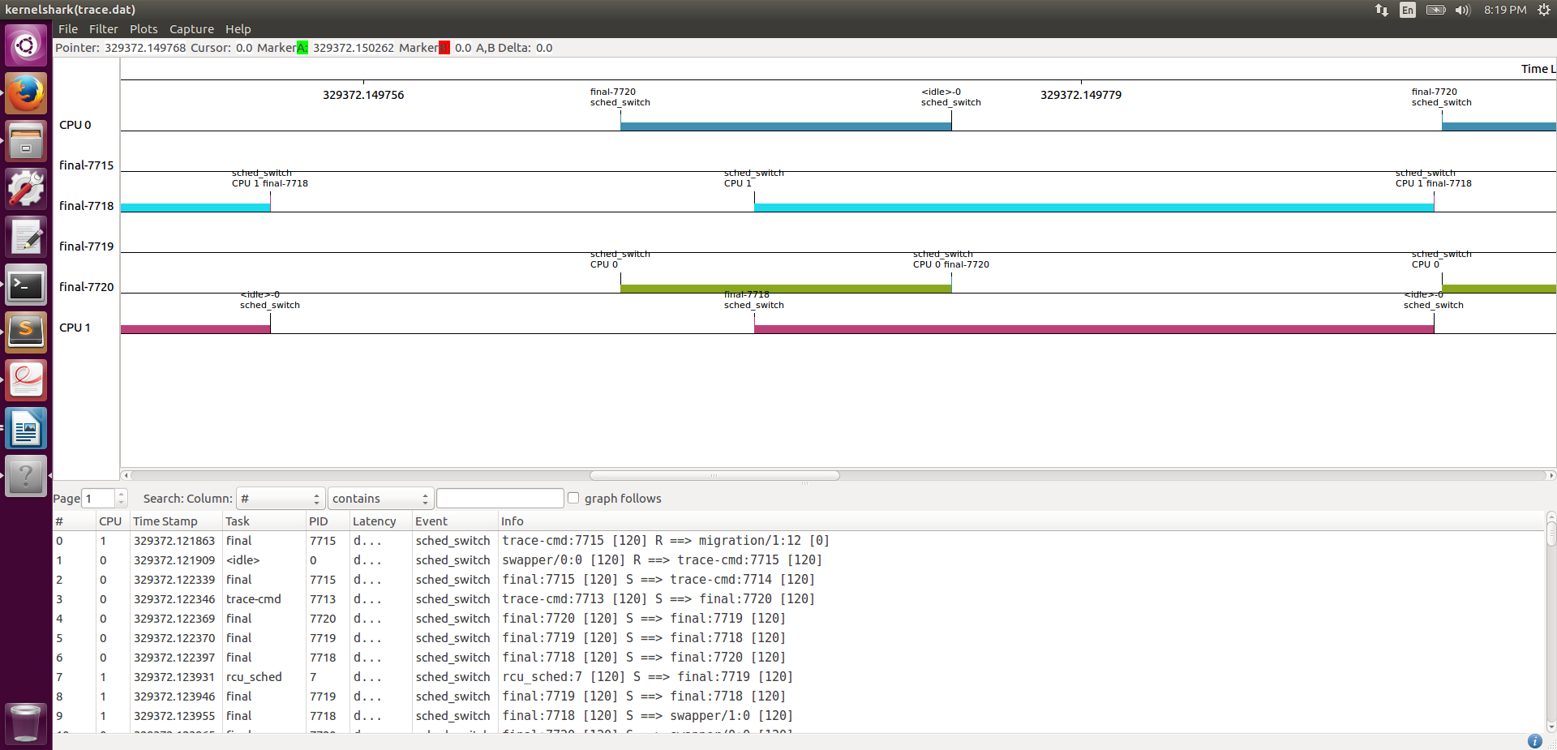
The priority inheritance mutex functionality can be viewed in the kernelshark output screenshot as shown below:
