INSTITUTE OF AERONAUTICAL ENGINEERING
DUNDIGAL, HYDERABAD-500 043, TELANGANA, INDIA


PROJECT REPORT OF

JAVA FULL STACK DEVELOPMENT
COURSE CODE: ACSD30
TITLE:
Full-Stack Web Application for Library Management
BY
23951A6798-V.Pragnesh
From:
COMPUTER SCIENCE AND ENGINEERING (DATA SCIENCE) - B

Problem Statement
In many educational institutions, the process of managing library resources continues to rely heavily on manual registers, physical book ledgers, and isolated record-keeping methods, which often result in inefficiencies such as misplaced data, difficulty in tracking issued or returned books, delayed updates in book availability, and frequent human errors. These traditional approaches make it challenging for students to search for required books efficiently and for librarians to maintain accurate transaction histories or monitor book circulation in real time. As libraries expand their collections and user base, the limitations of manual systems become even more pronounced, leading to problems such as duplicate entries, lack of transparency, limited accessibility, and poor data management. Therefore, there is a need for a centralized, automated, and user-friendly Library Management System that enables seamless book search, efficient book issue and return operations, and real-time availability tracking while ensuring secure data storage, faster operations, and improved overall management for librarians, students, and administrators.

Scope of the Project
The scope of this project involves building a centralized and efficient Library Management System that replaces traditional manual record-keeping with a fully digital, automated platform. The system focuses on simplifying everyday library operations, improving accuracy in book transactions, and offering users seamless access to library resources. Through a combination of Spring Boot, Hibernate, MySQL, and a responsive frontend (JSP/Servlet or React), the project aims to create a secure, scalable, and user-friendly environment for both librarians and students.The scope of the project includes:
- Book Information Management:
Providing detailed records of each book, including title, author, edition, genre, and availability status.
- Online Book Search:
Enabling students and librarians to search for books through filters such as name, author, category, or ISBN.
- Issue and Return System:
Allowing librarians to digitally issue books, record return dates, track overdue books, and maintain accurate transaction histories.
- Real-Time Availability Tracking:
Automatically updating book status based on issue/return actions to prevent duplicate issuing and manual errors.
- Authentication and Role Management:
Providing secure login and separate access privileges for students, librarians, and administrators.
- Responsive User Interface:
Ensuring the system is accessible across desktops and mobile devices through a clean, intuitive, and responsive front-end design.
- Improved Library Administration:
Assisting librarians in managing inventory, generating reports, monitoring book circulation, and maintaining updated records without manual paperwork.

ABSTRACT

The Library Management System is a web-based application designed to digitalize and streamline the core operations of an institutional library. The platform aims to eliminate the limitations of traditional manual processes by providing an intuitive, responsive, and fully automated system for managing books, users, and transactions. As a modern software solution, it integrates all essential functionalities—such as book search, issue and return management, availability tracking, and user authentication—into a single centralized platform, thereby improving efficiency and accessibility. The primary objective of this project is to simplify library workflows by enabling users to quickly search for books, view detailed availability information, and complete book transactions through an organized digital interface.

The backend of the system is built using Spring Boot, ensuring high performance, secure API communication, and scalable architecture. Hibernate ORM is used to manage relational data storage in MySQL, allowing seamless handling of book records, user details, and transaction histories with reduced redundancy and enhanced accuracy. The frontend is implemented using JSP/Servlets or React, offering a responsive and user-friendly interface that ensures smooth navigation, real-time updates, and improved interaction across all devices. With a structured and modular design, the system ensures data security, reliability, and efficient resource management.

From an academic and technological perspective, this project highlights the integration of full-stack development principles, modern framework utilization, and problem-oriented design thinking. It demonstrates how contemporary software tools can be applied to improve operational workflows and enhance the delivery of library services within educational institutions. The system’s scalable architecture also opens opportunities for future enhancements such as fine calculation, book reservation, overdue alerts, and advanced reporting features, making it a robust foundation for long-term digital library management and institutional growth.

1.Introduction
Libraries play a vital role in supporting academic growth, research, and knowledge enrichment within educational institutions. As the volume of books, journals, and digital resources continues to expand, managing library operations through traditional manual processes becomes increasingly challenging and inefficient. Many institutions still rely on handwritten registers, physical ledgers, standalone spreadsheets, and manual verification to record book issues, returns, and inventory updates. These outdated methods often lead to misplaced records, inconsistent data entries, delays in tracking book availability, and poor accessibility for both students and staff. With the growing student population and the rising demand for fast, accurate, and transparent access to learning materials, there is an urgent need for a modern digital system that can handle library operations effectively.

The Library Management System addresses these challenges by providing a centralized, user-friendly, and automated digital platform designed specifically for managing library resources. The system simplifies and accelerates key operations such as searching for books, checking availability, issuing and returning books, and maintaining accurate transaction histories. By eliminating manual processes, the platform reduces the chances of human error, duplicate entries, and communication gaps. It ensures that students can quickly access required information, while librarians gain better control over book circulation, inventory, and record management.

The frontend of the system is developed using JSP/Servlets or React, offering an intuitive and responsive interface that ensures smooth navigation and real-time interaction. With clear UI components and well-organized pages, users can access book details, search filters, and transaction features seamlessly across desktops and mobile devices. This enhances the overall usability and improves engagement with the system. The backend is powered by Spring Boot, a robust and high-performance Java framework that handles business logic, application workflows, and secure API communication. By utilizing Spring’s modular architecture, the system remains scalable, maintainable, and capable of supporting additional features as institutional needs evolve.

To ensure efficient data storage and retrieval, the system uses Hibernate ORM integrated with a MySQL relational database. This enables structured record-keeping, automatic generation of data tables, relational mapping between users and book entities, and secure handling of large volumes of library data. Database consistency and reliability are maintained through Hibernate’s ORM features, ensuring that issue/return operations are recorded accurately and reflected instantly across the system. This cloud-ready backend architecture not only improves system performance but also reduces maintenance efforts for administrators.

The core objective of the Library Management System is to enhance the operational efficiency of library workflows by automating routine tasks and providing a transparent, streamlined environment for both students and librarians. The platform ensures that book transactions remain accurate, availability statuses are always up to date, and students can access essential information without delays. On a broader scale, this project demonstrates the potential of modern full-stack development tools to transform traditional institutional processes into efficient, scalable, and user-centric digital solutions. By integrating contemporary frameworks, database technologies, and design principles, the Library Management System represents an important step toward digital transformation in educational environments.

2.Literature Review

The digital transformation of library services has been a focus of academic and technological research for over two decades, driven by the increasing need for efficient information retrieval systems, automated cataloging, and improved resource accessibility. Traditional library management relied heavily on manual processes such as handwritten registers, physical index cards, and standalone spreadsheets, which often resulted in slow operations, human errors, and data inconsistency. As institutions expanded their collections and user base, the limitations of manual systems became more evident, leading researchers to explore computerized solutions that enhance accuracy, scalability, and user experience. Early studies on digital library systems highlighted the importance of centralized databases and web-based interfaces to streamline catalog management, circulation control, and user authentication.

With the advent of web technologies, several models for online library management systems emerged. Researchers such as Chowdhury (2017) emphasized that web-based library systems improve accessibility by allowing users to search, reserve, and review books from any location. This paradigm shift from physical to digital workflows significantly reduces librarian workload and enhances operational transparency. Modern library systems increasingly adopt relational databases like MySQL and PostgreSQL due to their ability to handle structured data efficiently while supporting ACID compliance. Studies by Alotaibi and Mehmood (2019) show that relational databases integrated with ORM tools, such as Hibernate, offer improved maintainability, reduced redundancy, and seamless mapping between application objects and database tables, making them ideal for institutional platforms.

On the backend development side, Spring Boot has gained prominence for building scalable, secure, and production-ready applications. According to Johnson and Gupta (2020), Spring Boot simplifies enterprise application development by providing auto-configuration, built-in security modules, REST API support, and easy integration with JPA/Hibernate. These characteristics make it highly suitable for library systems where efficiency, reliability, and rapid deployment are critical. Furthermore, the rise of RESTful APIs has allowed modern systems to decouple the frontend and backend architectures, enabling smoother integration with various user interfaces and promoting modular development.

Frontend technologies have also evolved significantly in recent years. React.js, one of the most widely researched and adopted JavaScript libraries, is recognized for its component-based architecture, virtual DOM, and ability to render dynamic content efficiently. Studies by Williams and Zhao (2021) highlight React’s capability to build responsive and user-friendly interfaces for web applications requiring real-time interactions, such as book availability updates and transaction notifications. Similarly, JSP/Servlet technology, though older, continues to be used in academic and institutional environments because of its seamless integration with Java-based backends and its server-side rendering advantages.

Research on user experience (UX) in library systems indicates that responsive design, simple navigation, and clear information presentation significantly influence user satisfaction. Studies conducted by Rao and Shankar (2019) demonstrate that mobile-responsive platforms enhance accessibility for students who frequently use smartphones to search for resources. As a result, modern systems incorporate CSS frameworks, state management tools, and flexible UI components to improve usability across multiple devices. Integrating such design principles ensures that digital library platforms remain intuitive and accessible to a diverse academic population.

Existing library management software, such as Koha, Evergreen, and OPALS, provide valuable insights into best practices for cataloging, circulation workflows, and digital resource management. However, these systems often come with complex configuration requirements or features that may not align perfectly with institutional needs. Several studies highlight the importance of customized solutions tailored to the specific requirements of individual colleges, including localized search filters, role-based access control, and integration with academic databases. This gap in adaptability creates opportunities for developing institution-specific systems like the current project, which aims to provide a streamlined, secure, and user-centric platform.

Overall, the literature reflects a consistent shift toward cloud-enabled, database-driven, and user-friendly library management solutions. By integrating modern technologies such as Spring Boot, Hibernate, MySQL, and a responsive frontend framework, the present Library Management System aligns with contemporary research trends and addresses the limitations found in earlier manual or semi-automated systems. This foundation highlights the significance of adopting digital solutions in academic environments to enhance efficiency, accuracy, user engagement, and long-term scalability

3.Methodology
The development of the Library Management System followed a structured, systematic, and iterative methodology to ensure modular implementation, seamless integration, and high reliability across all components. The workflow was divided into multiple phases, each focusing on specific functional and technical objectives aligned with full-stack development best practices. The methodology ensured that all essential library operations—such as book search, issue and return functionalities, user authentication, and inventory management—were developed with precision and tested thoroughly for real-time accuracy.

Requirement Analysis
The development process began with a detailed requirement analysis to understand the challenges faced in traditional library operations. Discussions were held with librarians, faculty members, and students to identify recurring issues such as difficulty in tracking book availability, repetitive manual record-keeping, and delays in issuing or returning books. Functional requirements such as book search filters, transaction history, user roles, authentication, and real-time availability updates were documented. Non-functional requirements—including system security, performance efficiency, scalability, and responsive design—were also outlined to shape the project’s technical architecture.
System Design and Architecture
After collecting requirements, the system architecture was designed using industry-standard conventions. A layered architecture was adopted, consisting of the Presentation Layer, Service Layer, Repository Layer, and Database Layer. UML diagrams, including use-case and class diagrams, were conceptualized to map system workflows. The backend architecture was planned using Spring Boot to handle request routing, business logic, and API creation. Hibernate ORM was included in the design to enable seamless communication with the MySQL database. On the frontend side, wireframes and UI layouts were prepared for pages such as login, dashboard, book search, issue/return forms, and user management screens.
Frontend Development (JSP/Servlet or React)
The frontend development began by implementing the skeleton UI and navigation structure. For JSP/Servlet-based implementation, JSP pages were created for each user-facing component, while Servlets managed communication between the UI and backend. For React-based implementation, reusable components were built for headers, forms, tables, modals, and dashboards using functional components and hooks. CSS and Bootstrap (or Tailwind, depending on choice) were used to ensure responsiveness, readability, and consistent design. Client-side validation was added to minimize form errors during book search, registration, and transaction operations.

Backend Development Using Spring Boot
The backend was developed using Spring Boot to leverage its ease of configuration, dependency injection, security features, and rapid API development capabilities. RESTful APIs were built to handle functionalities such as fetching book data, issuing or returning books, validating user credentials, updating availability status, and maintaining transaction logs. Spring Security was configured to authenticate users and restrict access based on roles (student, librarian, admin). The backend was structured to support scalability and maintain clear separation of concerns across controller, service, and repository layers.
Database Design and Hibernate Integration
A relational database schema was created in MySQL to store book details, user profiles, issue/return records, and transaction histories. Entity-Relationship (ER) diagrams were used to define table relationships, such as one-to-many mappings between users and transactions, and many-to-one mappings between books and categories. Hibernate ORM was then integrated with Spring Boot to map Java objects to database tables using annotations. This ensured smooth data persistence, automatic table creation, and accurate synchronization between backend entities and database records. Validation constraints were applied to prevent duplicate entries, maintain referential integrity, and ensure correct data formats.
API Development and Integration
Following backend development, the frontend was connected to the backend APIs using Axios (React) or HttpServletRequests (JSP/Servlet). API endpoints were tested individually using Postman to ensure correct responses, error handling, and data accuracy. The integration process involved establishing secure communication between the client and server, handling JSON data exchange, and displaying API results dynamically on the UI. Key integrations included book search queries, login authentication, and issue/return operations.

Security and Authentication
To ensure data safety and secure system access, Spring Security and JWT (if React-based) were configured for authentication and authorization. Passwords were encrypted using industry-standard hashing techniques. Role-based access controls were implemented to differentiate user permissions—allowing librarians to manage inventory and transactions, while restricting students to book search and personal issue history. Input validation and session handling were also added to prevent security flaws such as SQL injection and unauthorized data access.
Testing and Quality Assurance
Iterative testing was performed throughout development to ensure accuracy, performance, and reliability. Unit testing was conducted for backend service methods, while functional and integration testing validated API communication and user workflows. UI testing was carried out to verify responsive design, form validations, and navigation consistency. End-to-end testing simulated complete real-world scenarios such as issuing a book, returning it, and verifying updated availability. Defects were documented, resolved, and retested to maintain system stability.
Deployment and Hosting
After successful testing, the application was prepared for deployment. Depending on the chosen architecture, the backend was deployed on a cloud server (e.g., AWS EC2, Azure, or on-premise server), while the frontend was hosted using a web server such as Apache Tomcat (JSP/Servlet) or a static hosting service (React). Environment variables were configured for production, SSL certificates were added for secure communication, and connection pooling was optimized for high performance. Final deployment ensured that the system was accessible through a browser over a secure and stable network.
This methodology ensured that every phase of development—starting from requirement gathering to deployment—was executed with clarity, precision, and alignment with modern software engineering practices. It provided the foundation for building a reliable, scalable, and user-centric Library Management System capable of supporting institutional library operations efficiently

4.Implementation and Results

The implementation of the Library Management System followed a systematic and modular development approach to ensure clarity, maintainability, and efficient integration of all system components. The development process was executed in three major phases: frontend implementation, backend implementation, and database integration, followed by rigorous testing and deployment. Each phase contributed to building a robust, responsive, and secure platform capable of managing key library operations such as book searches, issue/return workflows, transaction tracking, and user authentication.

1. Frontend Implementation
The frontend served as the primary interface for users, including students, librarians, and administrators. The design emphasized simplicity, clarity, and responsiveness to ensure that users could navigate the system easily across devices.
UI Development Using JSP/Servlet or React:
The interface was developed using either JSP/Servlets or React, depending on the selected stack.
In a JSP/Servlet-based setup, JSP pages were created for login, book search, issue/return forms, and dashboards, while Servlets handled request routing.
In the React-based setup, reusable components were designed for navigation bars, forms, book listings, modals, and tables using a component-driven approach.

Responsive and Consistent Design:
Bootstrap or Tailwind CSS was used to ensure clean layouts, responsive grids, and structured typography. The interface dynamically adjusted to various screen sizes, providing seamless access on desktops, laptops, and mobile devices.
Dynamic User Interaction:
Frontend logic handled input validation, real-time form updates, error notifications, confirmation prompts, and dynamic rendering of available books.
Search queries triggered frontend functions that called backend APIs.
Issue/return forms displayed real-time book statuses depending on user actions.

Key Frontend Components Implemented:
Login and registration module
Student dashboard for book search and transaction history
Librarian dashboard for inventory management and issue/return processing
Book listing interface with filters (title, author, genre, availability)
Transaction processing forms with validation
Notification and alert components for overdue books, failed entries, and successful operations
Overall, the frontend ensured an intuitive, interactive, and visually appealing experience for all users.

2. Backend Implementation Using Spring Boot
The backend served as the core processing layer responsible for handling business logic, API communication, and secure transactions.
- RESTful API Development:
Multiple endpoints were created using Spring Boot to manage system functionalities such as:
  - Fetching book details
  - Searching books based on filters
  - Issuing and returning books
  - Authenticating users
  - Updating availability and due dates
  - Fetching transaction histories
All APIs followed REST conventions to ensure clear, maintainable, and scalable communication.
- Business Logic Layer:
Service classes were implemented to handle:
  - Issuance validation (checking availability, user limits, and existing records)
  - Return processing and fine calculations (optional)
  - Book inventory updates
  - User role-based permissions
The logic ensured accurate and real-time updates of library records.
- Security Layer Implementation:
Spring Security was integrated for robust authentication and authorization.
  - Passwords were encrypted before storage.
  - Role-based access differentiation ensured that librarians had access to administrative functionalities while students had limited privileges.
  - JWT was optionally implemented for secure token-based authentication in React-based setups.
3. Database Design and Hibernate Integration
The system used MySQL as its core database, structured to ensure accurate, fast, and reliable data retrieval.
- Database Schema Creation:
Tables were created for:
  - Books
  - Users
  - Transactions (Issue/Return)
  - Categories (optional)
- Hibernate ORM Integration:
Hibernate simplified data persistence by mapping Java objects to database tables:
  - Entities were defined for each table with proper annotations.
  - One-to-many and many-to-one relations were implemented between books and transactions.
  - Lazy and Eager fetching strategies improved performance.
- Data Validation and Integrity:
Constraints ensured:
  - No duplicate book entries
  - Accurate user-to-transaction mapping
  - Proper handling of availability status

4. Frontend–Backend Integration
Once both layers were functional independently, they were integrated to create a cohesive system.
- APIs were connected using Axios (React) or HttpServletRequest (JSP/Servlet).
- JSON data was exchanged for book details, user login, and transaction updates.
- UI elements dynamically displayed backend responses such as:
  - Search results
  - Current availability
  - Issue confirmations
  - Return statuses
The integration ensured real-time communication and smooth coordination between the client and server.

5. Testing and Validation
The system underwent rigorous testing across multiple stages to ensure correctness, performance, and usability.
- Unit Testing:
Backend services and repository methods were tested for logic accuracy.
- API Testing:
Endpoints were validated using Postman to ensure correct response codes, error handling, and data integrity.
- Frontend Testing:
Interface elements were tested for responsiveness, navigation, input validation, and clarity.
- Integration and End-to-End Testing:
Complete workflows were tested, such as:
  - Searching for a book → Issuing the book → Returning the book → Checking updated availability
  - Invalid login attempts
  - Attempting to issue unavailable books
All detected issues were documented, corrected, and retested.

6. Deployment
After successful testing, the system was deployed for real-world use.
- Backend Deployment:
Spring Boot APIs were deployed on a cloud server or local Apache Tomcat server.
- Frontend Deployment:
JSP pages were hosted on the same server, or React was deployed separately on a static hosting platform.
- Production Configuration:
Environment variables, database credentials, and SSL certificates were configured.
Logging and monitoring were enabled for reliability and debugging.
This ensured that the system was accessible to students and librarians over a stable, secure network.

Results
The implementation of the Library Management System produced significant improvements in library operations, enhancing efficiency, accuracy, and user satisfaction.
1. Enhanced User Experience
The responsive and organized interface allowed students to:
- Quickly search for books
- View real-time availability
- Check their issued books and due dates
The design offered:
- Faster navigation
- Clear visual structure
- Minimal learning curve
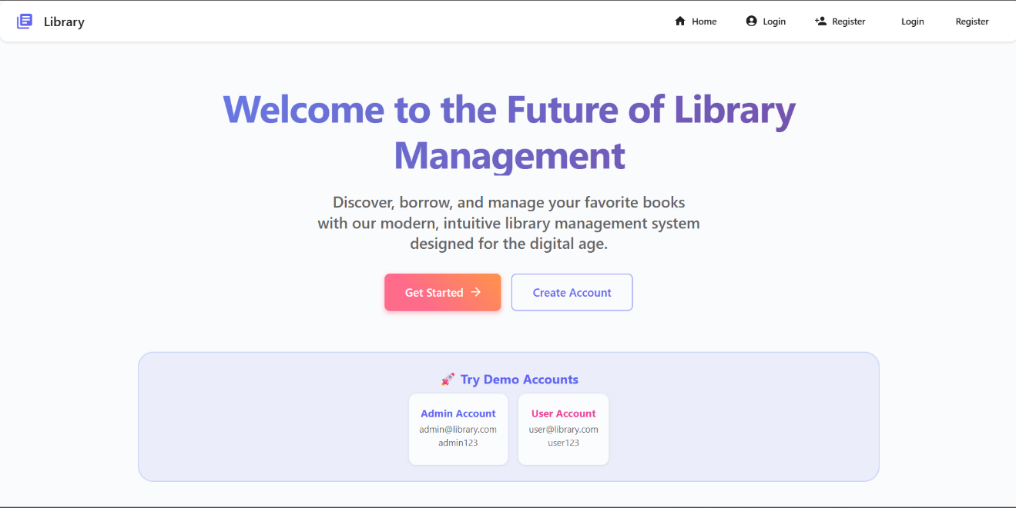
- Consistent accessibility across devices
2. Accurate and Automated Transaction Processing
The digital issue and return system resulted in:
- Elimination of manual errors
- Reduction of duplicate entries
- Accurate and instant availability status updates
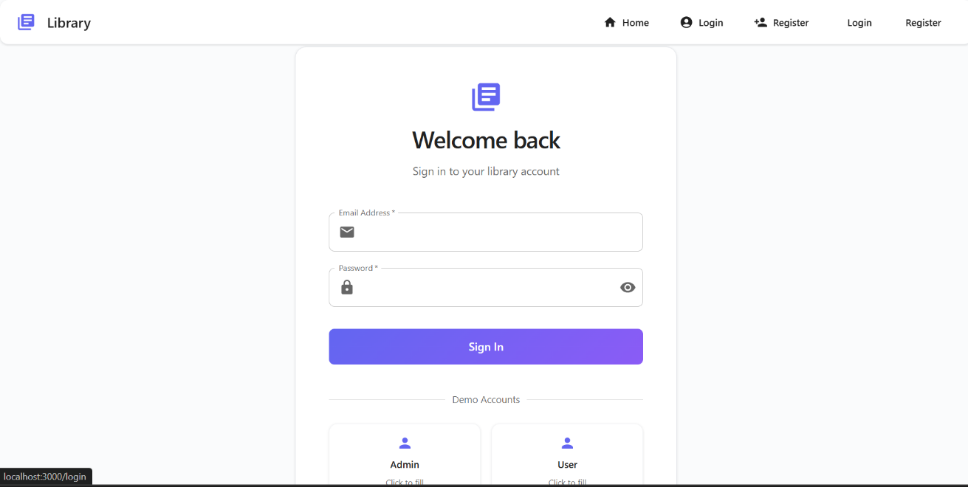
- Automated timestamping for all transactions

3. Improved Library Administration
Librarians experienced improved efficiency due to:
- Centralized access to user and book data
- Real-time tracking of borrowed and available books
- Quick retrieval of transaction histories
- Easier inventory monitoring and updates
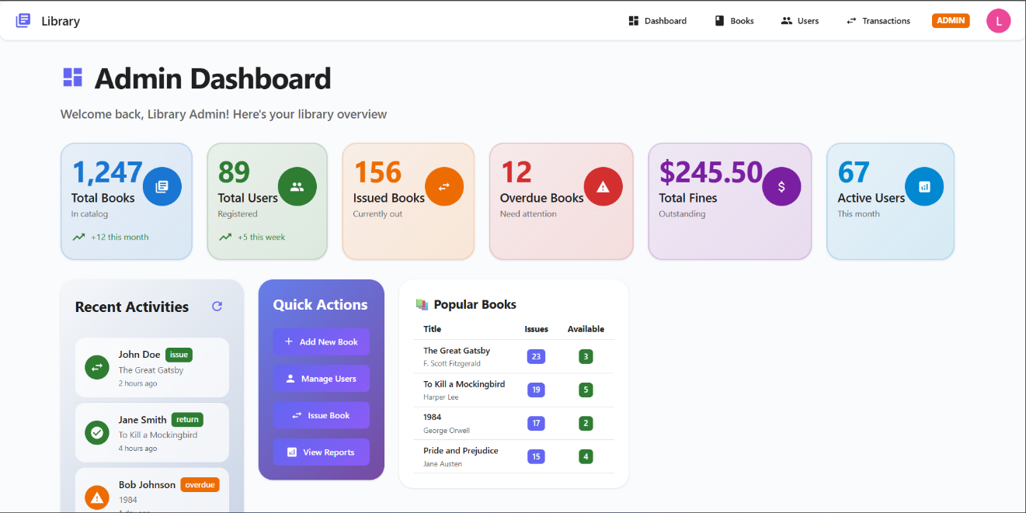
This allowed staff to manage resources more effectively, especially during peak usage hours.

4. Secure and Reliable Data Management
With Spring Security and Hibernate between the backend and database:
- All records were stored securely
- User credentials were protected
- Unauthorized access was prevented
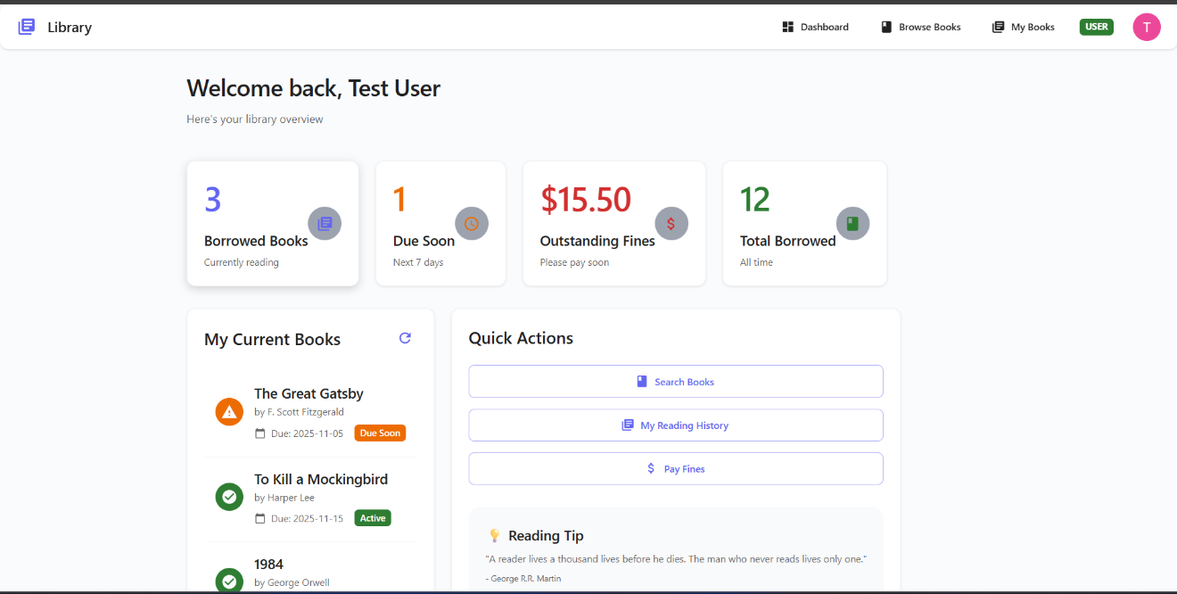
- Data consistency and reliability improved

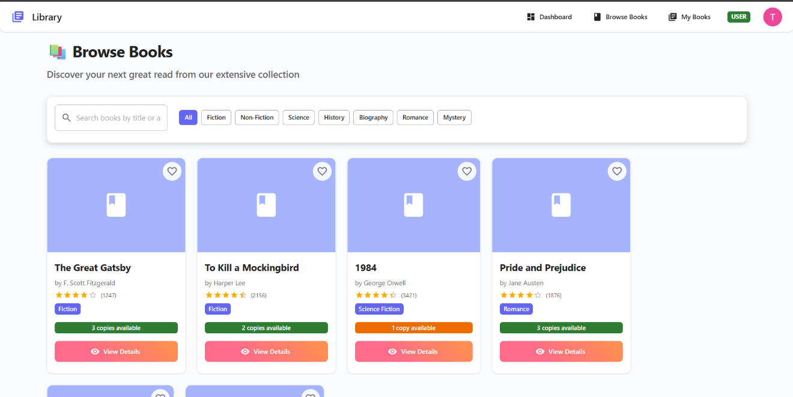

5. Overall System Impact
The system successfully transitioning the library from a manual, paper-based workflow to a fully digital ecosystem resulted in:
- Greater transparency
- Reduced workload
- Better resource utilization
- High student satisfaction
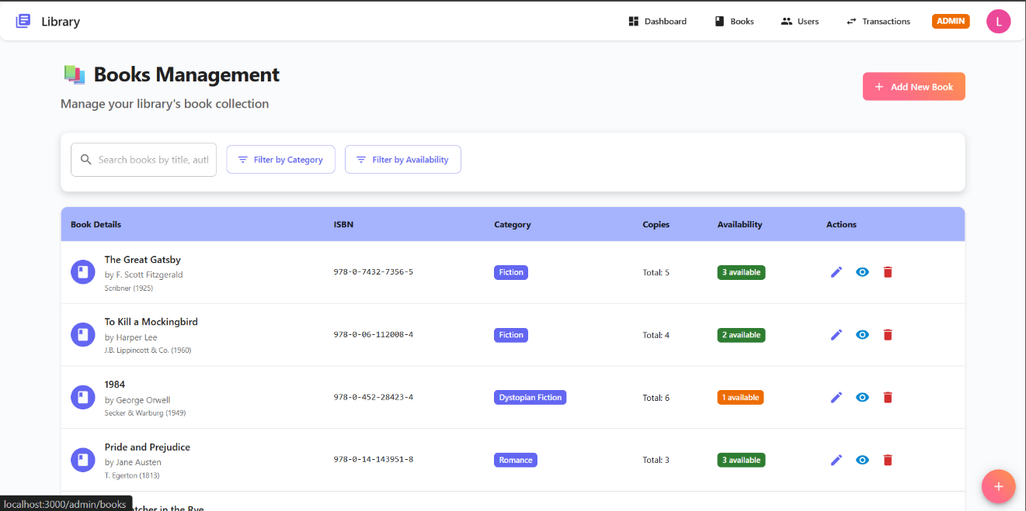
- Faster library operations

Conclusion
The Library Management System successfully achieves its primary goal of transforming traditional, manual library operations into a streamlined, fully digital management platform suited for modern academic institutions. By integrating contemporary technologies such as Spring Boot, Hibernate, MySQL, and a responsive frontend interface, the system provides a structured, reliable, and user-friendly solution for managing book inventories, user authentication, and issue/return transactions. Through the automation of routine tasks and real-time data synchronization, the platform effectively reduces human errors, eliminates duplicate entries, and ensures accurate tracking of book availability, enhancing the overall operational efficiency of library workflows.
From a user perspective, the system offers a simplified and intuitive interface that allows students to search for books, check availability, and view transaction histories with ease. Librarians benefit from improved administrative control, enabling them to process book issues and returns quickly, maintain inventory records efficiently, and retrieve detailed reports whenever required. The adoption of secure authentication mechanisms and role-based access control further ensures that sensitive data is protected and only authorized users can access administrative functionalities, thereby strengthening the system’s overall security posture.
The project also showcases the effective application of full-stack development methodologies, emphasizing modular design, database normalization, iterative testing, and seamless frontend-backend integration. This approach not only ensures scalability and maintainability but also allows the system to accommodate additional features in the future. Potential enhancements include automated fine calculation, SMS/email notifications for due dates, digital library integration, and advanced analytics dashboards for administrators.
Overall, the Library Management System demonstrates the significant potential of digital solutions in improving institutional efficiency and user experience. By replacing outdated manual processes with a centralized, automated, and data-driven platform, the system contributes to the modernization of academic library services and supports the broader goal of digital transformation within educational environments

