Manual Scavenging Awareness campaign

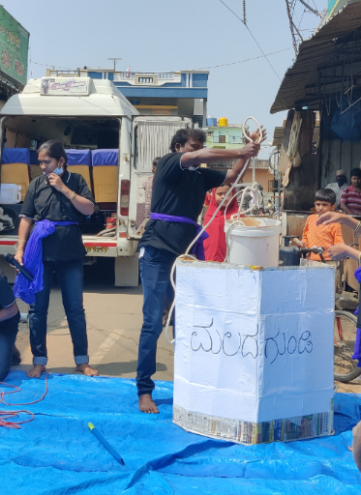In the small, happening region of JP Nagar Bengaluru, an awareness campaign against the practice of manual scavenging was held in the morning hours of 16th February 2021. Led by Obalesh Bheemappa, the state convener of the Safai Karmachari Kavalu Samiti, a team of men and women marched to condemn the practice and bring attention to the commonly overlooked yet fatal act.

In India, manual scavenging, one of the deadliest occupations in the world, is the starkest example of the continuing blight of caste on millions of lives. Often swept under the carpet, hundreds of thousands of Indians still make their daily wages as scavengers, cleaning dry toilets by hand, or clearing septic tanks and sewers without adequate gear.

The scavengers belong overwhelmingly to the very bottom of the intricate caste system that still governs whom most Indians converse with, live next to, what they eat – and who unclogs their sewers.

The Safai Karmachari Kavalu Samiti members held a play to highlight these issues. Mr Bheemappa began by requesting a few minutes of the bystanders’ time, asking them to denounce and stop perpetuating the use of humans to clean their toilet pits or septic tanks and instead reach out to the Bengaluru jalamandali for such problems.

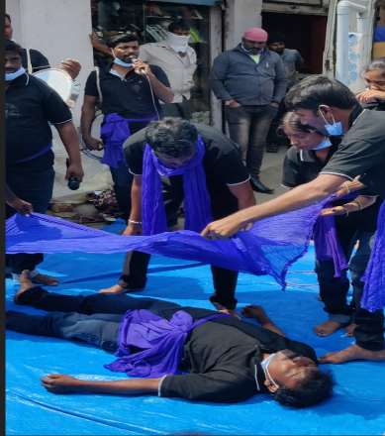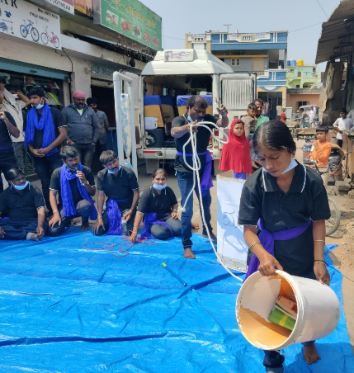The play followed the story of Ramana and Savitri- the inhabitants of a village- who struggled to use the washroom because of a clogged toilet pit. Savitri suggested that her husband, Ramana, take up the issue with the Bengaluru Jalamandali, however, Ramana promptly dismissed his wife. He claimed “the corporation will take too long” to heed his request. Later that day, Ramana encountered his friend, who when faced with the same problem, mentioned he sought the help of a local worker. Influenced by his friend, Ramana called the local workers to help clear the pit. When the workers raised concerns about their safety and the harmful working conditions, Ramana bribed them with money and alcohol. In need of money, the workers accepted Ramana’s offer, entered the pit without precaution and began cleaning it. Soon enough, the worker clearing the clogged pit succumbed to the deadly fumes, lost his balance and collapsed to his death. Ramana and the villages were incapacitated with guilt and grief but were incapable of defending their eventual arrest.

The allegorical play exposes the harsh fate of such deeds. It covers the themes of misinformation, inhumane working conditions, lack of safety for sanitation workers, poverty, and the dearth of initiative commonly present while undertaking the act of manual scavenging.

The play was backed by Kannada songs composed to deliver a message and garnered quite an interested crowd. All of whom seemed to take in the message, profoundly displayed through the efforts of the actors.

The display was tied together in the end by addressing the public one final time, encouraging them to seek the local authorities' help for sanitary complaints.