# Program Design:

Based on the MVC model following diagram below:

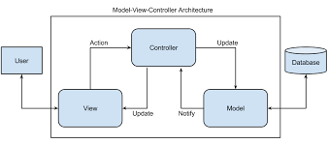

* Model:

The model is implemented using a sqlite3 database that holds all the players/tournaments/matches data. Data is updated as soon as the menu requests are fulfilled. All the database requests and updates are handled by the database.py which implements a python class named Database. This class contains all the interface layer with the sqlite3 for data storage and retrieval. It is structured around 4 tables that holds the data: players, competitors, tournaments and matches.

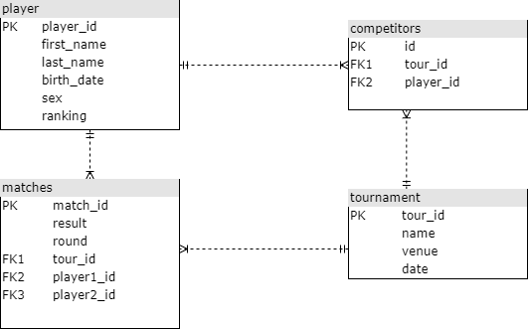

* Controller:
* The controller is implementer in file controller.py that contains a class Controller. It is managing the database either to retrieve some data or to update data depending on the action that the program user is requesting. The controller checks that the data is consistent with what is consistent with the database design (for example do not add twice or more the same player or the same tournament). It also able to generate the contests once a tournament and its competitors have been recorded. The contests are defined by the Swiss pairing system. The controller also processes the user requests coming from the menu and provides data for display in return to a request.
* View

This is implemented in source menu.py which contains class Menu. This class processes the user requests and does some syntactic checks for input data correctness. However, the data consistency checks are left to the controller. The display and formatting of data is done in this class.