# Comprater Performance testing

*Comparator:*

Scope: PL and CL products, PA and HO Quoting

Load: 200 concurrent users plus 50 concurrent users simulating comparator activity; targeted generation of 200 quotes in 60 minutes

Results:

Optimal results for most transactions

Latency noted in Carfax and Organization search

Issue with the Carfax was observed even in a standalone PC test

Slowness observed on the payment tab

Conclusion:

The observed slowness does not appear to be caused by the additional load from the comparative rater. Furthermore, the current test does not directly measure the performance of transactions processed through the comparative rater itself. Its purpose is to validate whether the increased load originating from the comparative rater has any impact on the performance of our core system.  
It is important to note that the slowness was also observed during a standalone test, independent of the comparative rater integration.

To accurately assess the performance of the comparative rater and its impact on the Guidewire (GW) system, testing should be conducted with full comparative rater integration. This will provide a true measure of the comparative rater’s effect on overall system performance.

## **Baseline metrics of PC_PL: Stand alone:**

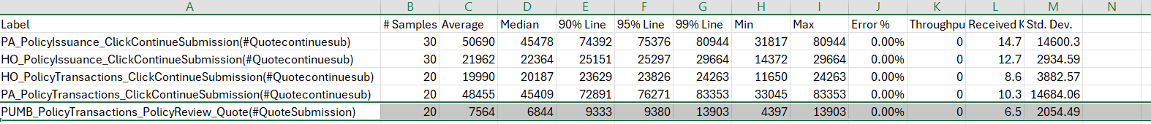

Pc PL_Standalone

## **Baseline metrics of PC_CL: Stand alone:**

PC:CL Standalone

## **Comprater Parallel**

### PC_PL simulating the Comprater Load(PA, HO)

comprater_Load

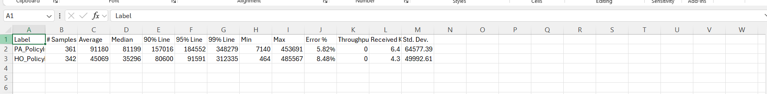

Jmeter Report

### Parallel _PC_PL

PC_PL (Parallel)

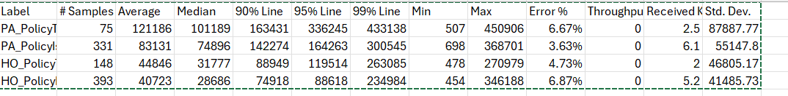

### Parallel PC_CL

PC_CL Parallel

### Parallel PC_ PL and CL complex policies

PC_PL and CL(Complex)

