1. Defect ID : DEF-FS-001
Title : Same origin and destination are accepted during flight search
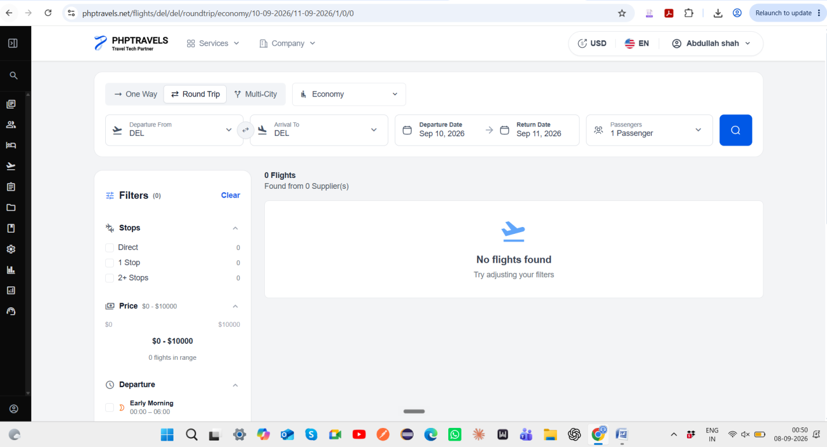
2. Defect ID: DEF-PAX-001
Title: Passenger name is silently truncated on invoice after accepting excessively long input
Accepted a very long name without error
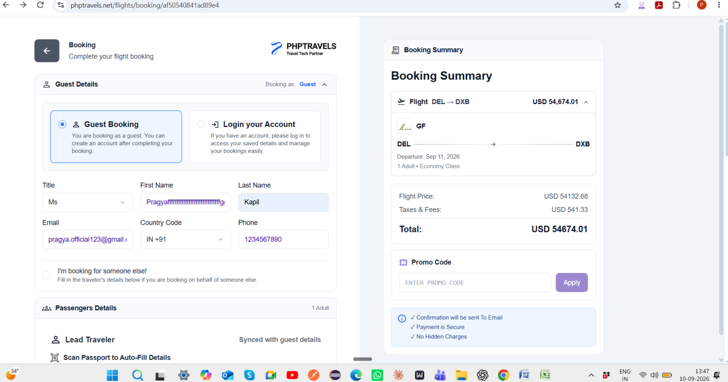
Truncated the name
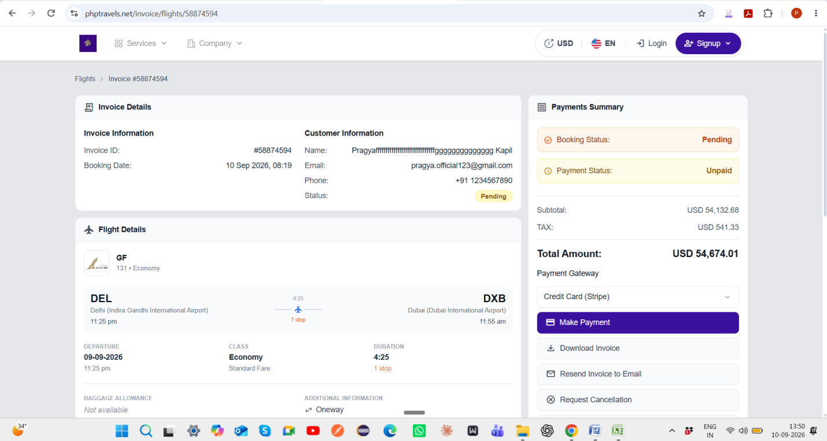
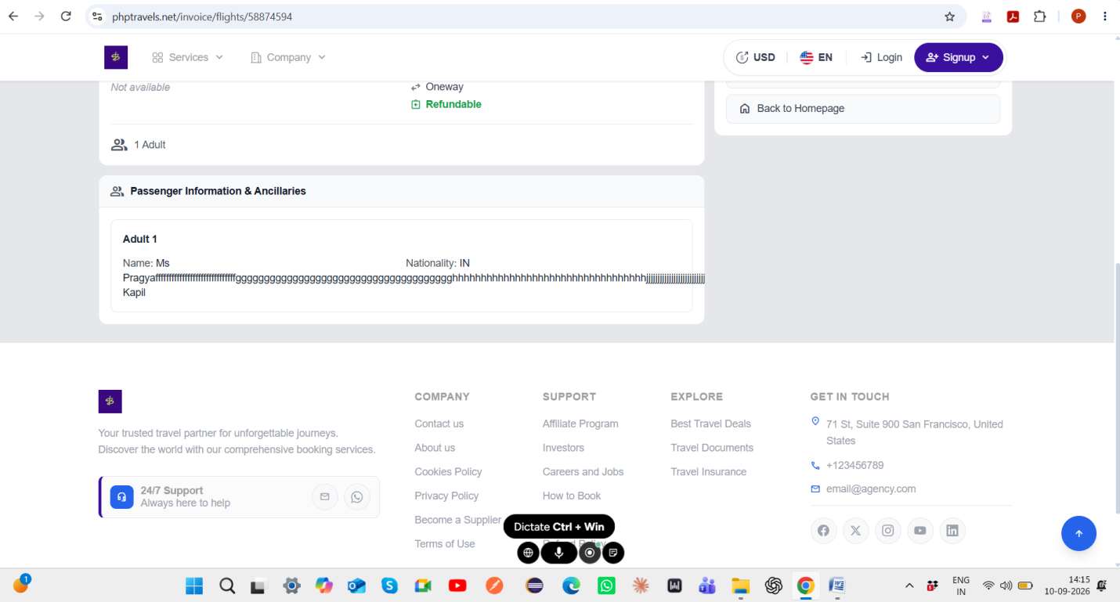
3. Defect ID: DEF-PAX-002
Title : Flight search returns zero results when a Child passenger is added despite flights being available for Adult-only search
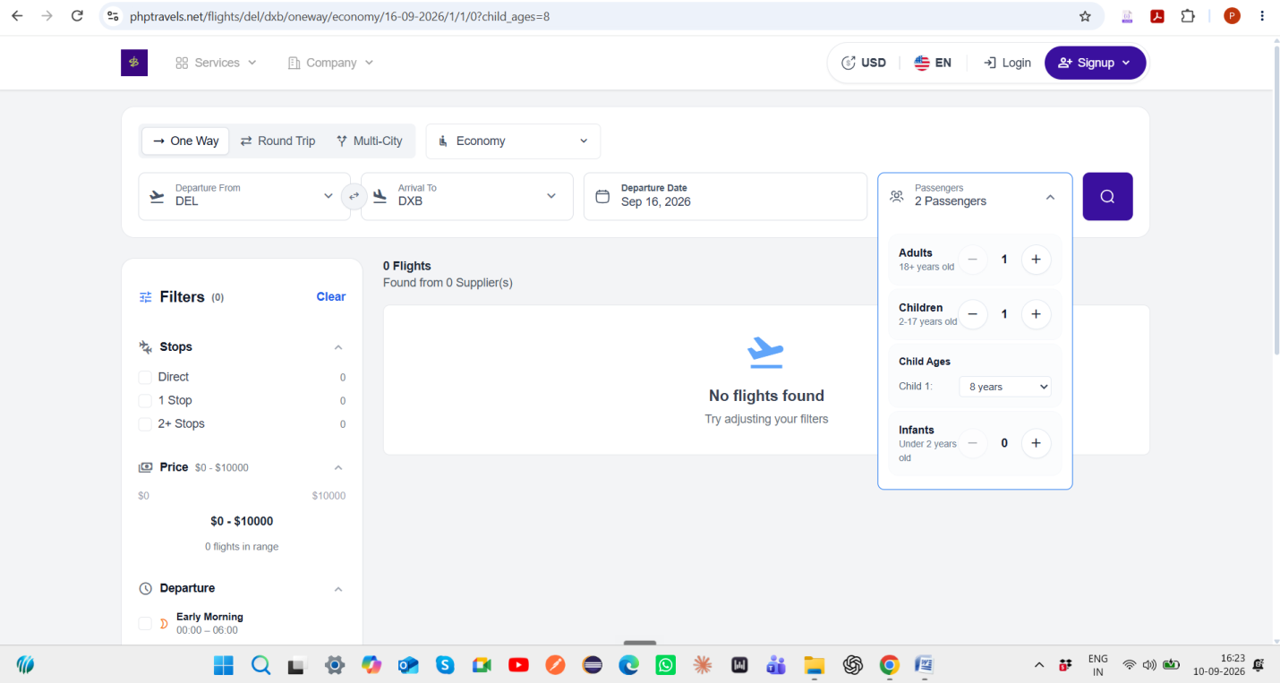
4. Defect ID : DEF-PAY-001
Title : Booking proceeds to payment gateway with amount exceeding configured transaction limit
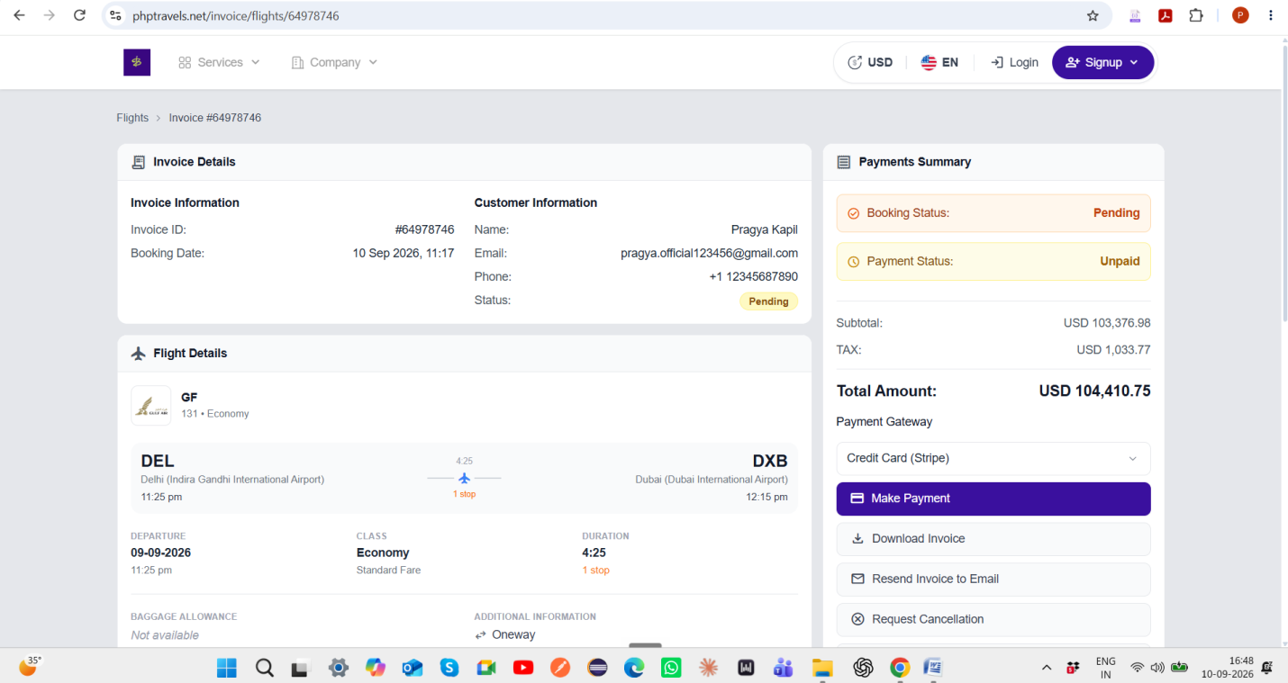
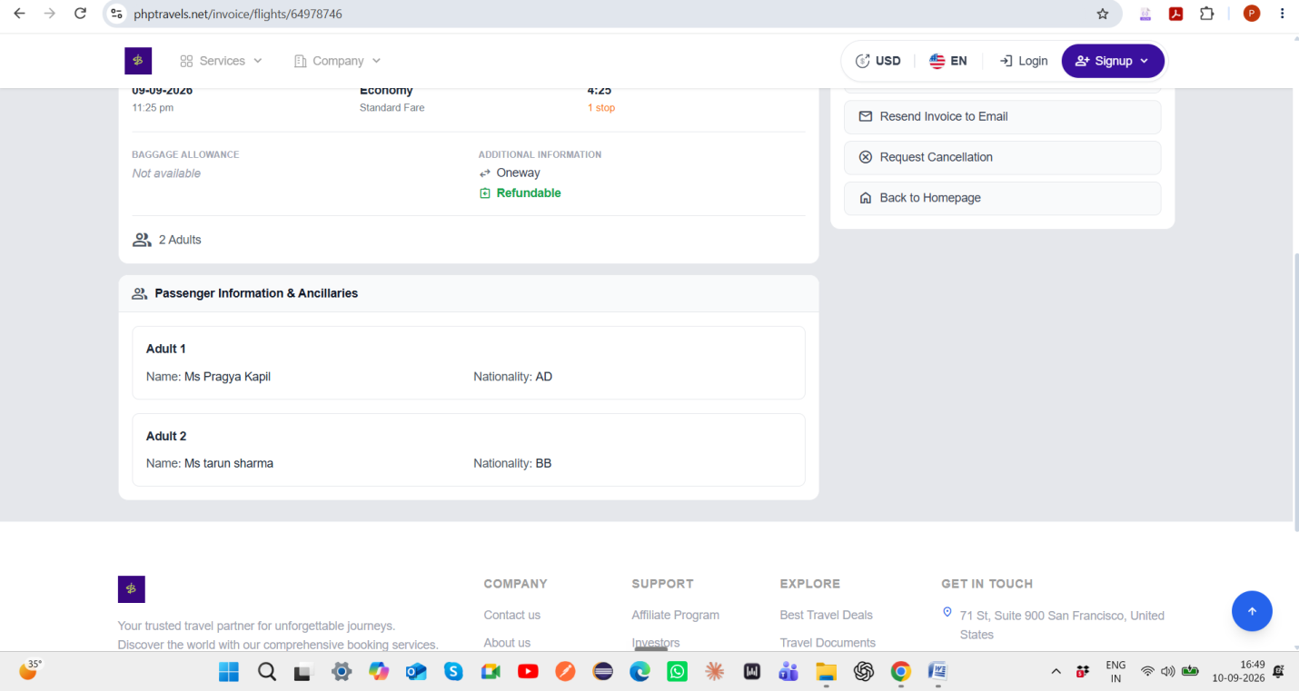
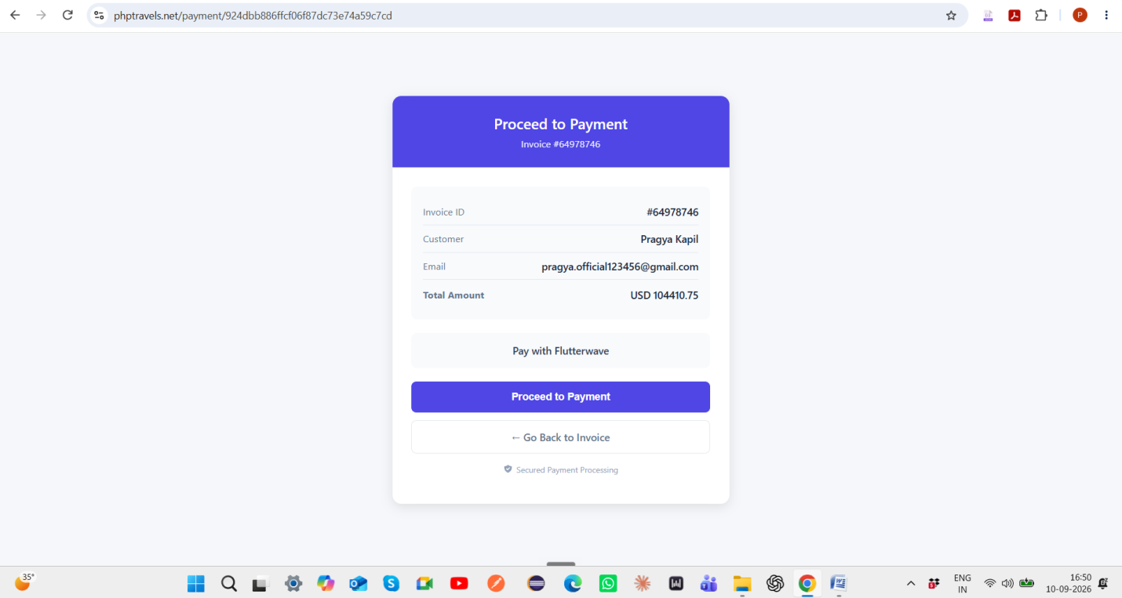
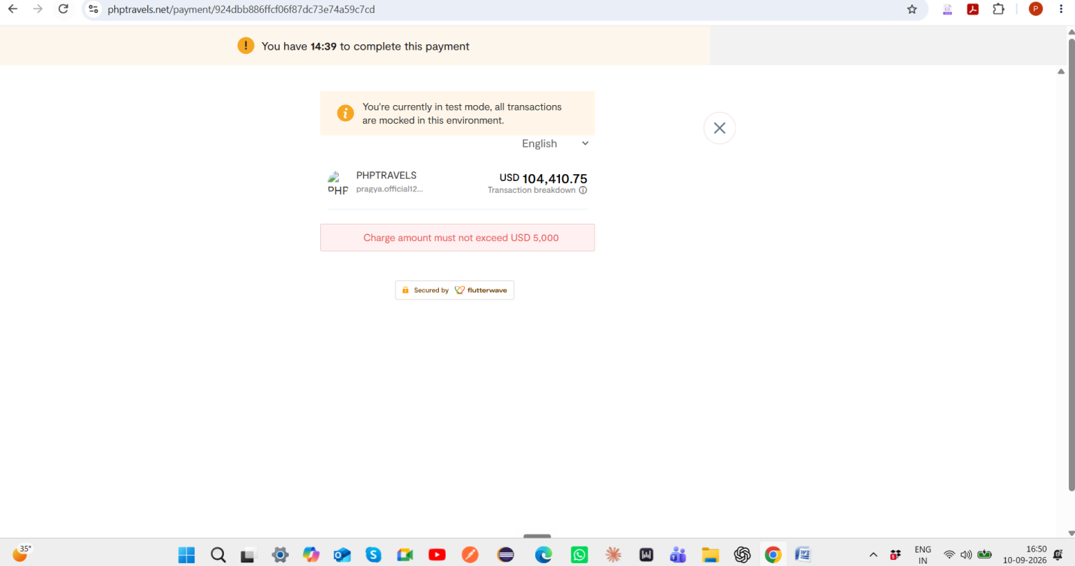
Re-test :
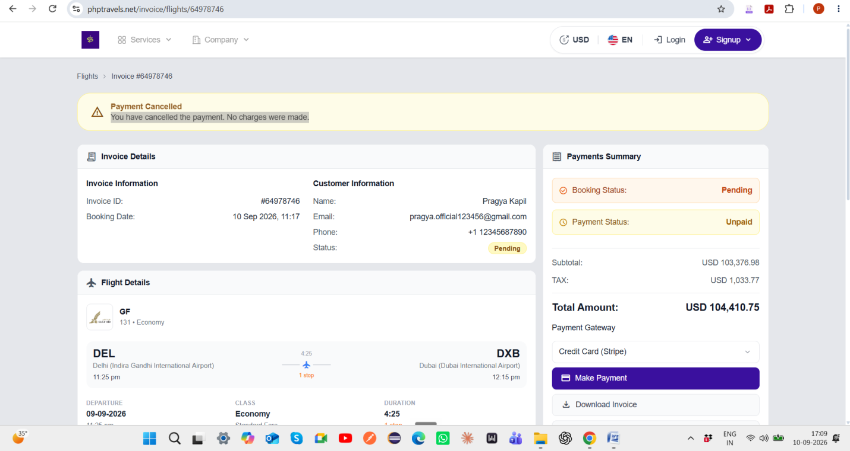
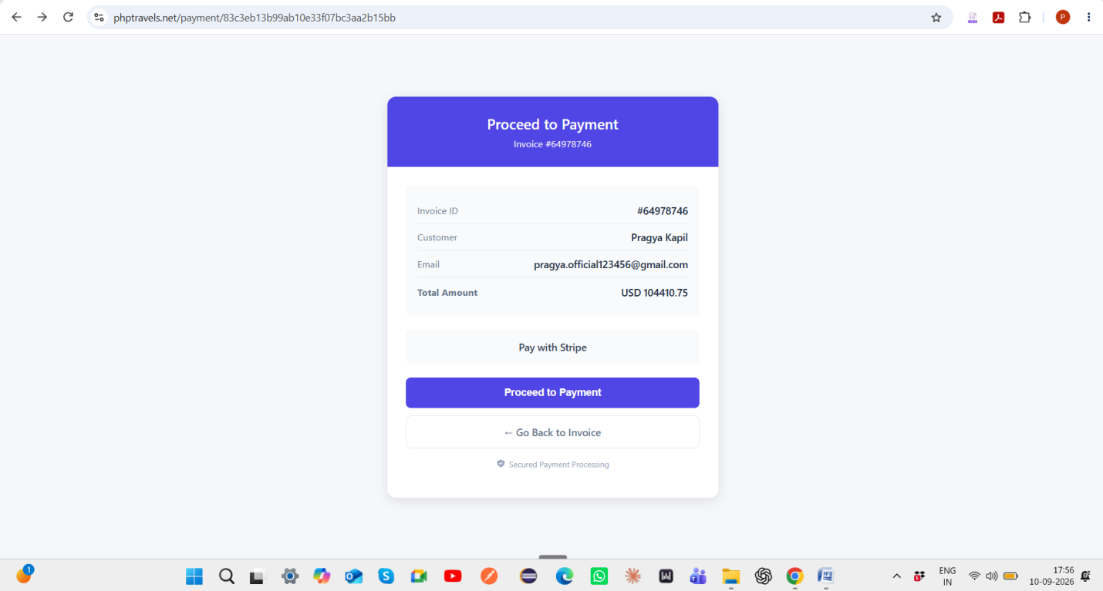
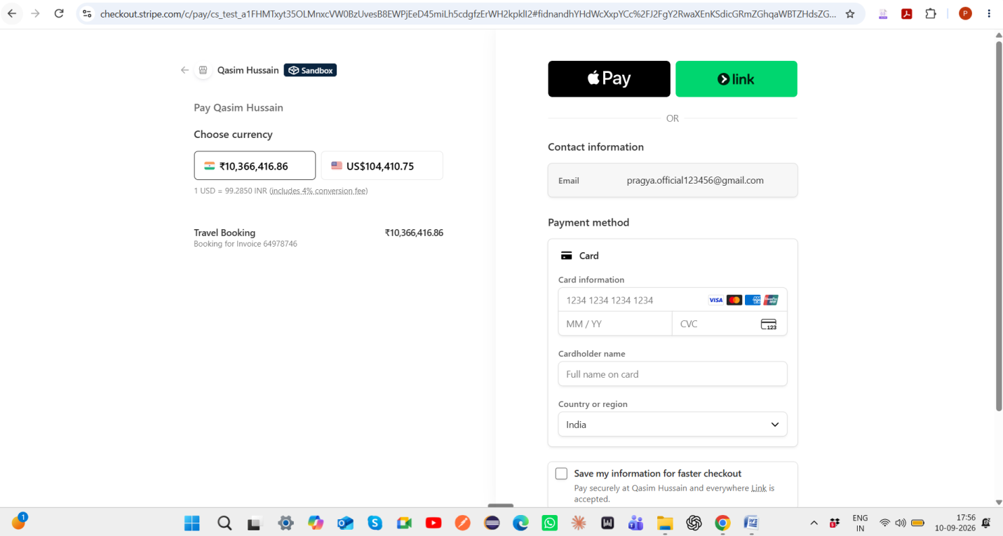
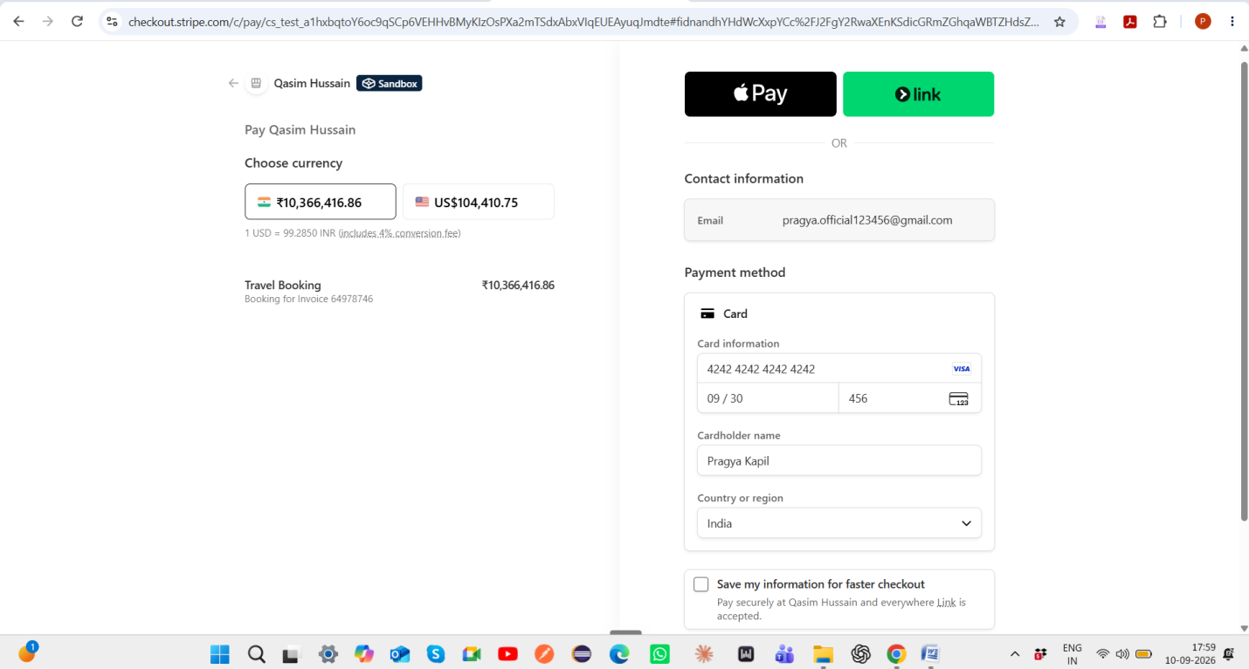
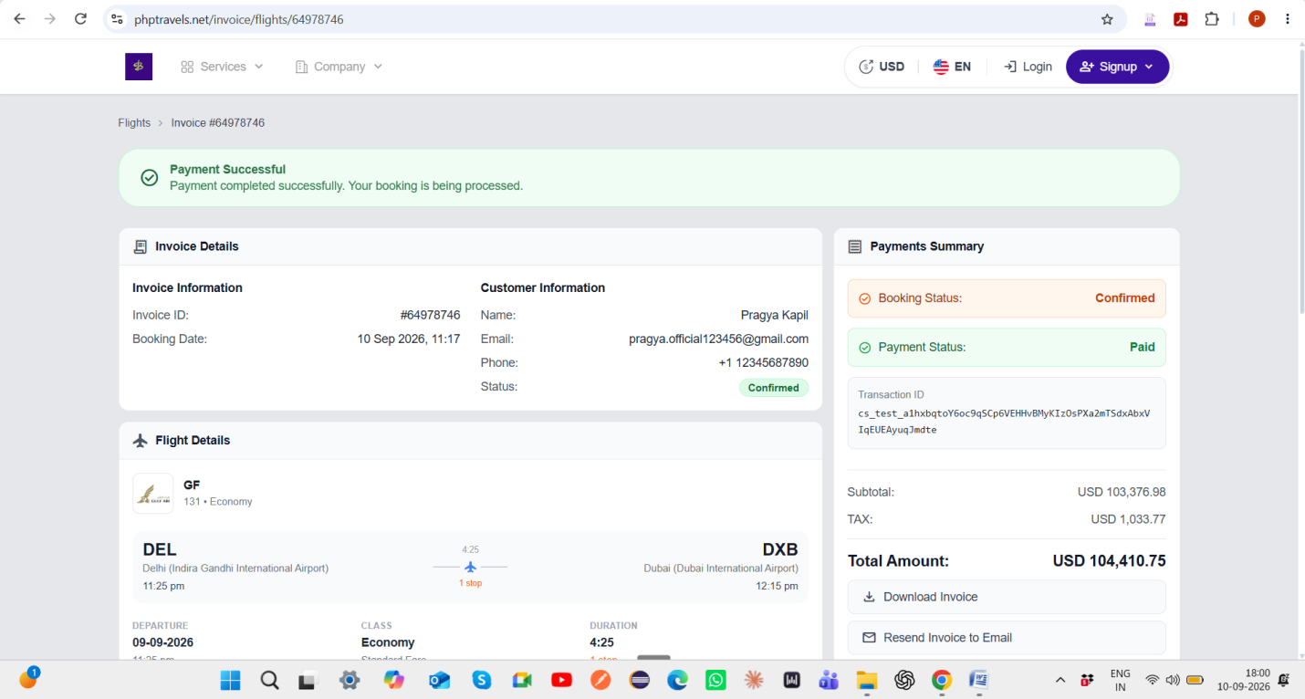
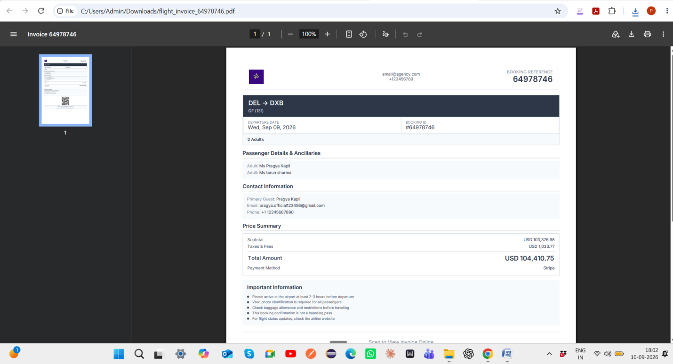
5. Defect ID : DEF-CAN-001
Title : Cancellation request cannot be completed for confirmed paid booking because PNR is not issued and Sabre API returns invalid JSON response
