

|  |  |  |
| --- | --- | --- |
| **Module** | **Portfolio** | **Assessment Type** |
| Collaborative Development (5CS024) | 1 | Individual Report |

[Project Case - Role]

Student Id : NP03A190261

Student Name : PRITISMA THAPA

Section : L5CG5

Group : L5CG5 Group 1

Module Leader : BIRAJ DULAL

Lecturer : PANKAJ NIRAULA

Submitted on : <dd-mm-yy>

Word Count :

**Acknowledgement**

**Table of Content**

# Self-appraisal form

|  |  |  |  |
| --- | --- | --- | --- |
| Student number | 2052300 | Name | Pritisma Thapa |
| Project | Content Management System | Date | 2021-05-16 |
| Role | Developer | Team | L5CG5 (group 1) |
| Sprint (1 or 2) | Sprint 2 |  |  |

# Personal objectives – performance measurement

|  |  |  |  |
| --- | --- | --- | --- |
| **Objectives** | **Evidence provided**  *(E.g. appendix A, file name etc.)* | **Evaluation**  *Student / tutor* | |
| Debug | For this part, Business Analyst of our team has assigned us with the bug report of the website. And us developers were told to fix the bug of our given part. I have fixed bug through researching some websites and following YouTube tutorials.  **Link to the Risk analysis document in the same file (Cross referencing) (Appendix A) ** | Self-evaluation | 8 |
| *Tutor feedback:* | | | |
| Implementing functional requirement | As the front-end of the team, I was responsible for the static part of the website. Just like in sprint 1, I have used language that I am more confident in.  **Link to the People Management document in the same file (Cross referencing) (Appendix A)** |  | 8 |
| *Tutor feedback:* | | | |
|  |  | /50 | /50 |

**Evidence Provided**: The reference of the appendix in which the evidence can be found (*Appendix A, appendix B, screenshot.jpg, myreport.docx* etc. please attach to this form). Don’t hesitate to add comments and notes to your appendices to highlight particular sections, relevant pieces of code etc.

# Collaboration Document

# Evidence of good collaboration

## Good communication and file sharing

|  |
| --- |
| Communication is the key when working in group project. From sprint 1, when our team lacked in proper communication, we learned our lesson. So, we started communicating more in this sprint than the previous. Sprint 2 happened during the lockdown, due to which we were not able to discuss and conduct meetings physically. So, we had to attend meetings in google meetings. And had to discuss both our problems and ideas through social media. |

Receivable evidence includes:

* Emails and other types of messages (Facebook messenger, WhatsApp etc.)
* Screenshots of Basecamp conversations in which you actively participate.
* Screenshots showing files (designs, reports) that **you** shared with your team on Basecamp

***Important****: Please include no more than 5 items*

Summarize What you have done (max 75 words)

**Link to the evidence document in the same file (Cross referencing) (Appendix B) **

**Continuing Personal Development (CPD)**

Receivable evidence includes:

* Course/seminar attendance register
* Online course: certificate of completion
* Word document summarising what was learnt and how it can be used on the project

***Important****: Please include no more than 5 items*

Summarize What you have done (max 75 words)

**Link to the 500-word report in the same file (Cross referencing) (Appendix B) **

## Issue tracking

Receivable evidence includes:

* Screenshots of **personal contributions** to GitHub issues.

***Important****: Please include no more than 5 items*

While working in a group, tracking bugs and errors of a system can be a hassle. The tracker used for bugs and error in GitHub is called Issues, which has its own segment in a repository. Issues are an excellent way to maintain track of the systems' objectives, adjustments, and issues. They are somewhat like email, except one can also discuss and review the work of the team members.

**Link to the 500-word report in the same file (Cross referencing) (Appendix B) **

## Work to deadlines

**No evidence required**. Your tutor will decide whether you have worked to deadlines based on various factors (team meetings, discussions with other team members, discussion with client etc.)

# Appendix A

## Debug

Debugging is the way of analyzing and fixing defects in a programming code that may trigger it to cause problems on the website. To debug a system, the programmer must first identify a problem, then identify & correct the issue's code. As an understanding of pattern recognition is required, the programmer must try to solve the error. (The Economic Times, n.d.)

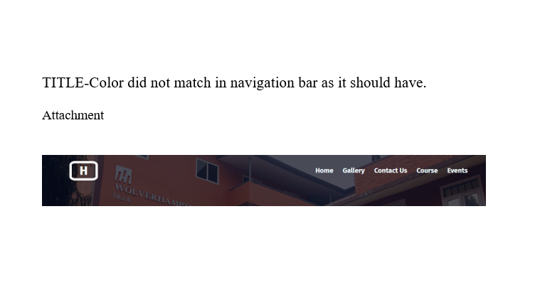

According to this bug, the navigation bar must have a different color so it can fit in the background and look more presentable. For this bug, I have added color to the navigation bar in CSS.

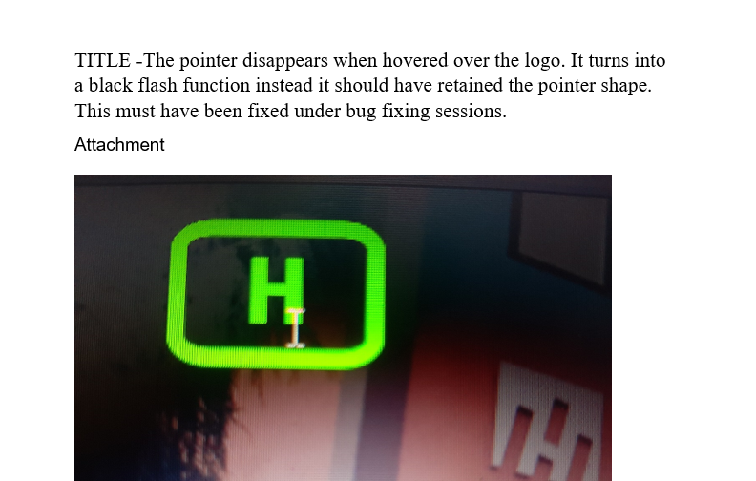

In the bug report, the pointer has no cursor property in the CSS. For this I changed in CSS

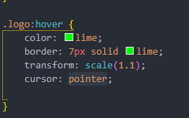

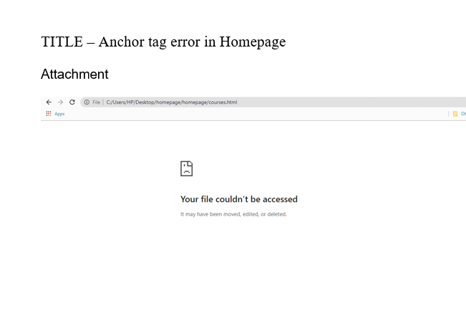

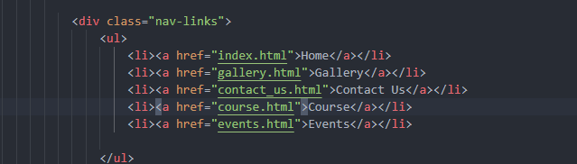



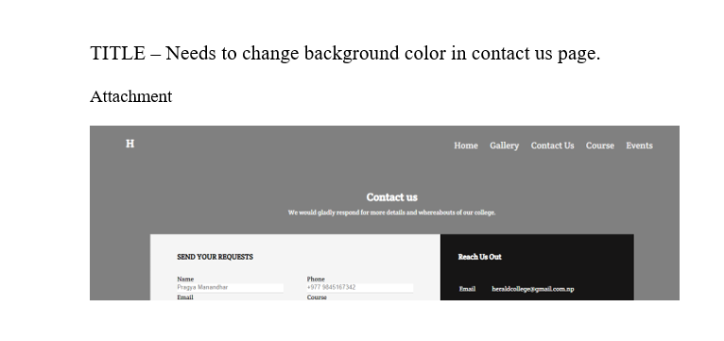

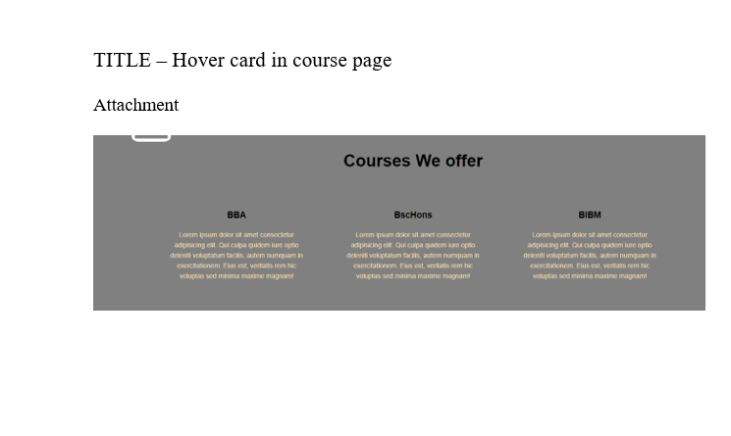

# Implementing functional requirement

## Codes and its explanation

## Use of Version control (Screenshots of logs)

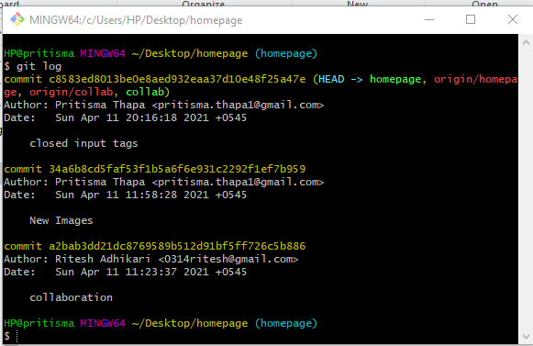

# Appendix 2

1. Evidences of Good communication and file sharing
2. Evidences of Continuing Personal Development (CPD)
3. Evidences of Issue tracking

# References