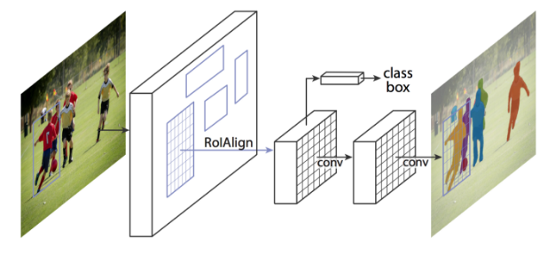

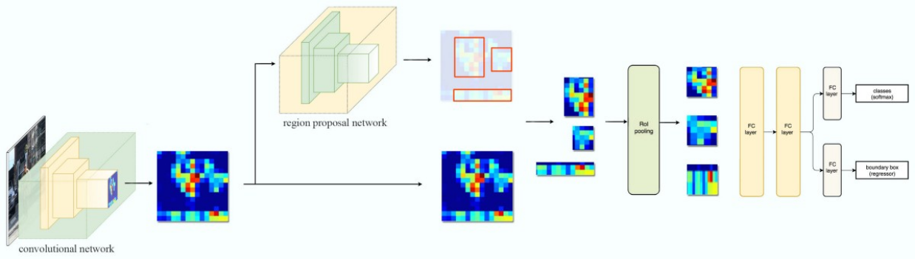
Faster RCNN

Layers in Mask_RCNN
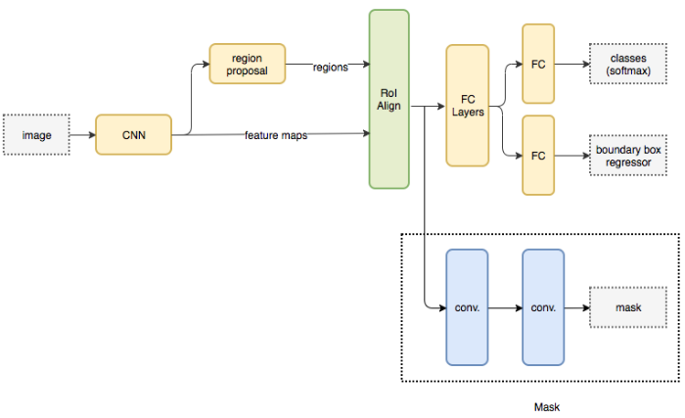

Mask-RCNN
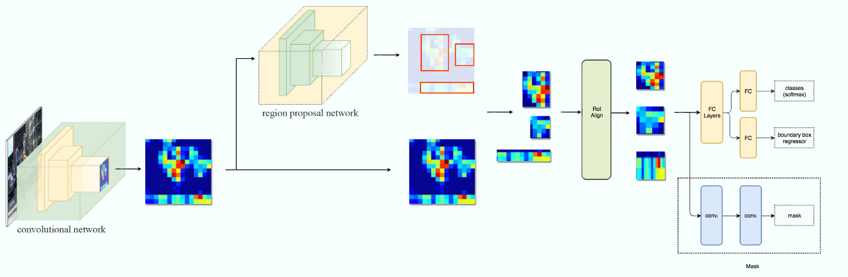
COCO dataset
- Understand difference b/w instance segmentation and semantic segmentation
- Very good explanation of Mask RCNN
