**IMAGE**

**PROCESSING**

**PDPM IIITDM Mentor:Dr.I.A.Ansari**

**JABALPUR Presented By:**

**Pragya,**

**Apoorva Vikram Singh**

**Mukul Mishra, Shivam Yadav**

INTRODUCTION

We worked in the field of **image processing**.

Now, What is image processing?

Image processing is a method to convert image into digital form and to perform some operations or to check it.

**Purpose of Image processing**

1.      Visualization - Observe the objects that are not visible.

2.      Image sharpening and restoration - To create a better image.

3.      Image retrieval - Seek for the image of interest.

4.      Measurement of pattern – Measures various objects in an image.

5.      Image Recognition – Distinguish the objects in an image.

Image processing includes many domains , the field in which we worked is **image watermarking.**

**IMAGE WATERMARKING**

In this field we basically worked in two domains namely:

1. **Ownership:** We basically check the one who owns the image or to whom the image belongs remains same or not while travelling of image from one place to other. Sometimes , it may happens that someone takes an image and guarantee that it is his image but it may not so here we check and verify whether image owns by him or not.

2. **Tampering:**  Here, we check that whether image which we got is the original one or not

Means sometimes it may happen somebody distort or try to destroy our image so by secret image hidden or watermark hidden we check whether image is original or not.

**TECHNIQUE USED**

In our whole project we used:

1. Matlab2016
2. Windows 10
3. RAM : 4.00 GB
4. Processor : INTEL(R) Core(TM) i3-6006U CPU @ 2.00GHz 1.99GHz
5. 64 bit operating system, x64 based processor

**METHODOLOGY**

Image is stored in the form of matrix which contains pixels. Images are broadly classified into three types :

1. **Binary Image(Black and White)** – It is an image whose pixel value is either 0 or 1.
2. **Grayscale Image –** The image has pixels ranging from 0 to 255 where 0 is completely black and 255 is completely white while others are shades of grey.
3. **Coloured Image(RGB)** – These images are formed by overlapping of these three shades red, green and blue. Pixels of all three varies between 0 to 255.

OWNERSHIP

Image watermarking are of two types :

1. Invisible
2. Visible

For ownership check we use invisible watermarking.

We take an image which we will be using as a hidden image technically it will be our watermark. Now the idea is to embed this watermark to our host image , now whenever someone will guarantee that this image is owned by him we will now check the watermark embedded and will assure that he is the right owner.

**LSB Based Image Watermarking**

LSB stands for least significant bit , means if we change LSB of any number then it will affect least. So , now we will take a 8 bit grayscale image , convert it’s pixel to binary one by one and now , we will change the LSB means last digit of binary number to the pixel of our watermark which is a binary image means watermark’s pixel will be either 1 or 0 so now we will replace host’s pixel in this way and after that we will get a new image called watermarked image.

By now if someone guarantee then we will extract the watermark and check it by original watermark.

We compared the host images with our watermarked images through several commands :

1. Peak signal to noise ratio(psnr)
2. Structural similarity index(ssim)
3. Mean squared error(immse)

There are two types of attacks:

1. Geometrical Processing
2. Signal Processing

Now we attacked on watermarked image which distorted our image in some or other way. Then we got watermarked attacked image , after that we extracted the watermark and checked it from original watermark usig BER command.

BER = Number of wrong bits/total bits

TAMPERING

Whenever image is distorted or changed in anyway then it is called tampering of an image.

Like if we changed one’s face to other or added something to it through editing.

Now we took an image and replaced its last four bits to first four bits in this way we got an

image which is almost similar to original one.

Now if someone tampered it then we will check those last bits again with the previous one

and will report that image is tampered.

**RESULTS**

**Result 1:** We took an 8- bit image and watermarked it with another 2-bit image and then finally compared the original image with the watermarked image using ssimval, peaksnr and Mse command and got the following result.

|  |  |  |  |
| --- | --- | --- | --- |
| Watermark 1 | | | |
|  | ssimval | peaksnr | Mse |
| Image1.jpg | 0.9982 | 50.088 | 0.6371 |
| Image2.jpg | 0.9981 | 49.9081 | 0.6642 |
| Image3.jpg | 0.9982 | 49.7368 | 0.6909 |
| Image4.png | 0.9982 | 49.6911 | 0.6982 |
| Image5.png | 0.9983 | 49.6621 | 0.7029 |

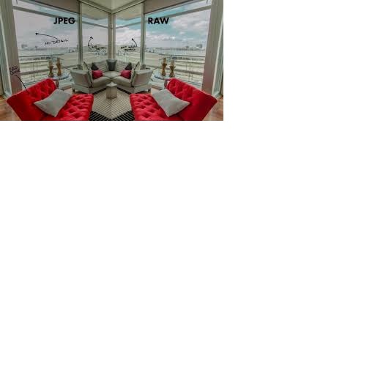 

Image1.jpg Image2.jpg

  

Image3.jpg Image4.png Image5.png

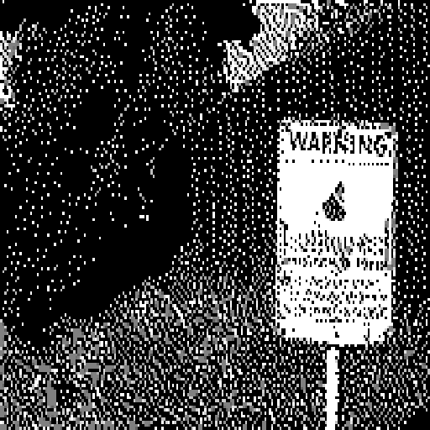

Watermark1

**Result 2:**

After watermarking the image, we attacked the watermarked image using different attack commands of geometric and signal processing attack. After attacking, we extracted the watermark from the attacked watermarked image and then compared it with the original watermark and finally got the following results.

**BER Table**

|  |  |  |  |  |  |  |
| --- | --- | --- | --- | --- | --- | --- |
| **HOST** | **WATRMRK** | **medfilt** | **Resize** | **Adjust** | **Noise(g)** | **translate** |
| **lena** | **Watermark1** | **1320,0.005** | **129476,0.4939** | **153376,0.5851** | **128890,0.4917** | **18608,0.071** |
| **lena** | **Watermark2** | **25436,0.097** | **129463,0.4939** | **15793,0.5867** | **129165,0.4927** | **79189,0.3.21** |
| **baboon** | **Watermark1** | **1357,0.0052** | **130936,0.4995** | **145014,0.5532** | **131303,0.5009** | **18608,0.071** |
| **baboon** | **Watermark2** | **27265,0.104** | **130955,0.4996** | **145004,0.5531** | **130928,0.4995** | **79189,0.3.21** |

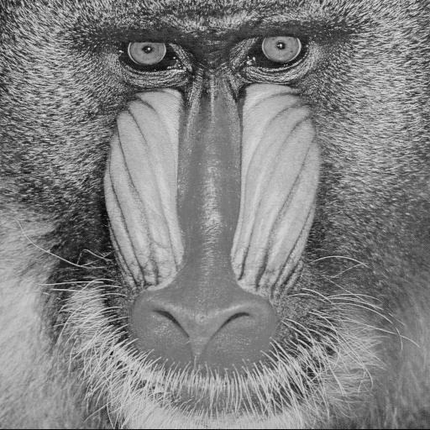**HOST IMAGES**

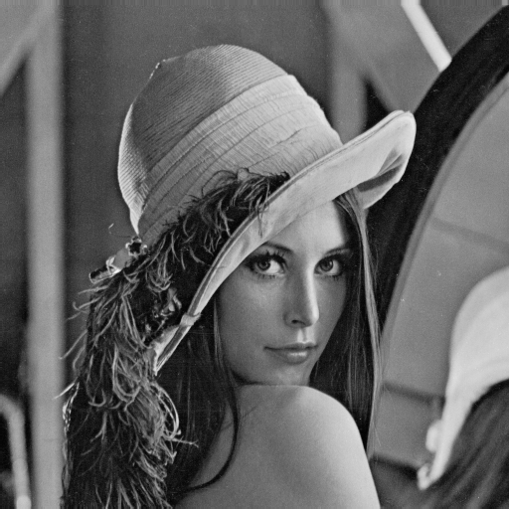

**Baboon Lena**

**Watermark**



**Watermark1**



**Watermark2**

**Lena.png Watermark1**



**Result 3:**

When we did the LSB watermarking , changes were not seen as expectd. So what we did was we watermarked at every bit one by one and then accordingly compared the resulted image with the original image one by one using psnr command. After watermarking at each bit we attacked each image and then extracted the watermark from it. And then compared the extracted attacked watermark with the original watermark and got the following image.

|  |  |  |
| --- | --- | --- |
| **Bit Position** | **psnr** | **ber** |
| **8** | **49.7436** | **0.5063** |
| **7** | **43.7321** | **0.5059** |
| **6** | **37.7037** | **0.5082** |
| **5** | **31.6985** | **0.5055** |
| **4** | **25.6657** | **0.5081** |
| **3** | **19.6316** | **0.5115** |
| **2** | **13.6279** | **0.5093** |
| **1** | **7.5728** | **0.0970** |

**Result 4:**

We took an image and changed the last 4 bits of its each pixel with the first 4 bits of the same pixel. After doing so, we tampered the image using MS – paint and then we compared the first 4 bits of each pixel with the last 4 bits of the same pixel.if the values matched,we left the it as it is.And if the values does not matched,we changed the bits of that pixel with 0 which result in the change of that portion into black.A nd this gave us the idea that at what position the image was tampered.



Watermark2 Tampered detected

CONCLUSION

Conclusion 1. We have seen that after changing LSB of each pixel to that of pixel of watermark , we are not getting much differences means there is similarity , images are almost similar and watermark is also inserted , so we can conclude that we are getting psnr values somewhat greater than 35db which showing similarity in the two images.

Conclusion 2. After attacking on images we distorted it and when we extracted watermark from attacked watermarked image we have seem ber values are not as much we need as this ratio should be nearly zero but it is not coming so we can say that LSB based watermarking is not useful as extracted watermark is not much similar to original one.

Conclusion 3. So as concluded above LSB is not correct position to embed watermark so now we checked psnr and ber values for all position and for MSB ber is very nearly zero but psnr is very low than 35db so,the best position which we got where ber is nearly zero and psnr is greater than 35dbis the middle position.

REFERENCES

1. Mathworks
2. YouTube
3. [www.tutorialspoint.com](http://www.tutorialspoint.com)
4. Watermarks Attacks by S. Voloshynovskiy CSE Department, University of Geneva, Switzerland
5. Wikipedia
6. Quora
7. Unacademy
8. ieeexplore.ieee.org
9. [www.udemi.com](http://www.udemi.com)