Task2:-

https://app.moqups.com/m9l3kwQdun0uZTAUdjUUPaL6DvWXDOri/edit/page/ad64222d5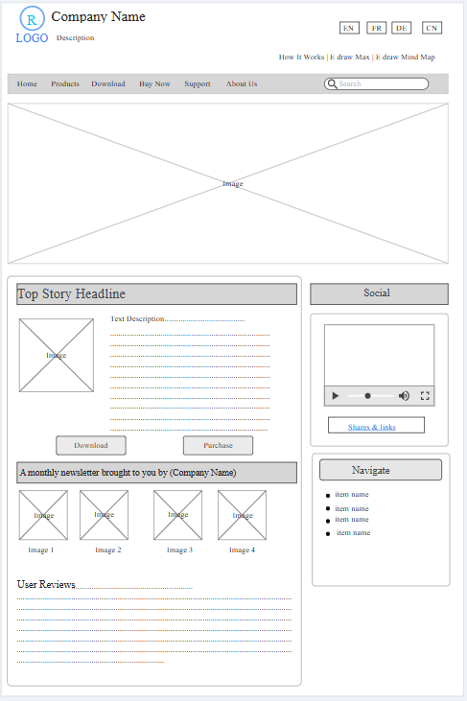

Task3: -

https://app.moqups.com/ZdUg338yv871mFhNOii0OgVbGf2R4S8w/edit/page/ad64222d5