Travel Agent Project - Screenshot Descriptions – By: Pragya Jha

# Screenshot 1

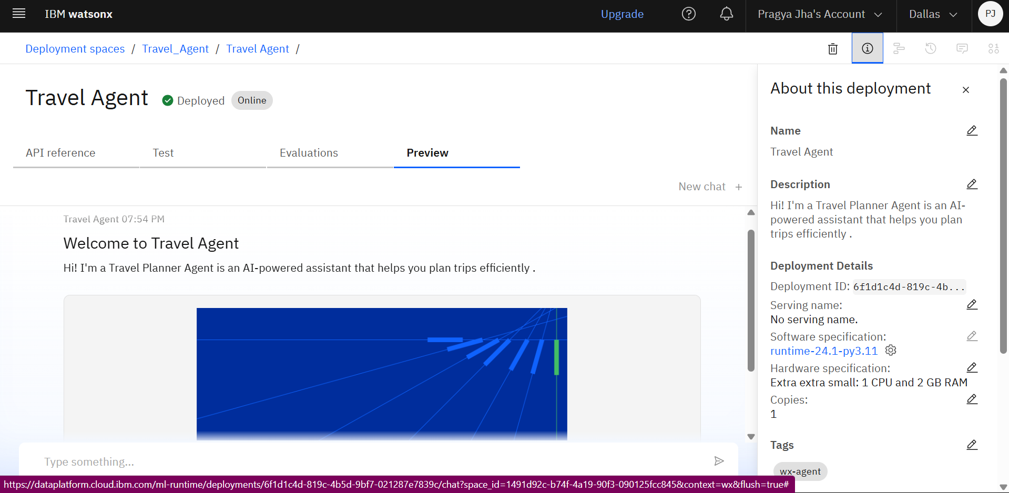

Deployment Details Preview: This screenshot shows the deployed status of the Travel Agent project on IBM Watsonx. It confirms that the project is live (Online), with details like Deployment ID, software and hardware specifications (runtime-24.1-py3.11, 1 CPU, 2 GB RAM), and an absence of a serving name.

# Screenshot 2

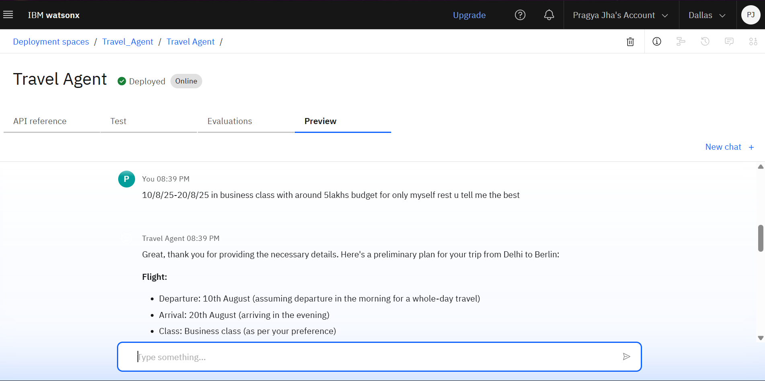

Agent Query and Response Example: This image demonstrates the Travel Agent AI in action. The user requests a travel plan from Delhi to Berlin from August 10 to August 20, 2025, in business class within a ₹5 lakh budget. The Travel Agent responds with a detailed plan including departure, arrival, and travel class.

# Screenshot 3

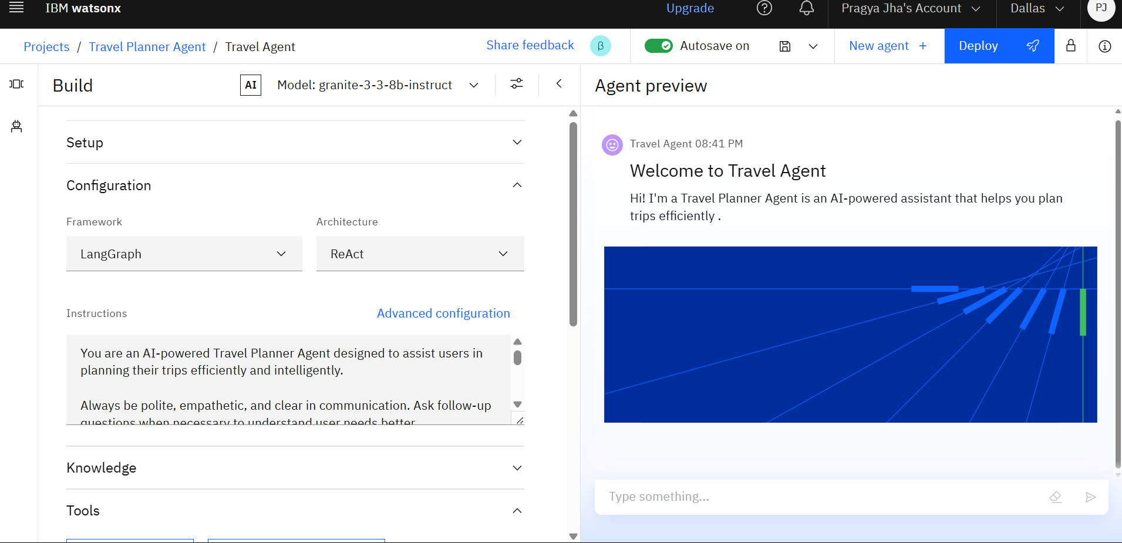

Project Build Interface - Configuration Tab: This screenshot highlights the Configuration section of the agent, showing the selected framework (LangGraph) and architecture (ReAct). The instructions clearly define the assistant's role as a polite, empathetic, and intelligent AI travel planner.

# Screenshot 4

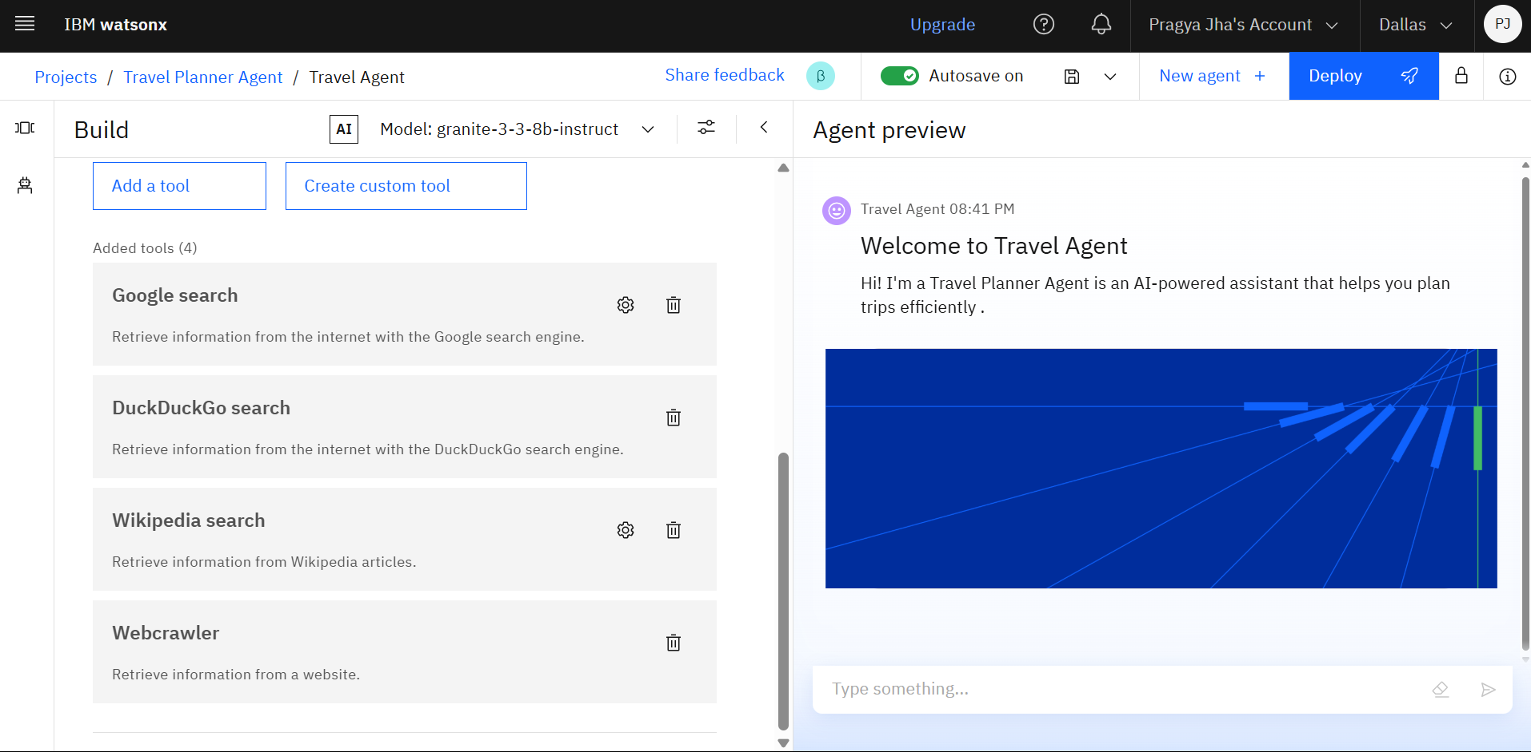

Tools Added to the Agent: This screenshot lists the internet-based tools integrated into the Travel Agent: Google Search, DuckDuckGo Search, Wikipedia Search, and Webcrawler, used to enhance the agent’s knowledge-gathering capabilities.

# Screenshot 5

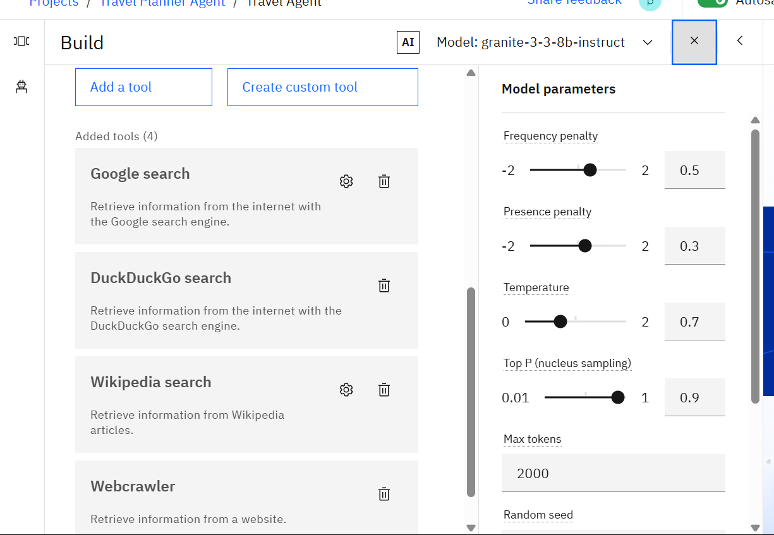

Model Parameters Configuration: This shows advanced model parameter tuning for the agent. Frequency penalty and presence penalty are set moderately (0.5, 0.3), temperature at 0.7 (for creative but reasonable responses), and nucleus sampling (Top P) at 0.9. Max tokens is set to 2000, allowing for longer and more complete outputs.