Game Design Document

Fill up the following document

1. Write the title of your project.

* My Awesome Crop Game

1. What is the goal of the game?

* The game has 3 levels. The goal of the first level is to grow crops. The goal of the second level is to take the rabbit to the carrot through the maze. And the goal of the last level is to pluck the oranges from the orange tree.

1. Write a brief story of your game.

* The overall theme of the game is all about nature and plants.
* So, the first level in the game is for growing crops virtually and saving the environment, in a hope that one day every person will do the same physically.
* This is a single-player game, in which the player must grow different types of crops and then proceed onto the next level.
* The second level has a maze in which the player is the rabbit and the rabbit/player must reach to the carrot following the path of the maze.
* In the last level, the player is the boy who is standing in the canvas. And the player has to hit the stone to the oranges for the them to fall down.

1. Which are the playing characters of this game?

* Playing characters are the ones who respond to the user based on the input from the user.
* Cars, monkeys, dinos, wizards, etc., are the playing characters in the game.

|  |  |  |
| --- | --- | --- |
| Number | Character Name | What can this character do? |
| Level 1 | The Farmer | The character can grow crops. |
| Level 2 | The Rabbit | The rabbit can go in all directions through the maze to reach to the carrot it wants to eat. |
| Level 3 | The Boy | The boy has a stone in his hand from which he can hit to the oranges. |
| 4 |  |  |
| 5 |  |  |
| 6 |  |  |
|  |  |  |
|  |  |  |

1. Which are the Non-Playing Characters of this game?

* Non-Playing characters are the ones that don't have an action or behavior when the user interacts with the game.
* Hurdles, stones, bananas, coins, etc., are non-playing characters in the game.

|  |  |  |
| --- | --- | --- |
| Number | Character Name | What can this character do? |
| Level 1 | Grasshopper | --- |
| Level 2 | Carrot | If the player/rabbit reaches the carrot, then he/se wins the game. |
| Level 3 | Tree, oranges, stone | Tree has oranges placed on it. The oranges have to fall when the stone hits it. The stone will be placed in the player’s/boy’s hand to hit the oranges. |
| 4 |  |  |
| 5 |  |  |
| 6 |  |  |
| 7 |  |  |
| 8 |  |  |

1. Draw your imagination of this game. What does this game look like?

* Draw the game either on your computer or on paper.
* Add images of the game scenes to show each of the playing and non-playing characters at least once.

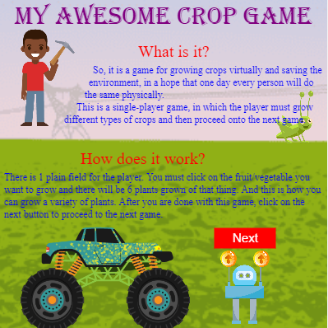

Press on this button to proceed with the game.

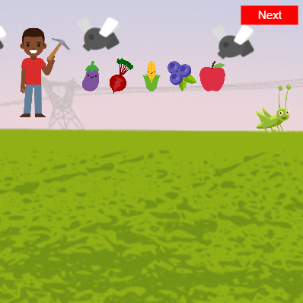

Press on this button to proceed with the next level of the game.

Press on these vegetables to grow the crops of the same.

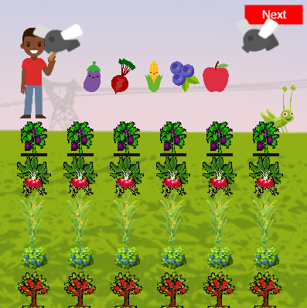

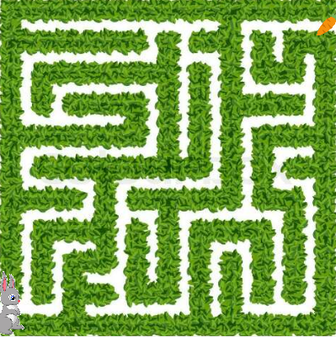

Now through the arrow keys take the rabbit to the carrot.

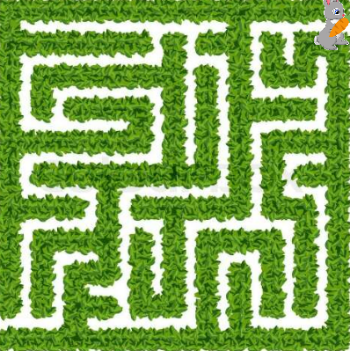

After reaching to the carrot, press, on the next button to proceed to the next level.

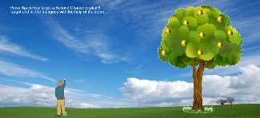

1. How do you plan to make your game engaging?

* I am planning to make my game engaging by putting 3 different levels in it. And, after each level the player receives an award. Also, by putting attractive images of playing and non-playing characters the game looks interesting.