ASSETS UNDER MANAGEMENT FOR 7 MUTUAL HOUSES

This report provides an analysis of Average Assets Under Management (AAUM) across different fields in the Mutual Fund Industry and short-term trends. Overall, the findings indicate a general upward trajectory in overall industry AUM, with few exceptions. Varying growth rates have been observed across HDFC Mutual Fund, SBI Mutual Fund, HSBC Mutual Fund, ICICI Mutual Fund, ICICI Mutual Fund, TATA Mutual Fund and DSP Mutual Fund as well as across distributors and scheme categories.

**METHODOLOGY**

The analysis utilized publicly available data sourced from the Statutory Disclosures section on each respective Mutual Fund's website. Data covering the period from April 2025 to June 2025 was collected, with AUM categorized by Fund House, Distributor Type, Scheme Category, and Scheme Sub-Category. The raw data subsequently underwent a cleaning process to ensure consistency. Following this, all data from these three months was consolidated into a master sheet, which was then loaded into R. Visual trends derived from the analysis are presented in accompanying plots, while precise numerical values for both historical and forecasted periods are provided in the supplementary Excel Tables.

**KEY FINDINGS**

1. **AAUM BY FUNDHOUSE**

Across the various fund houses, all of them demonstrated steady growth in their AUM over the observed period.

Notably, examining the trends of DSP Mutual Fund and TATA Mutual Fund reveals an interesting shift. TATA Mutual Fund initially held a higher AUM, but DSP Mutual Fund’s AUM surpassed TATAs by May. Both fund houses are projected to continue their upward trajectory, with the gap between DSP and TATA AUM gradually widening in the forecasted period.

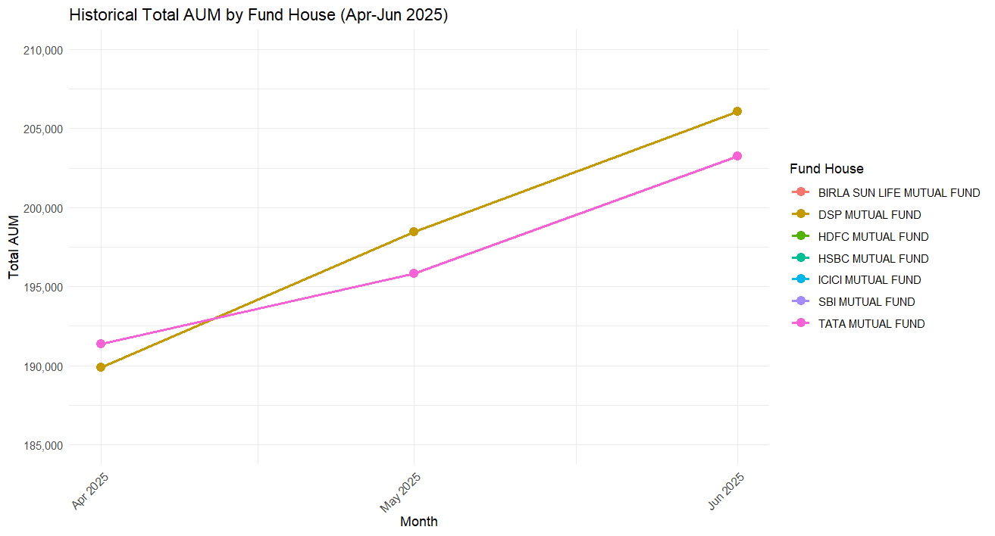

**FORECASTED TRENDS+HISTORICAL TRENDS- AAUM BY FUNDHOUSE**

As mentioned before, all fund houses are expected to have a growing AAUM (at varying rates) . Interestingly, as DSP and TATA mutual fund continue their individual growth paths, the gap between them widens.

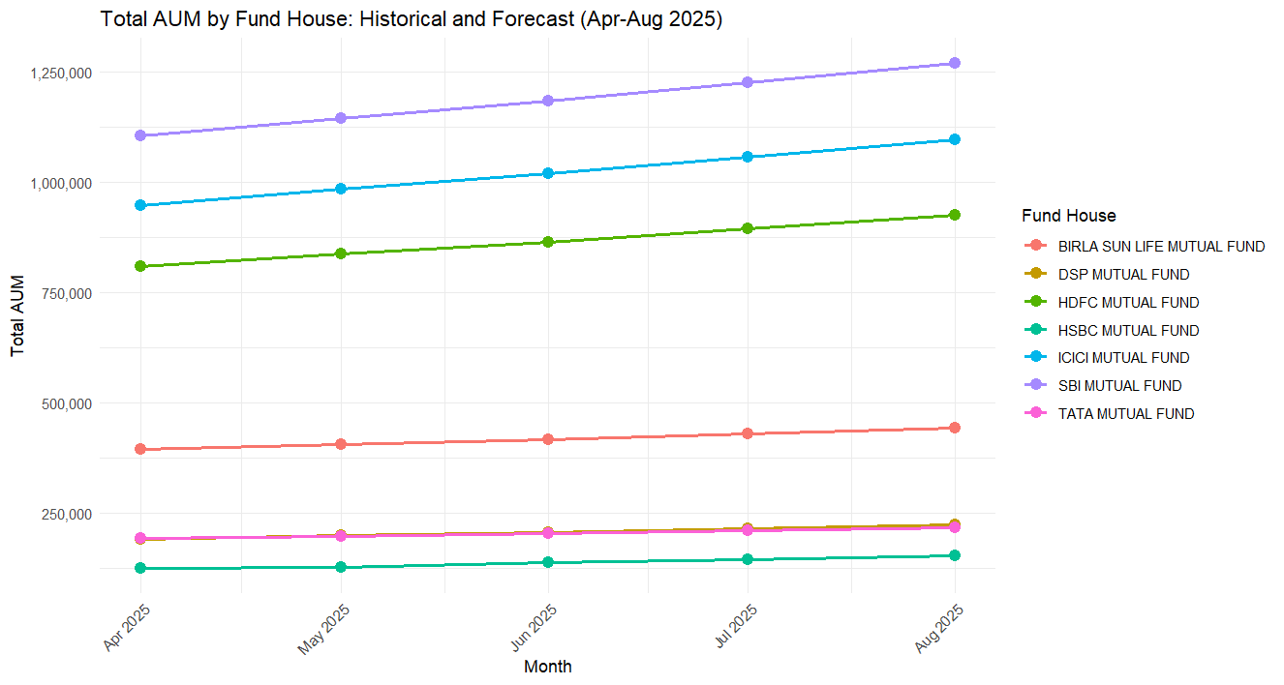For more precise values, please refer to the Excel workbook that was exported from R.

1. 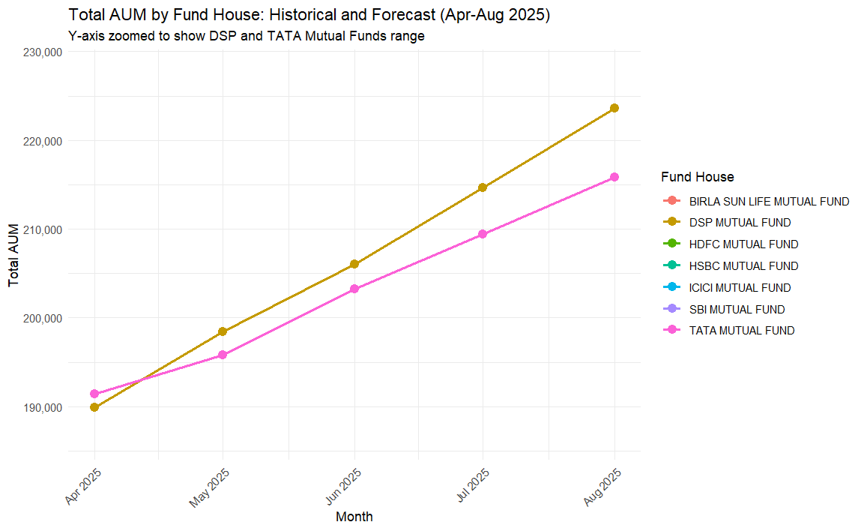**AAUM BY DISTRIBUTOR TYPE**

Analysis by distributor type reveals that “Direct plan” consistently accounts for the largest share of AUM, and its growth has been particularly strong. Following ‘Direct Plan’, the ‘non-associate’ channel holds the second largest share in AUM. In contrast AUM attributed to ‘associate’ distributors are significantly smaller. Representing a minor portion of the overall AUM.

**FORECASTED TRENDS+HISTORICAL TRENDS- AAUM BY DISTRIBUTOR TYPE**

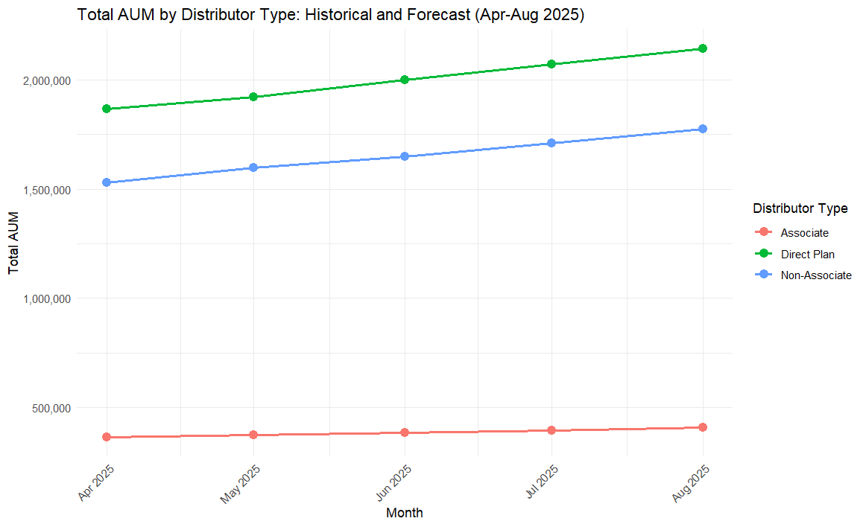

The forecasted trends mirror the average rate growths as in the 3 months April may June.

1. **AAUM BY SCHEME CATEGORY**

When examining AUM by scheme category, APRIL-JUNE period revealed dynamic shifts.

Initially, during April and May, Income/Debt oriented schemes showed an increasing trend in AUM. However, a notable change occurred in June, where Growth/Equity schemes experienced a sharp and significant increase, surpassing Income/Debt oriented schemes in AUM. Concurrently, Income/Debt oriented schemes saw a decrease in their AUM during AUM. Other scheme categories generally maintained a gradual upward trajectory throughout the observed period.

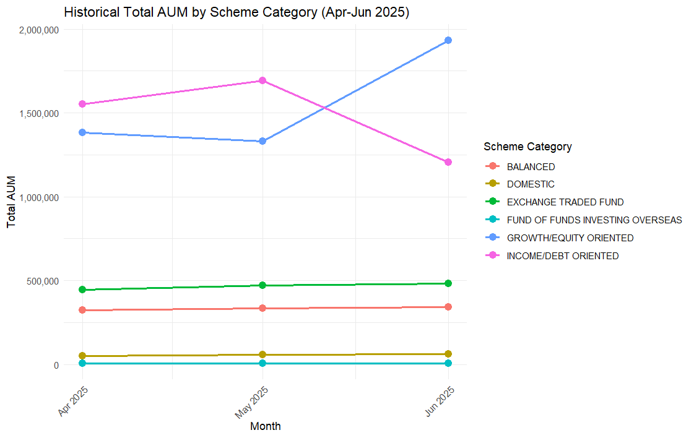

**FORECASTED+HISTORICAL TRENDS- AAUM BY SCHEME CATEGORY TYPE**

Looking ahead, due to the recent substantial decrease in Income/Debt AUM, its calculated average growth rate for forecasting has turned negative, thus projecting a continued decline for this category in the forecasted months. In contrast, Growth Equity schemes are forecasted to sustain their strong upward momentum. The remaining scheme categories are generally expected to continue their gradual increases

**ACCURACY NOTE:** - It is important to note, however, that the forecast for Income/Debt schemes, being heavily influenced by a recent drastic dip, might have reduced accuracy.

Such sharp fluctuations can sometimes be temporary, and a longer observation period (more than 3 months) will typically provide more robust trend data for these specific categories.

1. **AAUM BY SUB-SCHEME CATEGORY**

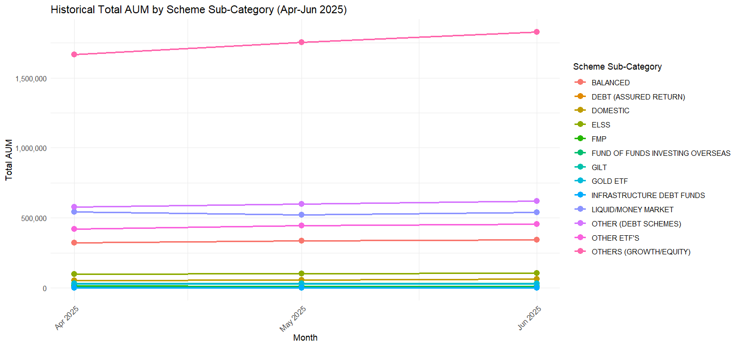At a more detailed level of scheme categories. Most sub-categories demonstrated consistent AUM growth throughout the historical period. Particularly notable was the significant expansion observed in Others (Growth/Equity Schemes). In contrast, Liquid/Money Market schemes were observed to be gradually decreasing in AUM. This trend within Liquid/Money Market schemes, which are part of the broader Income/Debt oriented category, notably contributed to the overall decline seen in the Income/Debt oriented category in June.

**HISTORICAL+FORECASTED TRENDS- AAUM BY SCHEME SUB-CATEGORY**

