FINANCIAL FRAUD DETECTION AND TRANSACTION ANALYSIS (Screenshots)
Submitted By
Pragya Raghuwanshi

EXCEL
TASK 1: DATA EXPLORATION
The exploratory analysis revealed transaction distribution patterns, identified fraud-prone categories, and highlighted the most active states by transaction volume. These insights provide a strong foundation for further fraud detection and analytical investigations.

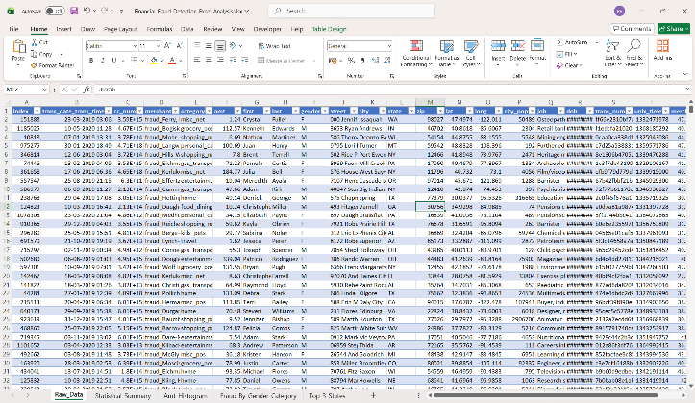
Statistical Summary-
Observation: Transaction amounts and city populations show considerable variation, indicating a diverse customer base and a wide range of spending behaviors.
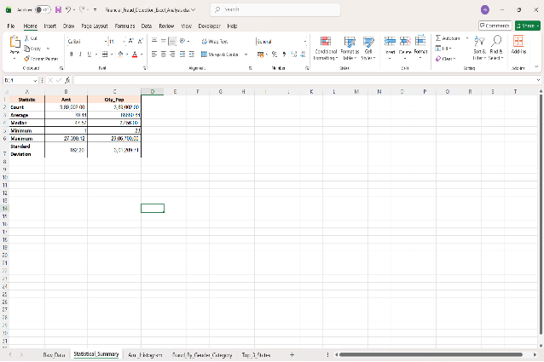
Amt_Histogram-
Observation: Most transactions are concentrated in lower transaction amounts, while high-value transactions occur less frequently. The distribution is positively skewed.
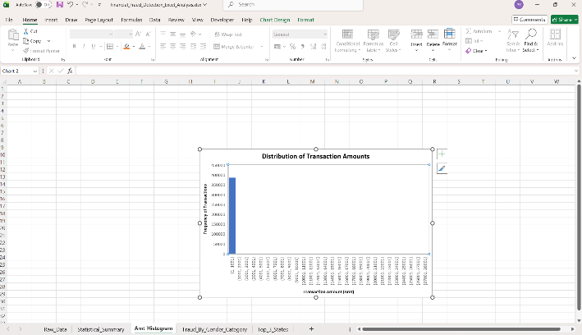

Fraud_By_Gender_Category-
Observation: Fraudulent transactions are observed across multiple categories for both genders. Grocery, shopping, and miscellaneous categories appear to have relatively higher fraud occurrences compared to other categories.
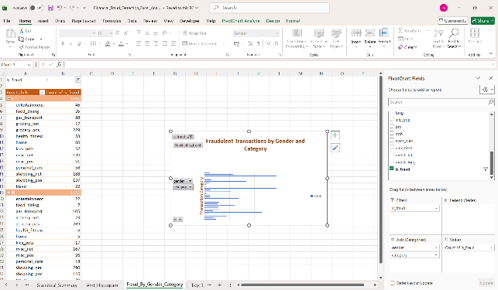
Top_3_States-
Observation: Texas (TX) recorded the highest number of transactions (28,482), followed by New York (NY) with 25,034 transactions and Pennsylvania (PA) with 23,911 transactions. These states represent the most active transaction regions in the dataset.

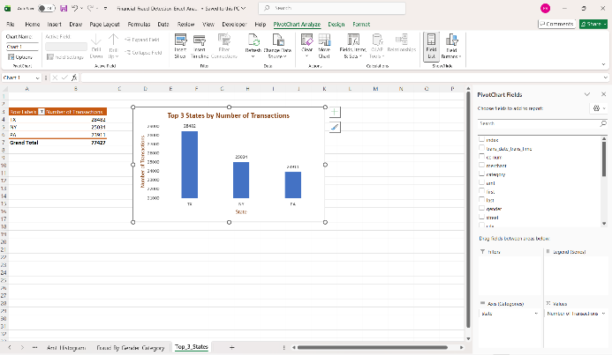
Excel Task 2
Conclusion: The analysis revealed a very weak correlation (0.0073) between transaction amount and city population, indicating little relationship between the two variables. Fraudulent transactions were concentrated in grocery and shopping-related categories, while spending behavior varied considerably across different occupations. These insights help identify fraud-prone categories and customer spending patterns.

Correlation_Analysis
Observation: The correlation coefficient between transaction amount and city population is 0.0073, indicating a very weak positive correlation. This suggests that city population has almost no influence on transaction amount in the dataset.
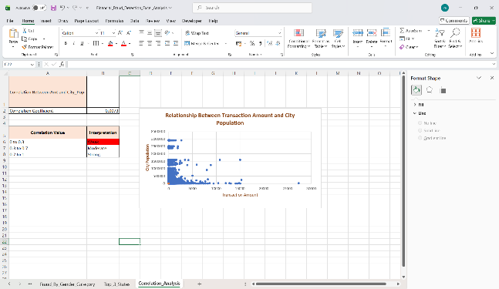

Fraud_By_Category
Observation: Fraudulent transactions are concentrated in a few categories. Grocery POS (518) and Shopping Net (478) recorded the highest number of fraud cases, while Health & Fitness (39) and Grocery Net (40) recorded the lowest. This indicates that shopping and grocery-related transactions are more susceptible to fraudulent activities.
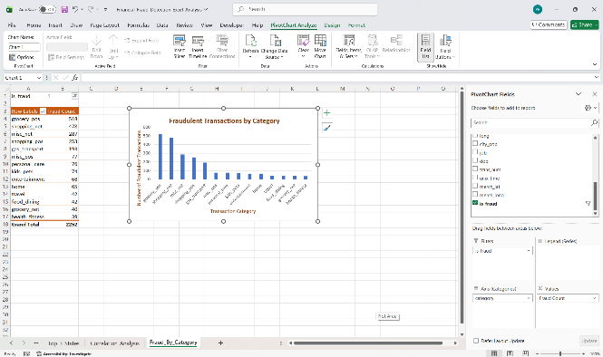
Avg_Amount_By_Job
Observation: Average transaction amounts vary significantly across occupations. Broadcast Journalists and Ship Brokers recorded the highest average transaction amounts, while many other professions showed considerably lower averages. This indicates that spending behavior differs across job roles.
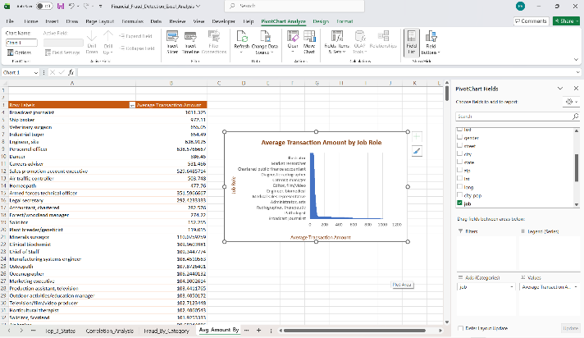

SQL
Create finance schema and import transaction and location datasets.
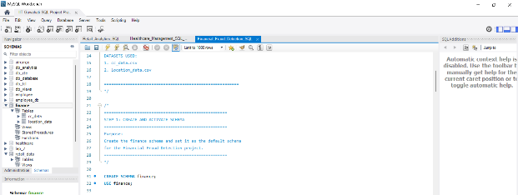

Create Table: cc_data
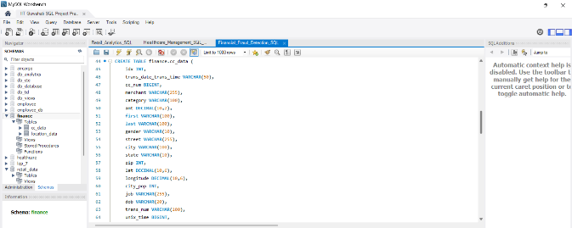

Create Table: location_data
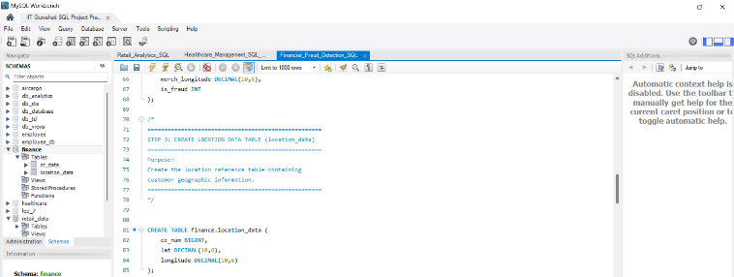
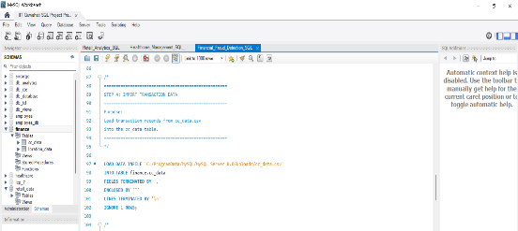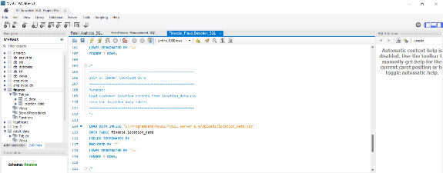

TASK 4.1: TOTAL NUMBER OF TRANSACTIONS
Objective:
Calculate the total number of transactions in the cc_data table.
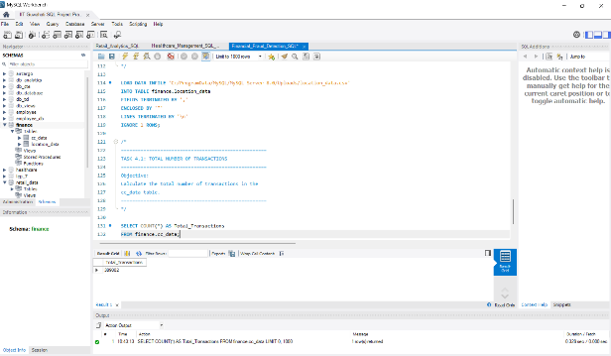

TASK 4.2: TOP 10 MOST FREQUENT MERCHANTS
Objective:
Identify the top 10 merchants with the highest number of transactions.
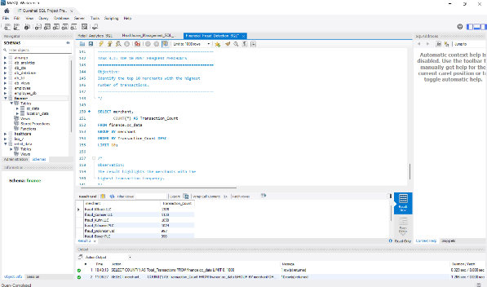
TASK 4.3: AVERAGE TRANSACTION AMOUNT BY CATEGORY
Objective:
Find the average transaction amount for each transaction category.
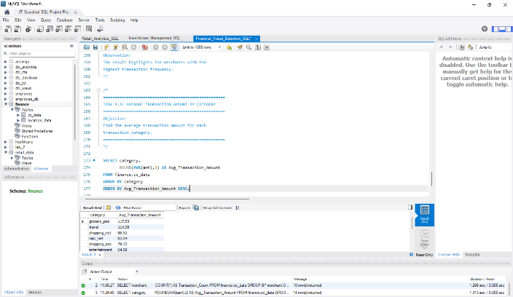
TASK 4.4: FRAUDULENT TRANSACTIONS PERCENTAGE
Objective:
Determine the number of fraudulent transactions and their percentage of total transactions.
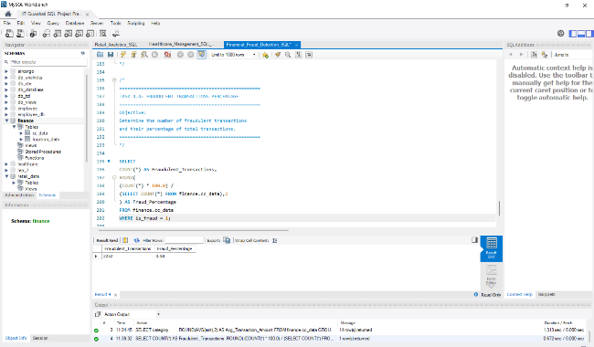
TASK 4.5: JOIN TRANSACTION AND LOCATION DATA
Objective:
Join cc_data and location_data tables to identify latitude and longitude information.
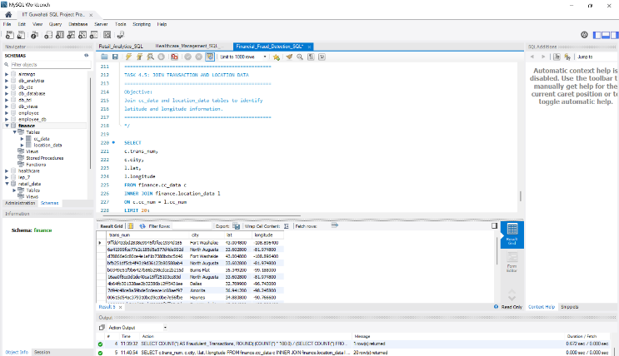
TASK 4.6: CITY WITH HIGHEST POPULATION
Objective:
Identify the city with the highest population.
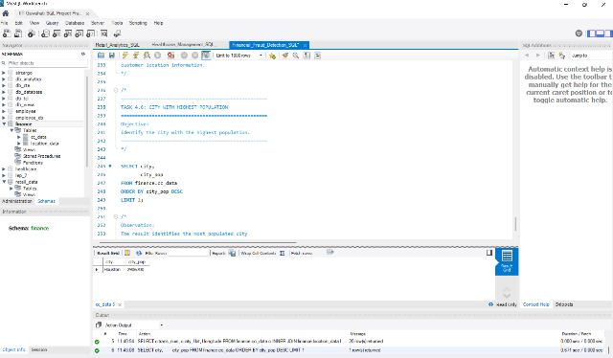

TASK 4.7: EARLIEST AND LATEST TRANSACTION DATE
Objective:
Find the earliest and latest transaction dates.
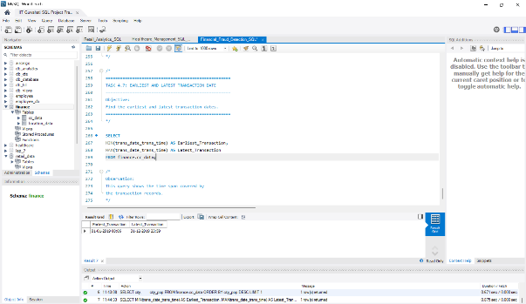
TASK 5 – DATA AGGREGATION WITH SQL
TASK 5.1: TOTAL AMOUNT SPENT
Objective:
Calculate the total amount spent across all transactions.
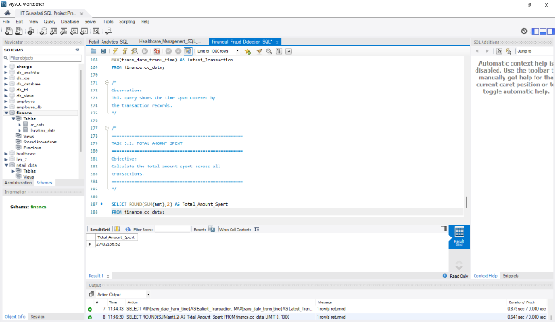
TASK 5.2: TRANSACTIONS BY CATEGORY
Objective:
Count the number of transactions occurring within each category.
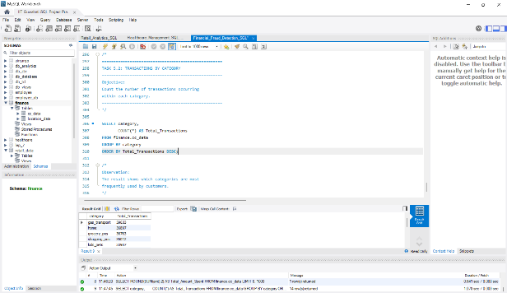
TASK 5.3: AVERAGE TRANSACTION AMOUNT BY GENDER
Objective:
Calculate average transaction amount for each gender.
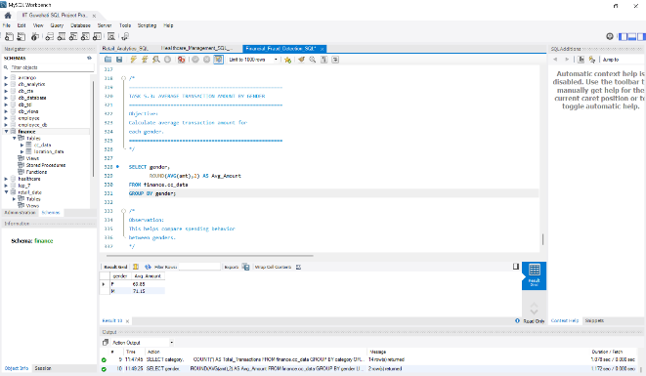
TASK 5.4: DAY WITH HIGHEST AVERAGE TRANSACTION AMOUNT
Objective:
Identify the day of the week with the highest average transaction amount.
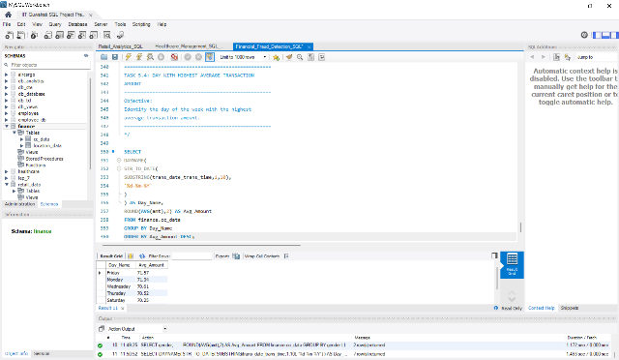
Python
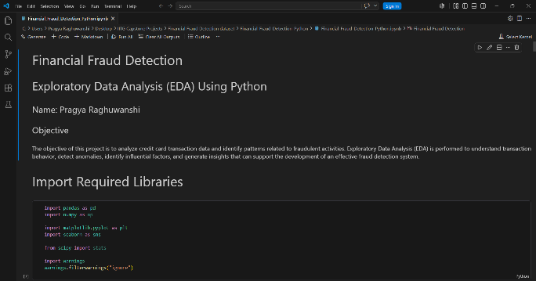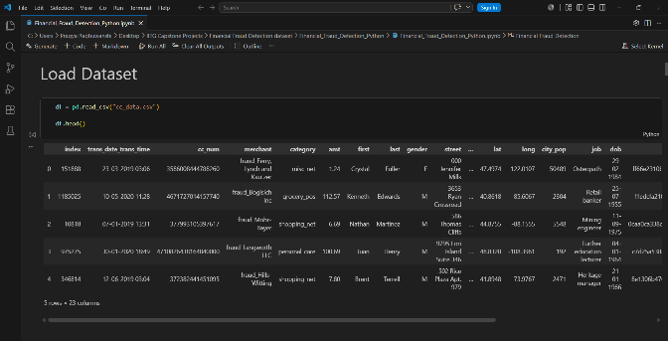
# Task 6.1: What are the dimensions (number of rows and columns) of the dataset?
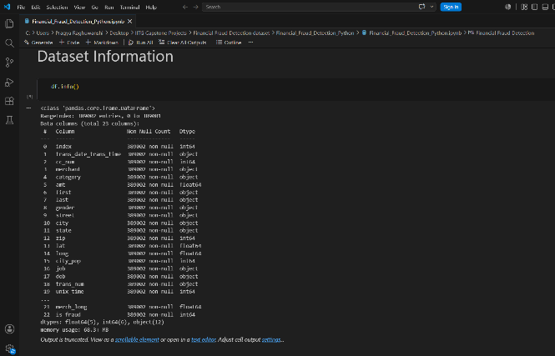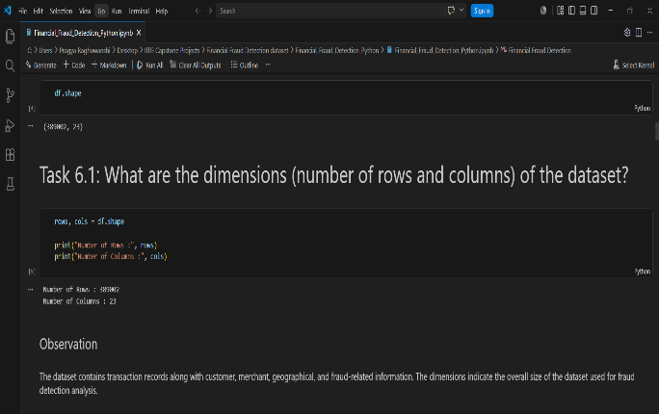
# Task 6.2: Unique Values in Categorical Variables
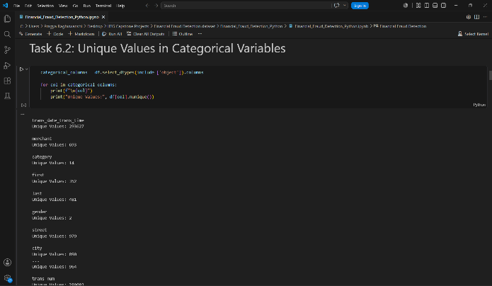
# Task 6.3: Distribution of Numerical Variables
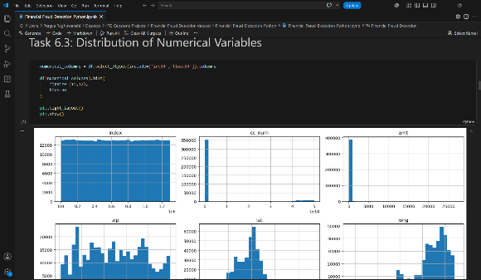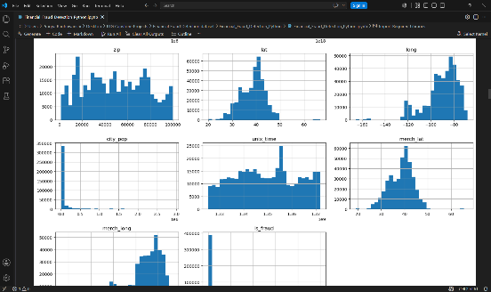
# Task 6.4: Missing Value Analysis
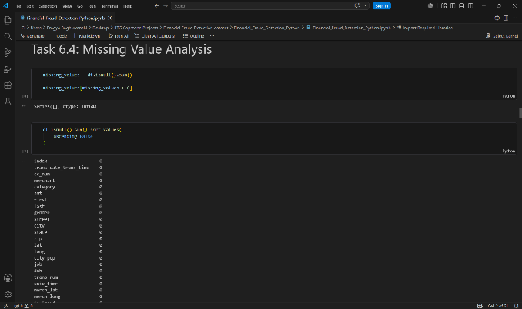
# Task 6.5: Summary Statistics for Numerical Variables
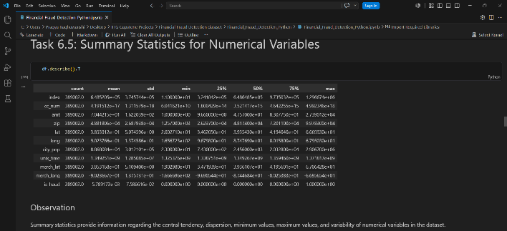
# Task 6.6: Correlation Between Numerical Variables
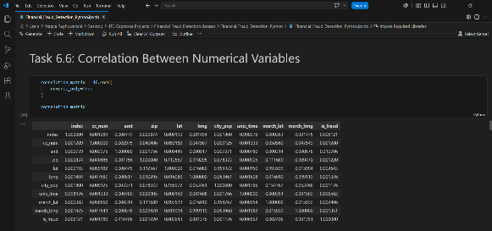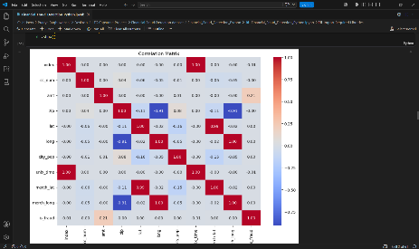
# Task 6.7: Distribution of Transaction Amount Across Fraud Categories
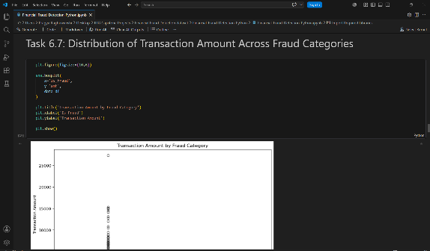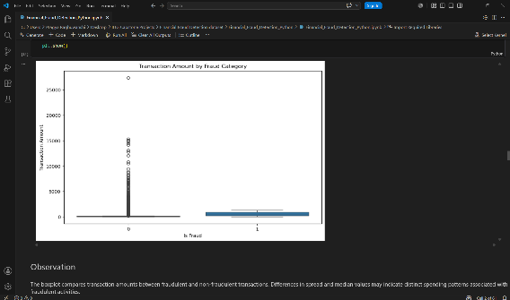
# Task 6.8: Outlier Detection
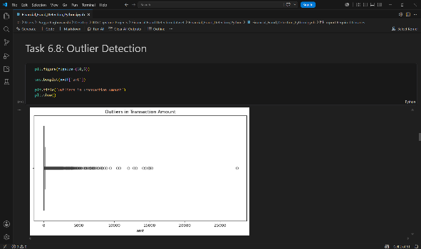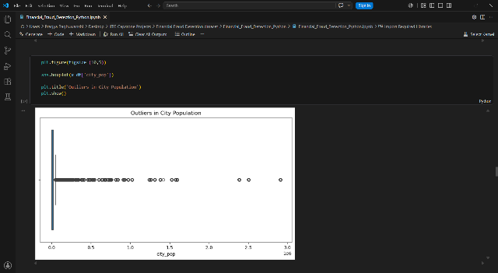
# Task 6.9: Time Trend Analysis
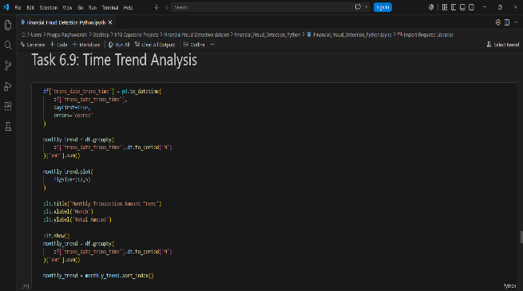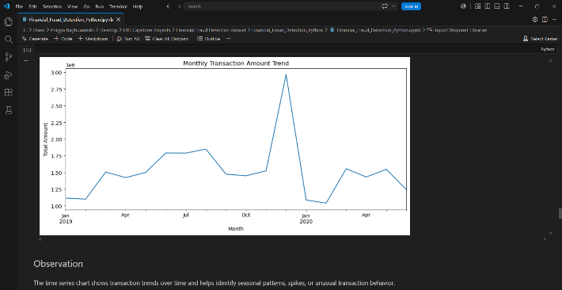
# Task 6.10: Fraud Distribution Across Categories
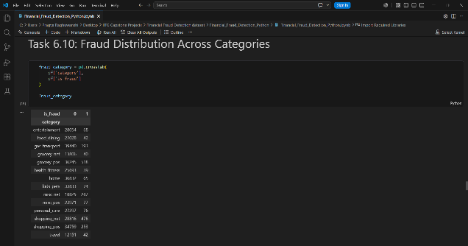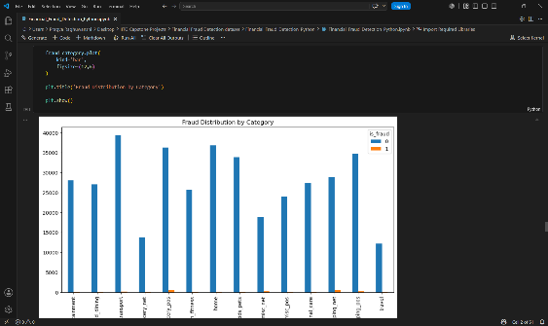
# Task 6.11: Unusual or Unexpected Values
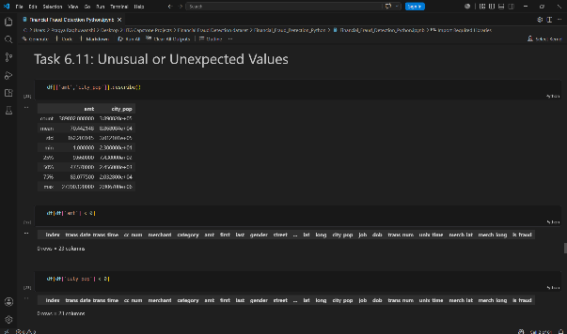
# Task 6.12: Data Quality and Consistency Check
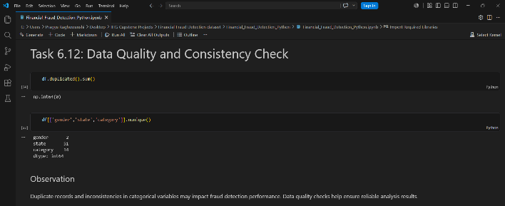
# Task 6.13: Group-wise Numerical Analysis
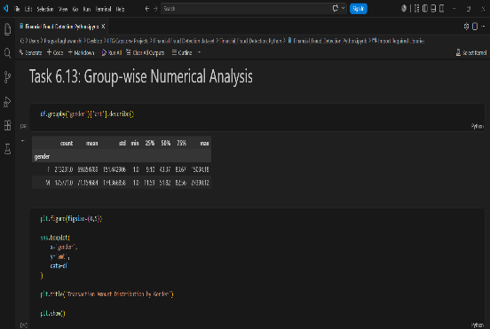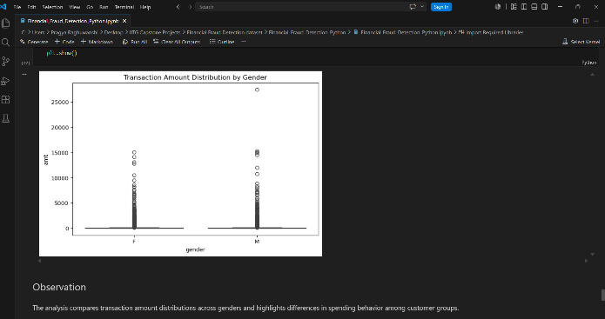
# Task 6.14: Factors Influencing Fraud
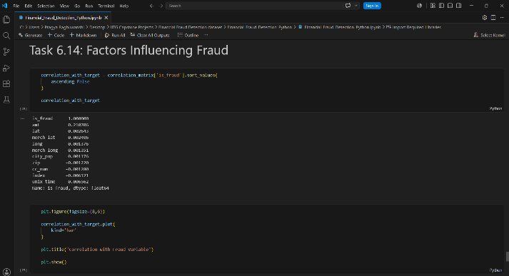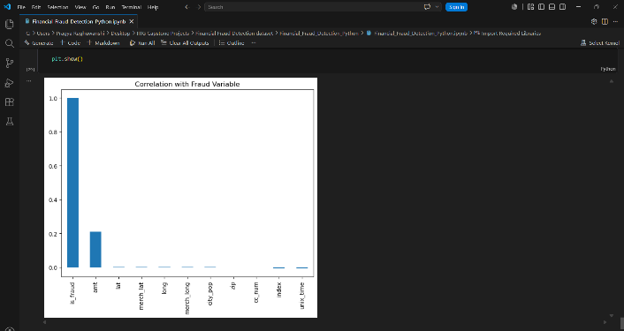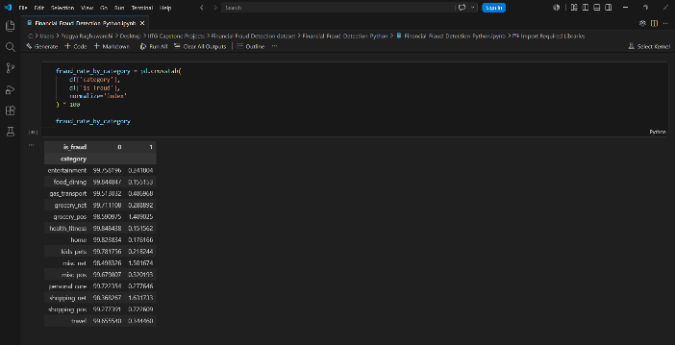
Tableau
SHEET 1
Amount Spent by Gender and Category (Box & Whisker Plot)
Transaction amounts vary across categories and genders, with travel and grocery-related transactions showing higher variability.
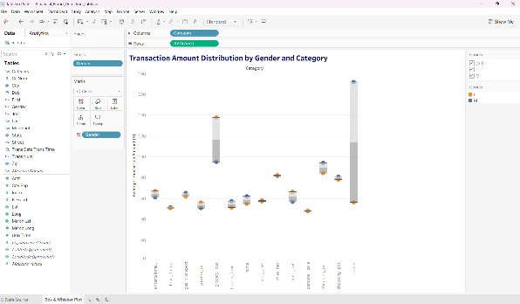
SHEET 2
Geographical Distribution of Transactions
Transaction activity is concentrated across major population centers in the United States, with higher transaction volumes visible in densely populated regions.
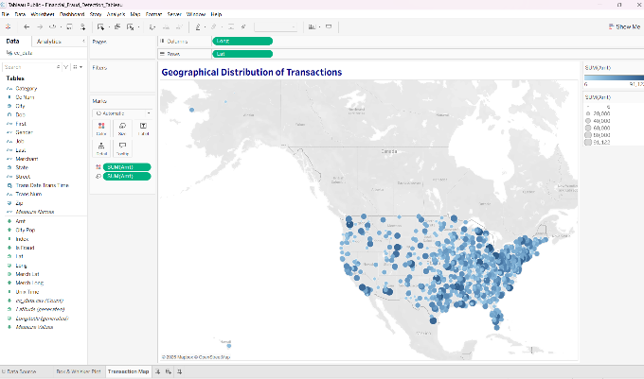
SHEET 3
Fraud Map
Fraudulent transactions are distributed across multiple geographic locations, with certain regions exhibiting higher concentrations of fraud activity.
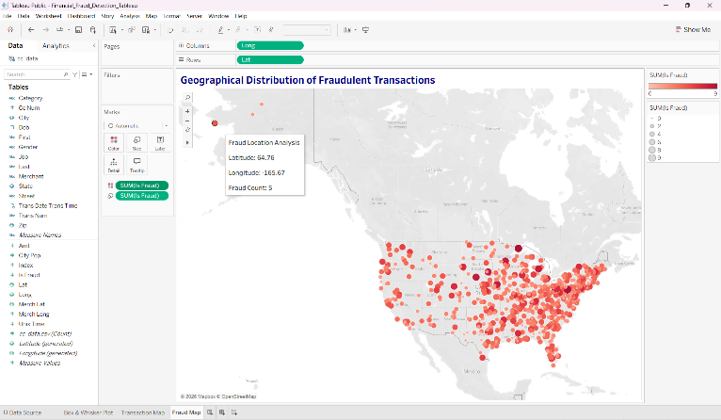
SHEET 4
Monthly Transaction Trend
Transaction activity varies across months, indicating seasonal fluctuations in transaction volume throughout the year.
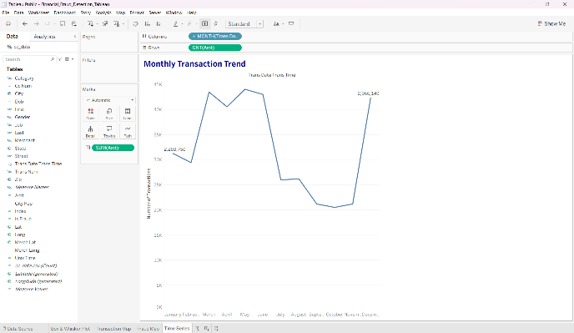
SHEET 5
Inflation-Adjusted Transaction Amount
Inflation-adjusted transaction values exhibit noticeable fluctuations across weeks, highlighting periods of increased transaction activity after accounting for inflation effects.
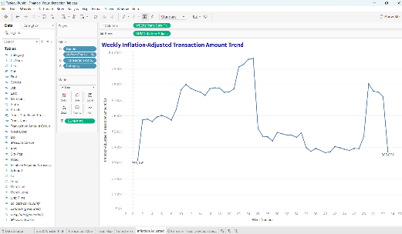

Dashboard
The dashboard provides a comprehensive view of financial transaction patterns, fraud-prone regions, category-wise spending behaviour, monthly transaction trends, and inflation-adjusted transaction analysis. Interactive filters and dashboard actions enable dynamic exploration of fraud patterns across different customer segments and transaction categories.
