Sim-to-Real Transfer with Onboard Domain Randomization
System Architecture Document
ROSPug Quadruped Robot · ROS 1 Melodic / Gazebo 9 / Stable-Baselines3 PPO
Version 1.0 · August 2026

1. Executive Summary
This document specifies the software architecture for training and evaluating reinforcement-learning (RL) locomotion policies for the ROSPug 12-degree-of-freedom quadruped robot. The system is built around a Sim-to-Real workflow, in which control policies are trained entirely within a Gazebo physics simulation and are intended (as a stretch goal) for deployment to physical hardware without further on-robot retraining.
The architecture is designed to answer a specific research question: does training with Domain Randomization (DR) — perturbing ground friction, body mass, and servo latency on every training episode — yield a policy that generalizes more robustly to unseen physical conditions than a policy trained under fixed, nominal physics? To evaluate this, the system trains and compares two PPO policies under a controlled experimental design: Policy A, trained on static simulation parameters, and Policy B, trained under randomized simulation parameters, with both policies subsequently benchmarked on a held-out set of randomized physical conditions.
This approach follows established precedent in sim-to-real robotics research — most notably OpenAI's Dactyl system and ANYmal's sim-to-real transfer work — adapted here to the ROSPug platform and its ROS 1 Melodic / Gazebo 9 / Stable-Baselines3 software stack.

2. Project Scope & Deliverables
Deliverable | Status | Description
Environment (RosPugEnv) | Step 3 — DONE ✓ | gymnasium.Env wrapper around Gazebo/ROS1
Docker Dev Environment | Step 1 — DONE ✓ | Reproducible ROS Melodic + Gazebo 9 + Python 3.8 image
Gait Baseline Controller | Step 2 — DONE ✓ | sim_gait_controller_v3.py — trot/yaw/strafe
Policy A — Fixed Physics | Step 4 (planned) | PPO policy trained on constant Gazebo physics
Policy B — Domain Randomized | Step 5 (planned) | PPO policy trained with DR (friction/mass/latency)
Head-to-Head Evaluation | Step 6 (planned) | Fall-rate & distance table across 5 held-out conditions
Real Hardware Deployment | Step 7 (planned) | Policy B on real ROSPug vs fixed-gait baseline

3. Architecture Overview
The architecture is organized into five layers that map cleanly onto the project execution phases. Each layer is independent enough to be tested in isolation, which is important on a constrained timeline where debugging one layer at a time is the only practical strategy.

3.1 System Architecture Diagram
Figure 1 — Full system architecture showing all five layers and data flows.
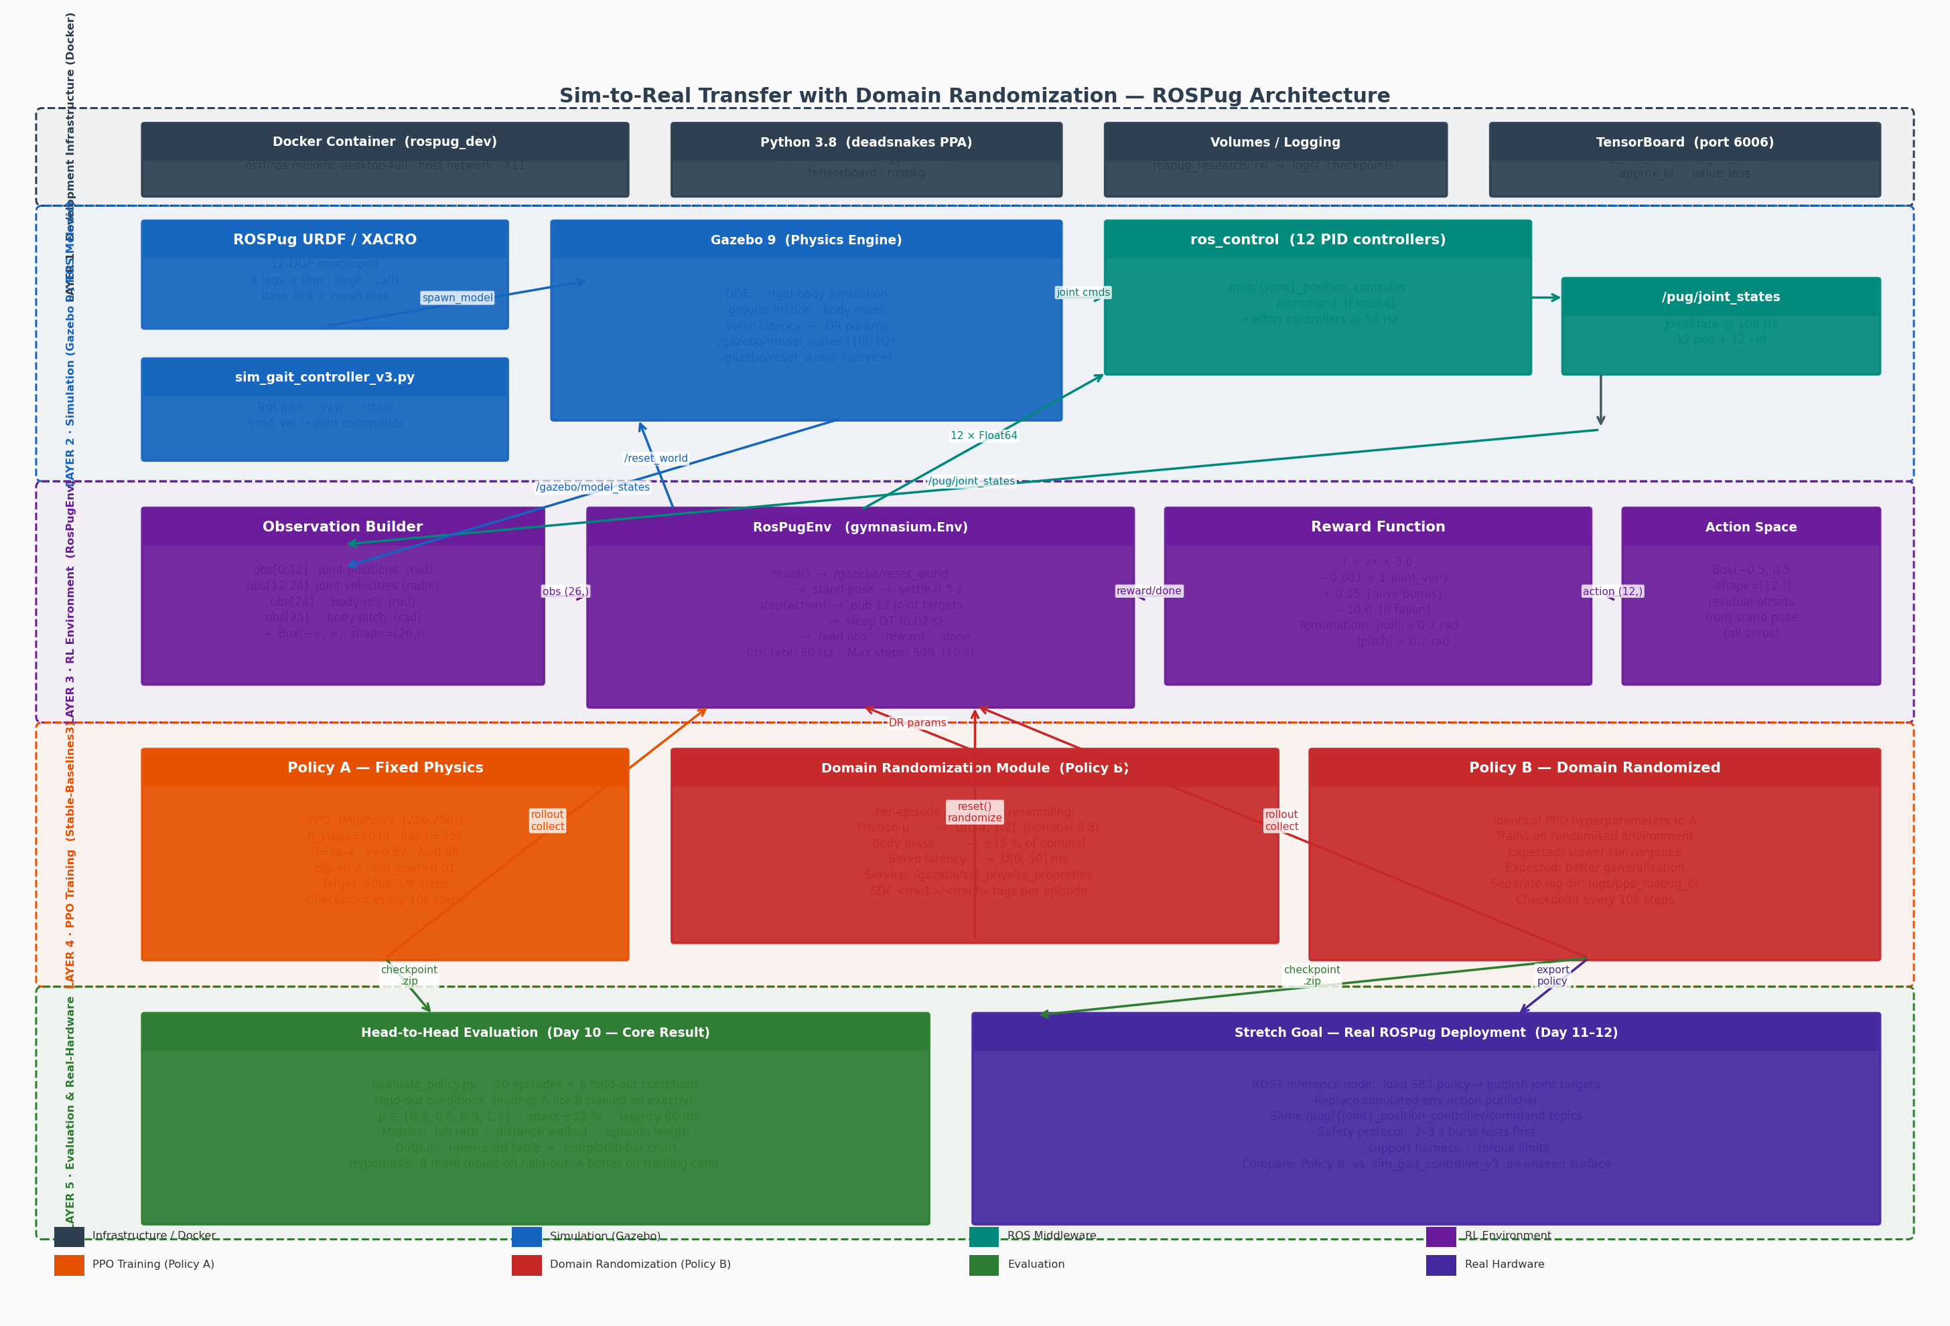

4. Layer Descriptions

4.1 Layer 1 — Development Infrastructure (Docker)
All development runs inside a Docker container built on osrf/ros:melodic-desktop-full (Ubuntu 18.04, ROS 1 Melodic, Gazebo 9). Host networking (network_mode: host) is used so that ROS topic discovery and TensorBoard HTTP access work without port-mapping complexity. An X11 socket and .Xauthority cookie mount enables the Gazebo GUI on the host display.
Component | Role | Key Detail
Docker image | Isolated runtime | osrf/ros:melodic-desktop-full + deadsnakes Python 3.8
docker-compose.yml | Container lifecycle | host network · X11 · rw volume → rospug_research/
entrypoint.sh | ROS environment | sources /opt/ros/melodic/setup.bash + catkin devel
Python 3.8 | RL stack runtime | stable-baselines3 · gymnasium · tensorboard · rospkg
TensorBoard | Training monitoring | logs/ → port 6006 on host browser
Volumes | Persistent artefacts | logs/ · checkpoints/ written to host filesystem

4.2 Layer 2 — Simulation (Gazebo 9 / ROS Melodic)
The ROSPug URDF/XACRO model is spawned into an empty Gazebo world via roslaunch pug_description gazebo.launch. The model exposes 12 position-controlled joints through ros_control's effort_controllers/JointPositionController, each with individually tuned PID gains defined in gazebo_control.yaml. Because the ROSPug URDF does not include a Gazebo IMU plugin, body orientation (roll and pitch) is obtained from /gazebo/model_states instead of a sensor_msgs/Imu topic.
ROS Topic / Service | Type | Rate | Consumer
/pug/joint_states | sensor_msgs/JointState | 100 Hz | RosPugEnv observation builder
/gazebo/model_states | gazebo_msgs/ModelStates | ~100 Hz | Body roll/pitch (quaternion→RPY)
/pug/{joint}_pos.../command | std_msgs/Float64 | 50 Hz | 12 PID controllers (action output)
/gazebo/reset_world | std_srvs/Empty (service) | on reset | RosPugEnv.reset()
/gazebo/set_physics_properties | gazebo_msgs service | on reset | Domain Randomization module

The gait baseline controller (sim_gait_controller_v3.py) subscribes to /cmd_vel and implements a joint-space trot gait with yaw differentials and hip-abduction strafe. It is not used during RL training but serves as the non-RL comparison baseline for the real-hardware stretch goal.

4.3 Layer 3 — RL Environment (RosPugEnv)
RosPugEnv (rl_env/rospug_env.py) wraps the ROS/Gazebo stack as a standard gymnasium.Env so that Stable-Baselines3 can train on it without knowing anything about ROS. The environment is single-threaded with a fixed 50 Hz control loop. ROS callbacks run in a background thread via rospy's subscriber mechanism; shared state is protected by a threading.Lock.
Property | Value | Notes
Action space | Box(−0.5, 0.5, (12,), float32) | Residual offsets from stand pose (all zeros)
Observation space | Box(−∞, ∞, (26,), float32) | 12 joint pos + 12 joint vel + roll + pitch
Control rate | 50 Hz (DT = 0.02 s) | sleep(DT) per step — wall-clock synchronised
Max episode steps | 500 steps = 10 s | Truncation (not termination)
Termination cond. | ‌|roll| > 0.7 rad OR |pitch| > 0.7 rad | ≈ 40° — falls detected here
Reset settle | 1.0 s physics + 0.5 s stand | Avoids carry-over physics state
Body orientation | Inline quat→RPY (no tf dep.) | _quat_to_rpy() from /gazebo/model_states

Reward Function
The reward is designed to encourage forward locomotion while penalising energy waste and falling. The alive bonus (+0.05/step) breaks the stand-still local optimum that would otherwise dominate early training:
r(t) = 3.0 × vx − 0.001 × Σ(joint_vel²) + 0.05 − 10.0 × fallen
At 0.2 m/s forward velocity: r ≈ +0.65/step. Standing still: r = +0.05/step. Falling: r = −10.0 (terminal). Random actions baseline: mean −1.06/step (dominated by energy penalty).

4.4 Layer 4 — PPO Training Pipeline
Both policies use Proximal Policy Optimization (PPO) from Stable-Baselines3 with an MLP policy network (two hidden layers of 256 units, tanh activations). The only difference between Policy A and Policy B is the environment they train on: Policy A uses a fixed-physics RosPugEnv; Policy B uses a RosPugEnv whose reset() method re-samples friction, mass, and servo latency before each episode.
Hyperparameter | Value | Rationale
Policy network | MlpPolicy [256, 256] | Two hidden layers; tanh activation
n_steps | 2048 | ~4 full 500-step episodes per rollout update
batch_size | 256 | Must divide n_steps evenly
learning rate | 3 × 10⁻⁴ | Adam; reduce to 1×10⁻⁴ if approx_kl > 0.05
γ (discount) | 0.99 | Long episode horizon (500 steps)
λ (GAE) | 0.95 | Standard GAE-Lambda
clip_range | 0.2 | PPO clipping parameter
ent_coef | 0.01 | Entropy bonus for exploration
Total timesteps | 500k – 1M | ~2.6–5.1 hours at ~194k steps/hour
Checkpoint every | 10,000 steps | Saved to checkpoints/ppo_rospug_*_steps.zip

4.5 Domain Randomization Design (Policy B)
Domain Randomization is the key technique that makes Policy B more robust than Policy A. At the start of each episode, the environment samples new physics parameters from the distributions below and applies them via Gazebo services before the robot is reset to its stand pose. The policy must learn to walk across all of these conditions simultaneously — this forces it to find a more general locomotion strategy rather than over-fitting to a single set of physics constants.
Parameter | Nominal | Randomization Range | Gazebo Mechanism
Ground friction (μ) | 0.8 | U[0.4, 1.2] | /gazebo/set_physics_properties + SDF <mu1>/<mu2>
Body mass | nominal | ± 15 % of nominal | /gazebo/set_physics_properties body inertial
Servo command latency | 0 ms | U[0, 50] ms | step() action buffer with random delay
(future) Surface tilt | 0° | ± 5° incline | Gazebo ground plane SDF rotation

Implementation note: randomization ranges are deliberately conservative. If Policy B fails to learn at all, the first fix is to narrow the ranges (e.g. friction U[0.6, 1.0]), not to change the policy architecture. A documented range-narrowing decision is a legitimate, reportable finding.

4.6 Layer 5 — Evaluation Framework
evaluate_policy.py runs both saved policies on held-out physics conditions that were in neither policy's training distribution (for Policy A: everything except the nominal values; for Policy B: the tails and extremes outside its sampled range). This is the project's core scientific result.
Held-Out Condition | Friction μ | Mass offset | Latency | Purpose
HO-1 (very low friction) | 0.30 | nominal | 0 ms | Outside DR lower bound
HO-2 (low friction) | 0.50 | nominal | 0 ms | Edge of DR range
HO-3 (nominal) | 0.80 | nominal | 0 ms | Training condition for A
HO-4 (high friction) | 1.10 | nominal | 0 ms | Edge of DR range
HO-5 (heavy + latency) | 0.80 | +20 % | 60 ms | Multi-param out-of-dist.

Output metrics per condition: fall rate (%), mean distance walked (m), mean episode length (steps). Final output: a side-by-side bar chart and mean ± std summary table comparing Policy A vs. Policy B across all five held-out conditions.

5. Data Flow Summary
The following sequence describes one training step (applies to both policies):
- PPO calls env.reset() → /gazebo/reset_world → DR module re-samples physics → robot placed at stand pose → settle 1.0 s
- PPO calls env.step(action[12]) → 12 × Float64 published to /pug/{joint}_pos_controller/command
- Gazebo steps physics one DT (0.02 s) → /pug/joint_states + /gazebo/model_states updated
- RosPugEnv reads joint states (pos, vel) + model quaternion → assembles obs[26]
- Reward computed: r = 3.0 × vx − 0.001 × Σ(vel²) + 0.05 − 10.0 × fallen
- If |roll| > 0.7 or |pitch| > 0.7: terminated=True, episode ends
- If step_count ≥ 500: truncated=True, episode ends
- PPO collects (obs, action, reward, done) tuples into a rollout buffer (n_steps=2048)
- After n_steps transitions: PPO computes GAE advantages, runs mini-batch gradient updates
- Checkpoint saved every 10,000 steps; TensorBoard scalar logged every update

6. Key File Structure
File / Directory | Layer | Purpose
Dockerfile | L1 | Container build: ROS Melodic + Python 3.8 + RL stack
docker-compose.yml | L1 | Container lifecycle, X11, volumes, host networking
entrypoint.sh | L1 | Sources ROS + catkin environments at container start
ROSPug/src/pug_description/ | L2 | URDF/XACRO model, Gazebo launch, PID controller config
ROSPug/src/pug_description/config/  gazebo_control.yaml | L2 | 12 PID effort controllers definition
rospug_research/sim_gait_controller_v3.py | L2 | Reference trot gait — baseline for real-hardware comparison
rl_env/rospug_env.py | L3 | RosPugEnv — gymnasium.Env wrapping Gazebo/ROS1
rl_env/__init__.py | L3 | Package marker; exports RosPugEnv
scripts/test_env_random.py | L3 | 20-episode random-action sanity test (Step 3 exit criterion)
scripts/train_ppo.py | L4 | PPO training script (Policy A; DR variant planned for Policy B)
scripts/evaluate_policy.py | L5 | Load checkpoint, run N episodes, print metrics
logs/ppo_rospug/ | L4 | TensorBoard event files (Policy A)
logs/ppo_rospug_dr/ | L4 | TensorBoard event files (Policy B — planned)
checkpoints/ | L4 | PPO .zip checkpoints every 10k steps
requirements_rl.txt | L1 | Pinned RL package versions

7. Key Interface Contracts
These contracts must not change between layers — any change here requires updating all consumers.
Interface | Defined In | Contract
Joint ordering (12) | rospug_env.py JOINT_ORDER | rf_j, rf_th, rf_ca, lf_j, lf_th, lf_ca, rb_j, rb_th, rb_ca, lb_j, lb_th, lb_ca
Action bounds | rospug_env.py ACTION_LIMIT | ± 0.5 rad residual from stand pose (all zeros)
Observation shape | rospug_env.py obs_space | (26,): indices 0-11 pos, 12-23 vel, 24 roll, 25 pitch
Control rate | rospug_env.py CTRL_RATE | 50 Hz (DT=0.02 s) — must match Gazebo physics step
Fall threshold | rospug_env.py FALL_THRESH | 0.7 rad ≈ 40° for both roll and pitch
DR parameter service | Gazebo ROS API | /gazebo/set_physics_properties (before each episode)

8. Stretch Goal — Real Hardware Deployment
If Steps 4–6 are completed ahead of schedule, Policy B is deployed to the physical ROSPug. The deployment path is:
- Export: load Policy B checkpoint with SB3's PPO.load(); run inference (policy.predict(obs)) in a ROS1 Python node
- Same action space: publish 12 × Float64 to the exact same /pug/{joint}_position_controller/command topics
- Observation: read from /pug/joint_states (pos/vel) and /pug/imu/data or an alternative body-orientation source
- Safety protocol: 2–3 s burst tests first; support harness; reduce max joint angle to ± 0.4 rad initially
- Comparison: Policy B vs. sim_gait_controller_v3 on a surface not used in simulation (rug, slight incline)
- If Policy B fails on hardware: document the reality gap; the simulation result (Step 6) stands independently

9. Known Limitations & Future Work
Limitation | Impact | Future Work
No IMU Gazebo plugin | Body orientation from /gazebo/model_states (unavailable on real robot) | Add IMU plugin to URDF; or use robot_localization on hardware
Single-CPU Gazebo | ~194k training steps/hour — slower than vectorised simulators | Isaac Gym / MJX / parallel Gazebo instances
No reality-gap estimator | DR ranges are hand-tuned, not auto-calibrated from real trials | Bayesian optimisation of DR ranges using real deployment data
Fixed MLP policy | No temporal context; may struggle with partially-observable states | Add LSTM layer or frame-stacking (obs history)
No perception / mapping | Policies navigate by open-loop locomotion only | Add depth camera or LiDAR; integrate with Nav2/move_base
2-week timeline | No real-hardware result guaranteed | Extend to 4-week sprint; add hardware in loop from week 2

10. References
- OpenAI (2019). Solving Rubik's Cube with a Robot Hand (Dactyl). arXiv:1910.07113.
- Hwangbo et al. (2019). Learning Agile and Dynamic Motor Skills for Legged Robots (ANYmal). Science Robotics.
- Tobin et al. (2017). Domain Randomization for Transferring Deep Neural Networks from Simulation to the Real World. IROS.
- Schulman et al. (2017). Proximal Policy Optimization Algorithms. arXiv:1707.06347.
- Raffin et al. (2021). Stable-Baselines3: Reliable Reinforcement Learning Implementations. JMLR.
- ROSPug Repository: https://github.com/Hiwonder/ROSpug (Jetson_nano_ros1 branch).
- ROSPug 2-Week Roadmap: rospug_research/ROSPug_2Week_Roadmap.md
- Project Progress Tracker: rospug_research/PROGRESS.md

