YUVAINTERN
Computer Vision Specialist Internship

WEEK 3 TASK REPORT
Real-Time Performance Optimization of Computer Vision Algorithms

Intern Name | Pragyan Parimita Nayak
Project | Real-Time Retail Shelf Object Detection and Counting
Internship Role | Computer Vision Specialist
Task | Week 3: Real-Time Performance Optimization of Computer Vision Algorithms
Internship Period | 01-Oct-2026 to 29-Oct-2026
Previous Model | TinyShelfDetector from Week 2
Optimization | Structured channel pruning + fine-tuning + TorchScript inference artifact
Benchmark Environment | CPU, PyTorch, batch size 1, 128×128 input, 4 CPU threads

1. Task Requirement Mapping
The Week 3 YuvaIntern task requires an existing computer vision model to be optimized for real-time performance, with modified source code, a detailed optimization report, and before/after performance benchmarks. The instructions specifically mention techniques such as pruning, quantization and algorithmic improvements and ask for comparative metrics including inference time and FPS. The report must also explain computational bottlenecks, optimization changes, trade-offs and future recommendations. fileciteturn1file0L155-L209
Requirement | What was done | Evidence
Use an existing model | Week 2 TinyShelfDetector was used as the baseline. | Week 2 checkpoint
Identify computationally intensive parts | Four convolution blocks dominate the forward pass. | Profiling/architecture analysis
Apply optimization | Removed low-importance convolution channels using L1 filter importance. | Modified model source
Benchmark before/after | 250 measured single-image inference runs plus 50 warm-up runs. | Benchmark JSON + chart
Report trade-offs | Accuracy/counting metrics and speed metrics are compared together. | Results section
Recommend further work | Pretrained detector, quantization/export, GPU/edge benchmarking and dense-object handling. | Future work section

2. Starting Point from Week 2
The Week 2 project used a compact four-block convolutional detector for a synthetic retail-shelf object detection experiment. The baseline model had 79,461 trainable parameters and produced the following validation results on the same 60-image synthetic validation split used for this Week 3 comparison.
Week 2 baseline metric | Measured value
Parameters | 79,461
Precision @ IoU 0.50 | 9.13%
Recall @ IoU 0.50 | 6.28%
Mean IoU of matched detections | 0.578
Counting MAE | 1.97 objects/image

3. Why Optimization Was Needed
The baseline model is already small, but the project requirement is real-time processing and the final application is intended to work on an image stream. The forward pass consists of four convolution layers followed by a 1×1 detection head. Convolution operations account for most of the model's learned parameters and multiply-accumulate work, so reducing the channel dimensions gives a direct way to reduce the tensor sizes passed through subsequent layers.
I selected structured channel pruning rather than simple unstructured zeroing of individual weights. PyTorch's structured pruning documentation describes channel-level pruning based on norm/importance values, while the official pruning tutorial notes that pruning can reduce model size and computational requirements. citeturn358426search0turn358426search10

4. Optimization Strategy
The optimization has three practical stages:
1. Calculate an L1 importance score for every convolution filter by summing the absolute values of its weights.
2. Keep 75% of the filters in each convolution block and physically rebuild the network with the smaller channel dimensions.
3. Fine-tune the smaller model for three epochs and export it as a TorchScript inference artifact for the final benchmark.
The original channel configuration was 16 → 32 → 64 → 96. The optimized configuration is 12 → 24 → 48 → 72. Because the reduction propagates through connected convolution layers, the final model parameter count falls by 43.48%, not just 25%.

5. Optimization Flow
Week 2 checkpoint → profile baseline → rank convolution filters by L1 score → remove low-importance filters → rebuild smaller model → transfer surviving weights → fine-tune → benchmark eager model → export optimized TorchScript artifact → benchmark deployment representation

6. Implementation Detail
A simplified version of the pruning operation is shown below. The code ranks complete convolution filters instead of masking individual weight elements.
score = conv.weight.detach().abs().sum(dim=(1, 2, 3))
keep = torch.topk(score, k=keep_count).indices.sort().values
new_conv.weight.copy_(old_conv.weight[keep][:, previous_input_channels])
new_conv.bias.copy_(old_conv.bias[keep])
After pruning, the surviving filter weights are copied into a physically smaller model. This is important for this benchmark because the optimized network actually performs convolution with fewer channels instead of carrying the same tensor dimensions with many zeros.

7. Fine-Tuning After Pruning
The pruned model was fine-tuned for three epochs using the same synthetic retail-shelf training distribution as Week 2. Adam was used with a learning rate of 0.0003. This short recovery phase was intended to let the remaining filters adapt after the structural change.
Epoch | Training loss | Validation loss
1 | 0.1949 | 0.1546
2 | 0.1448 | 0.1328
3 | 0.1214 | 0.1117
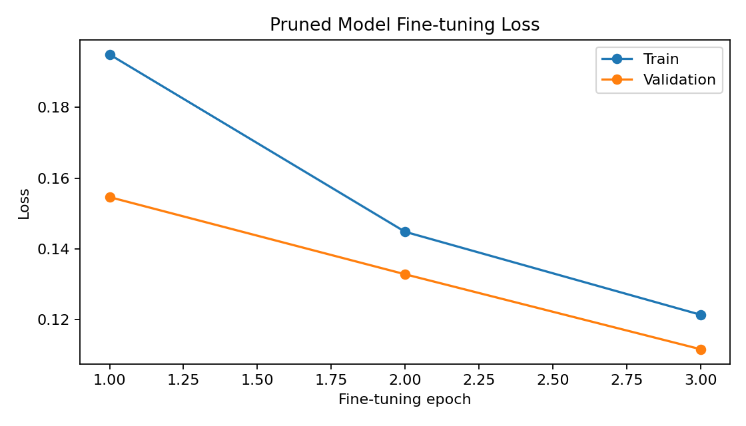
Figure 1. Loss during fine-tuning of the structurally pruned model.

8. Benchmark Method
To make the comparison fair, the same 128×128 input shape, CPU environment, thread count and model input batch size were used for all inference benchmarks. Each model was warmed up for 50 passes and then measured over 250 single-image inference passes. Median latency is reported because a small number of OS or runtime interruptions can create larger outliers in CPU timing. FPS is calculated from the median single-frame latency as 1000 / latency_ms.
Three versions were measured: the original Week 2 eager PyTorch model, the structurally pruned eager PyTorch model, and the pruned model exported to TorchScript and optimized for inference. PyTorch documentation describes inference optimization facilities and also notes that warm-up and thread configuration matter when benchmarking CPU inference. The current PyTorch documentation also marks TorchScript as deprecated in favour of torch.export; TorchScript is used here only as a deployment experiment for this internship task, not as a statement of preferred future PyTorch API direction. citeturn358426search12turn358426search13

9. Before-and-After Performance
Model | Parameters | Median latency | Median-based FPS | P95 latency
Baseline eager | 79461 | 1.902 ms | 525.78 | 5.071 ms
Pruned eager | 44909 | 1.654 ms | 604.73 | 4.372 ms
Pruned + TorchScript | 44909 | 0.771 ms | 1296.97 | 1.743 ms
Structured pruning alone reduced median latency from 1.902 ms to 1.654 ms, a 13.05% reduction and 1.15× speed-up. After TorchScript export/optimization, median latency reached 0.771 ms, corresponding to a 59.46% reduction versus the baseline and 2.47× the baseline median-based FPS.
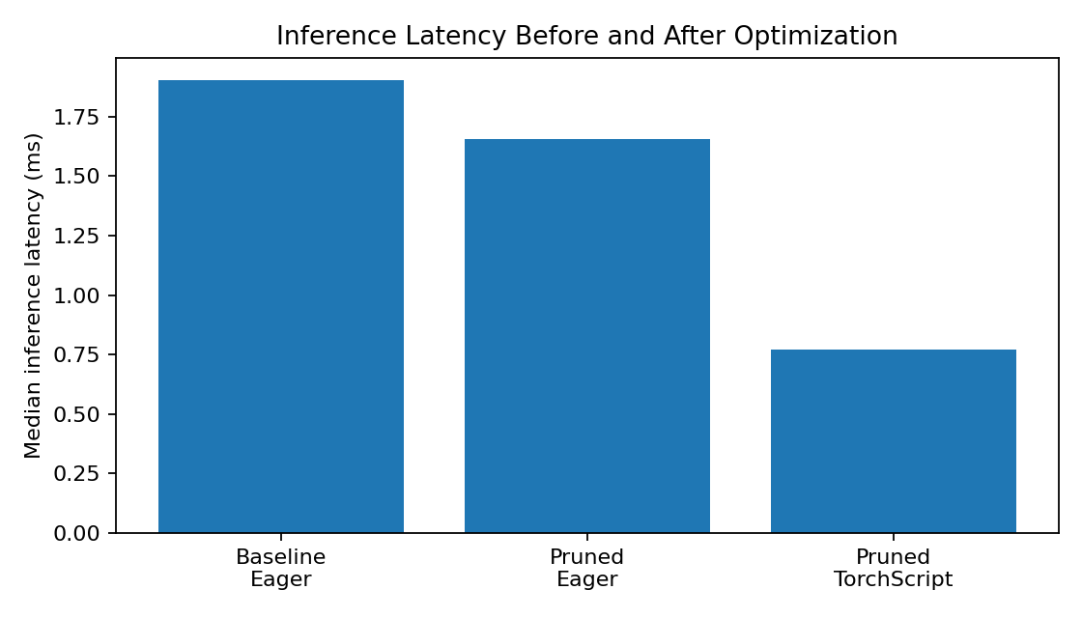
Figure 2. Median single-image inference latency comparison.

10. Detection Accuracy and Counting Trade-Off
Model | Precision | Recall | Mean matched IoU | Counting MAE
Baseline | 9.13% | 6.28% | 0.578 | 1.97
Pruned + fine-tuned | 14.62% | 13.66% | 0.602 | 1.00
In this experiment, the pruned and fine-tuned model did not suffer an accuracy drop. In fact, all reported detection metrics improved on the same synthetic validation split: precision increased from 9.13% to 14.62%, recall from 6.28% to 13.66%, mean matched IoU from 0.578 to 0.602, and counting MAE fell from 1.97 to 1.00 objects/image. These changes should be interpreted cautiously because the dataset is synthetic and small; they are evidence from this benchmark, not a general guarantee that pruning will improve accuracy on real retail images.
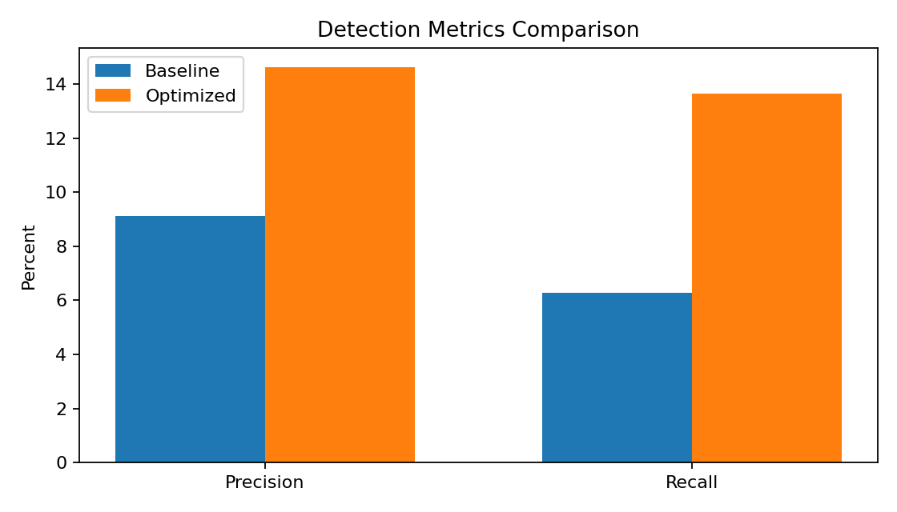
Figure 3. Precision and recall comparison on the Week 3 validation set.

11. Model Size Reduction
The baseline contains 79,461 parameters, while the optimized eager model contains 44,909. This corresponds to a 43.48% parameter reduction.
Using four bytes per FP32 parameter as a simple storage estimate, the learned parameter storage falls from approximately 310.4 KB to 175.4 KB. This is an estimate of raw parameter storage and does not include model metadata, runtime libraries or file container overhead.

12. What Was Learned from the Benchmark
• Reducing complete channels produced a measurable latency reduction while also lowering the parameter count.
• The largest practical speed increase in this experiment came from combining the smaller network with the optimized inference representation.
• Median latency is more useful for comparing typical performance, while P95 shows that occasional slower executions still occur.
• Model loss and runtime speed are separate objectives. A lower loss does not automatically mean a faster model.
• The optimized result is still only a prototype baseline because its detection metrics on the synthetic dataset are far below a level suitable for real retail deployment.

13. Challenges Encountered
• Physical channel pruning requires consistent slicing of both the output filters of one convolution and the input channels of the next convolution. Incorrect slicing can make the model dimensions incompatible.
• Pruning can change model behaviour, so fine-tuning was added instead of using the structurally reduced model without recovery training.
• CPU timing contains runtime variability. The benchmark therefore used warm-up passes, fixed thread count, batch size 1 and 250 repeated measurements.
• The current detector is a simplified grid model and is not designed for the full density and visual variation of real retail shelves.

14. Recommendations for Further Optimization
• Train a stronger pretrained YOLO-family detector on a documented SKU-110K subset before attempting additional compression.
• Compare structured pruning levels such as 10%, 25% and 40% and plot the accuracy-speed curve.
• Evaluate post-training or quantization-aware quantization on a supported deployment target.
• Use torch.export or another current deployment path rather than building a new production workflow around TorchScript, which current PyTorch documentation marks as deprecated.
• Benchmark on the actual target hardware, including GPU or edge hardware, because CPU latency alone does not represent every deployment environment.

15. Reproducibility Files
File | Purpose
week3_optimization.py | Core pruning and deployment optimization code
optimized_pruned_shelf_detector.pt | Structurally pruned and fine-tuned model
optimized_pruned_shelf_detector_torchscript.pt | TorchScript inference artifact
week3_benchmarks.json | Raw benchmark and metric record
finetuning_loss.png | Fine-tuning loss curve
latency_comparison.png | Latency benchmark graph
metric_comparison.png | Precision/recall benchmark graph
README.md | Run and project notes

16. Week 3 Work Allocation
Activity | Hours
Baseline profiling and benchmark setup | 5
Pruning strategy and channel-importance analysis | 7
Model reconstruction and weight transfer | 7
Fine-tuning and debugging | 5
Before/after benchmarking and graph generation | 4
Report writing and project packaging | 5
Total | 33

17. Conclusion
Week 3 extends the Week 2 detector into a measurable optimization experiment. Structured channel pruning reduced the model from 79,461 to 44,909 parameters, and the optimized model was fine-tuned before benchmarking. On the same synthetic validation distribution, the pruned eager model improved the measured detection metrics and reduced median inference latency by 13.05%. The final TorchScript representation reached 0.771 ms median latency, compared with 1.902 ms for the baseline, giving a 2.47× speed-up under the recorded CPU benchmark setup.
The main outcome is a lighter and faster prototype with documented evidence for every comparison. The result should not be interpreted as a production-ready retail detector, because the training and evaluation data remain synthetic. The next stage should focus on integrating this optimized inference path with the application prototype and testing the complete workflow, which aligns with the Week 4 integration and cross-functional testing task.

18. References
• YuvaIntern. Computer Vision Specialist Internship, Week 3 task instructions. Source material supplied in the internship dashboard.
• PyTorch documentation. LnStructured pruning. https://docs.pytorch.org/docs/stable/generated/torch.nn.utils.prune.LnStructured.html
• PyTorch Tutorials. Pruning Tutorial. https://docs.pytorch.org/tutorials/intermediate/pruning_tutorial.html
• PyTorch documentation. CPU threading and TorchScript inference. https://docs.pytorch.org/docs/stable/notes/cpu_threading_torchscript_inference
• PyTorch documentation. torch.fx optimize_for_inference. https://docs.pytorch.org/docs/main/generated/torch.fx.experimental.optimization.optimize_for_inference.html

