
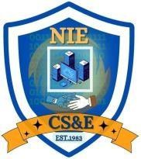
<Poster : Global Warming>
AN EXPERIENTIAL LEARNING ACTIVITY REPORT SUBMITTED TO
THE NATIONAL INSTITUTE OF ENGINEERING, MYSURU
(An Autonomous Institute under Visvesvaraya Technological University, Belagavi)

in partial fulfillment for the award of degree of

Bachelor of Engineering
in
Computer Science and Engineering
Submitted By
Pragyanshu Mishra 4NI23CS143
Prakhyaat Shandilya 4NI23CS148
Pulkit Garg 4NI23CS158
Rhitwik Mishra 4NI23CS168
Satyam Kumar Thakur 4NI23CS188

Under the guidance of Mr. Shashank T Assistant Professor
Department of Civil Engineering NIE, Mysuru

Department of Computer Science & Engineering
THE NATIONAL INSTITUTE OF ENGINEERING
(Autonomous Institution) Mysuru - 570 008
2025-26

TABLE OF CONTENTS

CONTENTS
Table Of Contents | I
List Of Figures | II

i

LIST OF FIGURES

FIG. NO. | DESCRIPTION | PAGE NO.

ii

<Global Warming>

Chapter 1
INTRODUCTION

Global warming is one of the most pressing challenges facing our planet today, demanding immediate attention and collective action. This awareness poster aims to highlight the urgent reality of a warming world, illustrating its severe "ill effects" on ecosystems and human societies, from rising sea levels and extreme weather to droughts and species extinction. More importantly, it serves as a call to action, showcasing viable "combat" mechanisms such as the adoption of renewable energy, reforestation efforts, reduction of our carbon footprint, and the embracing of sustainable living practices. It's a powerful reminder that our planet's future hinges on our choices today.

The imagery within the poster starkly contrasts the devastating consequences of inaction with the hopeful potential of proactive solutions. On one side, we see a world scarred by industrial pollution, melting glaciers, and rising temperatures, symbolizing the critical state of our environment. On the other, a vision of a sustainable future emerges, powered by clean energy and lush greenery—a testament to what can be achieved when humanity unites for a common cause. This dual perspective underscores a simple yet profound message: the power to mitigate global warming and secure a healthy planet for future generations lies squarely in our hands, urging us to "Act Now. Save Our Planet."

< Global Warming >

Chapter 2

DESCRIPTION

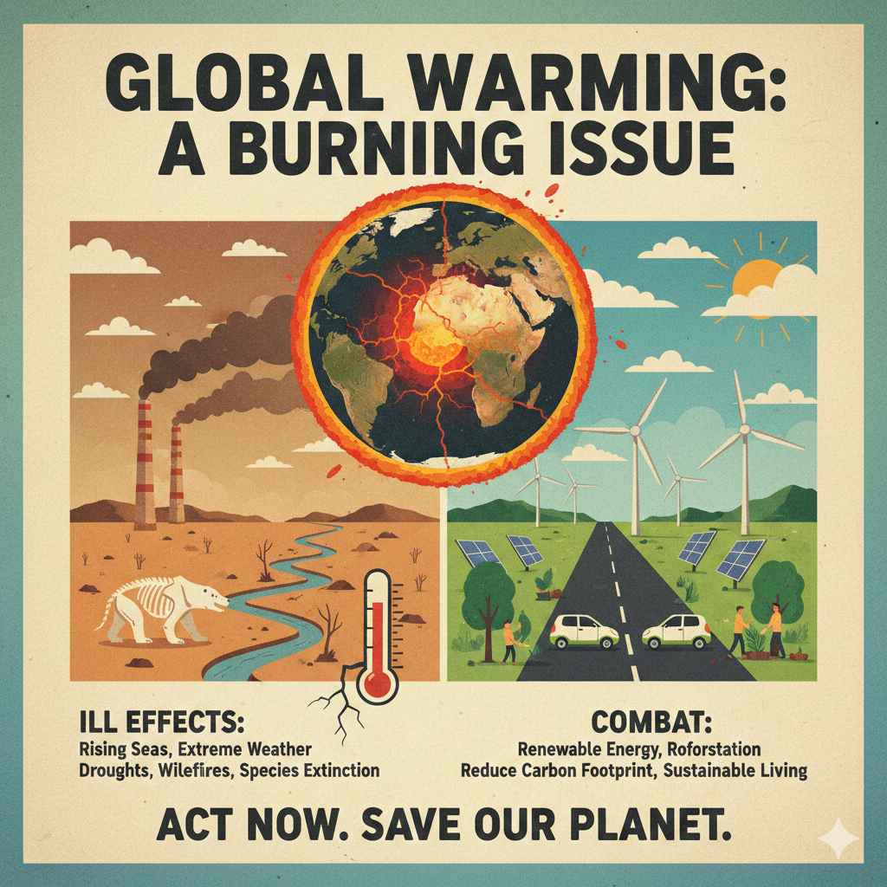

<Global Warming>

The poster is divided into four distinct quadrants, illustrating the problem and its solution, all framed around a central image of Earth in distress. The top center features the bold title, "GLOBAL WARMING: A BURNING ISSUE," emphasizing the urgency.

The top-left quadrant depicts the "Ill Effects" of global warming: industrial smokestacks billowing smoke into a barren, arid landscape, a dried-up riverbed, and a skeleton of a polar bear, symbolizing habitat loss and extinction. Below this, a thermometer shows dangerously high temperatures.
The top-right quadrant presents the "Combat" mechanisms: a vibrant, green landscape featuring an array of wind turbines and solar panels, with cars driving on a road beneath a sunny sky, indicating renewable energy and sustainable living.

In the lower section, the "ILL EFFECTS" are explicitly listed: Rising Seas, Extreme Weather, Droughts, Wildfires, and Species Extinction. Conversely, under "COMBAT," solutions are provided: Renewable Energy, Reforestation, Reduce Carbon Footprint, and Sustainable Living.
The poster culminates with a powerful call to action at the bottom: "ACT NOW. SAVE OUR PLANET." The overall aesthetic uses a distressed, vintage look, with muted colors in the "ill effects" section and brighter, more hopeful tones in the "combat" section, effectively conveying its message through both text and imagery.

<Global Warming>

Chapter 3

CONCLUSION

In conclusion, this awareness poster serves as a vital call to consciousness, urging every individual to recognize the gravity of global warming and the immediate need for collective action. By starkly contrasting the devastating "ill effects" of environmental neglect with the empowering potential of "combat" mechanisms, it provides both a clear warning and a hopeful pathway forward. The message is unequivocal: our planet is in peril, but solutions exist, and they are within our reach. It is a powerful reminder that the future of our world depends on the choices we make today, imploring us all to "Act Now. Save Our Planet" before it's too late.

Ultimately, this poster is more than just an informational graphic; it's a plea for humanity to embrace its responsibility as stewards of the Earth. It underscores that while the challenges are immense, the collective will to adopt renewable energy, reforest our lands, reduce our carbon footprint, and live sustainably can forge a healthier, more vibrant future. The striking visuals and concise text coalesce to form a memorable and impactful message, designed to resonate deeply and inspire not just thought, but tangible action, fostering a global community committed to environmental preservation.

