Desktop Procedure

# Document Control

## Document Information

This document step by step guide to analyse UserDetails , CookingSessions, OrderDetails dataset.

Pragyansu Behera

Final Version

Document Owner

Version

Abstract

# Contents

1.Introduction………………………………………………………………………………………………………………………1

2.Data Source……………………………………………………………………………………………………………………….1

3.Detail Steps……………………………………………………………………………………………………………………….1

# 1.Introduction

This document explains the functional specification for analysing UserDetails.csv, CookingSessions.csv, OrderDetails.csv dataset and finding related to user behaviour, cooking preferences, and order trends.

# 2.Data Source

* Data source given in excel format by.
* Which can be downloaded from [cooking_preference_dataset](https://github.com/Pragyansubehera/upliance_ai_assignment/raw/refs/heads/main/Assignment%20(1).xlsx) (ctrl + right click the link).
* This dataset has 3 sheets containing i.e UserDetails.csv, CookingSessions.csv, OrderDetails.csv

# 3.Detail Steps

Refer Google colab notebook for detail data analysis ([colab_ipynb](https://github.com/Pragyansubehera/upliance_ai_assignment/blob/main/upliance_ai_assignment.ipynb)) .

Python Data Analysis

* Create a google colab note book. Use pandas library to import dataset and save the value to dedicated variable.
* It contains basic analysis (e.g. shape, info, dtypes, columns)
* After analysis we find relationship between 3 table i.e

One to one (using session_id)

OrderDetails CookingSessions

many to one (using user_id)

UserDetails OrderDetails

* 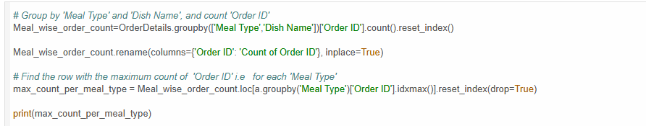After merging dataset , find out maximum order dish according to meal type

* 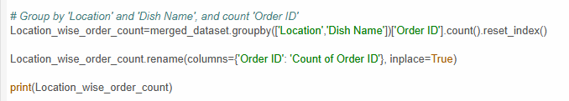Geographical cooking preference according to order