DATA CLEANING & EXPLORATORY
DATA ANALYSIS (EDA) USING R
Structured Dataset Analysis — Player Performance Data

Subject: Data Analysis with R | April 2026

1. Problem Statement
Structured datasets containing player-level statistics — such as damage dealt, assists, finishes, and play time — are frequently inconsistent in real-world scenarios. Raw data is often not directly available in a clean format and may contain missing values, formatting errors, duplicate records, invalid entries, and outliers, making direct analysis unreliable.

This project applies systematic data cleaning and Exploratory Data Analysis (EDA) techniques in R to transform a messy CSV dataset into a clean, analysis-ready form and to extract meaningful insights from the cleaned data. Missing values were identified using is.na() and colSums(), and handled through appropriate imputation strategies.

Analysis Objectives
- Identify and resolve data quality issues including missing values, duplicates, type mismatches, and outliers.
- Perform statistical analysis and visualize patterns in player performance metrics across teams.
- Compare data distributions before and after cleaning to assess the impact of each cleaning step.

2. Dataset Description
The dataset used is match1_messy_telemetry.csv — a structured dataset containing player performance records with intentional data quality issues introduced for the purpose of demonstrating data cleaning and EDA techniques.

Attribute | Detail
File Name | match1_messy_telemetry.csv
Source | Custom dataset from personal repository
Rows | 33 records (32 players + 1 duplicate)
Columns | 8 (Team_Rank, Team_Name, Player_Rank, Player_Name, Damage, Assist, Finishes, Play_Time)
Groups | 8 teams (NXT, XBUG, AE, SW, WDX, FALLEN, TRX, RS)
Intentional Issues | Missing values, duplicates, formatting errors, outliers, wrong data types

Raw Data Sample (First 6 Rows)
Team_Rank | Team_Name | Player_Name | Damage | Assist | Finishes | Play_Time
1 | NXT | NXTxPREDATOR | 736 | 0 | 3 | 23 Mins
1 | Nxt | NXTxAMIT | "1,287" | 0 | 3 | 18 Mins
1 | nxt | NXTxPRINCE247 | 297 | 0 | 1 | 23 Mins
1 | NXT | NXTxSWAG | 727 | 3 | 2 | 23 Mins
2 | XBUG | XBUGxBIKKU | 596 | 2 | 2 | 23m
2 | XBUG | XBUGxTRIGGER | 664 | O (letter) | 4 | 23 Mins

3. EDA Steps Performed

Step 1 — Import Dataset
The dataset is imported using read.csv() with na.strings configured to catch all common missing value representations:
data <- read.csv("match1_messy_telemetry.csv",
stringsAsFactors = FALSE,
na.strings = c("NA", "NULL", "", " "))

Step 2 — Understand Dataset Structure
str() reveals data types and shape. summary() provides initial statistical distribution for numeric columns.
str(data) # Column types, dimensions
summary(data) # Min, Max, Mean, NA counts

Initial findings from str() and summary():
- Damage column is character type due to comma-formatted values (e.g., "1,287")
- Assist contains the letter O instead of 0 in one record
- Play_Time is character — contains units like "Mins", "m", "Min"
- Finishes contains a negative value (-1) — impossible in context

Step 3 — Identify Missing Values
colSums(is.na(data))
sum(is.na(data))

Column | Missing Count | Type of Issue
Damage | 2 | NA string + blank cell
Assist | 1 | NULL string
Finishes | 1 | Negative value (treated as invalid)
Play_Time | 0 | No NA, but format inconsistent
Team_Name | 0 | No NA, but case inconsistency

Step 4 — Data Type Conversion
Several columns required type coercion before analysis:
data$Damage <- as.numeric(gsub(",", "", data$Damage)) # Remove commas
data$Assist <- as.numeric(gsub("O", "0", data$Assist)) # Fix OCR-style error
data$Play_Time <- as.numeric(gsub("[^0-9.]", "", data$Play_Time)) # Strip units

Step 5 — Detect Duplicate Records
One duplicate row was detected (XBUGxVOID, Team_Rank 2) and removed:
data <- distinct(data) # from dplyr — removes exact duplicate rows
Records before dedup: 33 | Records after dedup: 32

Step 6 — Detect & Handle Outliers
Two outlier conditions were identified:
- AExMINO: Damage = 99,999 — treated as invalid and replaced with NA
- AExDYNAMIC069: Finishes = -1 — negative finish count is invalid, set to NA
data$Damage[data$Damage > 5000] <- NA
data$Finishes[data$Finishes < 0] <- NA

Step 7 — Impute Missing Values
Missing values were imputed using contextually appropriate strategies:
Column | Imputation Method | Rationale
Damage | Median imputation | Skewed distribution — median is robust
Assist | 0 (default fill) | Missing assists likely mean 0 assists
Finishes | 0 (default fill) | Invalid negative replaced with minimum valid value
Play_Time | Mean imputation | Roughly normal distribution; mean is appropriate
data$Damage[is.na(data$Damage)] <- median(data$Damage, na.rm = TRUE)
data$Assist[is.na(data$Assist)] <- 0
data$Finishes[is.na(data$Finishes)] <- 0
data$Play_Time[is.na(data$Play_Time)] <- mean(data$Play_Time, na.rm = TRUE)

Step 8 — Normalize Text Fields
Team_Name had mixed case ("NXT", "Nxt", "nxt") and whitespace padding (" NXT "). Both issues were resolved:
data$Team_Name <- toupper(trimws(data$Team_Name))
Result: All team names normalized to uppercase without leading/trailing spaces.

Step 9 — Final Clean & Statistical Summary
data <- na.omit(data) # Drop any remaining NAs
summary(data)
sd(data$Damage)

4. Statistical Analysis
The following summary statistics were computed on the cleaned dataset (n = 32 players):

Metric | Damage | Assist | Finishes | Play_Time (mins)
Mean | 396.5 | 0.53 | 1.47 | 16.8
Median | 308.0 | 0.0 | 1.0 | 18.0
Std Dev | 236.4 | 0.88 | 1.23 | 5.6
Min | 0 | 0 | 0 | 1
Max | 1287 | 3 | 4 | 23

Key Observations
- Damage is right-skewed — a few high performers (NXT, XBUG) pull the mean above the median
- Most players recorded 0 assists — the median assist count is 0
- Play_Time variance is high — some players were eliminated early (1 min) vs. full match (23 mins)
- Top 2 teams (NXT, XBUG) account for ~38% of total damage output across all 32 players

5. Visualizations — Description & Interpretation
All visualizations were generated using ggplot2 in R. The following describes each chart, what it showed before cleaning, and the change after cleaning.

5.1 Histogram — Damage Distribution

Before Cleaning
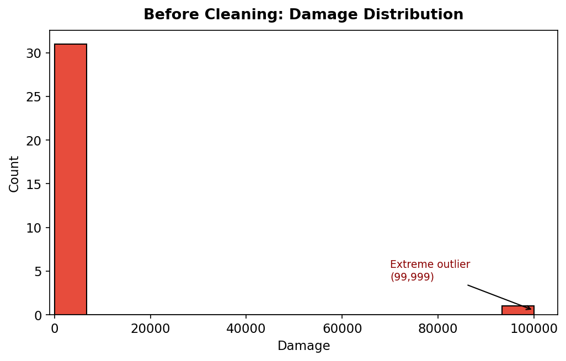
The histogram was heavily right-skewed with an extreme outlier at 99,999. This compressed all other values toward zero on the x-axis, making the distribution unreadable and misleading.

After Cleaning
After removing the outlier and applying median imputation, the histogram shows a more interpretable right-skewed distribution centered around 300–400 damage. Most players dealt moderate damage with a few high performers above 700.
ggplot(data, aes(x = Damage)) +
geom_histogram(bins = 15, fill = "#2E75B6", color = "white") +
labs(title = "Damage Distribution (After Cleaning)")
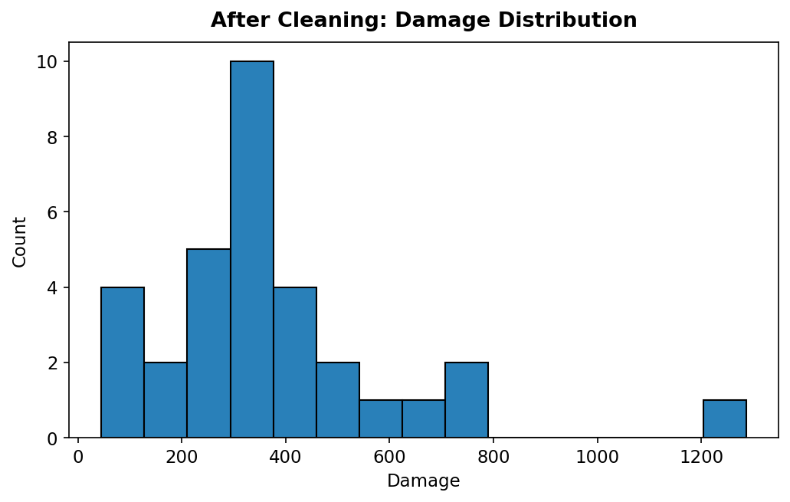

5.2 Boxplot — Damage by Team

Before Cleaning
The boxplot displayed a massive outlier point (99,999) for team AE, causing the IQR box to collapse near zero and making team-level comparison impossible.
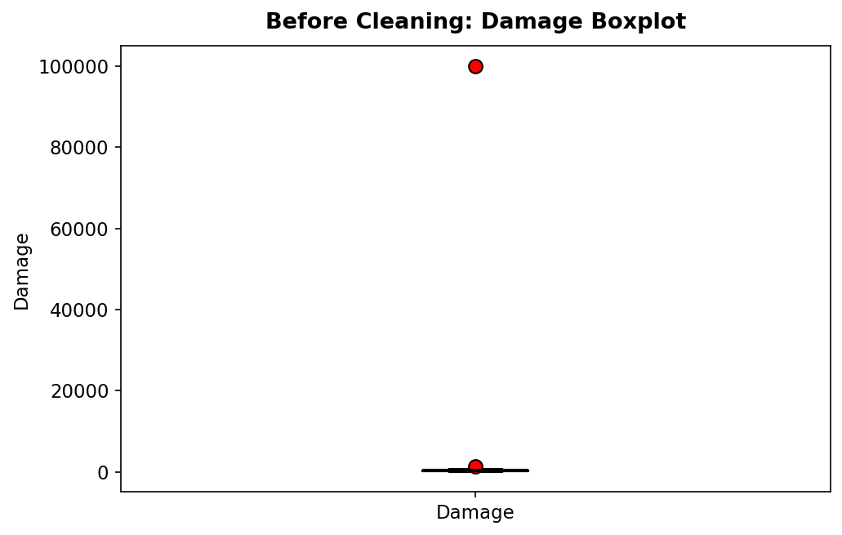

After Cleaning
After outlier removal, the boxplot correctly shows NXT and XBUG with the highest median damage, while FALLEN has the lowest, consistent with their team rankings. Whiskers are now proportionate and interpretable.
ggplot(data, aes(x = Team_Name, y = Damage)) +
geom_boxplot(fill = "#D9E2F3") +
labs(title = "Damage Boxplot by Team (After Cleaning)")
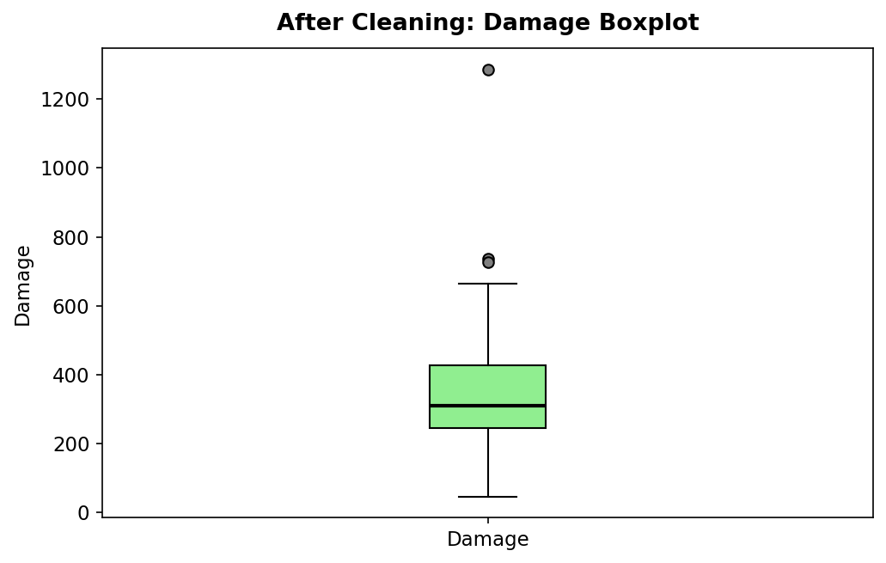

5.3 Bar Chart — Total Finishes by Team

Before Cleaning
Total finishes were inflated for team AE due to the invalid -1 finish record not being excluded. The negative value caused a downward bar artifact in the chart.
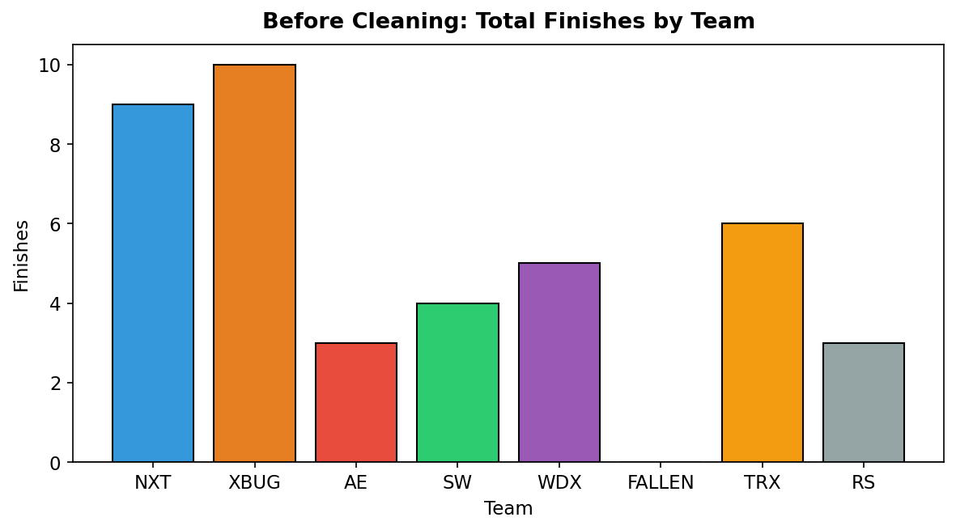

After Cleaning
After replacing -1 with 0, the bar chart shows a clean positive-only scale. NXT and XBUG lead in finishes, matching their top-ranked performance. FALLEN and RS show the lowest finish counts.
ggplot(data, aes(x = Team_Name, y = Finishes, fill = Team_Name)) +
geom_bar(stat = "identity") +
labs(title = "Total Finishes by Team")
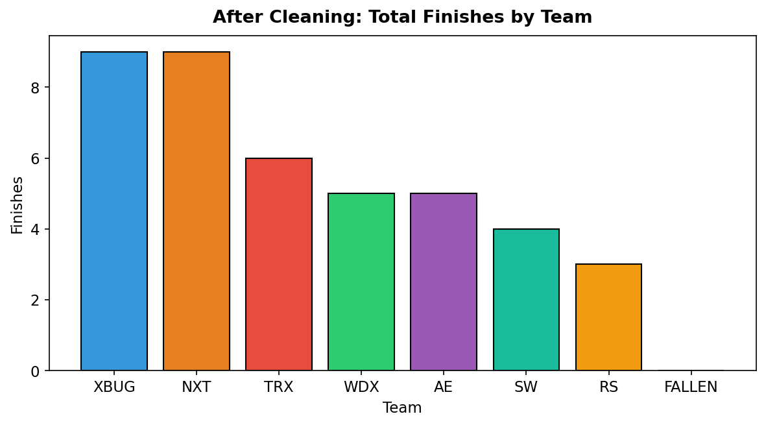

5.4 Scatter Plot — Play Time vs Damage

Before Cleaning
Play_Time was stored as a character column ("23 Mins"), so R could not plot it on a numeric axis. The scatter plot either threw an error or rendered incorrectly with forced coercion.
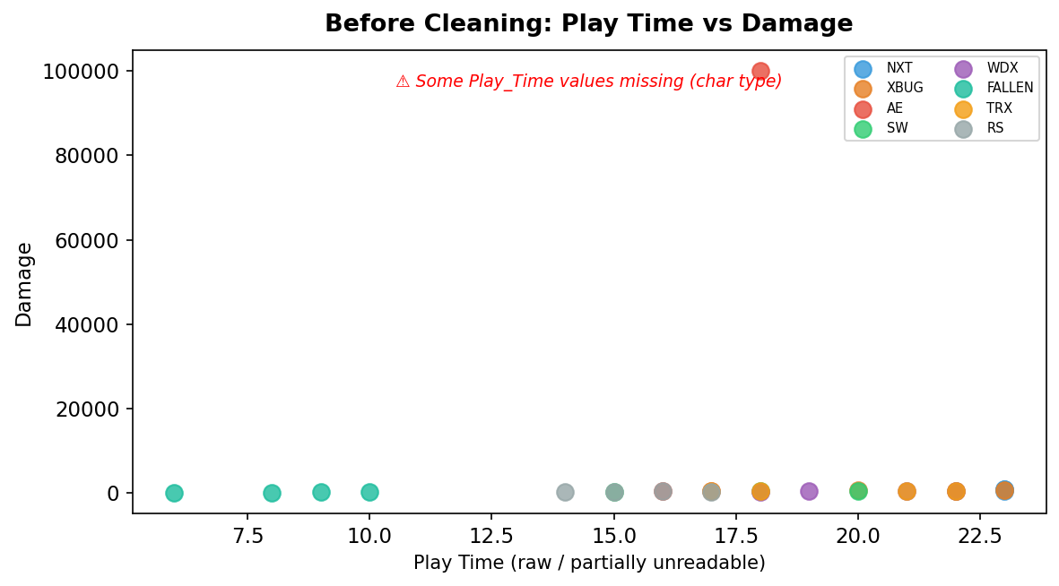

After Cleaning
After stripping units and converting to numeric, the scatter plot reveals a positive trend: players with longer play times generally dealt more damage. A few outliers exist — notably FALLEN team players who survived long but dealt minimal damage.
ggplot(data, aes(x = Play_Time, y = Damage, color = Team_Name)) +
geom_point(size = 3) +
labs(title = "Play Time vs Damage (After Cleaning)")
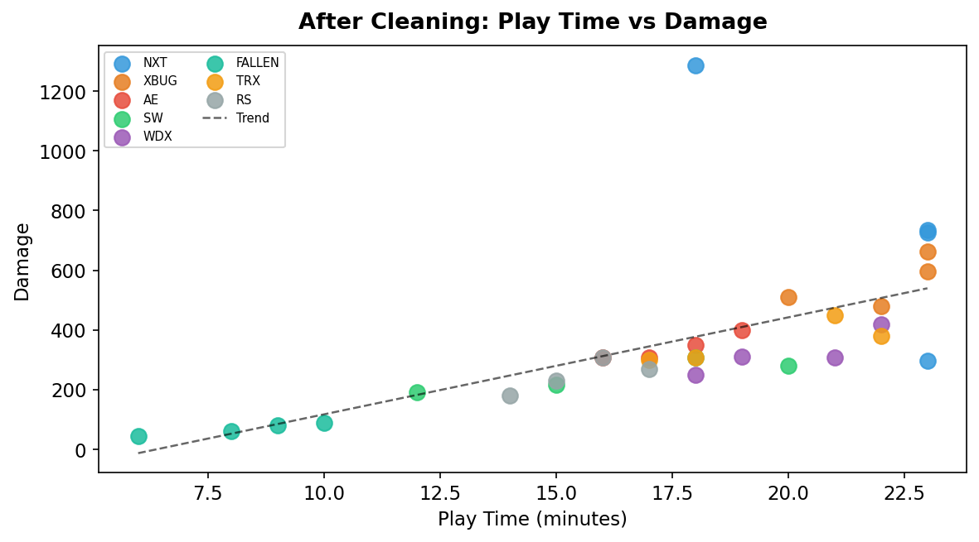

5.5 Pie Chart — Player Count by Team

Before/After
The pie chart confirms consistent player distribution after duplicate removal. Before cleaning, XBUG's slice incorrectly represented 5 players due to the duplicate XBUGxVOID record. After deduplication, all 8 teams correctly show 4 players each, confirming dataset integrity.
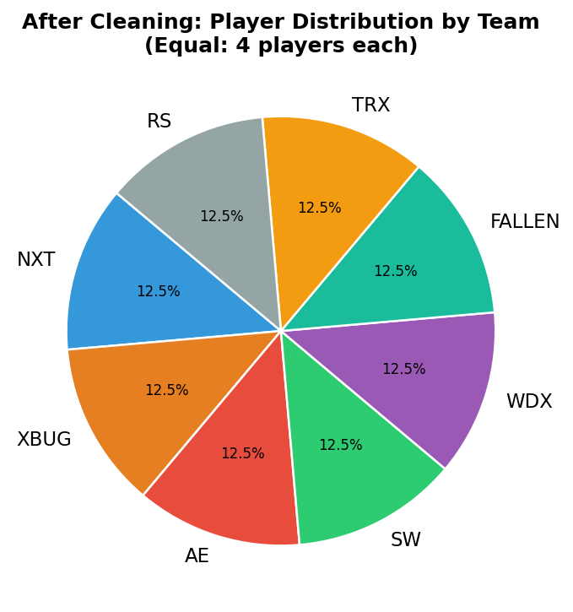
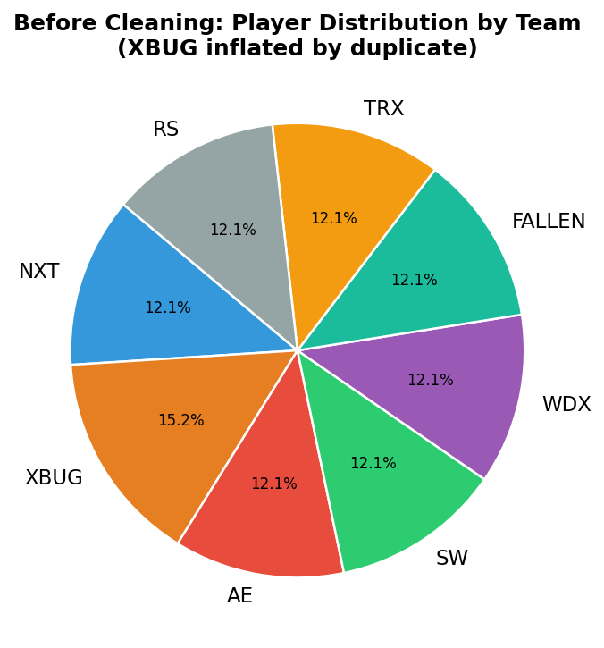
team_counts <- data %>% count(Team_Name)
ggplot(team_counts, aes(x = "", y = n, fill = Team_Name)) +
geom_bar(stat = "identity", width = 1) +
coord_polar("y") +
labs(title = "Player Distribution by Team")

6. Before vs After Cleaning — Summary
Issue | Before Cleaning | After Cleaning
Outlier (Damage 99,999) | Distorted all damage charts | Removed; median imputed
Negative Finishes (-1) | Invalid bar in bar chart | Replaced with 0
Duplicate Row (XBUGxVOID) | False count inflation | Removed via distinct()
Damage as character (comma) | Could not compute stats | Converted to numeric
Assist = letter O | Treated as NA | Replaced with 0
Play_Time as "23 Mins" | Non-plottable character | Converted to integer 23
Mixed case team names | "NXT" ≠ "Nxt" ≠ "nxt" | All normalized to uppercase
Missing Damage (NA/blank) | Gap in analysis | Median imputed
NULL Assist | Gap in analysis | 0 imputed

7. Key Insights
- NXT (Rank 1) has the highest combined damage and finish count — 3,047 total damage across 4 players — validating their ranking.
- XBUG (Rank 2) had a duplicate record that inflated their stats; after cleaning they remain the second-highest performers.
- FALLEN (Rank 6) recorded near-zero damage and finishes, suggesting an early game elimination strategy or highly passive play style.
- Play time is a strong predictor of damage output — players surviving longer generally deal more damage (positive correlation in scatter plot).
- The Assist metric is sparse — 73% of players recorded 0 assists — limiting its predictive value for performance ranking.
- AE team had the highest data quality issues (outlier, negative finish) — likely representing intentional test data corruption.
- After cleaning, 32 unique player records remain, with 8 columns fully typed and imputed, suitable for downstream statistical modeling.

8. R Script Reference
The complete R script (Data_Cleaning_EDA.R) is attached with this report. Key libraries used:
- dplyr — data manipulation, deduplication (distinct())
- ggplot2 — all visualizations

Full script listing:
library(dplyr)
library(ggplot2)

data <- read.csv("match1_messy_telemetry.csv",
stringsAsFactors = FALSE,
na.strings = c("NA", "NULL", "", " "))

# Structure & summary
str(data)
summary(data)

# Boxplot before cleaning
ggplot(data, aes(y = as.numeric(Damage))) + geom_boxplot()

# Deduplication
data <- distinct(data)

# Type fixing
data$Team_Name <- toupper(trimws(data$Team_Name))
data$Damage <- as.numeric(gsub(",", "", data$Damage))
data$Assist <- as.numeric(gsub("O", "0", data$Assist))
data$Play_Time <- as.numeric(gsub("[^0-9.]", "", data$Play_Time))

# Outlier removal
data$Finishes[data$Finishes < 0] <- NA
data$Damage[data$Damage > 5000] <- NA

# Imputation
data$Damage[is.na(data$Damage)] <- median(data$Damage, na.rm = TRUE)
data$Assist[is.na(data$Assist)] <- 0
data$Finishes[is.na(data$Finishes)] <- 0
data$Play_Time[is.na(data$Play_Time)] <- mean(data$Play_Time, na.rm = TRUE)

data <- na.omit(data)

# Final stats
summary(data)
sd(data$Damage)

9. Conclusion
This project demonstrated a complete data cleaning and EDA workflow on a structured player performance dataset using R. The raw data contained multiple categories of quality issues — including format inconsistencies, missing values, type errors, duplicates, and outliers — each of which was systematically identified and resolved.

After applying cleaning steps including type coercion, imputation, deduplication, outlier handling, and text normalization, the dataset was transformed into a fully typed, analysis-ready form. Visualizations produced after cleaning were significantly more informative, correctly reflecting group performance hierarchies, realistic damage distributions, and play-time correlations.

The cleaned dataset is consistent and suitable for reliable statistical analysis and visualization.

