HanuAi ML Assessment — Submission Report
Prepared from the assignment instructions and supplied Task 2 dataset. Task 1 is an executable template; live scraping results are not fabricated.

Executive Summary
Task 2 has 1,000 rows and 20 original columns. Exact duplicate rows: 0; duplicate Event id occurrences: 0. The main unstructured fields are CAUSAL_VERBATIM, CORRECTION_VERBATIM, and CUSTOMER_VERBATIM.

Task 1 — Web Scraping and Sentiment Analysis
The notebook provides Selenium + BeautifulSoup scaffolding. Verify a Best Buy Canada product with at least 50 public reviews, current terms/robots.txt, and live HTML selectors before running. The output CSV is an empty schema template, not scraped results.
Stop on CAPTCHA, access denial, or blocking; do not bypass access controls or evade blocks. VADER is used as a baseline: compound >= 0.05 Positive, <= -0.05 Negative, otherwise Neutral. Validate a manual sample and consider a review-tuned transformer for production.

Task 2 — Data Quality and EDA
Rows: 1000; columns: 20; unique Event IDs: 1000; exact duplicate rows: 0; duplicate Event ID occurrences: 0.
Missing values: Fix Component: 995, Fix Condition: 995, Additional Context: 995, Failure Condition: 995, Trigger: 995, Failure Component: 995, CAUSAL_CD_DESC: 3, CAUSAL_VERBATIM: 1, IN_USE_DATE: 1. Placeholder strings may still represent missing information.

Most common extracted tags (overlap allowed)
- Radio/audio unit: 986 events
- Replacement/repair: 906 events
- Software/programming: 813 events
- Display/black screen: 443 events
- Electrical/power: 227 events
- Communication/data bus: 208 events
- Connectivity/network: 178 events
- Controls/buttons: 130 events
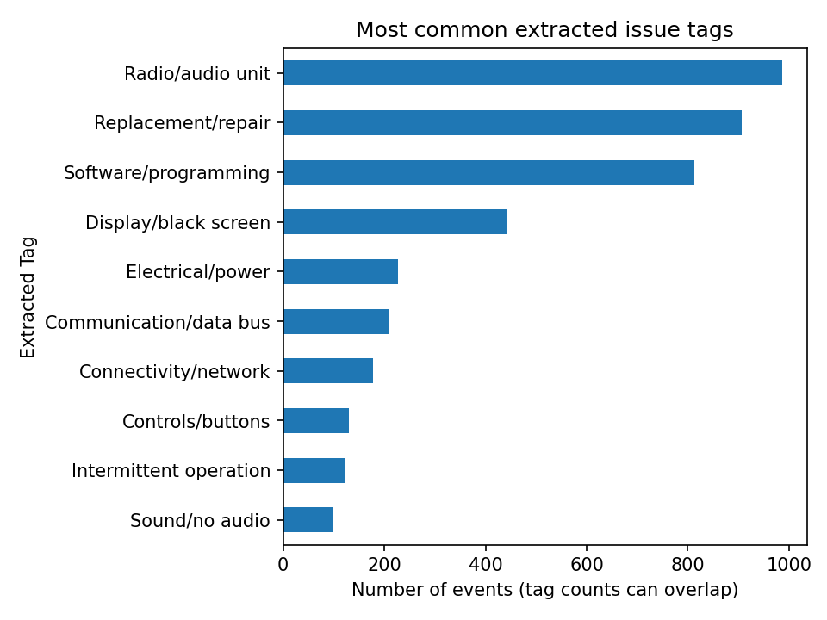

Existing coded fields
Top causal descriptions: Module/Component-No/Incorrect Communication (377); Module/Component-Shorted (237); Module/Component-Registers Incorrectly (121); Wiring/Electrical/Sensors-No/Incorrect Communication (50); Module/Component-Broken (41); Wiring/Electrical/Sensors-Shorted (23); Other-Campaign/ Tech Bulletin (22); Other-Follow operation (22).
Top complaint descriptions: Audio/Entertainment/Navigation - Audio (337); Audio/Entertainment/Navigation - Other issues (263); Audio/Entertainment/Navigation - Communication (194); Audio/Entertainment/Navigation - Video (103); Features/Controls/Displays - Other issues (47); Audio/Entertainment/Navigation - Navigation (32); Features/Controls/Displays - Gauges/Warning Lights (12); Audio/Entertainment/Navigation - Abnormal Noise (11).
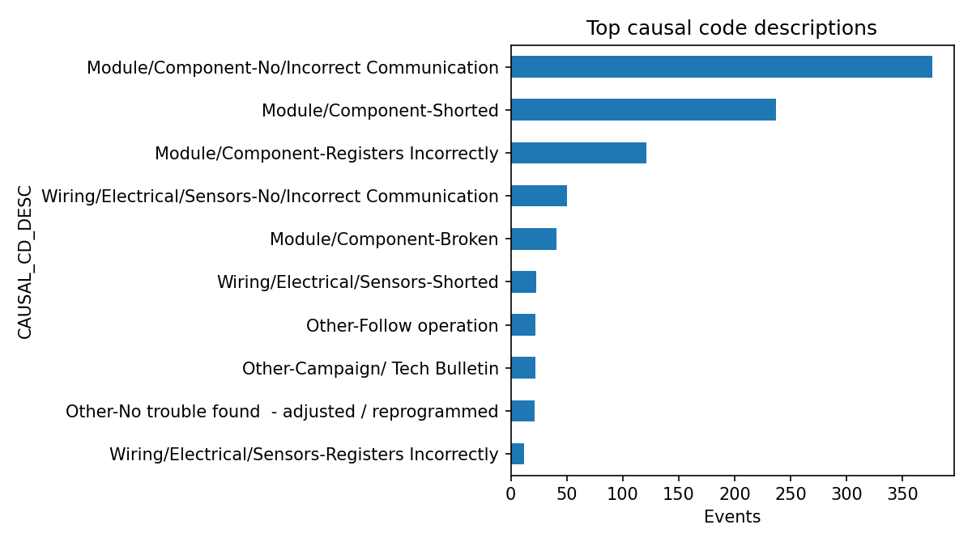

Time trend
Events by opened year: 2019: 95, 2020: 698, 2021: 207. Counts are not failure rates without exposure denominators.
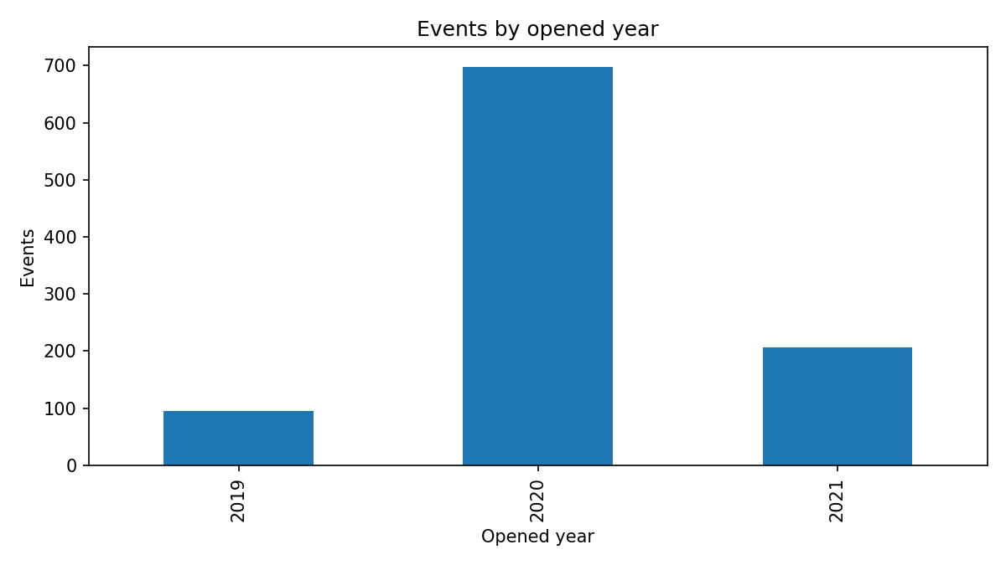

Text Mining and Clustering
Rule-based tags are explainable but can miss synonyms and mishandle negation. TF-IDF + K-Means (k=5) clusters are exploratory and not confirmed root causes.
- Cluster 1 — 185 events; terms: radio, screen, radio screen, blank, display, goes, replaced, replaced radio
- Cluster 2 — 90 events; terms: xm, radio, xm radio, signal, customer, antenna, states xm, replaced
- Cluster 3 — 590 events; terms: radio, customer, tac, usb, replaced, replace, states, update
- Cluster 4 — 46 events; terms: card, sd, sd card, error, navigation, radio, error code, nav
- Cluster 5 — 89 events; terms: camera, radio, rear, coax, camera inop, video, cable, backup

Stakeholder Recommendations
- Prioritize engineering review of recurring radio/audio, display, connectivity, and communication/data-bus themes when supported by counts and case examples.
- Build Pareto views by issue tag, causal code, model year, build plant, and month; add exposure denominators before comparing true failure rates.
- Separate customer-reported symptoms from technician-confirmed causes and repair actions; retain verbatim text and evidence for every tag.
- Manually label a sample of events from each high-volume theme and measure tag precision/recall before operational use.
- Use cluster examples to guide expert review, not to automatically declare root causes; track recurrence after repairs.
- Create a dashboard with failure modes, repair actions, event trends, and time-to-repair if the required fields are available.

Limitations and Next Steps
Validate tags against manually labelled examples, review clusters with engineering experts, compare cluster stability, and add exposure denominators before drawing risk conclusions. Run Task 1 against a verified product page to produce real review data.

Task 1 Compliance Decision — Important
The assignment asks for Best Buy Canada reviews but also requires compliance with website policy. Best Buy Canada's current Conditions of Use explicitly prohibit scraping and data-mining. Therefore this submission does not run automated scraping against BestBuy.ca. The Task 1 notebook instead provides a complete sentiment-analysis and aspect-tagging workflow for an authorized review export, plus a responsible-handling plan. No review records or sentiment results have been fabricated. To complete the live-data portion, obtain written permission or an approved data export.
Source: Best Buy Canada Conditions of Use — https://www.bestbuy.ca/en-ca/help/policies-and-terms-and-conditions/conditions-of-use

